UNITED STATES

SECURITIES AND EXCHANGE COMMISSION
Washington, D.C. 20549

FORM 8-K

CURRENT REPORT

Pursuant to Section 13 or 15(d)

of the Securities Exchange Act of 1934

Date of Report (Date of Earliest Event Reported): April 8, 2022

Blueprint Medicines Corporation

(Exact name of registrant as specified in its charter)

Delaware | 001-37359 | 26-3632015
(State or other jurisdiction | (Commission File Number) | (I.R.S. Employer
of incorporation) |  | Identification No.)
45 Sidney Street
Cambridge, Massachusetts |  | 02139
(Address of principal executive offices) |  | (Zip Code)
 | Registrant’s telephone number, including area code: (617) 374-7580
 | (Former name or former address, if changed since last report)

Check the appropriate box below if the Form 8-K filing is intended to simultaneously satisfy the filing obligation of the registrant under any of the following provisions:

- Written communications pursuant to Rule 425 under the Securities Act (17 CFR 230.425)

- Soliciting material pursuant to Rule 14a-12 under the Exchange Act (17 CFR 240.14a-12)

- Pre-commencement communications pursuant to Rule 14d-2(b) under the Exchange Act (17 CFR 240.14d-2(b))

- Pre-commencement communications pursuant to Rule 13e-4(c) under the Exchange Act (17 CFR 240.13e-4(c))

Indicate by check mark whether the registrant is an emerging growth company as defined in Rule 405 of the Securities Act of 1933 (§230.405 of this chapter) or Rule 12b-2 of the Securities Exchange Act of 1934 (§240.12b-2 of this chapter).

Emerging growth company ☐

If an emerging growth company, indicate by check mark if the registrant has elected not to use the extended transition period for complying with any new or revised financial accounting standards provided pursuant to Section 13(a) of the Exchange Act.

Securities registered pursuant to Section 12(b) of the Exchange Act:

Title of each class | Trading symbol(s) | Name of each exchange on which registered
Common stock, par value $0.001 per share | BPMC | Nasdaq Global Select Market

Item 7.01 Regulation FD.

On April 8, 2022, Blueprint Medicines Corporation (the “Company”) is hosting an investor conference call and webcast to review data presented at the American Association for Cancer Research (“AACR”) Annual Meeting 2022 for multiple research- and clinical-stage programs across its precision oncology and hematology portfolio. A copy of the presentation from the investor conference call and webcast is furnished as Exhibit 99.1 to this Current Report on Form 8-K.

The information in Item 7.01 of this Current Report on Form 8-K, including Exhibit 99.1 attached hereto, is intended to be furnished and shall not be deemed “filed” for purposes of Section 18 of the Securities Exchange Act of 1934, as amended (the “Exchange Act”), or otherwise subject to the liabilities of that section, nor shall it be deemed incorporated by reference in any filing under the Securities Act of 1933, as amended, or the Exchange Act, except as expressly set forth by specific reference in such filing.

Item 8.01 Other Events.

On April 8, 2022, the Company issued a press release announcing data for multiple research- and clinical-stage programs across its precision oncology and hematology portfolio from various poster presentations at the AACR Annual Meeting 2022. A copy of the press release is filed herewith as Exhibit 99.2 to this Current Report on Form 8-K and incorporated herein by reference.

Item 9.01 Financial Statements and Exhibits.

(d) Exhibits.
Exhibit No. |  |  |  |  | Description
99.1 |  |  | Corporate slide presentation of Blueprint Medicines Corporation dated April 8, 2022
99.2 |  |  | Press release issued by Blueprint Medicines Corporation on April 8, 2022
104 |  |  | Cover Page Interactive Data File (embedded within the Inline XBRL document and incorporated as Exhibit 101)

SIGNATURES

Pursuant to the requirements of the Securities Exchange Act of 1934, the registrant has duly caused this report to be signed on its behalf by the undersigned hereunto duly authorized.

 | BLUEPRINT MEDICINES CORPORATION
Date: April 8, 2022 | By: | /s/ Kathryn Haviland
 |  | Kathryn Haviland
 |  | Chief Executive Officer

Exhibit 99.1


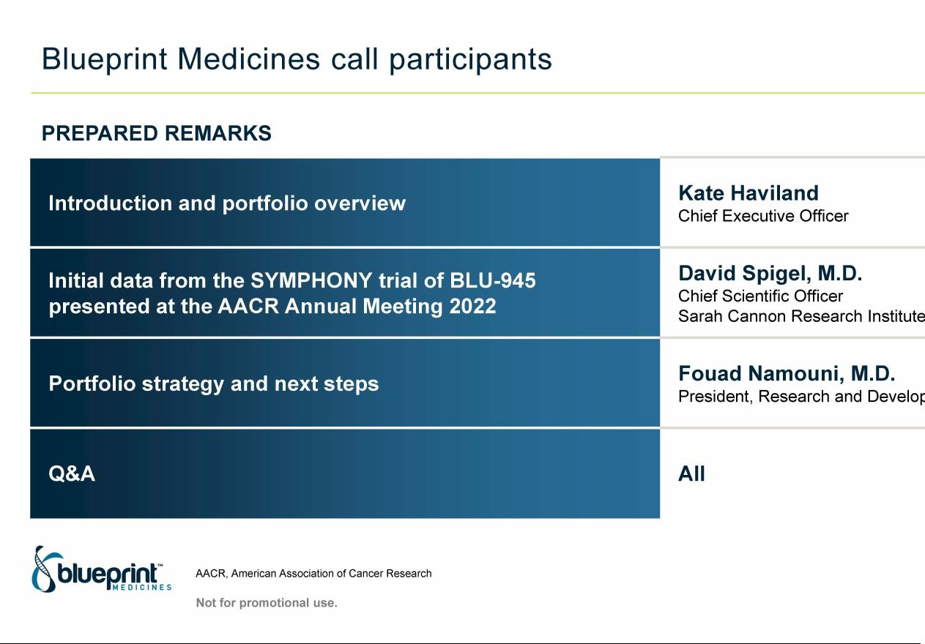

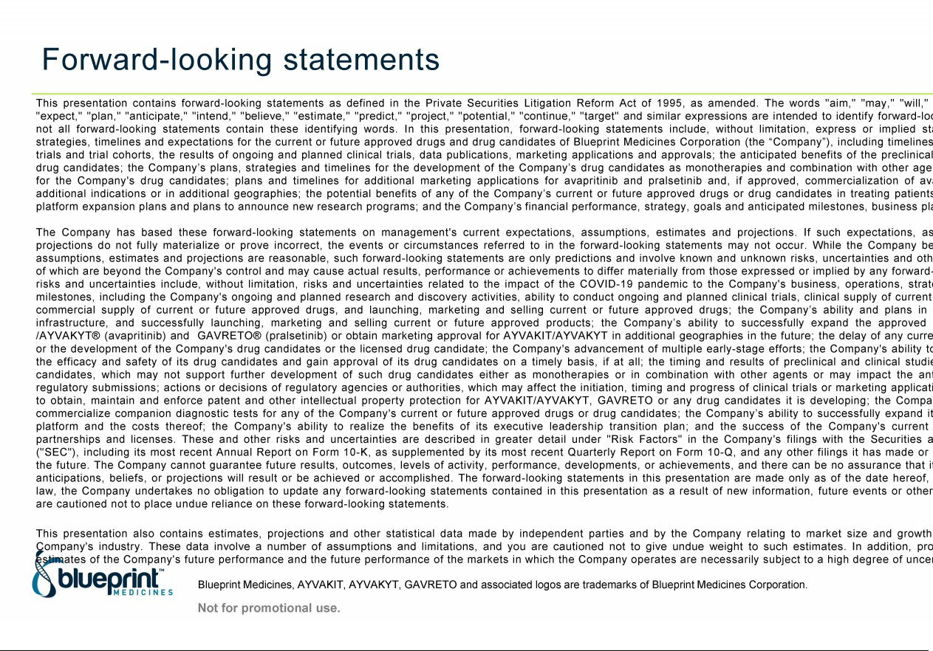

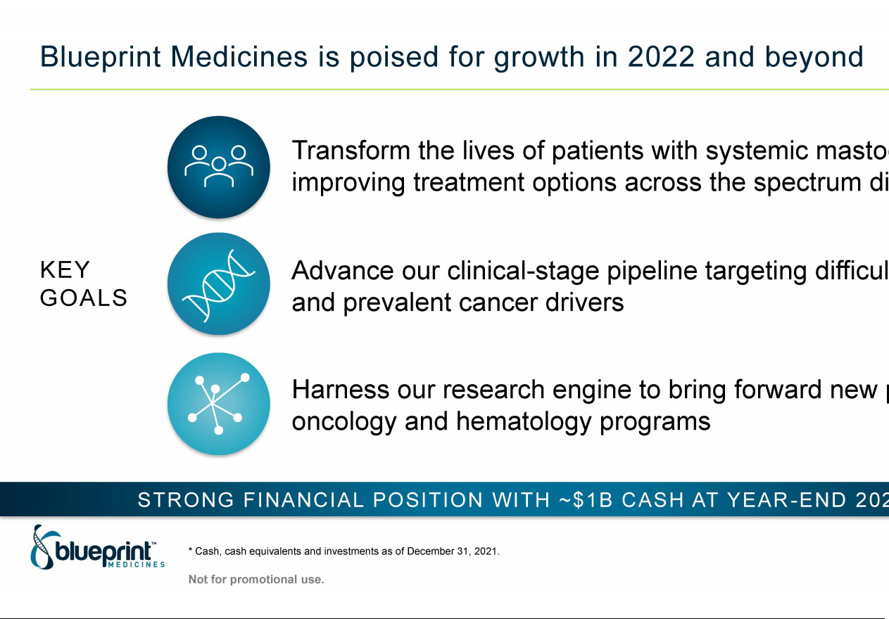

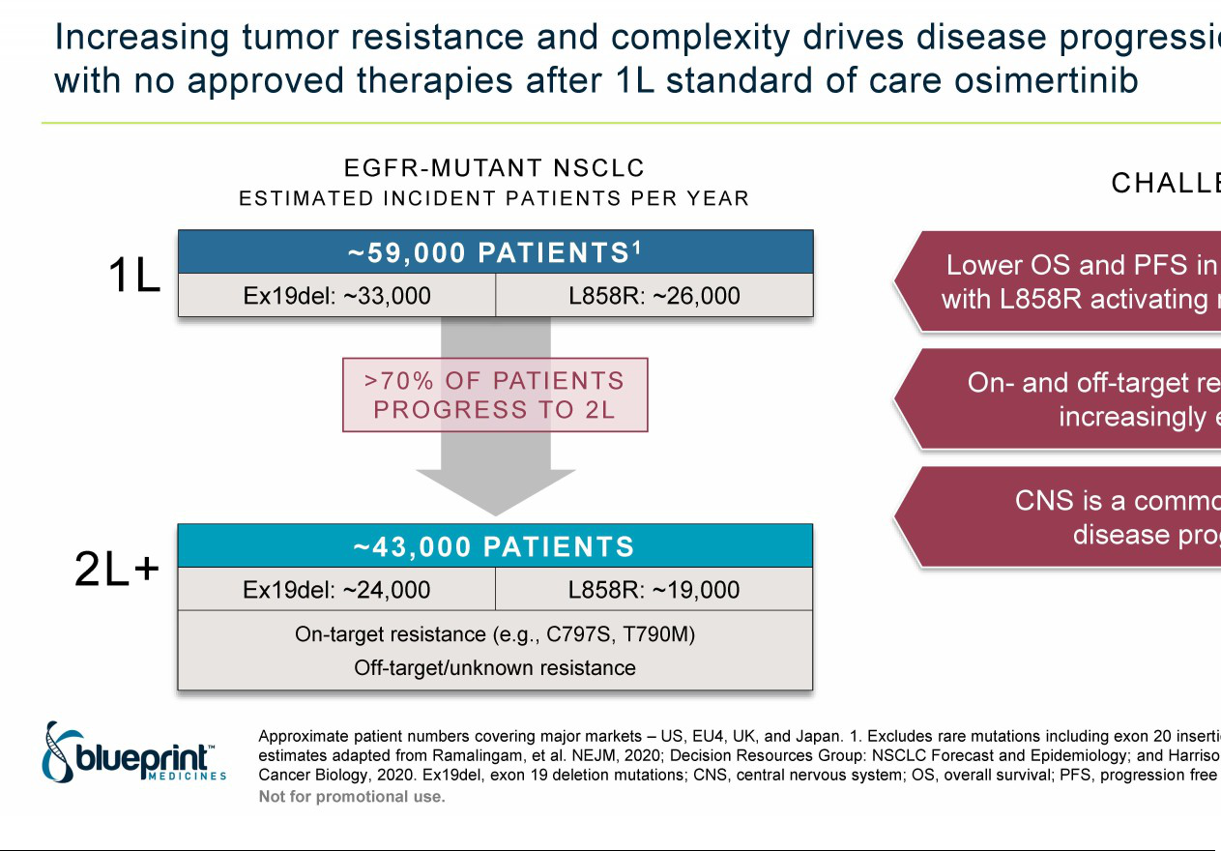

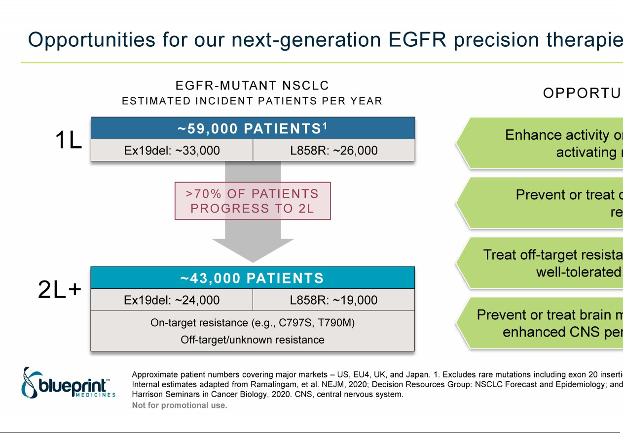

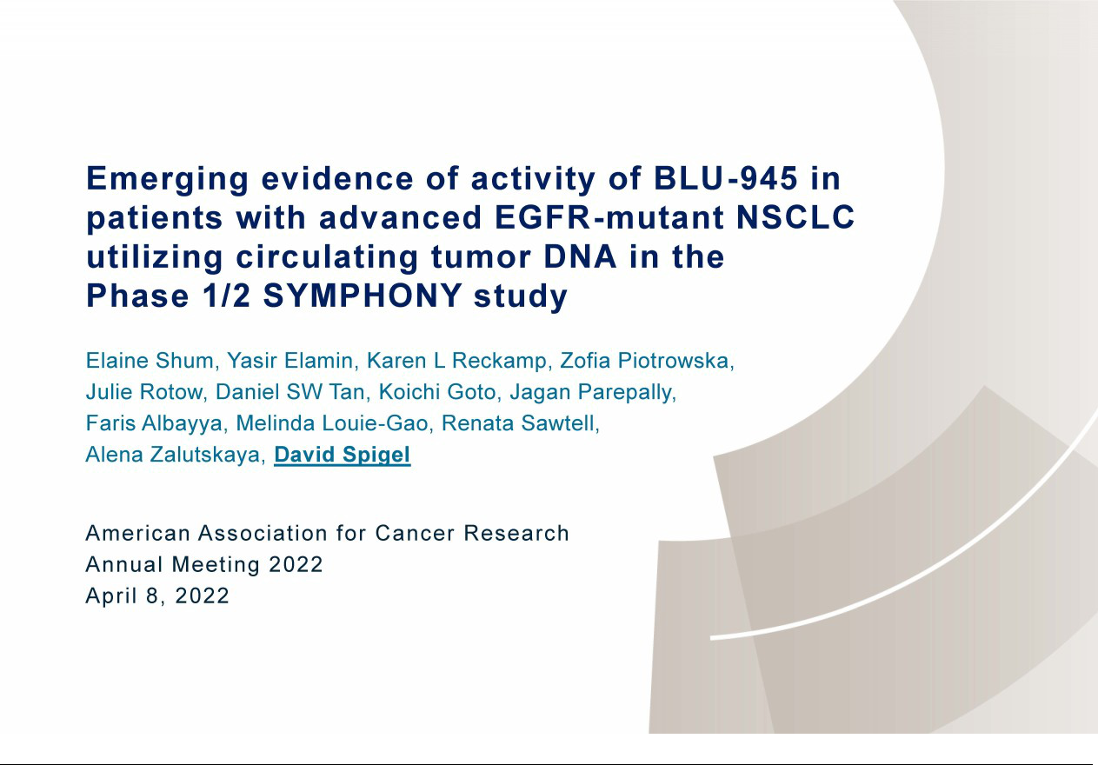

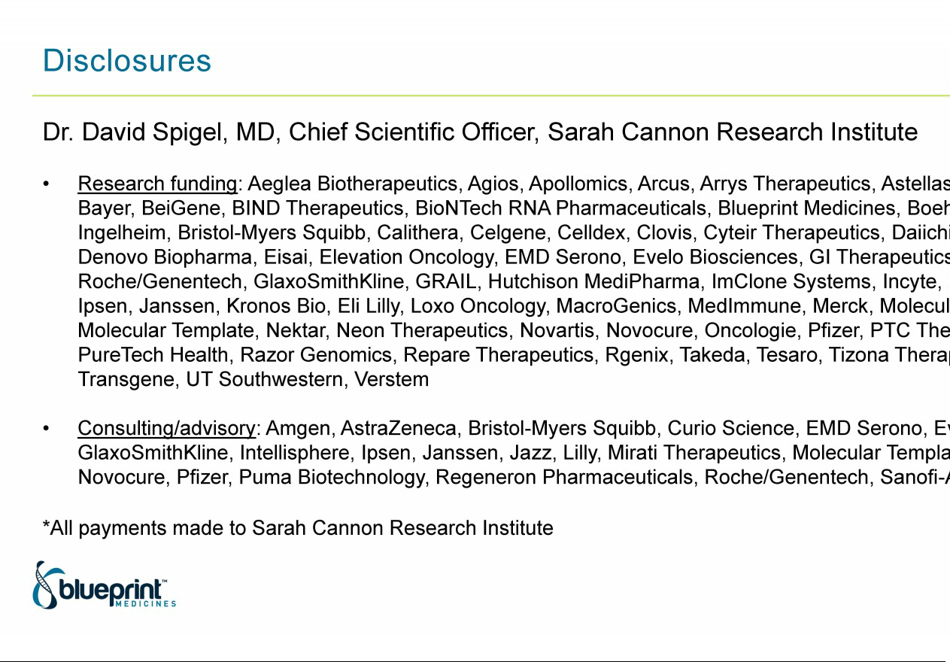

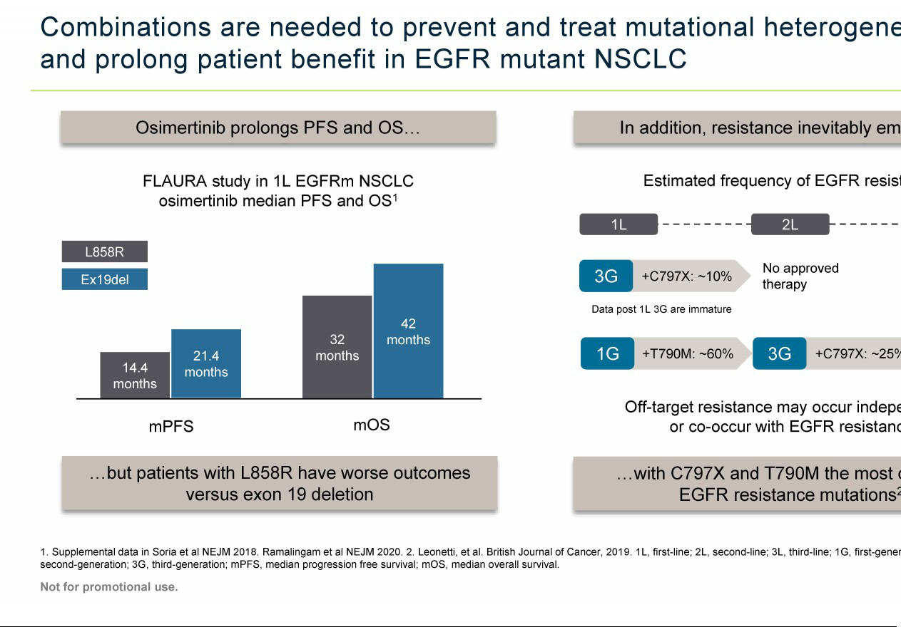

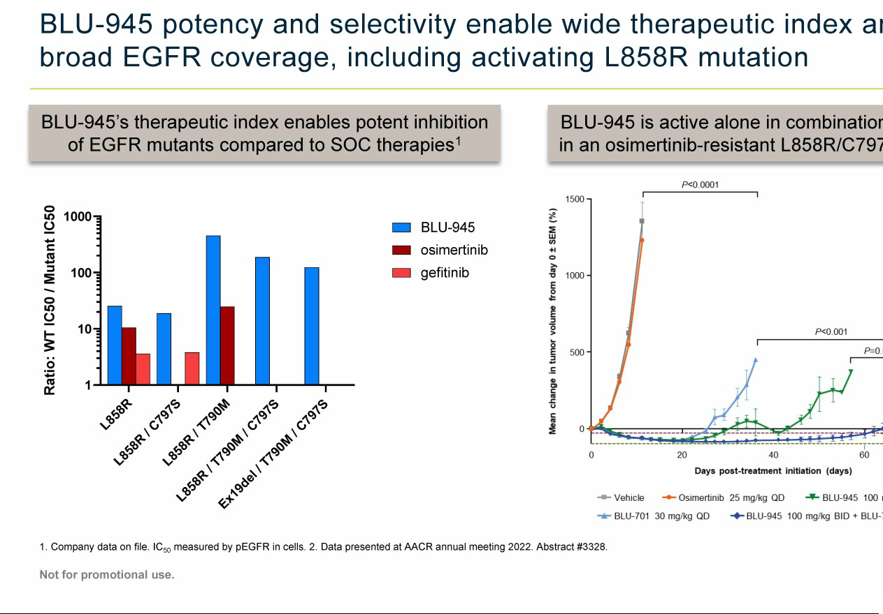

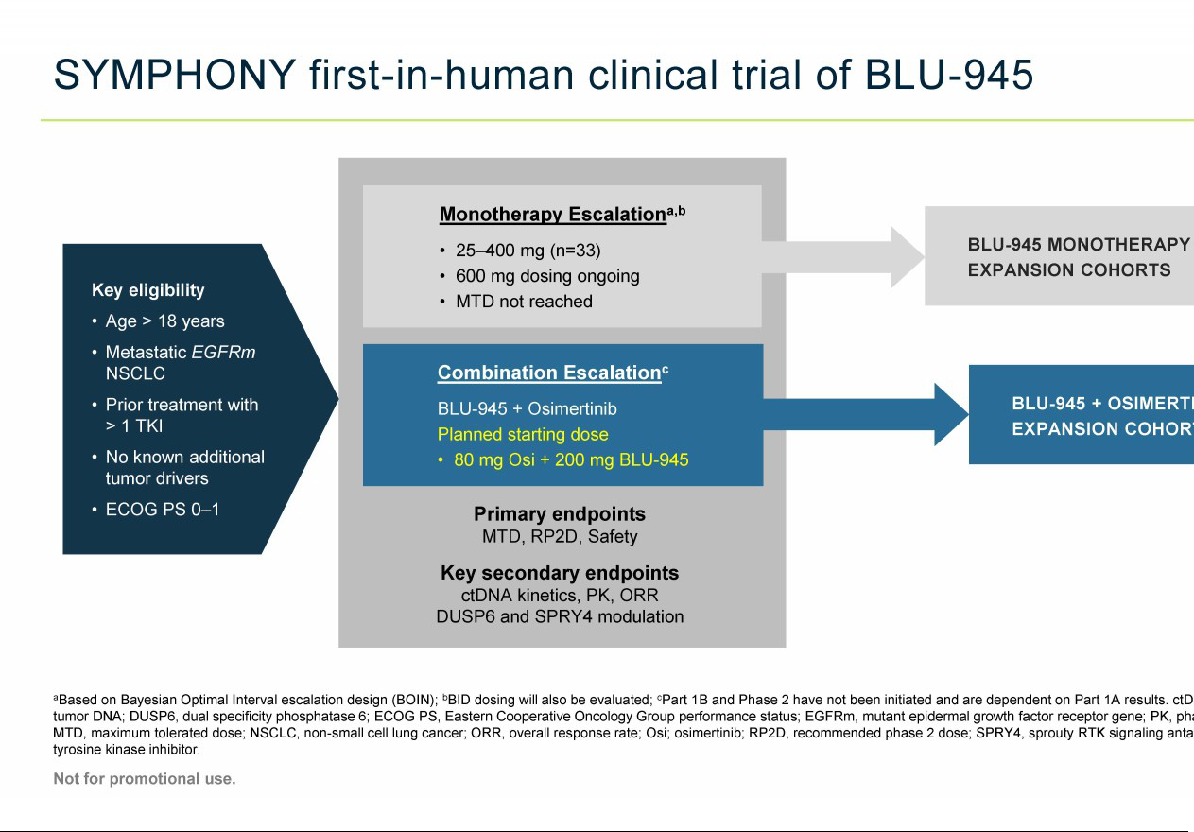

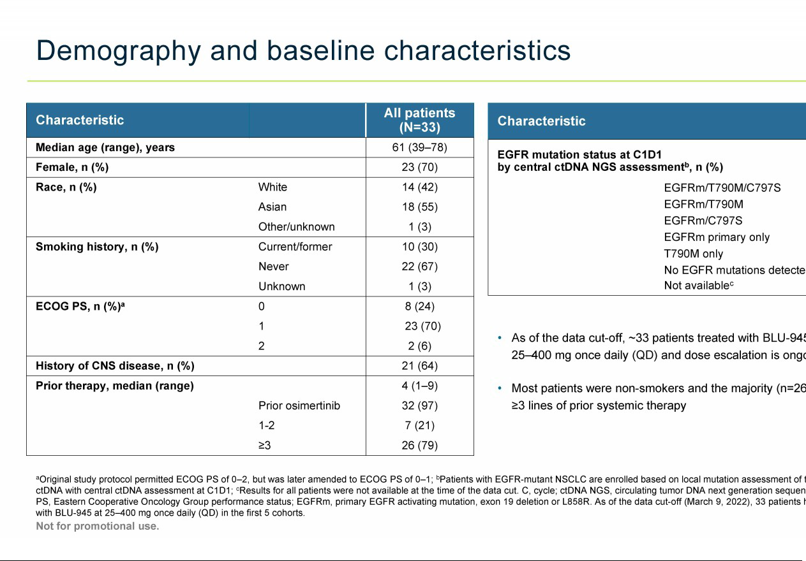

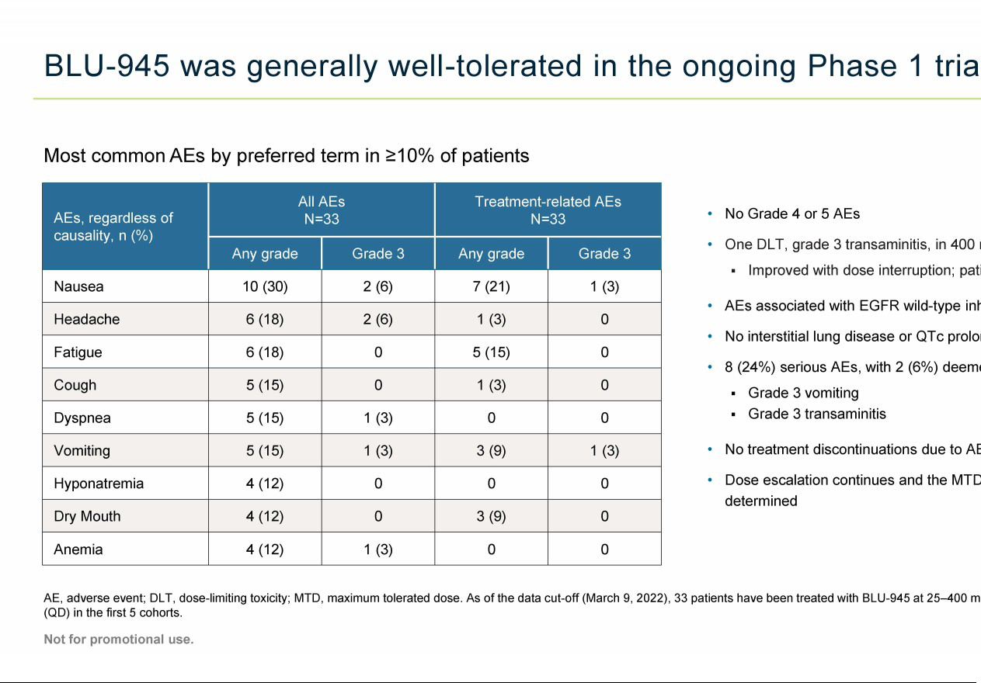

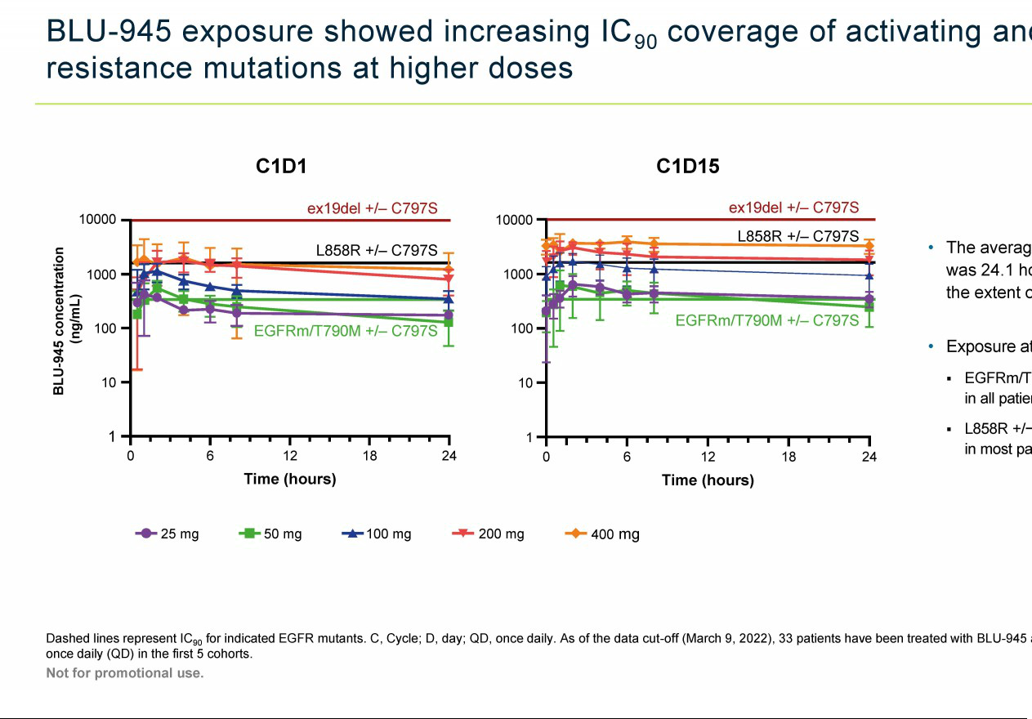

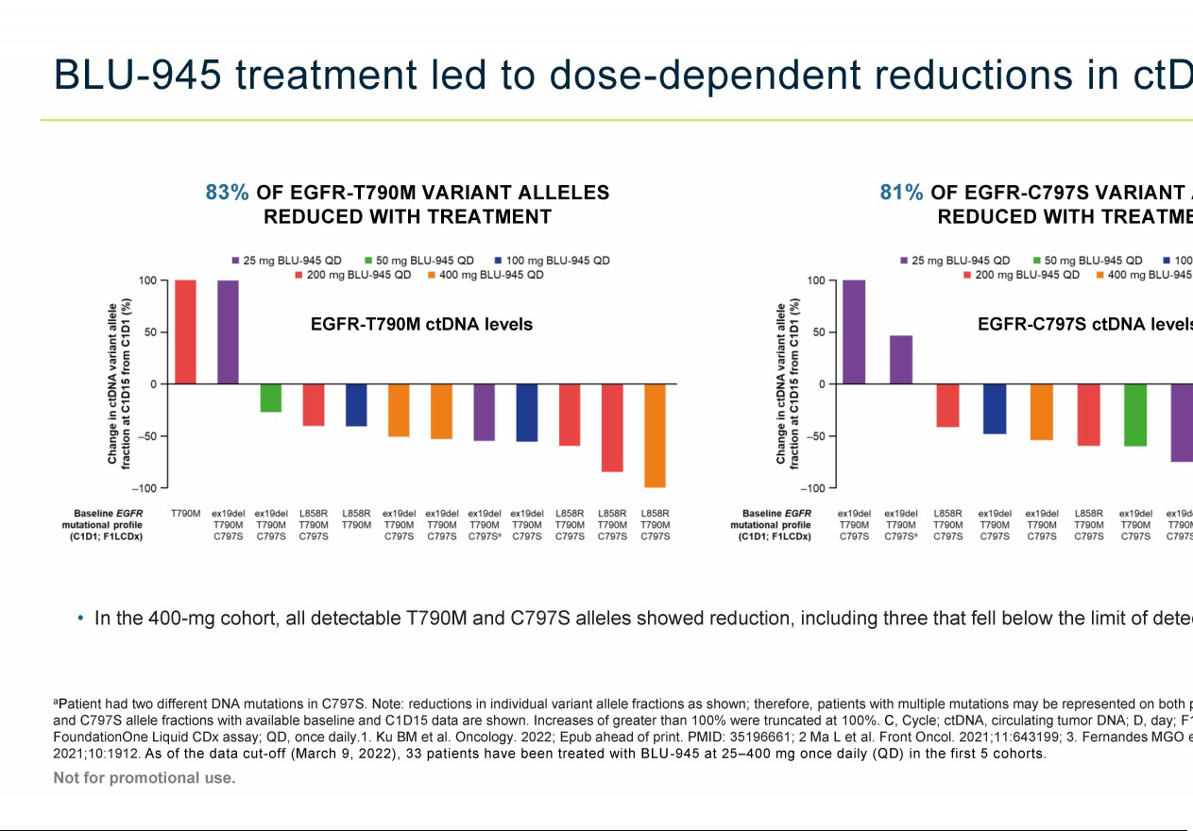

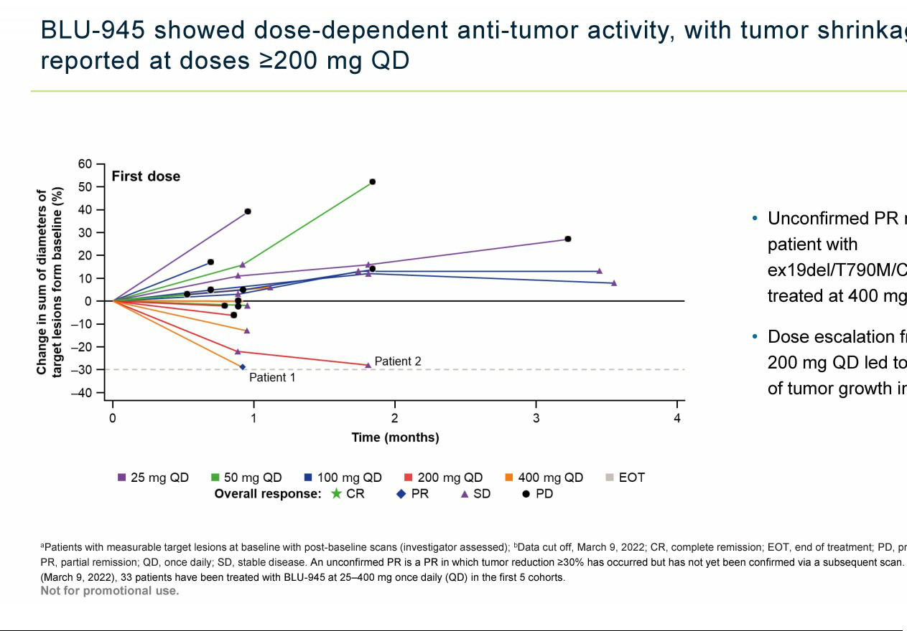

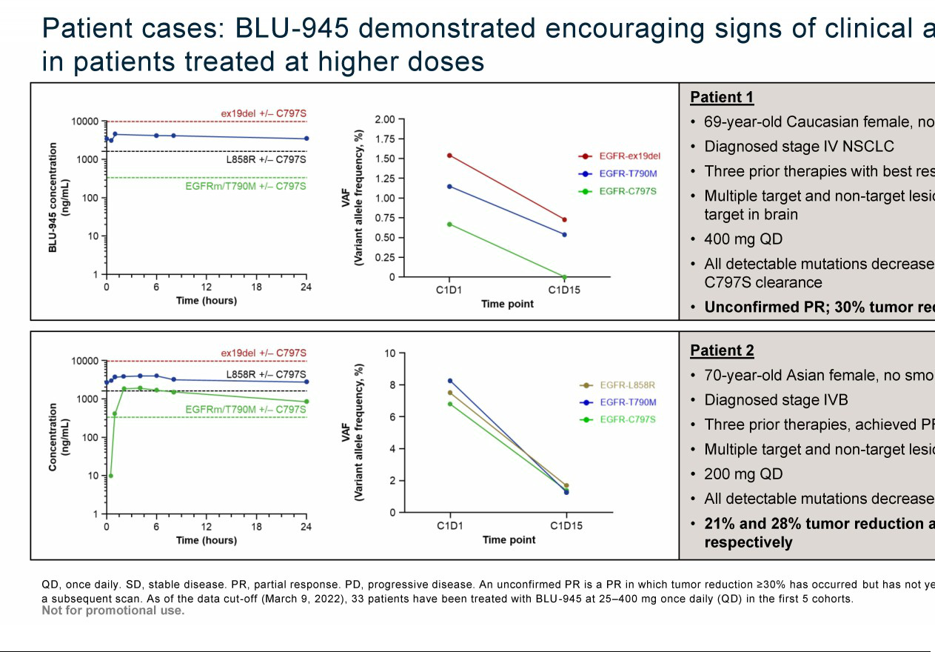

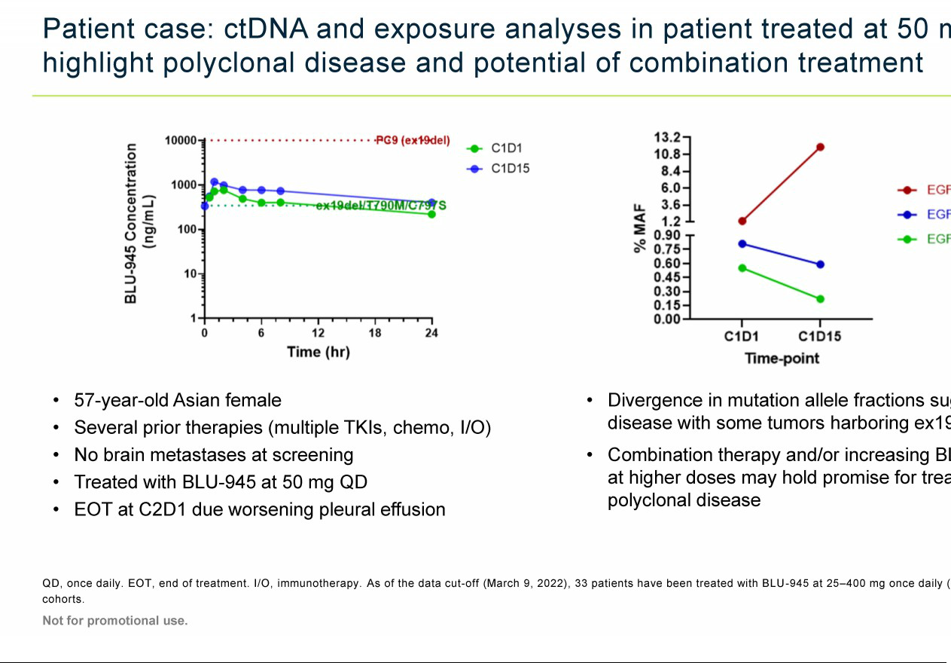

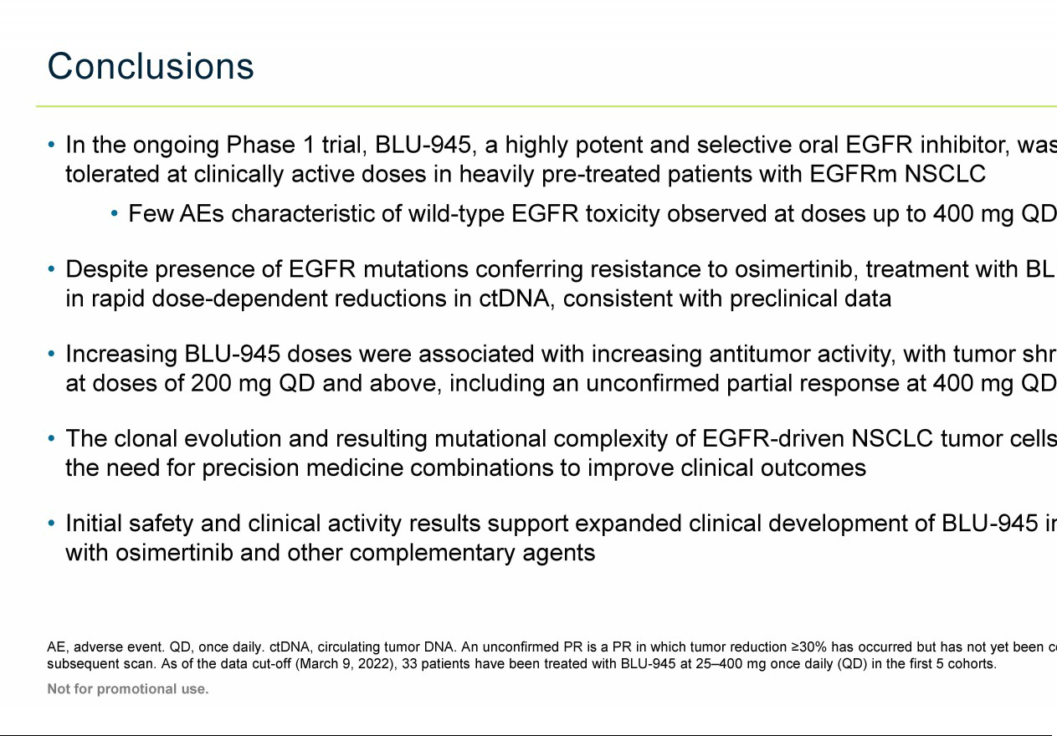

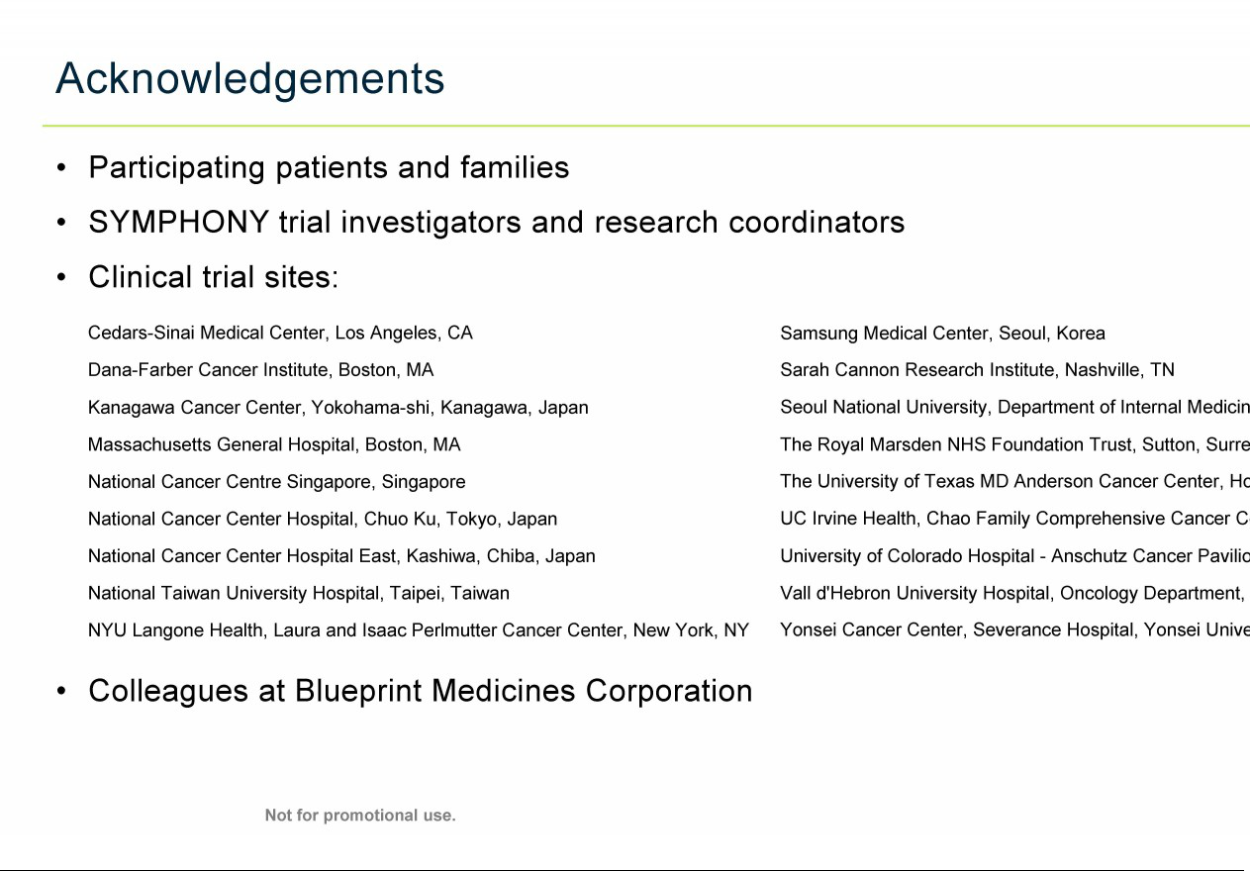

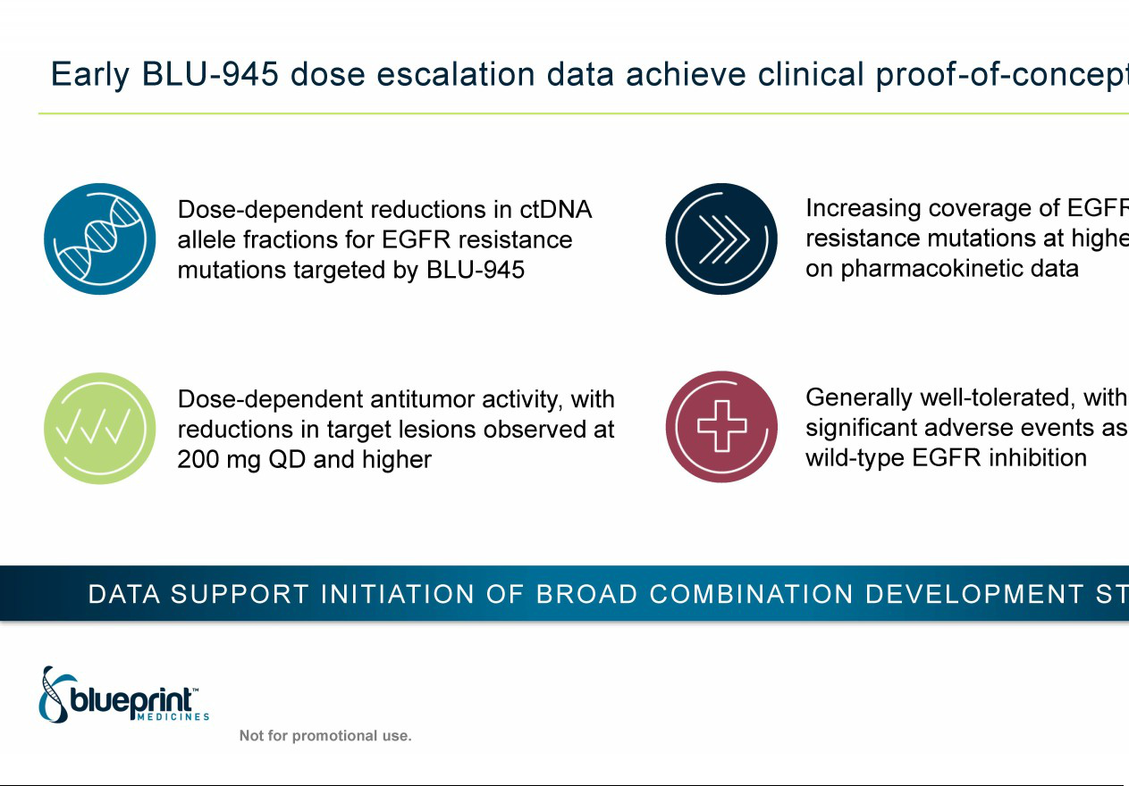

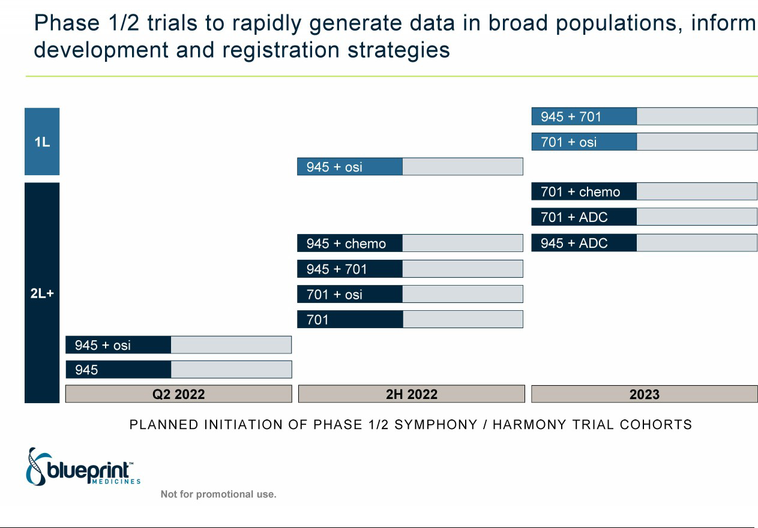

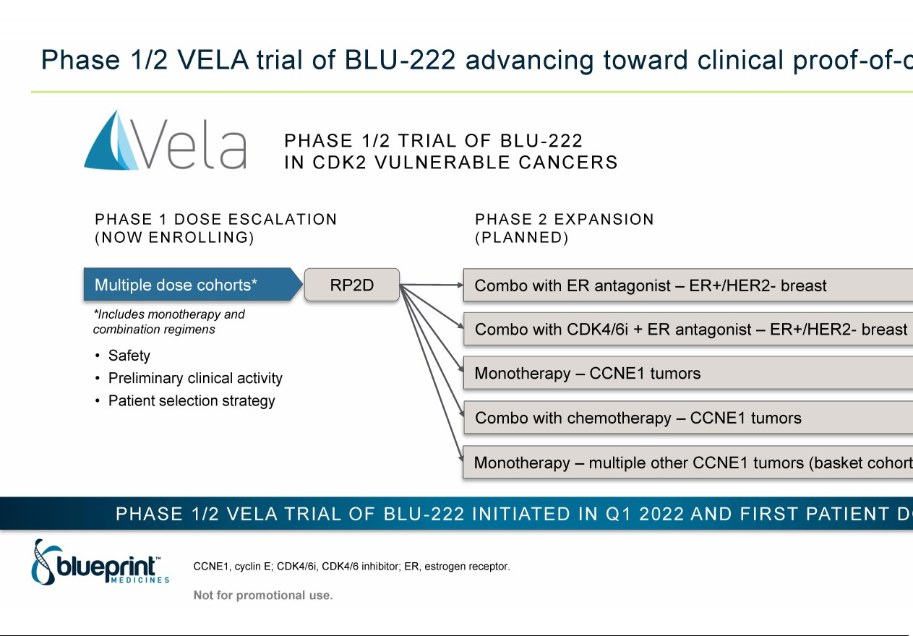

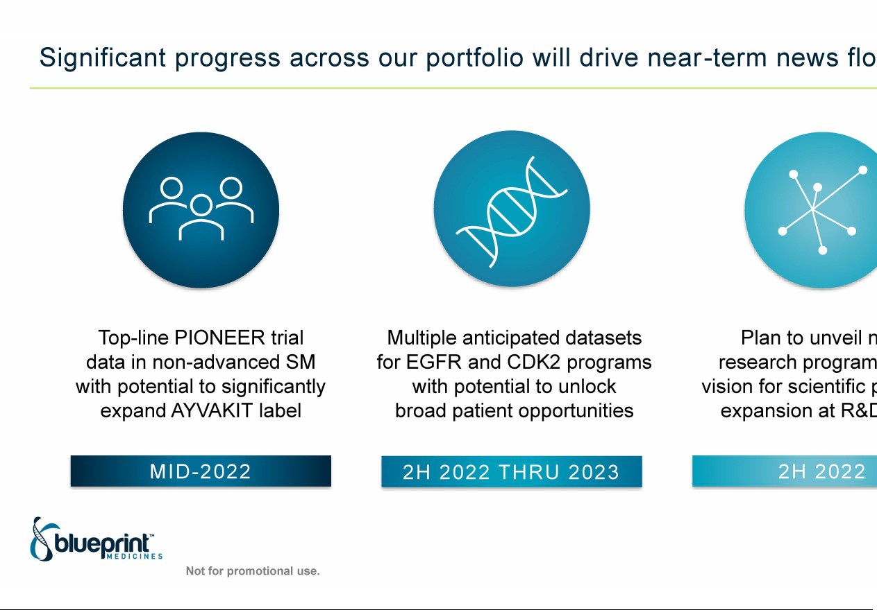



Exhibit 99.2


Blueprint Medicines Announces BLU-945 Proof-of-Concept Data Supporting Initiation of Comprehensive Combination Development Strategy in EGFR-mutant Non-Small Cell Lung Cancer

-- Early dose escalation data show dose-dependent reductions in ctDNA and tumor burden --

-- Generally well-tolerated with most AEs Grade 1 or 2, supporting continued dose escalation --

-- Initiating SYMPHONY trial cohort to evaluate BLU-945 in combination with osimertinib --

-- Clinical trial supply agreement signed with AstraZeneca to provide osimertinib for combination development in ongoing BLU-945 and BLU-701 trials --

-- Blueprint Medicines to host investor conference call and webcast on Friday, April 8 at 2:00 pm ET --

CAMBRIDGE, Mass., April 8, 2022 -- Blueprint Medicines Corporation (NASDAQ: BPMC) today announced proof-of-concept data from the Phase 1/2 SYMPHONY clinical trial of BLU-945, an investigational precision therapy for advanced EGFR-mutant non-small cell lung cancer (NSCLC). The trial results showed early evidence of safety and clinical activity consistent with preclinical data, supporting plans to expand development of BLU-945 in combination with multiple agents including osimertinib, with the goal of preventing or treating tumor resistance to prolong patient benefit. The data were reported today at the American Association for Cancer Research (AACR) Annual Meeting 2022 in New Orleans.

Early data from the ongoing Phase 1 dose escalation part of the SYMPHONY trial showed dose-dependent decreases in circulating tumor DNA (EGFR variant allele fractions) and radiographic tumor reductions, including a partial response (PR) in a patient treated with 400 mg once daily (QD), the highest dose tested as of the data cutoff date. Pharmacokinetic results showed BLU-945 exposures at higher doses were associated with broad EGFR mutation coverage, including the activating L858R mutation with or without the osimertinib-resistant C797S mutation. BLU-945 was generally well-tolerated, with no significant adverse events (AEs) associated with wild-type EGFR inhibition. The maximum tolerated dose and recommended Phase 2 dose have not yet been identified, and dose escalation is continuing.

“Today, targeted therapies are the mainstay treatment for EGFR-mutant lung cancer, but tumor resistance emerges in the majority of patients, driving mutational heterogeneity and disease progression. Innovative treatment strategies, including targeted therapy combinations, are urgently needed to prevent or treat this mutational heterogeneity and prolong patient benefit,” said Elaine Shum, M.D., assistant professor in the Department of Medicine and a medical oncologist at NYU Langone Health’s Perlmutter Cancer Center, and an investigator on the SYMPHONY trial. “The initial BLU-945 data reported today, which highlight its potential to address resistance to current standard of care therapies including osimertinib and enable well-tolerated, broad-acting combinations, are an important step forward toward improving outcomes for patients with EGFR-mutant lung cancer.”

“We believe BLU-945 is distinguished from other EGFR-directed therapies, based on its ability to inhibit the most difficult-to-target EGFR mutations while maintaining a wide therapeutic index over wild-type EGFR, a known driver of toxicity. As a result, BLU-945 has significant potential as a combination partner with other targeted therapies and broad-acting agents,” said Fouad Namouni, M.D., President, Research & Development at Blueprint Medicines. “We are excited to see the preclinical profile of BLU-945 translated in the clinic, with early dose escalation data showing evidence of clinical activity, broad EGFR mutation coverage and tolerability. Based on these promising data, we plan to rapidly expand development of BLU-945 in combination with osimertinib and other agents to address important medical needs across all lines of therapy.”

Blueprint Medicines is initiating a SYMPHONY trial cohort assessing BLU-945 in combination with osimertinib in patients with second-line or later EGFR-mutant NSCLC, following disease progression on osimertinib. After the selection of a recommended Phase 2 combination dose regimen, the company plans to initiate an expansion cohort with registration potential in biomarker-selected second-line patients, as well as an expansion cohort in front-line patients, by the end of 2022. Additional combinations with BLU-701, chemotherapy and antibody-drug conjugate therapy are planned across multiple mutation profiles and lines of therapy.

In addition, Blueprint Medicines announced today a clinical trial supply agreement with AstraZeneca (LSE/STO/Nasdaq: AZN). Under the terms of the agreement, Blueprint Medicines will evaluate BLU-945 and BLU-701 in combination with osimertinib in the ongoing SYMPHONY and HARMONY trials, respectively.

BLU-945: Data from the Phase 1/2 SYMPHONY Trial

As of a data cutoff date of March 9, 2022, 33 patients with EGFR-mutant NSCLC have been treated with BLU-945 across five dose escalation cohorts (range: 25-400 mg QD). The majority of patients (79 percent) previously received at least three lines of systemic therapy, including osimertinib (97 percent). Patient eligibility criteria require the presence of an EGFR mutation based on local assessment of tumor biopsy or circulating tumor DNA (ctDNA).

BLU-945 was generally well-tolerated at all doses tested. The most common AEs (regardless of relationship to BLU-945; ≥10 percent) were nausea, headache, fatigue, cough, dyspnea, vomiting, hyponatremia, dry mouth and anemia. Reported AEs associated with wild-type EGFR inhibition were infrequent and low grade, including rash (one patient; Grade 1) and diarrhea (three patients; all Grade 1). One dose-limiting toxicity (Grade 3 transaminitis) occurred in the 400 mg QD cohort, which improved with dose interruption. There were no treatment discontinuations due to AEs.

Pharmacokinetic data showed dose-proportional plasma concentrations, with exposures at increasing doses consistent with broad EGFR mutation coverage, based on preclinical activity thresholds. Mean plasma exposures at doses of 100 mg QD or higher exceeded the IC₉₀ for mutants harboring the T790M and C797S resistance mutations, regardless of activating mutation. In addition, mean plasma exposure at 400 mg QD exceeded the IC₉₀ for mutants harboring the activating L858R mutation with or without the C797S mutation.

The SYMPHONY trial is one of the first oncology studies to analyze plasma ctDNA via real-time next-generation sequencing to assess tumor biology and early drug activity. Results for patients with detectable T790M and C797S allele fractions at baseline and available post-baseline assessments showed dose-dependent reductions in both variant allele fractions. In patients treated with 400 mg QD, all detectable T790M and C797S allele fractions declined, including three that fell below the limit of detection (clearance).

Patients with measurable target lesions at baseline and at least one post-baseline scan were evaluable per Response Evaluation Criteria in Solid Tumors (RECIST) version 1.1. In a heavily pre-treated population, higher BLU-945 doses

led to increased antitumor activity. Tumor shrinkage was observed in patients treated with 200-400 mg QD, including an unconfirmed PR¹ in a patient treated with 400 mg QD. This patient had NSCLC harboring exon 19 deletion, T790M and C797S mutations, and previously received platinum-based chemotherapy, erlotinib and osimertinib with a best response of stable disease.

- An unconfirmed PR is a PR in which tumor reduction ≥30% has occurred, but has not yet been confirmed via a subsequent scan.

Copies of Blueprint Medicines data presentations from the AACR annual meeting, including the SYMPHONY trial presentation, are available in the “Science—Publications and Presentations” section of the company’s website at www.blueprintmedicines.com.

Investor Conference Call Information

Blueprint Medicines will host a live webcast today, April 8, 2022 beginning at 2:00 p.m. ET, to discuss the data reported at AACR. To access the live call, please dial 844-200-6205 (domestic) or 929-526-1599 (international), and refer to conference ID 084402. A webcast of the conference call will be available in the Investors & Media section of Blueprint Medicines’ website at http://ir.blueprintmedicines.com/. The archived webcast will be available on Blueprint Medicines’ website approximately two hours after the conference call and will be available for 30 days following the call.

About Blueprint Medicines’ Clinical Development Programs in EGFR-Mutant NSCLC

Blueprint Medicines is developing three investigational agents, BLU-701, BLU-945 and BLU-451, with the goal of addressing nearly all activating mutations (>90 percent) in EGFR-mutant NSCLC. The introduction of EGFR-targeted therapies, including osimertinib, has transformed the care of patients with EGFR-mutant NSCLC; however, there is a significant need for new treatment options designed to prevent or treat a broad range of resistance mechanisms before they emerge, with the goal of prolonging patient benefit. There are no approved targeted therapies for patients with disease progression following osimertinib, and limited treatment options for patients with EGFR exon 20 insertion-positive NSCLC.

BLU-701 and BLU-945 were designed to provide broad coverage of common activating and on-target resistance mutations, spare wild-type EGFR and other kinases to help limit off-target toxicities, and prevent or treat central nervous system (CNS) metastases. These preclinical profiles may enable BLU-701 and BLU-945 to become the backbones of a range of combination strategies across lines of therapy. The Phase 1/2 SYMPHONY trial (NCT04862780) of BLU-945 and the Phase 1/2 HARMONY trial (NCT05153408) of BLU-701 are currently ongoing for patients with EGFR-mutant NSCLC.

BLU-451 is a selective and potent inhibitor of EGFR exon 20 insertion-positive NSCLC. Based on preclinical data, BLU-451 potently inhibited all common EGFR exon 20 insertion variants with marked selectivity over wild-type EGFR and off-target kinases, and has shown CNS penetration. Blueprint Medicines has initiated a Phase 1/2 trial of BLU-451 (NCT05241873) in EGFR exon 20 insertion-positive NSCLC.

To learn about ongoing or planned clinical trials, contact Blueprint Medicines at medinfo@blueprintmedicines.com or 1-888-BLU-PRNT (1-888-258-7768). Additional information is available at blueprintclinicaltrials.com or clinicaltrials.gov.

Cautionary Note Regarding Forward-Looking Statements

This press release contains forward-looking statements within the meaning of the Private Securities Litigation Reform Act of 1995, as amended, including, without limitation, statements regarding Blueprint Medicines’ plans, strategies, timelines and expectations for clinical trials, trial cohorts and indications; the anticipated benefits of the preclinical profiles of BLU-945, BLU-701 and BLU-451; Blueprint Medicines’ plans, strategies and timelines for the development of BLU-945 and BLU-701 as monotherapies and in combination with other agents; the potential benefits of Blueprint Medicines’ current or future approved drugs or drug candidates in treating patients; and Blueprint Medicines’ strategy, goals and anticipated milestones, business plans and focus. The words “aim,” “may,” “will,” “could,” “would,” “should,” “expect,” “plan,” “anticipate,” “intend,” “believe,” “estimate,” “predict,” “project,” “potential,” “continue,” “target” and similar expressions are intended to identify forward-looking statements, although not all forward-looking statements contain these identifying words. Any forward-looking statements in this press release are based on management’s current expectations and beliefs and are subject to a number of risks, uncertainties and important factors that may cause actual events or results to differ materially from those expressed or implied by any forward-looking statements contained in this press release, including, without limitation, risks and uncertainties related to the impact of the COVID-19 pandemic to Blueprint Medicines’ business, operations, strategy, goals and anticipated milestones, including Blueprint Medicines’ ongoing and planned research and discovery activities, ability to conduct ongoing and planned clinical trials, clinical supply of current or future drug candidates, commercial supply of current or future approved products, and launching, marketing and selling current or future approved products; Blueprint Medicines’ ability and plans in establishing a commercial infrastructure, and successfully launching, marketing and selling current or future approved products, including AYVAKIT® (avapritinib) and GAVRETO® (pralsetinib); Blueprint Medicines’ ability to successfully expand the approved indications for AYVAKIT and GAVRETO or obtain marketing and reimbursement approvals for AYVAKIT and GAVRETO in additional geographies in the future; the delay of any current or planned clinical trials or the development of Blueprint Medicines’ current or future drug candidates; Blueprint Medicines’ advancement of multiple early-stage efforts; Blueprint Medicines’ ability to successfully demonstrate the safety and efficacy of its drug candidates and gain approval of its drug candidates on a timely basis, if at all; the preclinical and clinical results for Blueprint Medicines’ drug candidates, which may not support further development of such drug candidates either as monotherapies or in combination with other agents or may impact the anticipated timing of data or regulatory submissions; the timing of the initiation of clinical trials and trial cohorts at clinical trial sites and patient enrollment rates; actions of regulatory agencies, which may affect the initiation, timing and progress of clinical trials and marketing applications; Blueprint Medicines’ ability to develop and commercialize companion diagnostic tests for its current and future drug candidates; Blueprint Medicines’ ability to successfully expand its operations, research platform and portfolio of therapeutic candidates, and the timing and costs thereof; Blueprint Medicines’ ability to realize the anticipated benefits of its executive leadership transition plan; and the success of Blueprint Medicines’ current and future acquisitions, collaborations, partnerships or licensing arrangements. These and other risks and uncertainties are described in greater detail in the section entitled “Risk Factors” in Blueprint Medicines’ filings with the Securities and Exchange Commission (SEC), including Blueprint Medicines’ most recent Annual Report on Form 10-K, as supplemented by its most recent Quarterly Report on Form 10-Q and any other filings that Blueprint Medicines has made or may make with the SEC in the future. Any forward-looking statements contained in this press release represent Blueprint Medicines’ views only as of the date hereof and should not be relied upon as representing its views as of any subsequent date. Except as required by law, Blueprint Medicines explicitly disclaims any obligation to update any forward-looking statements.

About Blueprint Medicines

Blueprint Medicines is a global precision therapy company that invents life-changing therapies for people with cancer and blood disorders. Applying an approach that is both precise and agile, we create medicines that selectively target genetic drivers, with the goal of staying one step ahead across stages of disease. Since 2011, we have leveraged our research platform, including expertise in molecular targeting and world-class drug design capabilities, to rapidly and reproducibly translate science into a broad pipeline of precision therapies. Today, we are delivering approved medicines directly to patients in the United States and Europe, and we are globally advancing multiple programs for systemic mastocytosis, lung cancer and other genomically defined cancers, and cancer immunotherapy. For more information, visit www.BlueprintMedicines.com and follow us on Twitter (@BlueprintMeds) and LinkedIn.

Trademarks

Blueprint Medicines, AYVAKIT, GAVRETO and associated logos are trademarks of Blueprint Medicines Corporation.

Media Contact

Andrew Law

617-844-8205

media@blueprintmedicines.com

Investor Relations Contact

Kristin Hodous

617-714-6674

ir@blueprintmedicines.com

