UNITED STATES

SECURITIES AND EXCHANGE COMMISSION

Washington, D.C. 20549

FORM 8-K

CURRENT REPORT

Pursuant to Section 13 or 15(d)

of the Securities Exchange Act of 1934

Date of Report (Date of Earliest Event Reported): November 15, 2018

Blueprint Medicines Corporation

(Exact name of registrant as specified in its charter)

Delaware

(State or other jurisdiction

of incorporation)

001-37359

(Commission File Number)

26-3632015

(I.R.S. Employer

Identification No.)

45 Sidney Street

Cambridge, Massachusetts

(Address of principal executive offices)

02139

(Zip Code)

Registrant’s telephone number, including area code: (617) 374-7580

(Former name or former address, if changed since last report)

Check the appropriate box below if the Form 8-K filing is intended to simultaneously satisfy the filing obligation of the registrant under any of the following provisions:

- Written communications pursuant to Rule 425 under the Securities Act (17 CFR 230.425)

- Soliciting material pursuant to Rule 14a-12 under the Exchange Act (17 CFR 240.14a-12)

- Pre-commencement communications pursuant to Rule 14d-2(b) under the Exchange Act (17 CFR 240.14d-2(b))

- Pre-commencement communications pursuant to Rule 13e-4(c) under the Exchange Act (17 CFR 240.13e-4(c))

Indicate by check mark whether the registrant is an emerging growth company as defined in Rule 405 of the Securities Act of 1933 (§230.405 of this chapter) or Rule 12b-2 of the Securities Exchange Act of 1934 (§240.12b-2 of this chapter).

Emerging growth company ☐

If an emerging growth company, indicate by check mark if the registrant has elected not to use the extended transition period for complying with any new or revised financial accounting standards provided pursuant to Section 13(a) of the Exchange Act. ☐

Item 7.01 Regulation FD Disclosure.

On November 15, 2018, Blueprint Medicines Corporation (the “Company”) issued a press release announcing updated data from its ongoing Phase 1 NAVIGATOR clinical trial evaluating avapritinib for the treatment of advanced gastrointestinal stromal tumors. The data will be presented on Thursday, November 15, 2018 in an oral presentation at the Connective Tissue Oncology Society 2018 Annual Meeting (“CTOS Annual Meeting”) in Rome, Italy. A copy of the press release is furnished as Exhibit 99.1 to this Current Report on Form 8-K, and a copy of the presentation at the CTOS Annual Meeting is furnished as Exhibit 99.2 to this Current Report on Form 8-K.

In addition, on November 15, 2018, the Company hosted an investor call and live webcast to discuss the data presented at the CTOS Annual Meeting. A copy of the presentation from the investor call is furnished as Exhibit 99.3 to this Current Report on Form 8-K.

The information in Item 7.01 of this Current Report on Form 8-K, including Exhibits 99.1, 99.2 and 99.3, is intended to be furnished and shall not be deemed “filed” for purposes of Section 18 of the Securities Exchange Act of 1934, as amended (the “Exchange Act”), or otherwise subject to the liabilities of that section, nor shall it be deemed incorporated by reference in any filing under the Securities Act of 1933, as amended, or the Exchange Act, except as expressly set forth by specific reference in such filing.

Item 9.01 |  |  |  |  | Financial Statements and Exhibits.
(d) Exhibits.
 | Exhibit No. |  |  | Description
 | 99.1 |  |  | Press release issued by Blueprint Medicines Corporation on November 15, 2018
99.2 |  |  |  | Presentation by Blueprint Medicines Corporation at the CTOS Annual Meeting on November 15, 2018
99.3 |  |  |  | Presentation by Blueprint Medicines Corporation at investor call on November 15, 2018
 |  |  |  |  | 2

SIGNATURES

Pursuant to the requirements of the Securities Exchange Act of 1934, the registrant has duly caused this report to be signed on its behalf by the undersigned hereunto duly authorized.

 | BLUEPRINT MEDICINES CORPORATION
Date: November 15, 2018 | By: /s/ Tracey L. McCain
 |  | Tracey L. McCain
 |  | Chief Legal Officer

3

Exhibit 99.1


Blueprint Medicines Announces Updated NAVIGATOR Trial Results in Patients with Advanced Gastrointestinal Stromal Tumors Supporting Development of Avapritinib Across All Lines of Therapy

– 84% ORR in PDGFRα D842V GIST and 20% ORR in fourth-line or later GIST support plans to submit New Drug

Application to FDA in the first half of 2019 –

– 26% ORR in regorafenib-naïve third- and fourth-line GIST and 25% ORR in second-line GIST strongly support clinical

development in earlier lines of treatment –

– Blueprint Medicines to host investor conference call and webcast on Thursday, November 15, 2018 at 7:30 a.m. ET –

CAMBRIDGE, Mass., November 15, 2018 – Blueprint Medicines Corporation (NASDAQ: BPMC), a leader in discovering and developing targeted kinase medicines for patients with genomically defined diseases, today announced updated data for the registration-enabling NAVIGATOR clinical trial of avapritinib, a potent and highly selective KIT and PDGFRA inhibitor in development for patients with advanced gastrointestinal tumors (GIST). The data showed that avapritinib was highly active across all lines of therapy for patients with PDGFRα D842V-driven GIST and in second-, third- and fourth-line for other GIST patients. In addition, avapritinib was well-tolerated with most adverse events (AEs) reported by investigators as Grade 1 or 2. These results will be presented today in an oral presentation at the Connective Tissue Oncology Society 2018 Annual Meeting in Rome, Italy.

The updated data from the ongoing Phase 1 NAVIGATOR trial support Blueprint Medicines’ plans to submit a New Drug Application (NDA) in the first half of 2019 to the U.S. Food and Drug Administration (FDA) for the treatment of PDGFRA Exon 18 mutant GIST, which primarily includes patients with the D842V mutation, and fourth-line GIST. There are currently no approved or effective therapies in these patient populations. In patients with PDGFRα D842V-driven GIST, avapritinib demonstrated an objective response rate (ORR) of 84 percent and a 12-month duration of response (DoR) of 76 percent. In heavily pre-treated patients with fourth-line or later GIST, avapritinib demonstrated an ORR of 20 percent, tumor reductions in 60 percent of patients and a median DoR of 7.3 months. ORR and DoR per central radiographic review will be the primary endpoints for the NDA submission, consistent with regulatory precedent for accelerated approvals based on single-arm oncology studies. In addition, avapritinib demonstrated an ORR of 26 percent in regorafenib-naïve third- and fourth-line GIST and an ORR of 25 percent in second-line GIST. Patients with PDGFRα D842V-driven GIST were excluded from both of these populations.

“With an increased understanding of molecular drivers of GIST over the last decade, it is encouraging to see an investigational drug, like avapritinib, bring a precision therapy approach to GIST,” said Michael Heinrich, M.D., Professor of Medicine at Oregon Health & Science University and an investigator on the NAVIGATOR trial. “Avapritinib has the potential to be a significant therapeutic advance in GIST, a rare cancer with high medical needs across lines of treatment. In particular, the updated data demonstrate the broad clinical impact of avapritinib for patients with PDGFRα D842V-driven GIST and fourth-line GIST, where there are currently no effective therapies. In addition, the data strongly support clinical development of avapritinib in early lines, including second- and third-line treatment.”

“These data highlight the potential of avapritinib, a potent and highly selective inhibitor of KIT and PDGFRA mutant kinases, to be a cornerstone precision therapy in GIST,” said Andy Boral, M.D., Ph.D., Chief Medical Officer of Blueprint Medicines. “The results validate Blueprint Medicines’ approach to designing precision therapies that specifically target genetic drivers of disease, with the goals of delivering transformative benefit to patients and enabling rapid progress toward registration. Avapritinib’s highly potent anti-tumor activity in PDGFRα D842V-driven GIST, combined with differentiated activity across treatment lines in KIT-driven GIST, reflect its promise as a potentially foundational treatment option across multiple GIST populations. We are committed to advancing a comprehensive and scientifically driven clinical development program with the goal of improving the lives of GIST patients.”

Data Highlights from the Ongoing Phase 1 NAVIGATOR Clinical Trial

As of the data cutoff date of October 15, 2018, 231 patients were treated with avapritinib in the dose escalation and expansion portions of the Phase 1 clinical trial at eight dose levels, ranging from 30 mg once daily (QD) to 600 mg QD. This population consisted of 167 patients with KIT-driven GIST, 56 patients with PDGFRα D842V-driven GIST and eight patients with other PDGFRA mutations. Patients in the expansion portion of the clinical trial were treated at the recommended Phase 2 dose of 300 mg QD.

Safety Data

As of the data cutoff date, avapritinib was well-tolerated, and most AEs reported by investigators were Grade 1 or 2.
Across all doses, 20 patients (8.7 percent) discontinued treatment with avapritinib due to treatment-related AEs.

Across all grades, the most common treatment-emergent AEs (regardless of relationship to avapritinib) reported by investigators (≥20 percent) included nausea (61 percent), fatigue (55 percent), anemia (46 percent), periorbital edema (40 percent), diarrhea (39 percent), vomiting (38 percent), decreased appetite (35 percent), peripheral edema (33 percent), increased lacrimation (31 percent), memory impairment (26 percent), constipation (23 percent), face edema (23 percent), hair color changes (21 percent) and dizziness (20 percent).

Investigator-reported Grade 3 or 4 treatment-related AEs (≥2 percent) included anemia, fatigue, hypophosphatemia, increased bilirubin, decreased white blood count/neutropenia and diarrhea.

Clinical Activity Data

As of the data cutoff date, the following patients were evaluable for response assessments: 56 patients with PDGFRα D842V-driven GIST, 109 patients with fourth-line or later GIST, 23 patients with third- or fourth-line GIST who did not receive prior regorafenib (which is comparable to the VOYAGER trial population) and do not harbor the PDGFRα D842V mutation, and 20 patients with second-line GIST who do not harbor the PDGFRα D842V mutation. Patients were evaluable if they had at least one centrally reviewed radiographic scan, and data are based on modified Response Evaluation Criteria in Solid Tumors version 1.1 (mRECIST 1.1 criteria) for GIST.

Across multiple lines of therapy, avapritinib demonstrated important clinical activity in patients with PDGFRA- and KIT-driven GIST.

 | Evaluable |  | Clinical Benefit |  | Median PFS
GIST Population | Evaluable | ORR | Rate at Four | Median DoR | Central Review
GIST Population | Patients | ORR | Months (≥Two | Median DoR | (Investigator
 |  |  | Scans) |  | Review)
PDGFRα D842Vª | 56 | 84%^{f} | 96% | Not estimable; | Not reached
 |  |  |  | 76% at 12 months
Fourth-line or later^{b,c} | 109 | 20%^{g} | 40% | 7.3 months | 3.7 months
 |  |  |  |  | (5.4 months)
Regorafenib-naïve | 23 | 26% | 70% | 10.2 months | 8.6 months
third- or fourth-line^{b,d} |  |  |  |  | (10.2 months)
Second-line^{d,e} | 20 | 25%^{h} | NR^{i} | NR^{i} | NR^{i}

Notes: (a) Treated at all doses; (b) Treated at doses of 300 or 400 mg QD; (c) Included patients with the PDGFRα D842V mutation, whose proportion was consistent with the known mutational prevalence in this GIST population; (d) Did not include patients with the PDGFRα D842V mutation, whose proportion was greater than the known mutational prevalence in this GIST population; (e) Treated at doses up to and including 300 or 400 mg QD; (f) Four PR pending confirmation; (g) One PR pending confirmation; (h) Three PR pending confirmation; (i) NR, not reported, as data are too early to estimate.

Additional Data Support Clinical Development Strategy in Earlier Lines of Therapy Third- and Fourth-Line GIST
Preliminary data showed robust clinical activity in regorafenib-naïve third- and fourth-line GIST patients lacking the PDGFRα D842V mutation. As of the data cutoff date, the ORR was 26 percent, tumor reductions were demonstrated in 78 percent of patients, and the median PFS was 8.6 months per central radiographic review and 10.2 months per investigator review. In contrast, historical data showed a 5 percent ORR and a median PFS of 4.8 months for regorafenib, the current standard-of-care treatment in third-line GIST.

In regorafenib-naive patients with PDGFRα D842V-driven third- or fourth-line GIST, the ORR was 80 percent (eight out of 10 evaluable patients, with one response pending confirmation). Blueprint Medicines’ ongoing Phase 3 VOYAGER trial of avapritinib versus regorafenib in third- or fourth-line GIST permits enrollment of patients with both KIT- and PDGFRA-driven GIST, including patients with the PDGFRα D842V mutation. Blueprint Medicines anticipates completing enrollment of the VOYAGER trial in the second half of 2019.

Second-Line GIST

Preliminary data showed a 25 percent ORR in second-line GIST, excluding patients with the PDGFRα D842V mutation. In patients with second-line PDGFRα D842V-driven GIST, the ORR was 94 percent (15 out of 16 evaluable patients, with two responses pending confirmation).

In addition, analyses of circulating tumor DNA (ctDNA) from the NAVIGATOR trial across all lines showed increased activity for avapritinib in patients without the secondary KIT V654A or T670I mutations, which are estimated to occur in about 20 to 25 percent of GIST patients following treatment with imatinib (second-line or later). Independently published data for sunitinib, the current standard of care therapy for second-line GIST, have shown activity against these mutations.

Based on the totality of data, Blueprint Medicines believes a precision medicine approach has the potential to optimize patient outcomes in second-line GIST. The company plans to initiate the registration-enabling Phase 3 COMPASS-2L clinical trial in the second half of 2019 using a ctDNA-guided patient selection strategy. The planned trial will select patients with PDGFRA- and KIT-driven second-line GIST who do not have the KIT V654A or T670I mutations, and randomize them to receive avapritinib or sunitinib with an anticipated primary endpoint of PFS.

Conference Call Information

Blueprint Medicines will host a live conference call and webcast on November 15, 2018 at 7:30 a.m. ET to review the updated data for avapritinib in GIST. The conference call may be accessed by dialing (855) 728-4793 (domestic) or (503) 343-6666 (international) and referring to conference ID 3479587. A live webcast of the conference call will be available under “Events and Presentations” in the Investors section of Blueprint Medicines’ website at http://ir.blueprintmedicines.com. The archived webcast will be available on Blueprint Medicines’ website approximately two hours after the conference call and will be available for 30 days following the call.

About the Avapritinib Clinical Development Program in GIST

Blueprint Medicines is pursuing a broad clinical development program for avapritinib across all lines of GIST. Avapritinib is currently being evaluated in two ongoing registration-enabling clinical trials for GIST: the Phase 1 NAVIGATOR trial and the Phase 3 VOYAGER trial.

The NAVIGATOR trial is designed to evaluate the safety and tolerability of avapritinib in patients with advanced GIST. The trial consists of two parts, a dose escalation portion and an expansion portion. The dose escalation portion is complete, and trial objectives include assessing response, pharmacokinetics and pharmacodynamic measures. Response assessments use blinded, central radiology review. The expansion cohorts of the trial are designed to enroll a total of approximately 200 patients at multiple sites in the United States, United Kingdom and European Union.

The VOYAGER trial is a global, open-label, randomized, Phase 3 trial designed to evaluate the safety and efficacy of avapritinib versus regorafenib in patients with third- or fourth-line advanced GIST. The trial is designed to enroll approximately 460 patients randomized 1:1 to receive either avapritinib or regorafenib at multiple sites in the United States, United Kingdom, European Union, Australia and Asia.

In the second half of 2019, Blueprint Medicines plans to initiate COMPASS-2L, a global, randomized, Phase 3 precision medicine trial. The trial will evaluate the safety and efficacy of avapritinib versus sunitinib in patients with second-line advanced GIST and pre-specified disease genotypes.

Patients and physicians interested in the Phase 3 VOYAGER trial can contact the Blueprint Medicines study director at VOYAGER@blueprintmedicines.com or 1-617-714-6707. For more information about

the VOYAGER trial, please visit www.voyagertrial.com. Additional details are available on www.clinicaltrials.gov (ClinicalTrials.gov Identifier: NCT03465722).

About GIST

GIST is a sarcoma, or tumor of bone or connective tissue, of the gastrointestinal (GI) tract. Tumors arise from cells in the wall of the GI tract and occur most often in the stomach or small intestine. Most patients are diagnosed between the ages of 50 to 80, and diagnosis is typically triggered by GI bleeding, incidental findings during surgery or imaging and, in rare cases, tumor rupture or GI obstruction.

Most GIST cases are caused by a spectrum of clinically relevant mutations that force the KIT or PDGFRA protein kinases into an increasingly active state. Because currently available therapies only bind to the inactive protein conformations, certain primary and secondary mutations typically lead to treatment resistance and disease progression.

Treatment options for KIT-driven GIST patients whose disease progresses or develops resistance are currently limited. There are no effective treatment options for patients with PDGFRA-driven GIST, and progression often occurs in as little as three months with available therapies. In advanced GIST, clinical benefits from existing treatments can vary by mutation type. Early testing is critical to help guide therapy that effectively treats the underlying driver of disease and is recommended in expert guidelines.

About Avapritinib

Avapritinib is a potent and selective oral inhibitor of KIT and PDGFRA mutant kinases. It is a type 1 inhibitor designed to target the active kinase conformation; all oncogenic kinases signal via this conformation. Avapritinib has demonstrated broad inhibition of KIT and PDGFRA mutations associated with GIST, and the most potent activity against activation loop mutations, which currently approved therapies do not inhibit. In contrast with existing multi-kinase inhibitors, avapritinib has shown marked selectivity for KIT and PDGFRA over other kinases. In addition, avapritinib is uniquely designed to bind and inhibit the KIT D816V mutation, the primary driver of disease in up to 95 percent of systemic mastocytosis (SM) patients. Preclinical studies have shown avapritinib potently inhibited KIT D816V at sub-nanomolar potencies with minimal off-target activity.

Blueprint Medicines is initially developing avapritinib, an investigational medicine, for the treatment of advanced GIST, advanced SM, and indolent and smoldering SM. The FDA has granted avapritinib two Breakthrough Therapy Designations, one for the treatment of PDGFRα D842V-driven GIST and one for advanced SM.

Blueprint Medicines has an exclusive collaboration and license agreement with CStone Pharmaceuticals for the development and commercialization of avapritinib and certain other drug candidates in Mainland China, Hong Kong, Macau and Taiwan. Blueprint Medicines retains development and commercial rights for avapritinib in the rest of the world.

About Blueprint Medicines

Blueprint Medicines is developing a new generation of targeted and potent kinase medicines to improve the lives of patients with genomically defined diseases. Its approach is rooted in a deep understanding of the genetic blueprint of cancer and other diseases driven by the abnormal activation of kinases.

Blueprint Medicines is advancing multiple programs in clinical development for subsets of patients with gastrointestinal stromal tumors, hepatocellular carcinoma, systemic mastocytosis, non-small cell lung cancer, medullary thyroid cancer and other advanced solid tumors, as well as multiple programs in research and preclinical development. For more information, please visit www.blueprintmedicines.com.

Cautionary Notes Regarding Forward-Looking Statements

This press release contains forward-looking statements within the meaning of the Private Securities Litigation Reform Act of 1995, as amended, including, without limitation, statements regarding plans and timelines for the clinical development of avapritinib, including plans and timelines for initiating the Phase 3 COMPASS-2L trial and completing enrollment in the Phase 3 VOYAGER trial; expectations regarding the potential benefits of avapritinib in treating patients with GIST; plans and timelines for submitting an NDA to the FDA for avapritinib for the treatment of PDGFRA Exon 18 mutant GIST and fourth-line GIST; and Blueprint Medicines’ strategy, business plans and focus. The words “may,” “will,” “could,” “would,” “should,” “expect,” “plan,” “anticipate,” “intend,” “believe,” “estimate,” “predict,” “project,” “potential,” “continue,” “target” and similar expressions are intended to identify forward-looking statements, although not all forward-looking statements contain these identifying words. Any forward-looking statements in this press release are based on management’s current expectations and beliefs and are subject to a number of risks, uncertainties and important factors that may cause actual events or results to differ materially from those expressed or implied by any forward-looking statements contained in this press release, including, without limitation, risks and uncertainties related to the delay of any current or planned clinical trials or the development of Blueprint Medicines’ drug candidates, including avapritinib, BLU-554, BLU-667 and BLU-782; Blueprint Medicines’ advancement of multiple early-stage efforts; Blueprint Medicines’ ability to successfully demonstrate the safety and efficacy of its drug candidates; the preclinical and clinical results for Blueprint Medicines’ drug candidates, which may not support further development of such drug candidates; actions of regulatory agencies, which may affect the initiation, timing and progress of clinical trials; Blueprint Medicines’ ability to develop and commercialize companion diagnostic tests for its current and future drug candidates, including companion diagnostic tests for avapritinib for PDGFRα D842V-driven GIST, BLU-554 for FGFR4-driven hepatocellular carcinoma and BLU-667 for RET-driven non-small cell lung cancer; the success of Blueprint Medicines’ current and future collaborations, including its cancer immunotherapy collaboration with F. Hoffmann-La Roche Ltd and Hoffmann-La Roche Inc. and its collaboration with CStone Pharmaceuticals. These and other risks and uncertainties are described in greater detail in the section entitled “Risk Factors” in Blueprint Medicines’ Quarterly Report on Form 10-Q for the quarter ended September 30, 2018, as filed with the Securities and Exchange Commission (SEC) on October 30, 2018, and any other filings that Blueprint Medicines has made or may make with the SEC in the future. Any forward-looking statements contained in this press release represent Blueprint Medicines’ views only as of the date hereof and should not be relied upon as representing its views as of any subsequent date. Except as required by law, Blueprint Medicines explicitly disclaims any obligation to update any forward-looking statements.

Investor Relations Contact

Kristin Hodous
617-714-6674
KHodous@blueprintmedicines.com

Media Relations Contact

Andrew Law
617-844-8205
ALaw@blueprintmedicines.com

Exhibit 99.2
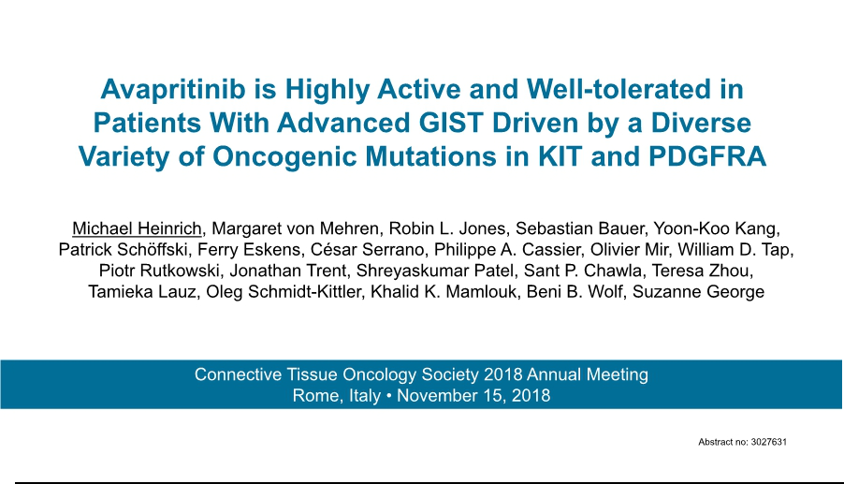

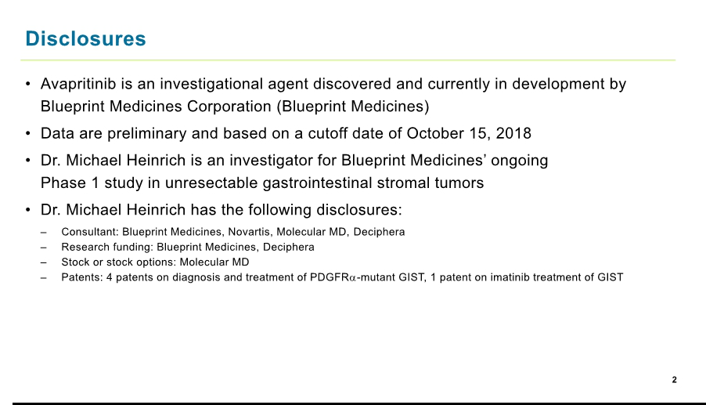

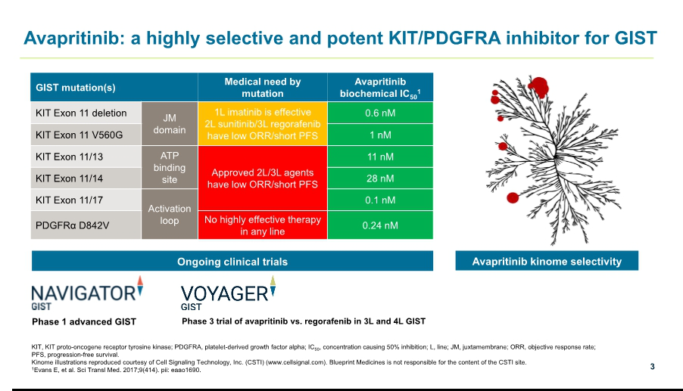

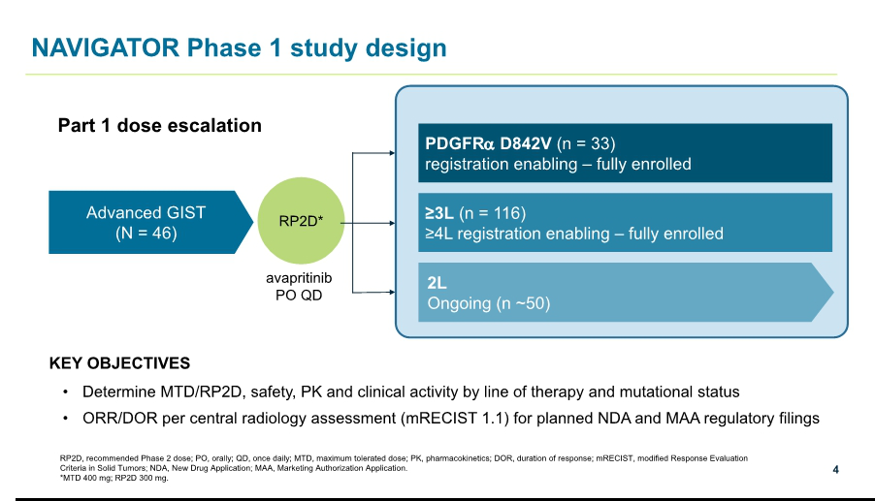

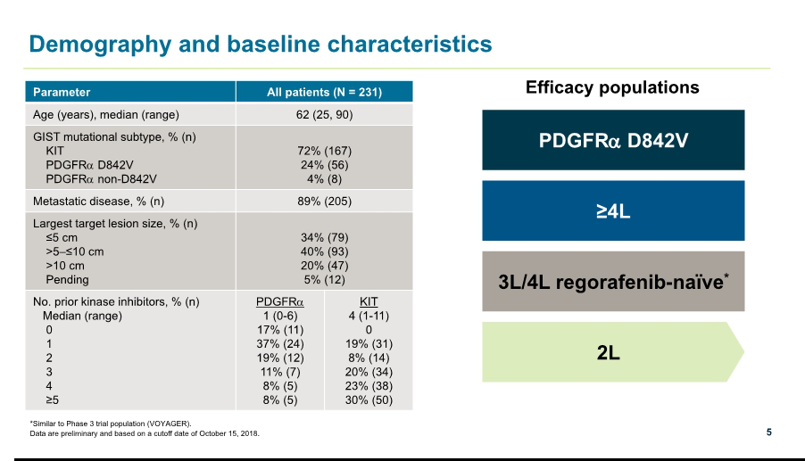

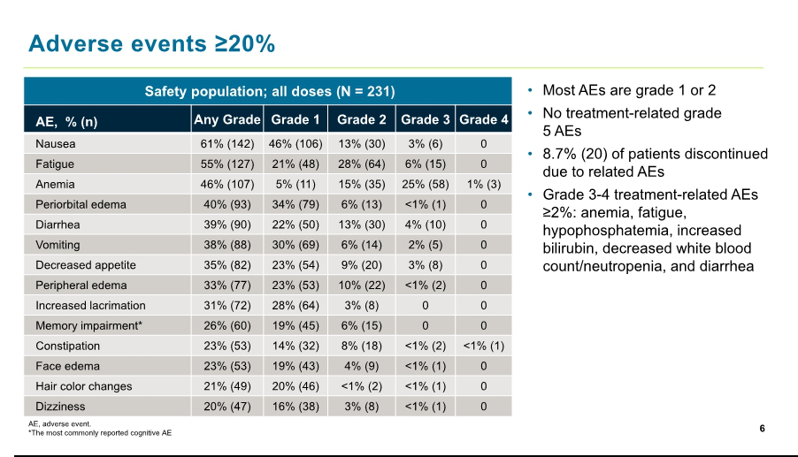

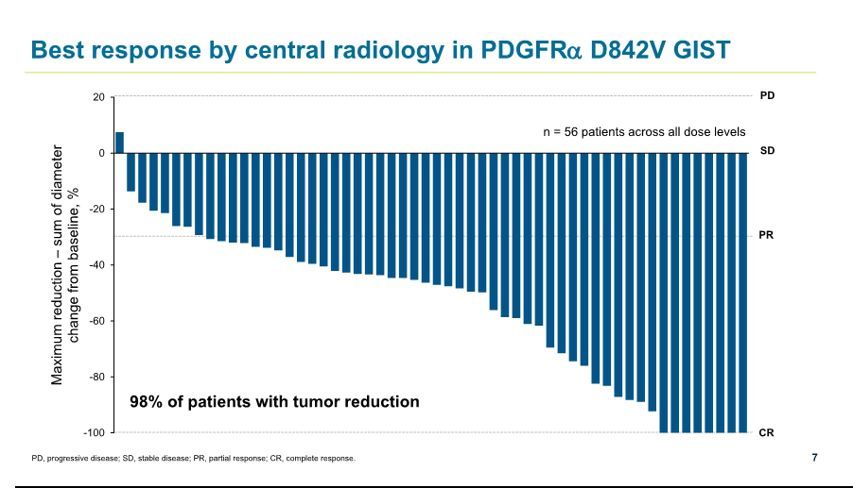

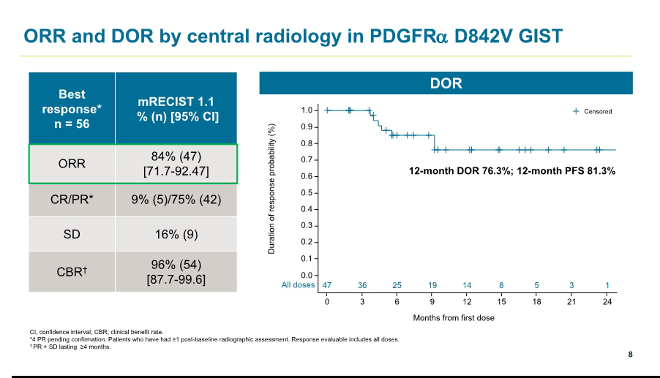

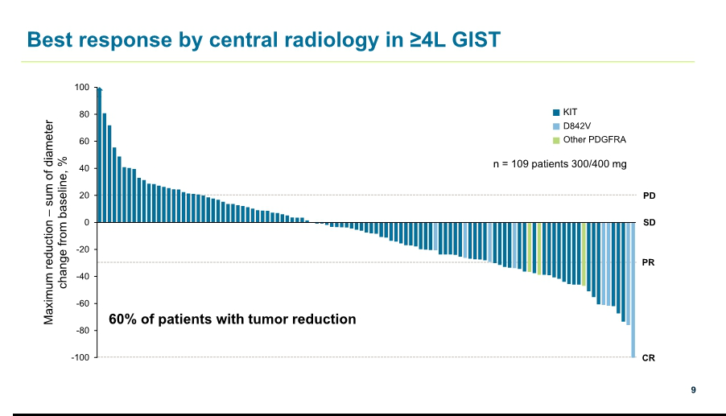

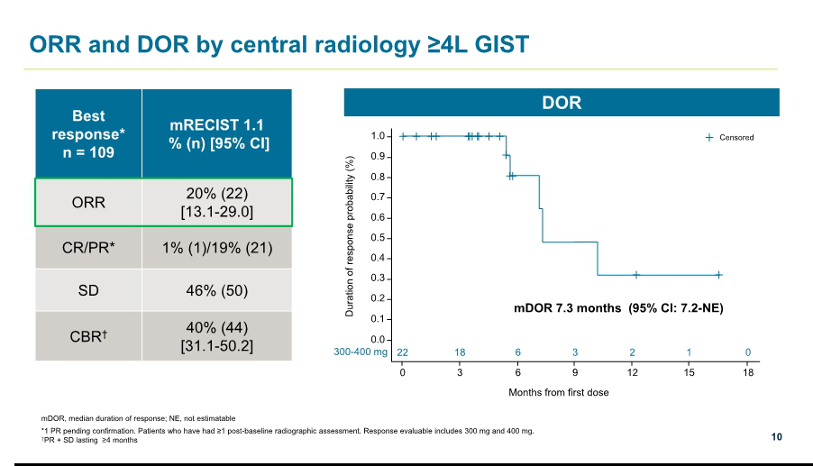

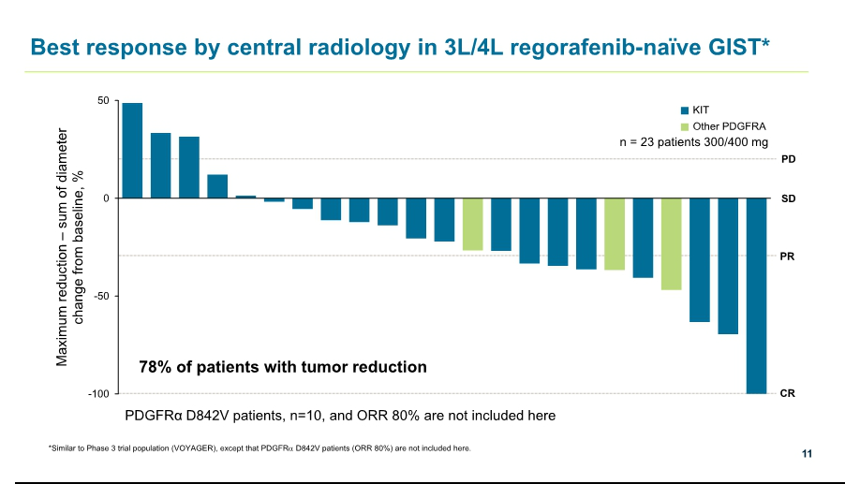

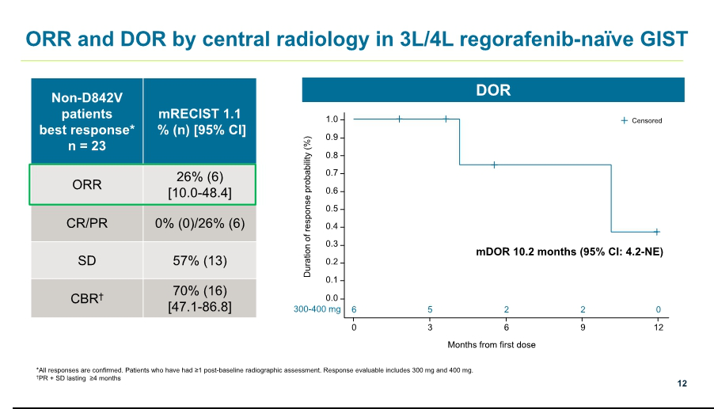

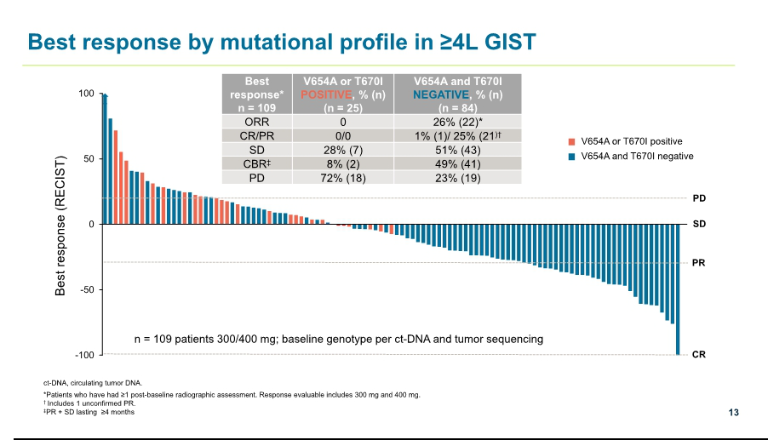

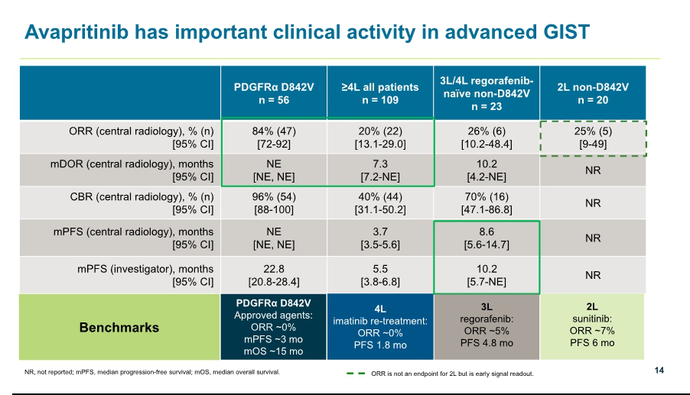

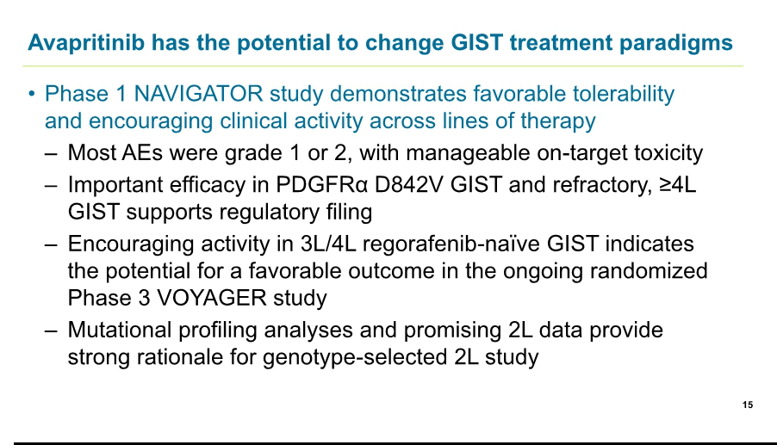

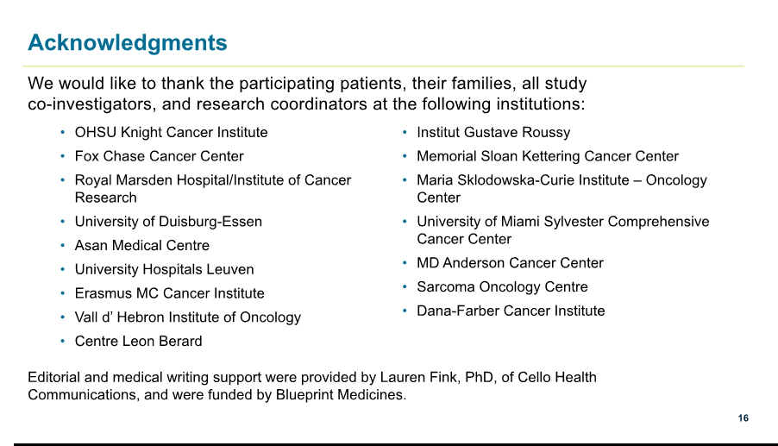

Exhibit 99.3








