UNITED STATES

SECURITIES AND EXCHANGE COMMISSION

Washington, D.C. 20549

FORM 8-K

CURRENT REPORT

Pursuant to Section 13 or 15(d)

of the Securities Exchange Act of 1934

Date of Report (Date of Earliest Event Reported): January 10, 2022

Blueprint Medicines Corporation

(Exact name of registrant as specified in its charter)

Delaware

(State or other jurisdiction

of incorporation)

001-37359

(Commission File Number)

26-3632015

(I.R.S. Employer

Identification No.)

45 Sidney Street

Cambridge, Massachusetts

(Address of principal executive offices)

02139

(Zip Code)

Registrant’s telephone number, including area code: (617) 374-7580

(Former name or former address, if changed since last report)

Check the appropriate box below if the Form 8-K filing is intended to simultaneously satisfy the filing obligation of the registrant under any of the following provisions:

- Written communications pursuant to Rule 425 under the Securities Act (17 CFR 230.425)

- Soliciting material pursuant to Rule 14a-12 under the Exchange Act (17 CFR 240.14a-12)

- Pre-commencement communications pursuant to Rule 14d-2(b) under the Exchange Act (17 CFR 240.14d-2(b))

- Pre-commencement communications pursuant to Rule 13e-4(c) under the Exchange Act (17 CFR 240.13e-4(c))

Indicate by check mark whether the registrant is an emerging growth company as defined in Rule 405 of the Securities Act of 1933 (§230.405 of this chapter) or Rule 12b-2 of the Securities Exchange Act of 1934 (§240.12b-2 of this chapter).

Emerging growth company ☐

If an emerging growth company, indicate by check mark if the registrant has elected not to use the extended transition period for complying with any new or revised financial accounting standards provided pursuant to Section 13(a) of the Exchange Act. ☐

Securities registered pursuant to Section 12(b) of the Exchange Act:

Title of each class | Trading symbol(s) | Name of each exchange on which registered
Common stock, par value $0.001 per share | BPMC | Nasdaq Global Select Market

Item 7.01 Regulation FD.

From time to time, the Company presents and/or distributes to the investment community at various industry and other conferences slide presentations to provide updates and summaries of its business. The Company is posting to the “Investors & Media” portion of its website at http://ir.blueprintmedicines.com/ a copy of its current corporate slide presentation. A copy of the presentation is furnished as Exhibit 99.1 to this Current Report on Form 8-K.

The information in Item 7.01 of this Current Report on Form 8-K, including Exhibit 99.1 attached hereto, is intended to be furnished and shall not be deemed “filed” for purposes of Section 18 of the Securities Exchange Act of 1934, as amended (the “Exchange Act”), or otherwise subject to the liabilities of that section, nor shall it be deemed incorporated by reference in any filing under the Securities Act of 1933, as amended, or the Exchange Act, except as expressly set forth by specific reference in such filing.

Item 8.01 Other Events.

On January 10, 2022, the Company issued a press release announcing its corporate goals for 2022 and certain other business updates. A copy of the press release is filed herewith as Exhibit 99.2 to this Current Report on Form 8-K and incorporated herein by reference.

Item 9.01 Financial Statements and Exhibits.

(d) Exhibits.
Exhibit No. |  | Description
99.1 |  | Corporate slide presentation of Blueprint Medicines Corporation dated January 10, 2022
99.2 |  | Press release issued by Blueprint Medicines Corporation on January 10, 2022
104 |  | Cover Page Interactive Data File (embedded within the Inline XBRL document and incorporated as Exhibit 101)

SIGNATURES

Pursuant to the requirements of the Securities Exchange Act of 1934, the registrant has duly caused this report to be signed on its behalf by the undersigned hereunto duly authorized.

 | BLUEPRINT MEDICINES CORPORATION
Date: January 10, 2022 | By: /s/ Jeffrey W. Albers
 |  | Jeffrey W. Albers
 |  | Chief Executive Officer

Exhibit 99.1
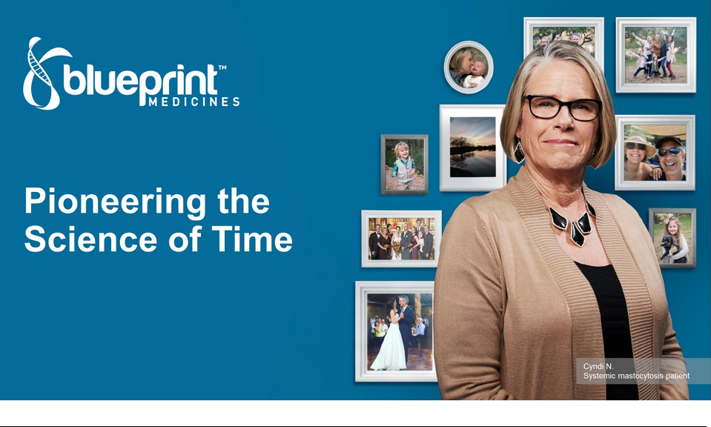

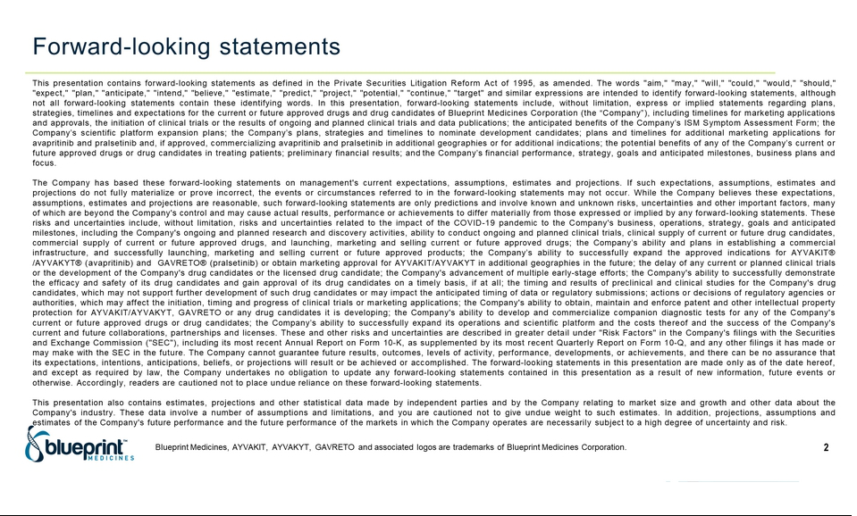

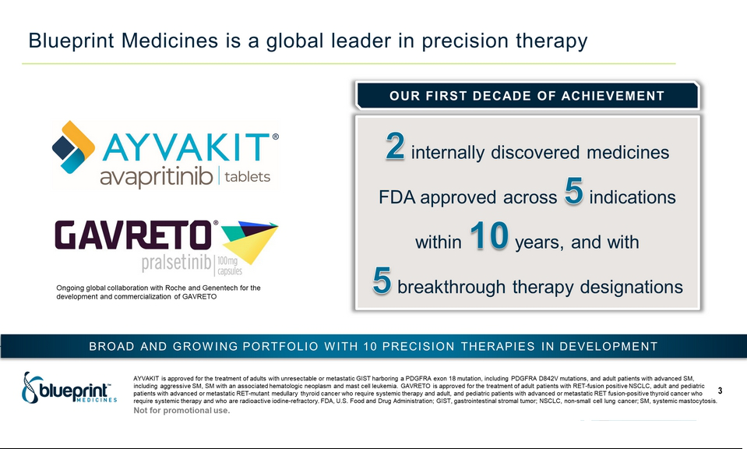

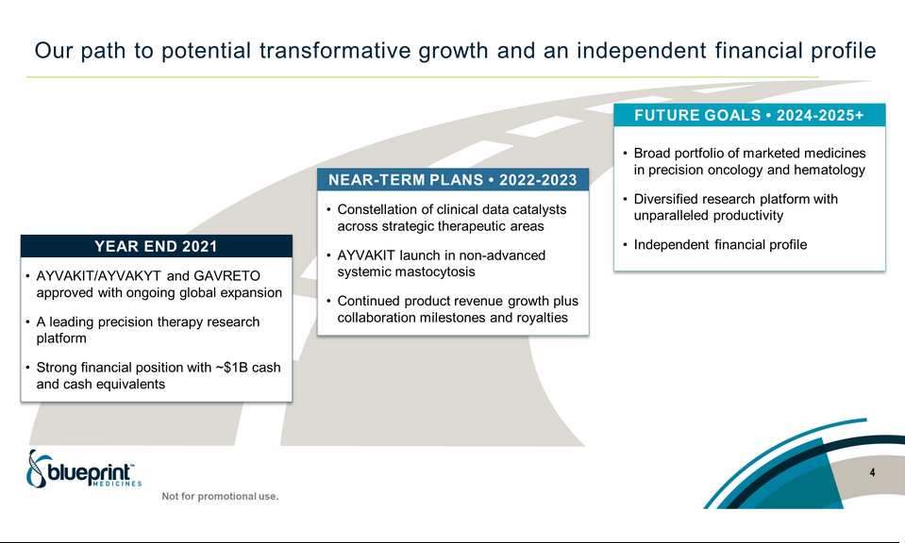

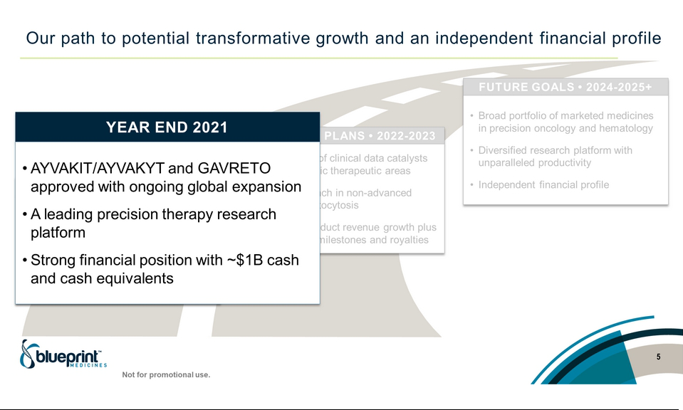

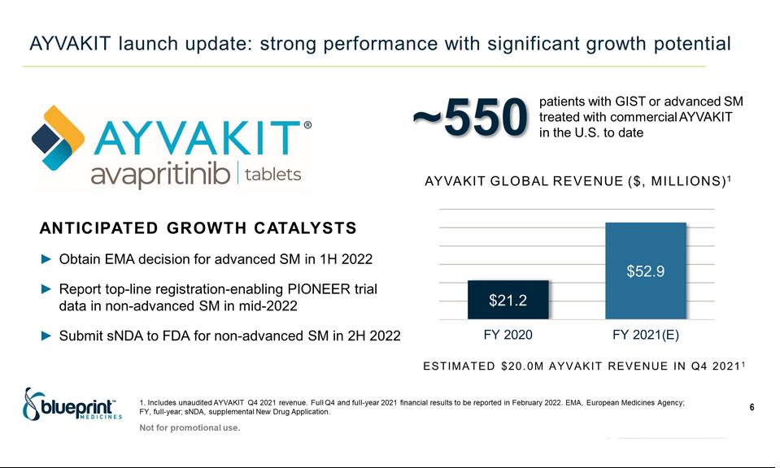

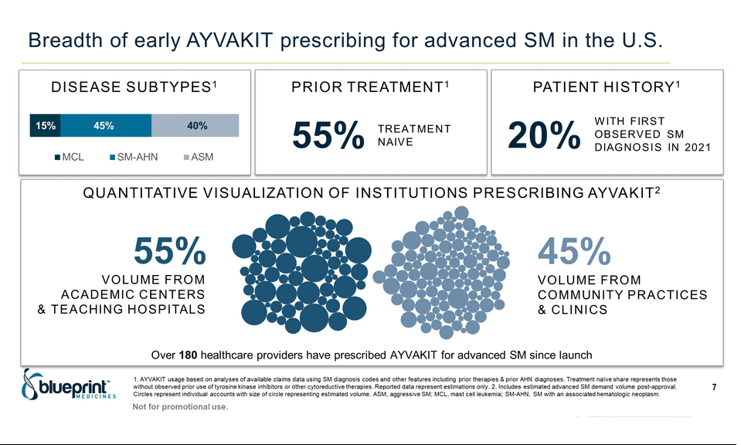

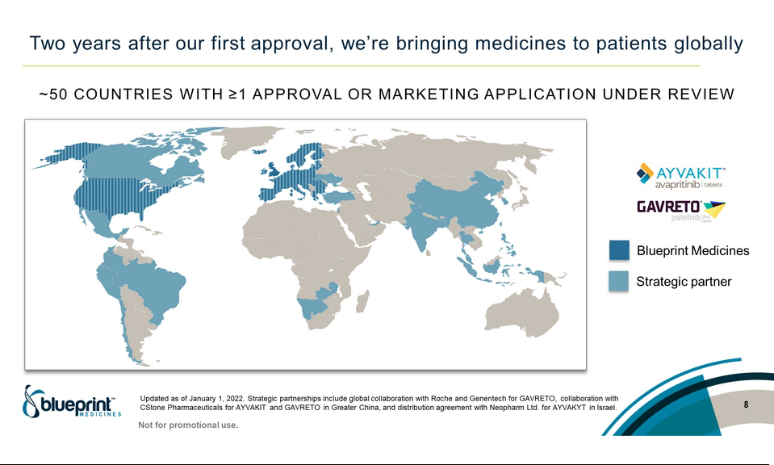

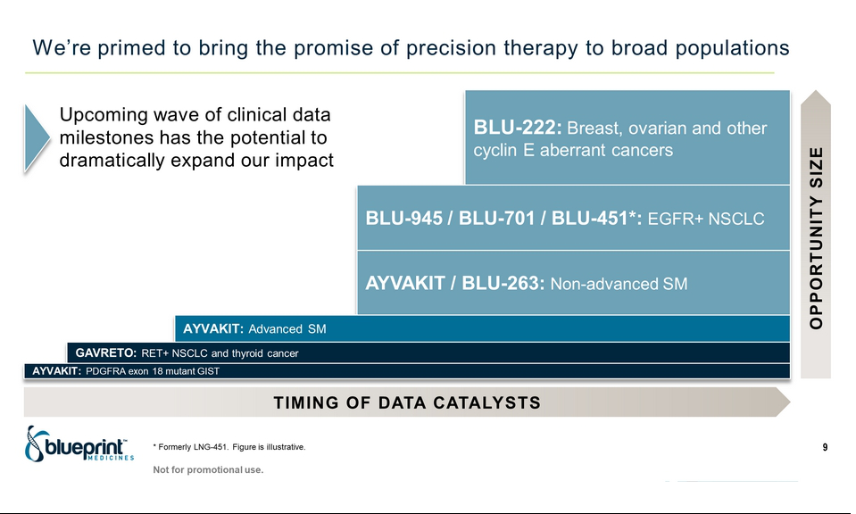

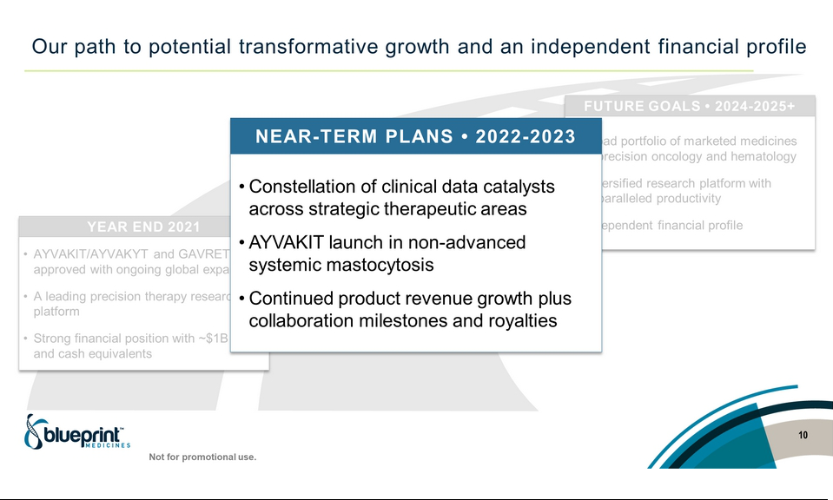

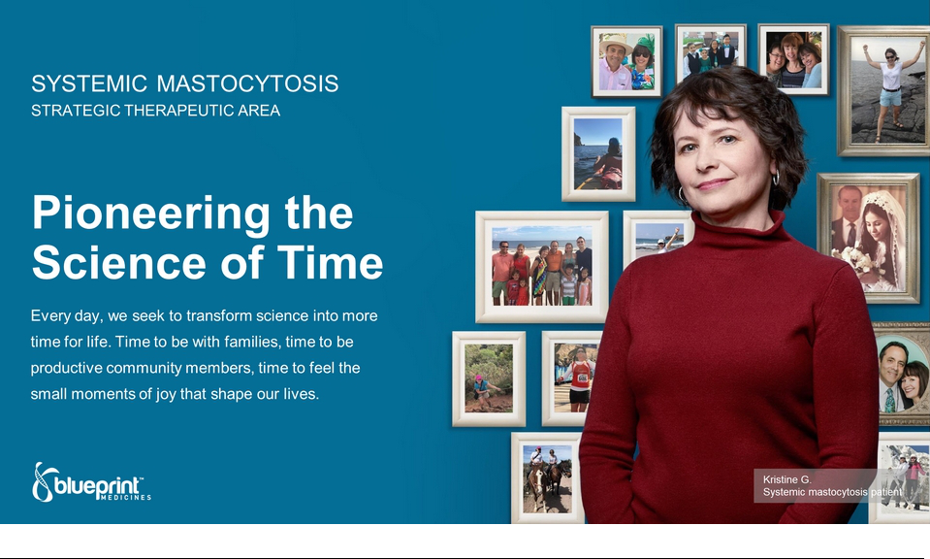

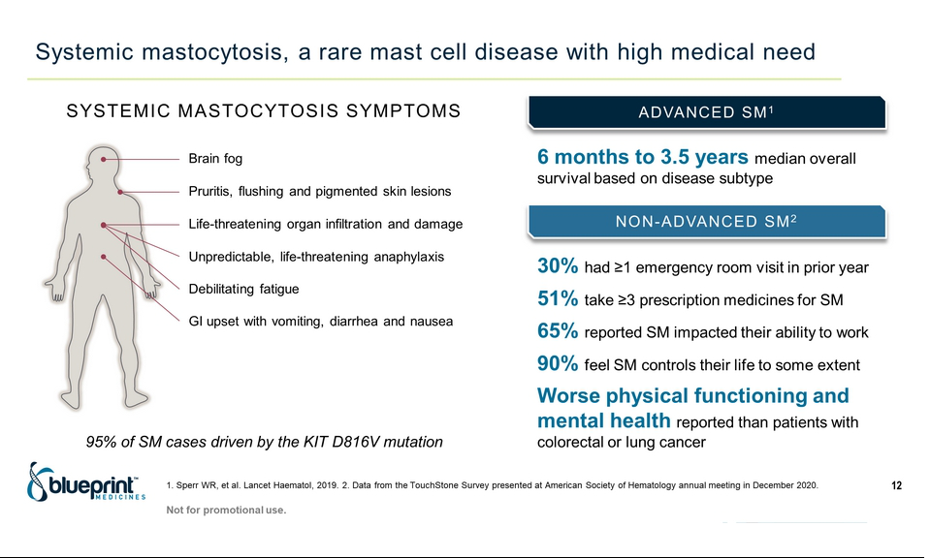

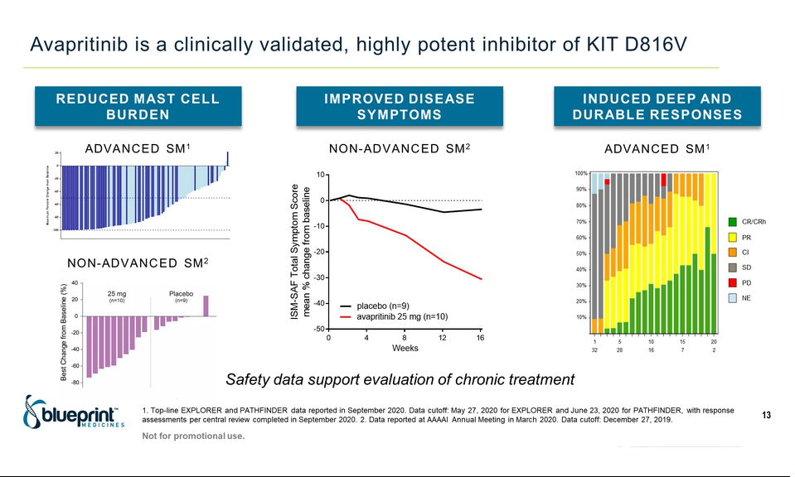

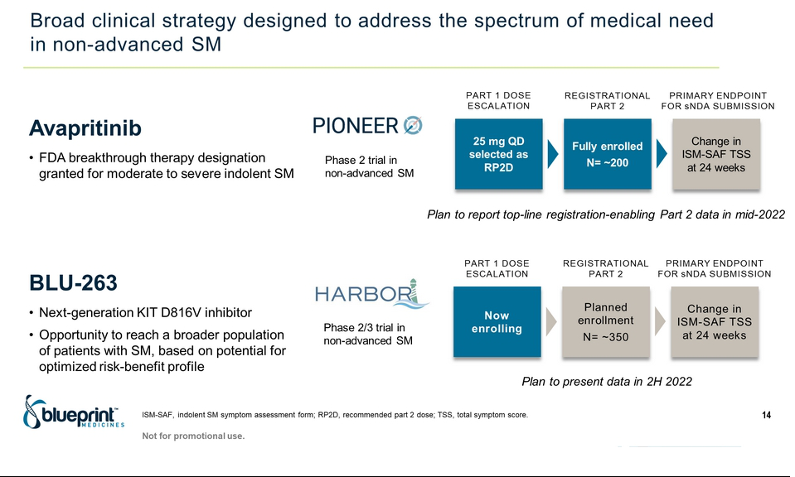

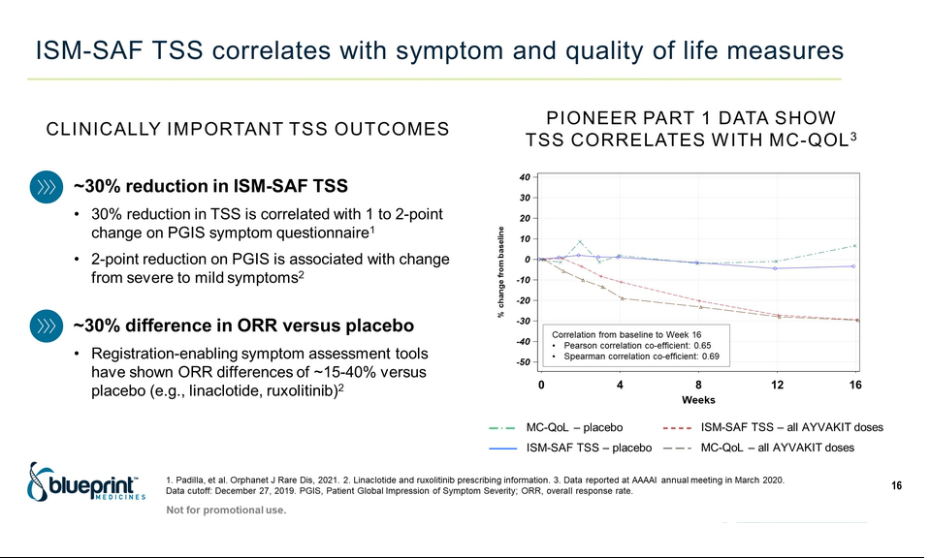

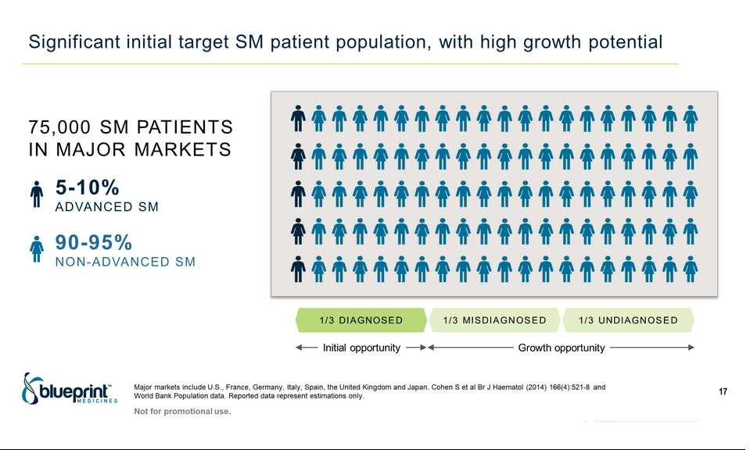

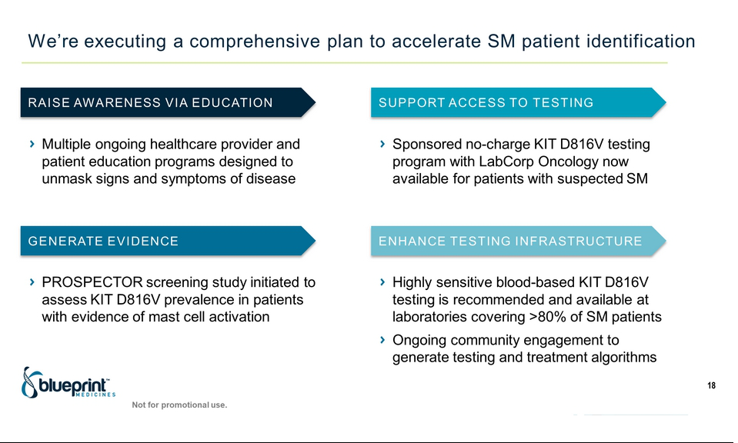

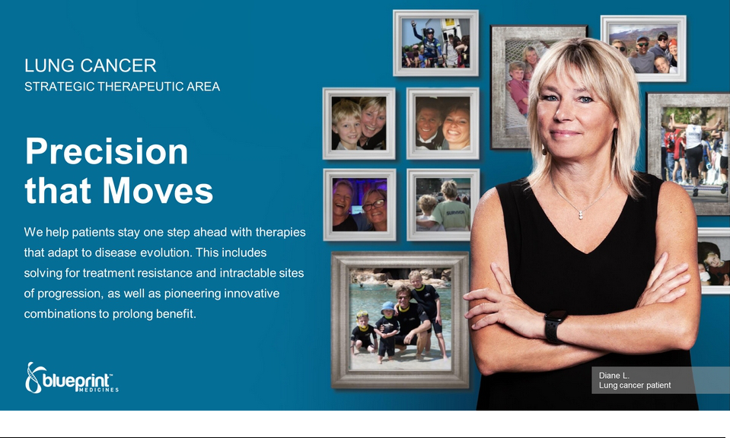

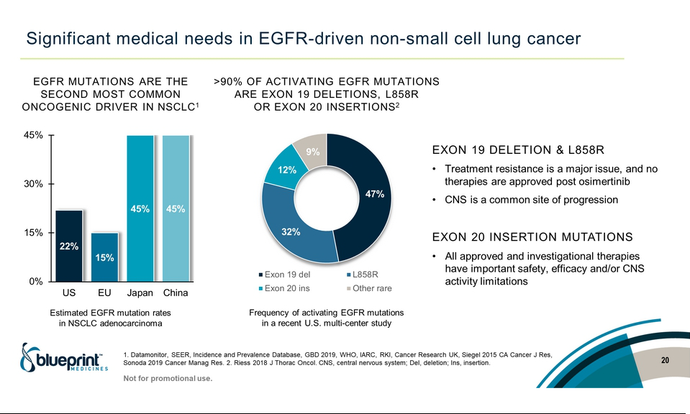

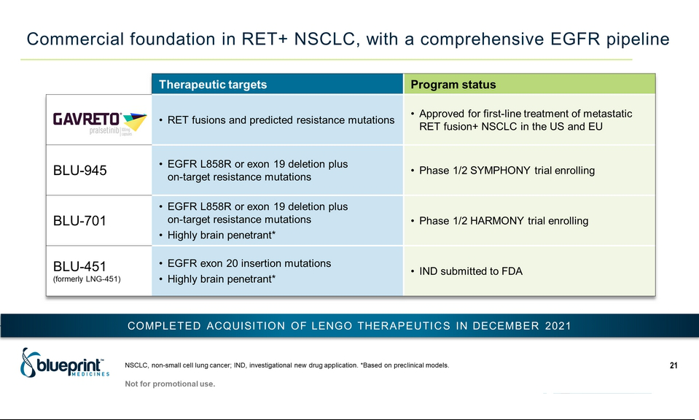

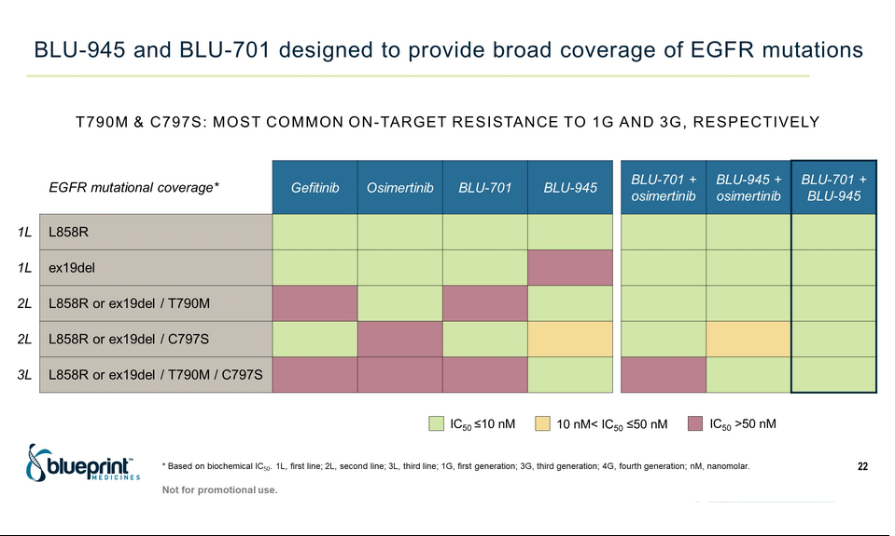

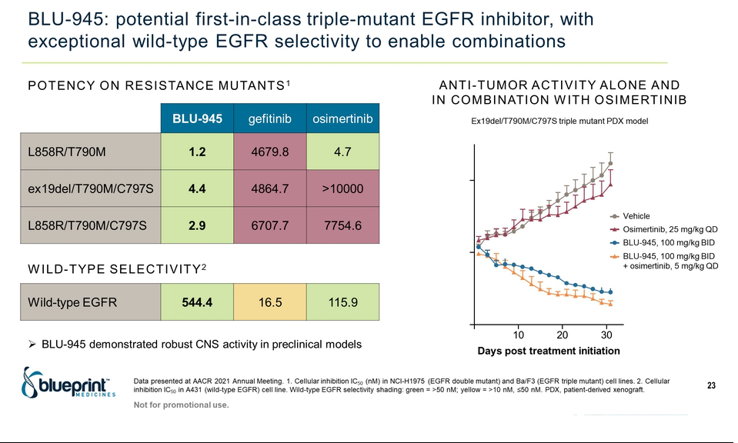

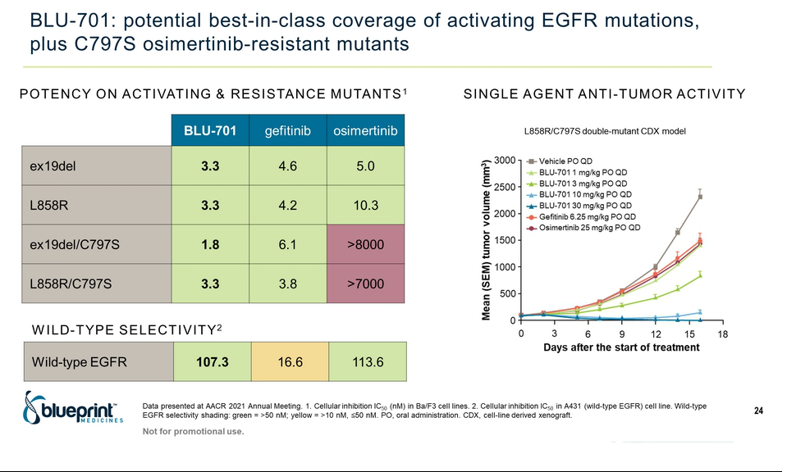

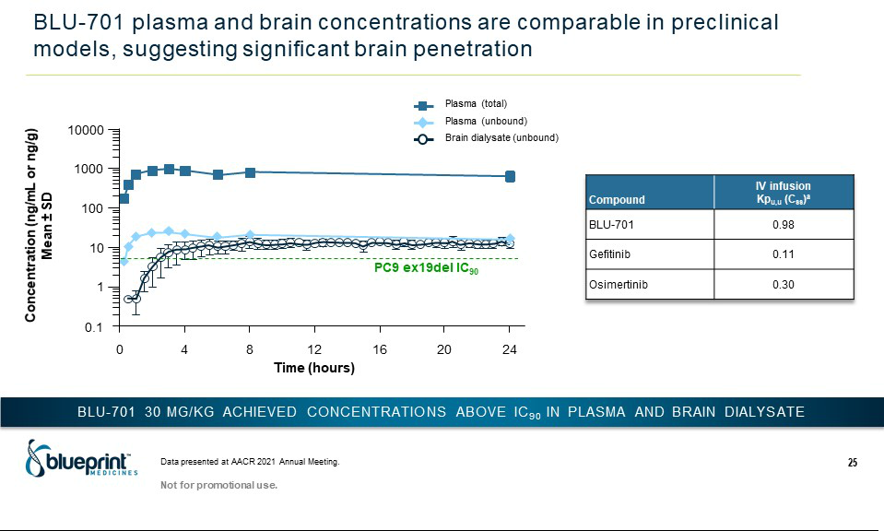

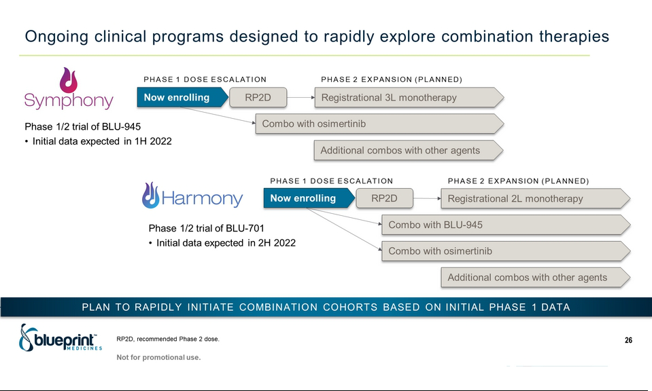

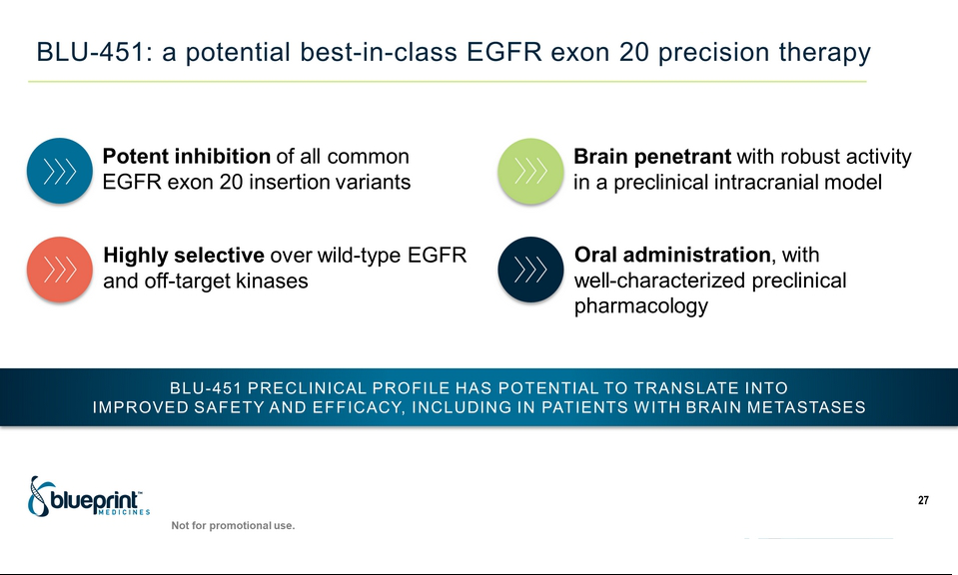

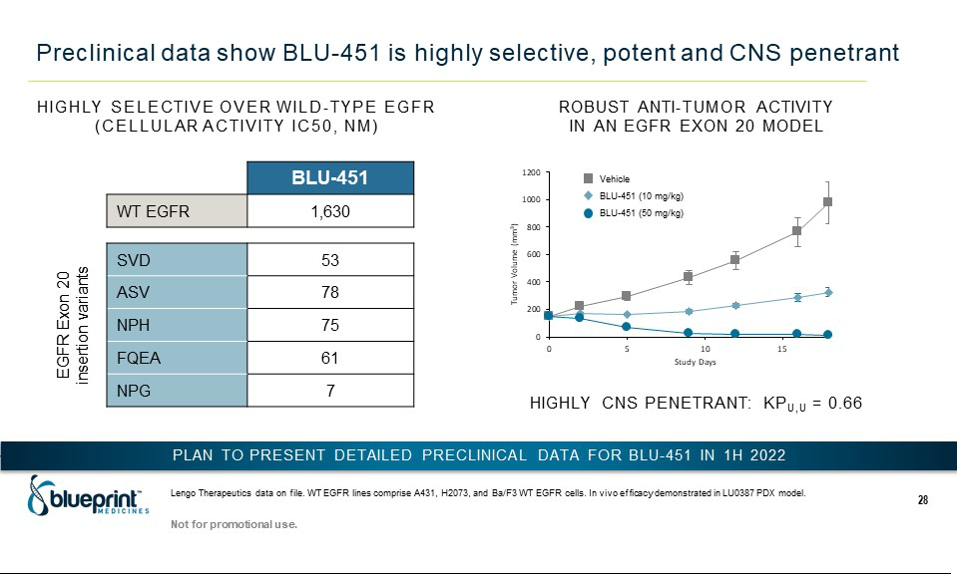

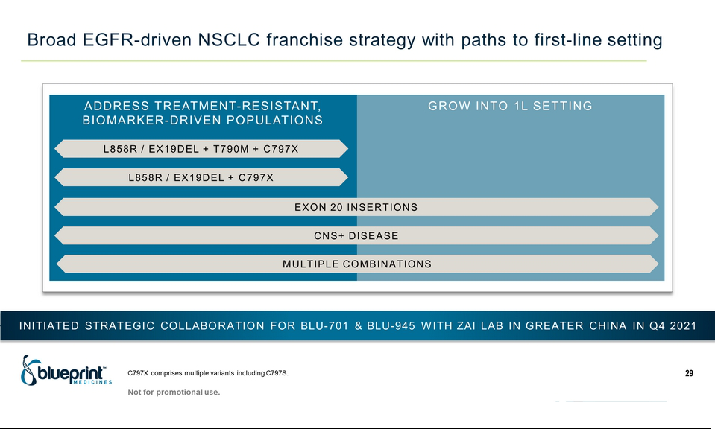



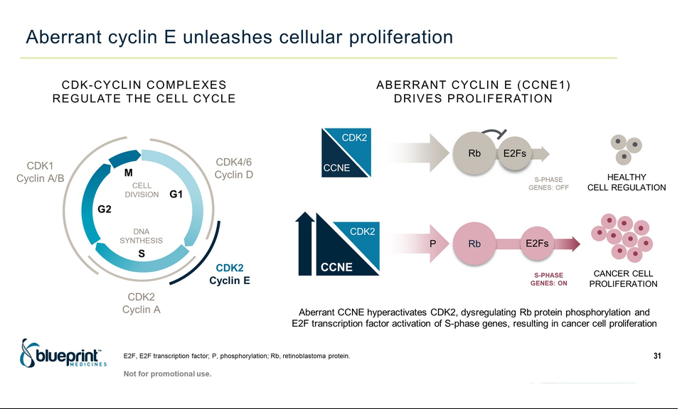

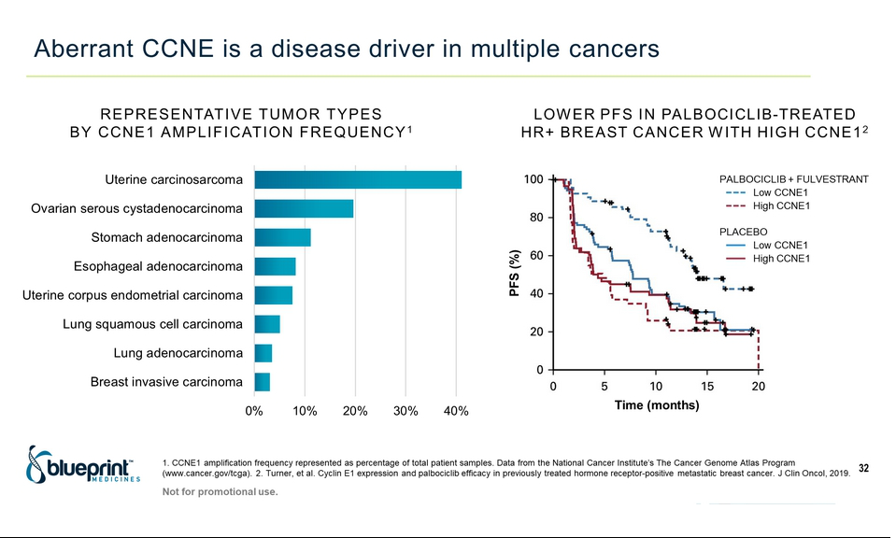

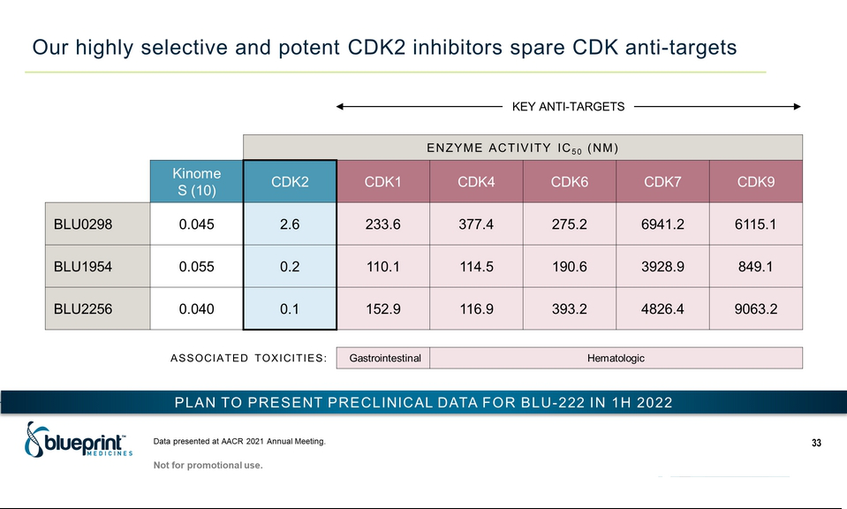

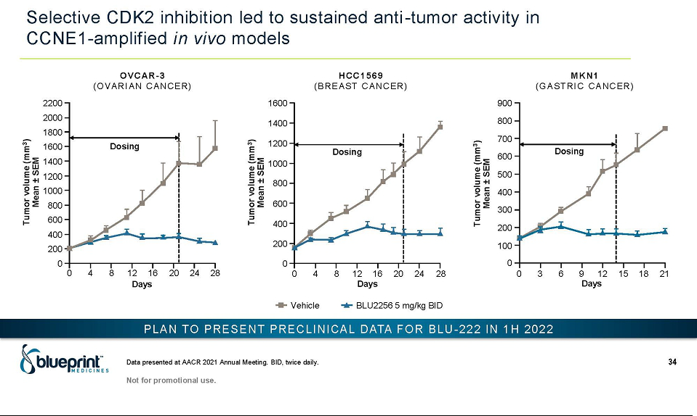

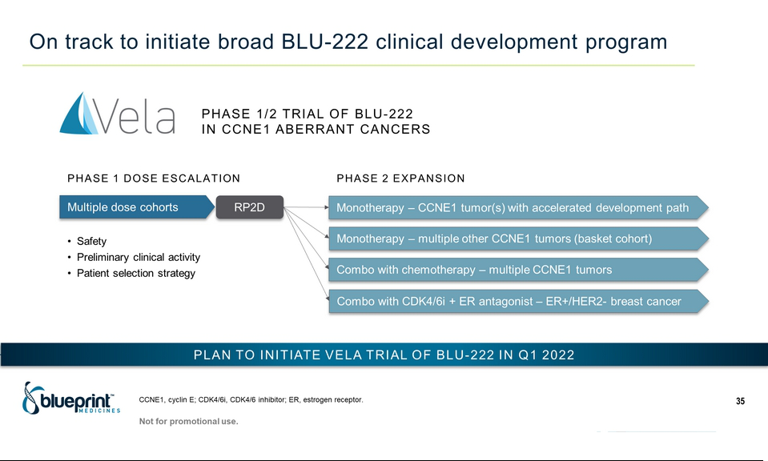

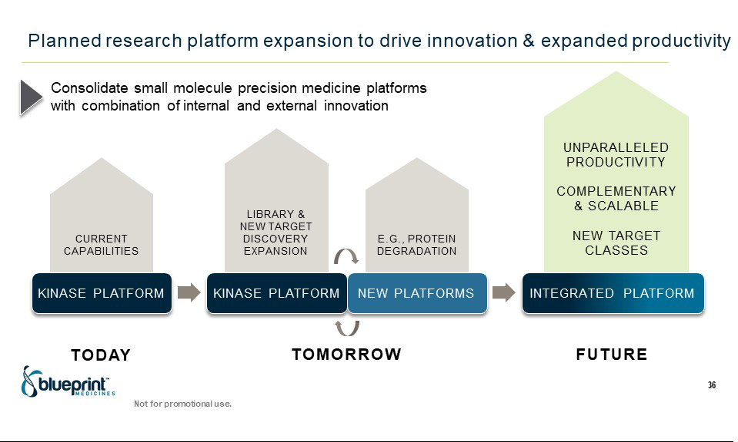

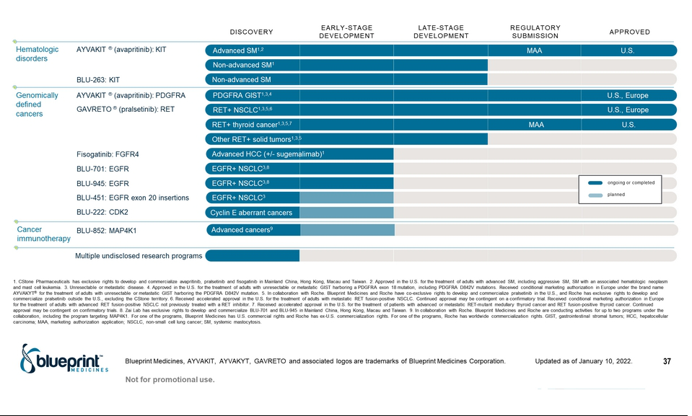

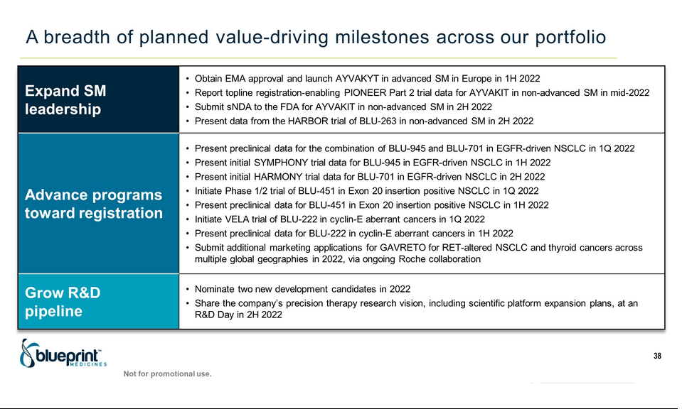

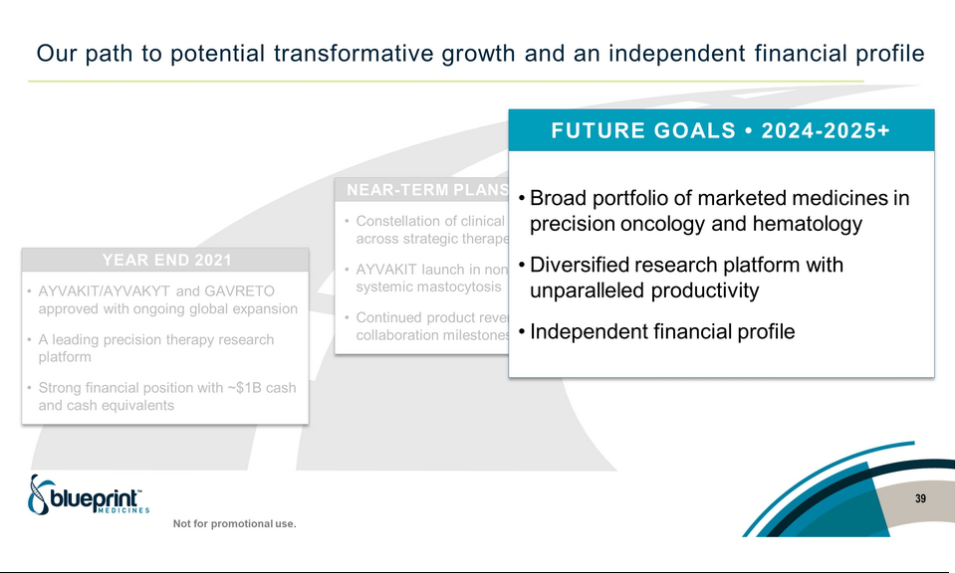

Exhibit 99.2

Blueprint Medicines Provides 2022 Portfolio Goals Targeting Expanded Precision Therapy Leadership

– Achieved full-year 2021 preliminary global net product revenue for AYVAKIT of approximately $52.9 million, representing an increase of approximately 150% over 2020 based on strong initial U.S. demand in advanced SM –

– Registration-enabling PIONEER trial of AYVAKIT in non-advanced systemic mastocytosis fully enrolled,

with data expected in mid-2022 –

– Plan to report initial SYMPHONY trial data for BLU-945 in EGFR-driven lung cancer in 1H 2022 –

– Initiated HARMONY trial of BLU-701 in EGFR-driven lung cancer, with initial data expected in 2H 2022 –

– Plan to initiate clinical trials of BLU-451 (formerly LNG-451) in EGFR exon 20 insertion positive lung cancer

and BLU-222 in cyclin E aberrant cancers in Q1 2022 –

CAMBRIDGE, Mass., January 10, 2022 – Blueprint Medicines Corporation (NASDAQ: BPMC) today outlined upcoming portfolio milestones that are anticipated to extend its position as a leading precision therapy company.

“With two precision therapies expanding their global reach across multiple approved indications, four INDs filed from our portfolio in 2021, and a range of clinical data inflection points anticipated over the next 12 to 18 months, Blueprint Medicines is entering a new, transformative phase of growth,” said Jeff Albers, Chief Executive Officer of Blueprint Medicines. “As we look ahead to 2022, we have the foundation in place to dramatically expand our opportunity to improve the lives of increasingly broad populations of patients with cancer and blood disorders. We will do this by advancing our systemic mastocytosis franchise to improve treatment across the spectrum of disease, progressing multiple innovative precision therapies for lung cancer and other genomically defined cancers toward registration, and diversifying our scientific platform to maintain unparalleled research productivity. Supported by strong commercial performance for AYVAKIT in advanced systemic mastocytosis and a clear pathway to financial independence, we are well positioned to usher in a new era of leadership and innovation in the field of precision medicine.”

The company’s key strategies and upcoming goals are to:

- Expand the company’s leadership position in systemic mastocytosis (SM), improving treatment options for patients across the spectrum of the disease.

AYVAKIT®/AYVAKYT® (avapritinib) and BLU-263: SM

  - Obtain regulatory approval from the European Medicines Agency and launch AYVAKYT in advanced SM in Europe in the first half of 2022.

  - Report topline data from the registration-enabling Part 2 of the PIONEER trial of AYVAKIT in non-advanced SM in mid-2022.

  - Submit a supplemental new drug application to the U.S. Food and Drug Administration for AYVAKIT in non-advanced SM in the second half of 2022.

  - Present data from the HARBOR trial of BLU-263 in non-advanced SM in the second half of 2022.

- Advance a robust portfolio of innovative clinical programs towards registration.

BLU-945 and BLU-701: EGFR-driven NSCLC

- Present preclinical data supporting the combination of BLU-945 and BLU-701 in the first quarter of 2022.

- Present initial clinical data from the Phase 1/2 SYMPHONY trial of BLU-945 in the first half of 2022.

- Present initial clinical data from Phase 1/2 HARMONY trial of BLU-701 in the second half of 2022.

BLU-451 (formerly LNG-451): EGFR exon 20 insertion-positive NSCLC

  - Initiate a Phase 1/2 trial of BLU-451 in the first quarter of 2022.

  - Present preclinical data for BLU-451 in the first half of 2022. BLU-222: Cyclin-E aberrant cancers

  - Initiate the Phase 1/2 VELA trial of BLU-222 in the first quarter of 2022.

  - Present preclinical data for BLU-222 in the first half of 2022. GAVRETO® (pralsetinib): RET-altered cancers

  - Submit additional marketing applications for GAVRETO for RET-altered NSCLC and thyroid cancers across multiple additional global geographies in 2022, via the company’s ongoing global collaboration with Roche.

- Grow the R&D pipeline with diverse, high-value programs from company’s prolific scientific platform.

Research

- Expand pipeline with two new development candidates in 2022.

- Share the company’s research vision, including scientific platform expansion plans, at an R&D Day in the second half of 2022.

Financial Guidance

Blueprint Medicines also announced preliminary¹ global product revenues for AYVAKIT for full year 2021 and the fourth quarter of 2021 were approximately $52.9 million, and $20.0 million, respectively, representing an increase of approximately 150 percent and 230 percent over the same periods in 2020 based on strong initial U.S. demand in advanced SM. Full year 2021 total revenues, including collaboration revenues, are expected to be at the higher-end of previous guidance of $170-$180 million. Cash, cash equivalents and

investments as of December 31, 2021 were approximately $1.0 billion.¹ Based on its current operating plans, Blueprint Medicines continues to expect that its existing cash, cash equivalents and investments, together with anticipated future product revenues, will provide sufficient capital to enable the company to achieve a self-sustainable financial profile.

¹The preliminary selected financial results are unaudited, subject to adjustment, and provided as an approximation in advance of the Company’s announcement of complete financial results in February 2022.

About Blueprint Medicines

Blueprint Medicines is a global precision therapy company that invents life-changing therapies for people with cancer and blood disorders. Applying an approach that is both precise and agile, we create medicines that selectively target genetic drivers, with the goal of staying one step ahead across stages of disease. Since 2011, we have leveraged our research platform, including expertise in molecular targeting and world-class drug design capabilities, to rapidly and reproducibly translate science into a broad pipeline of precision therapies. Today, we are delivering approved medicines directly to patients in the United States and Europe, and we are globally advancing multiple programs for systemic mastocytosis, lung cancer and other genomically defined cancers. For more information, visit www.BlueprintMedicines.com and follow us on Twitter (@BlueprintMeds) and LinkedIn.

Cautionary Note Regarding Forward-Looking Statements

This press release contains forward-looking statements within the meaning of the Private Securities Litigation Reform Act of 1995, as amended, including, without limitation, statements regarding plans, strategies, timelines and expectations for Blueprint Medicines' current or future approved drugs and drug candidates, including timelines for marketing applications and approvals, the initiation of clinical trials or the results of ongoing and planned clinical trials; plans to expand Blueprint Medicines’ scientific platform; Blueprint Medicines' plans, strategies and timelines to nominate development candidates; plans and timelines for additional marketing applications for avapritinib and pralsetinib and, if approved, commercializing avapritinib and pralsetinib in additional geographies or for additional indications; the potential benefits of any of Blueprint Medicines' current or future approved drugs or drug candidates in treating patients; the potential benefits of Blueprint Medicines' collaborations; preliminary selected financial results; and Blueprint Medicines' strategy, goals and anticipated financial performance, milestones, business plans and focus. The words "aim," "may," "will," "could," "would," "should," "expect," "plan," "anticipate," "intend," "believe," "estimate," "predict," "project," "potential," "continue," "target" and similar expressions are intended to identify forward-looking statements, although not all forward-looking statements contain these identifying words. Any forward-looking statements in this press release are based on management's current expectations and beliefs and are subject to a number of risks, uncertainties and important factors that may cause actual events or results to differ materially from those expressed or implied by any forward-looking statements contained in this press release, including, without limitation, risks and uncertainties related to the impact of the COVID-19 pandemic to Blueprint Medicines' business, operations, strategy, goals and anticipated milestones, including Blueprint Medicines' ongoing and planned research and discovery activities, ability to conduct ongoing and planned clinical trials, clinical supply of current or future drug candidates, commercial supply of current or future approved products, and launching, marketing and selling current or future approved products; Blueprint Medicines' ability and plans in continuing to establish and expand a commercial infrastructure, and successfully launching, marketing and selling current or future approved products; Blueprint Medicines' ability to successfully expand the approved indications for AYVAKIT/AYVAKYT and GAVRETO or obtain marketing approval for AYVAKIT/AYVAKYT in additional geographies in the future; the delay of any current or planned clinical trials or the development of Blueprint Medicines' current or future drug candidates; Blueprint Medicines' advancement of multiple early-stage efforts; Blueprint Medicines' ability to successfully demonstrate the safety and efficacy of its drug candidates and gain approval of its drug candidates on a timely basis, if at all; the timing and results of preclinical and clinical studies for Blueprint Medicines' drug candidates, which may not support further development of such drug candidates or may impact the timing of data publications or regulatory submissions; actions of regulatory agencies, which may affect the initiation, timing and progress of clinical trials; Blueprint Medicines' ability to obtain, maintain and enforce patent and other intellectual property protection for AYVAKIT/AYVAKYT, GAVRETO or any drug candidates it is developing; Blueprint Medicines' ability to develop and commercialize companion diagnostic tests for AYVAKIT/AYVAKYT, GAVRETO or any of its current and future drug candidates; Blueprint Medicines’ ability to successfully expand its operations and scientific platform and the costs thereof; and the success of Blueprint Medicines' current and future collaborations, partnerships or licensing arrangements. These and other risks and uncertainties are described in greater detail in the section entitled "Risk Factors" in Blueprint Medicines' filings with the Securities and Exchange Commission (SEC), including Blueprint Medicines' most recent Annual Report on Form 10-K, as supplemented by its most recent Quarterly Report on Form 10-Q and any other filings that Blueprint Medicines has made or may make with the SEC in the future. Any forward-looking statements contained in this press release represent Blueprint Medicines' views only as of the date hereof and should not be relied upon as representing its views as of any subsequent date. Except as required by law, Blueprint Medicines explicitly disclaims any obligation to update any forward-looking statements.

Trademarks

Blueprint Medicines, AYVAKIT, AYVAKYT, GAVRETO and associated logos are trademarks of Blueprint Medicines Corporation.

Media Contact

Andrew Law

617-844-8205

media@blueprintmedicines.com

Investor Contact

Kristin Hodous

617-714-6674

ir@blueprintmedicines.com

