UNITED STATES

SECURITIES AND EXCHANGE COMMISSION
Washington, D.C. 20549

FORM 8-K

CURRENT REPORT

Pursuant to Section 13 or 15(d)

of the Securities Exchange Act of 1934

Date of Report (Date of Earliest Event Reported): May 29, 2020

Blueprint Medicines Corporation

(Exact name of registrant as specified in its charter)

Delaware

(State or other jurisdiction

of incorporation)

001-37359

(Commission File Number)

26-3632015

(I.R.S. Employer

Identification No.)

45 Sidney Street

Cambridge, Massachusetts

(Address of principal executive offices)

02139

(Zip Code)

Registrant’s telephone number, including area code: (617) 374-7580

(Former name or former address, if changed since last report)

Check the appropriate box below if the Form 8-K filing is intended to simultaneously satisfy the filing obligation of the registrant under any of the following provisions:

- Written communications pursuant to Rule 425 under the Securities Act (17 CFR 230.425)

- Soliciting material pursuant to Rule 14a-12 under the Exchange Act (17 CFR 240.14a-12)

- Pre-commencement communications pursuant to Rule 14d-2(b) under the Exchange Act (17 CFR 240.14d-2(b))

- Pre-commencement communications pursuant to Rule 13e-4(c) under the Exchange Act (17 CFR 240.13e-4(c))

Indicate by check mark whether the registrant is an emerging growth company as defined in Rule 405 of the Securities Act of 1933 (§230.405 of this chapter) or Rule 12b-2 of the Securities Exchange Act of 1934 (§240.12b-2 of this chapter).

Emerging growth company ☐

If an emerging growth company, indicate by check mark if the registrant has elected not to use the extended transition period for complying with any new or revised financial accounting standards provided pursuant to Section 13(a) of the Exchange Act. ☐

Securities registered pursuant to Section 12(b) of the Exchange Act:

Title of each class | Trading symbol(s) | Name of each exchange on which registered
Common stock, par value $0.001 per share | BPMC | Nasdaq Global Select Market

Item 7.01 Regulation FD Disclosure.

On May 29, 2020, Blueprint Medicines Corporation (the “Company”) is hosting an investor conference call and webcast to report data from its ongoing ARROW trial of pralsetinib in patients with RET fusion-positive non-small cell lung cancer (“NSCLC”), thyroid cancer and other solid tumors. A copy of the presentation from the investor conference call and webcast is furnished as Exhibit 99.1 to this Current Report on Form 8-K.

The information in Item 7.01 of this Current Report on Form 8-K, including Exhibit 99.1 attached hereto, is intended to be furnished and shall not be deemed “filed” for purposes of Section 18 of the Securities Exchange Act of 1934, as amended (the “Exchange Act”), or otherwise subject to the liabilities of that section, nor shall it be deemed incorporated by reference in any filing under the Securities Act of 1933, as amended, or the Exchange Act, except as expressly set forth by specific reference in such filing.

Item 8.01 Other Events.

On May 29, 2020, the Company issued a press release announcing data from its ongoing ARROW trial of pralsetinib in patients with RET fusion-positive NSCLC, thyroid cancer and other solid tumors. These data are also being presented at the American Society of Clinical Oncology 2020 Virtual Scientific Program. A copy of the press release is filed herewith as Exhibit 99.2 to this Current Report on Form 8-K and incorporated herein by reference.

Item 9.01 Financial Statements and Exhibits.

(d) Exhibits.
 | Exhibit No. |  | Description
 | 99.1 |  | Corporate slide presentation of Blueprint Medicines Corporation dated May 29, 2020
99.2 |  |  | Press release issued by Blueprint Medicines Corporation on May 29, 2020
104 |  |  | Cover Page Interactive Data File (embedded within the Inline XBRL document)
 |  |  | 2

SIGNATURES

Pursuant to the requirements of the Securities Exchange Act of 1934, the registrant has duly caused this report to be signed on its behalf by the undersigned hereunto duly authorized.

BLUEPRINT MEDICINES CORPORATION

Date: May 29, 2020 By: /s/ Jeffrey W. Albers

Jeffrey W. Albers

Chief Executive Officer

3

Exhibit 99.1


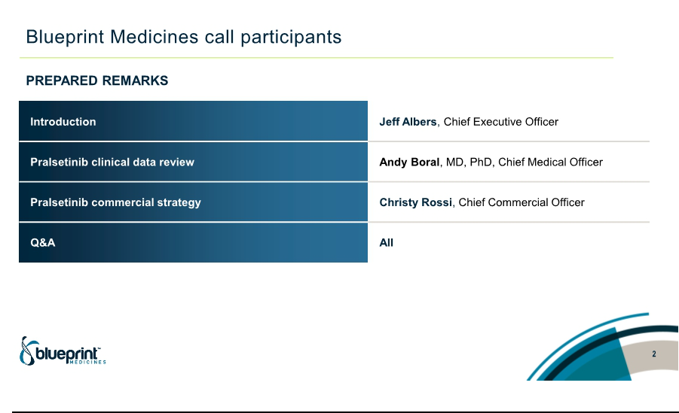

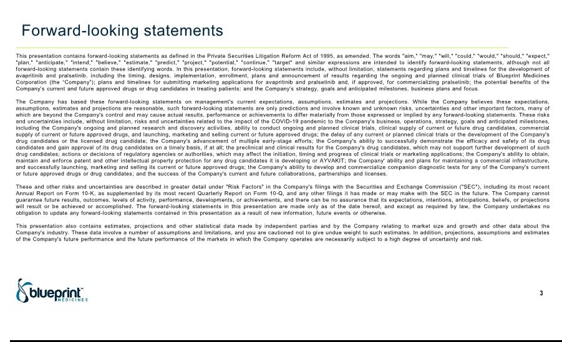

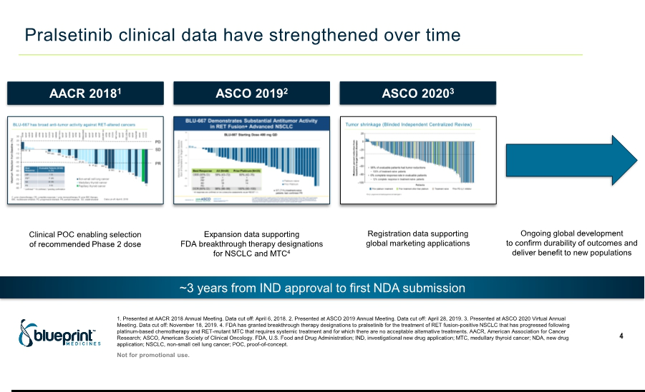

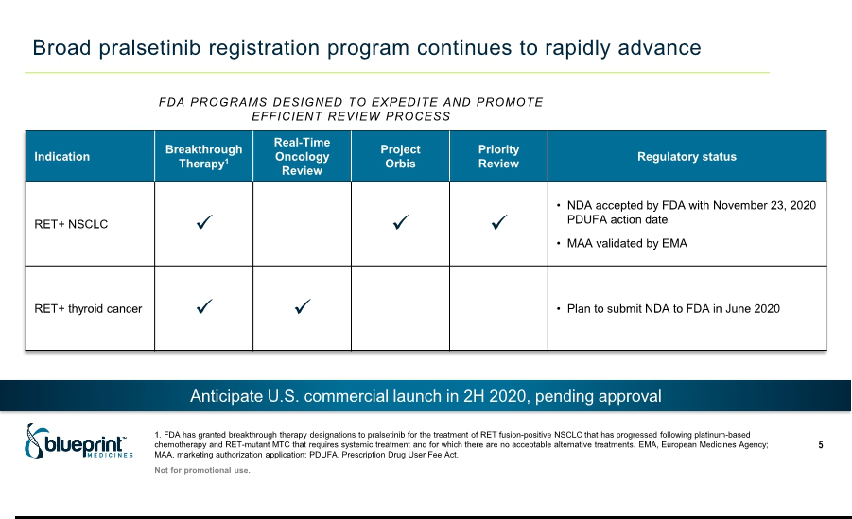

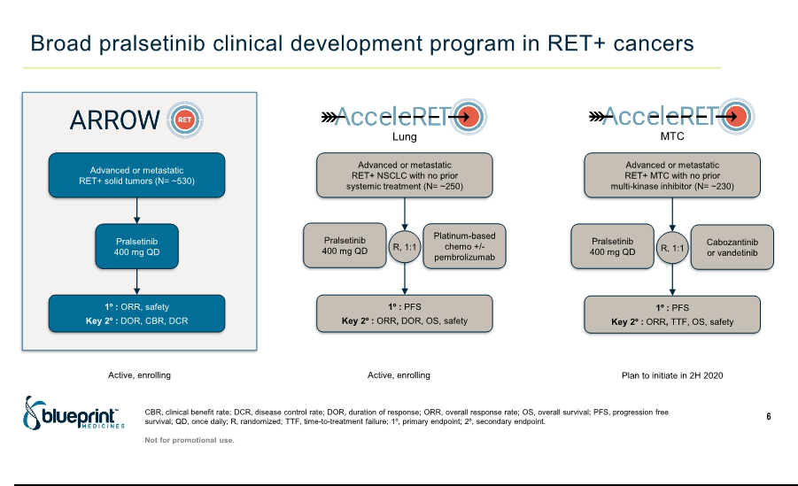



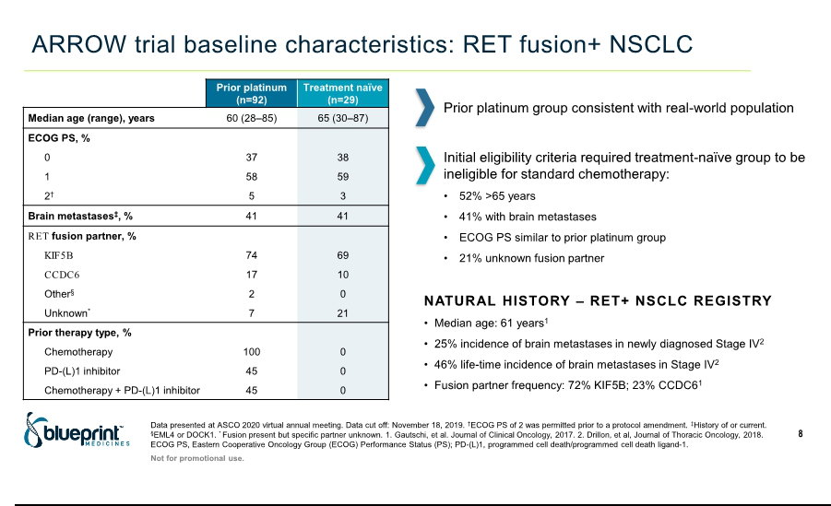

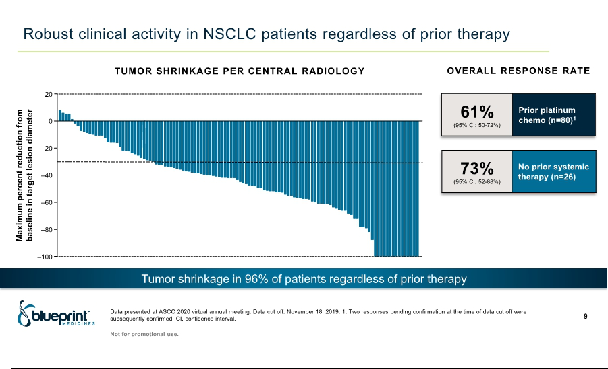

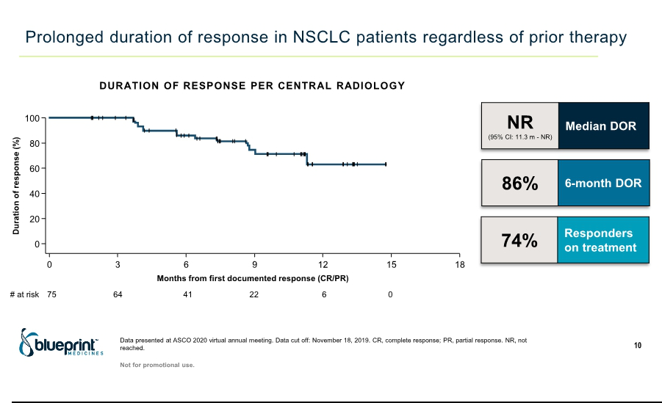

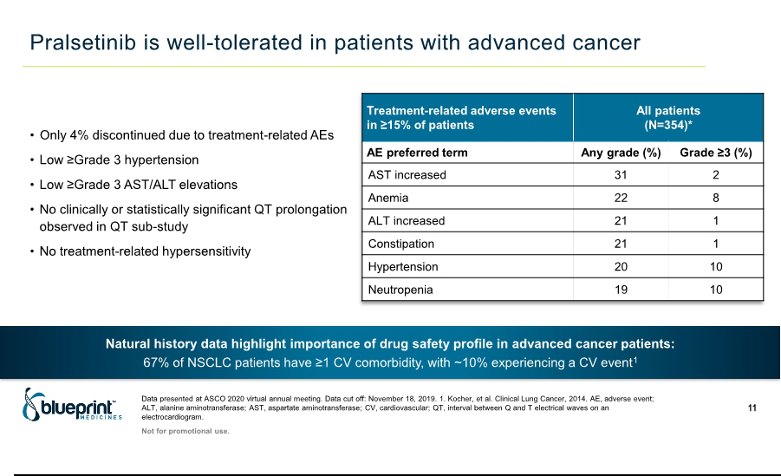

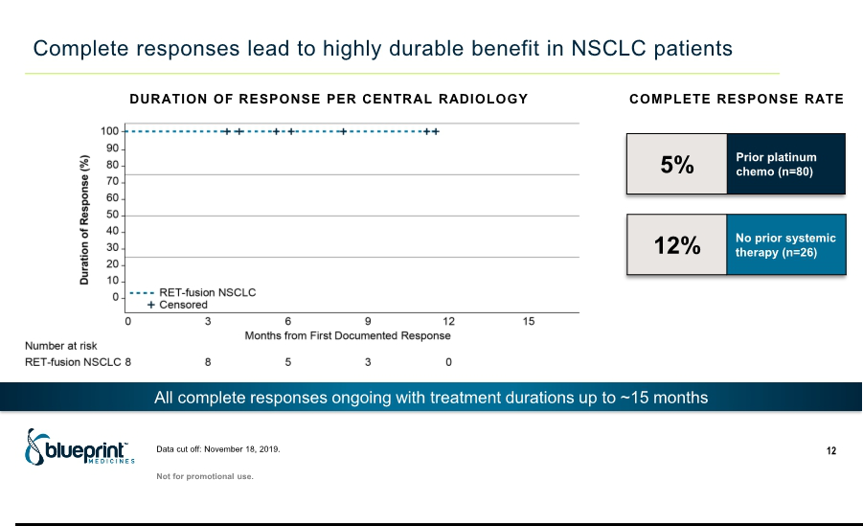

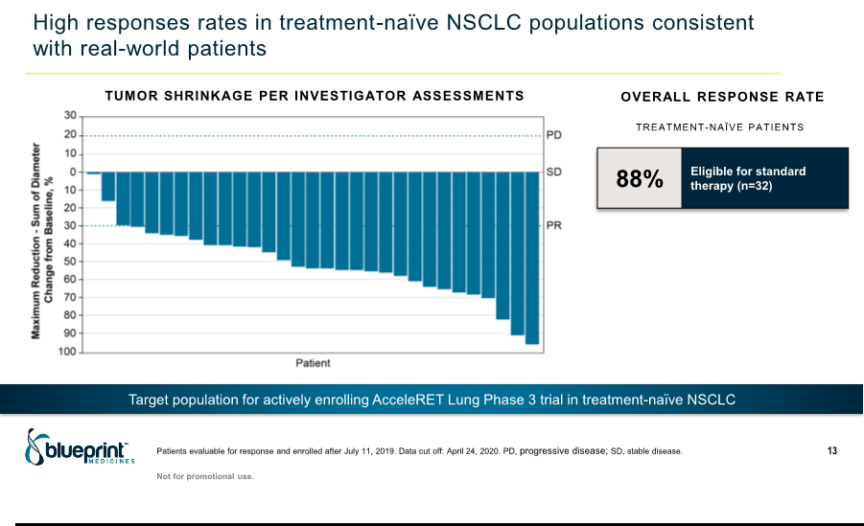

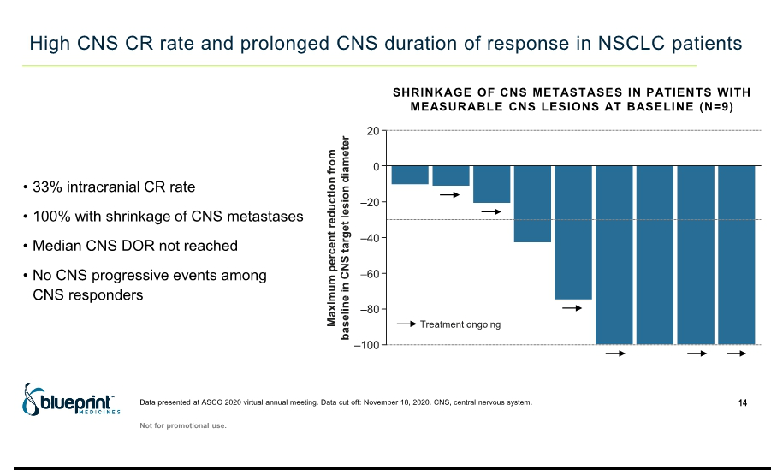

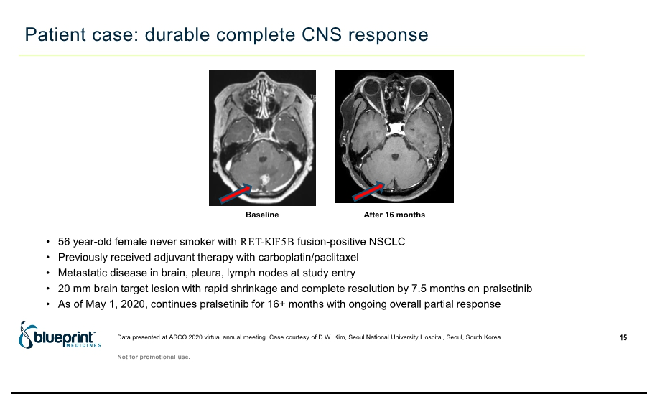

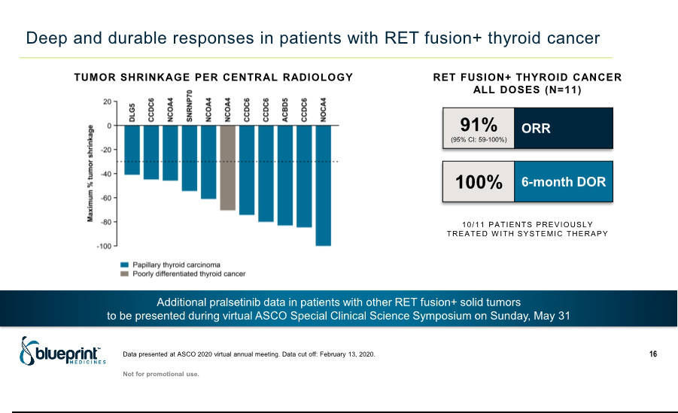

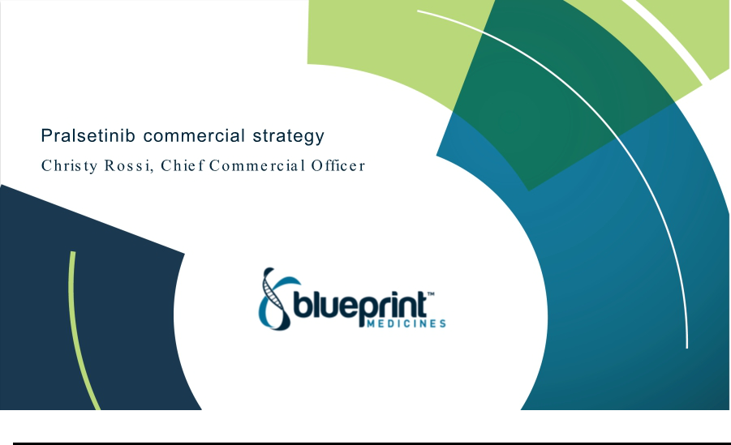

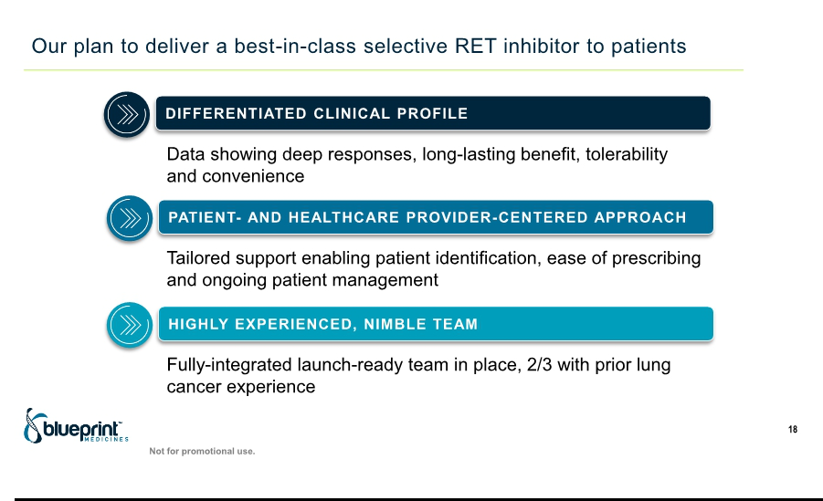



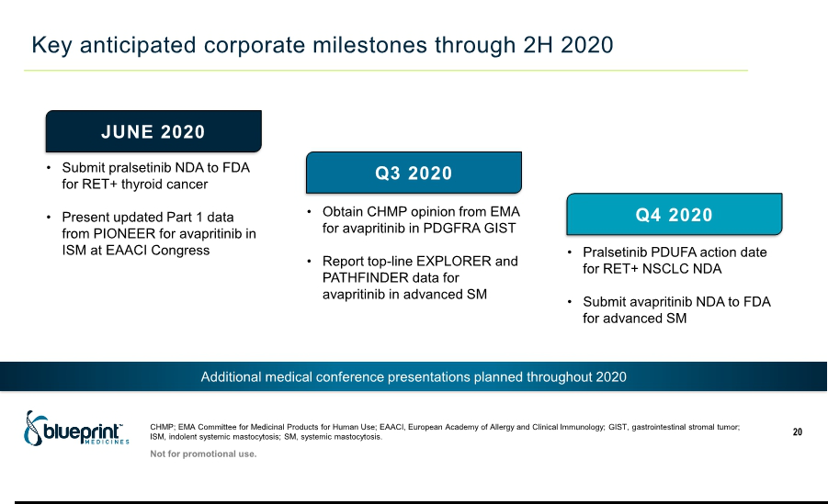



Exhibit 99.2

Blueprint Medicines Announces Data Presentations at ASCO20 Highlighting Deep, Durable Clinical Activity and Well-Tolerated Safety Profile of Pralsetinib Across Broad Range of RET Fusion-Positive Tumors

- Registrational data in RET fusion-positive NSCLC show 61% ORR in patients previously treated with platinum-based chemotherapy and 73% ORR in treatment-naïve patients --

    - 12% complete response rate in patients with treatment-naïve RET fusion-positive NSCLC --

  - Median DOR not reached across lines of therapy in RET fusion-positive NSCLC, with 6-month DOR of 86% --

-- NDA accepted by FDA and MAA validated by EMA for pralsetinib in RET fusion-positive NSCLC --


-- Blueprint Medicines to host investor conference call and webcast today at 8:30 a.m. ET --

CAMBRIDGE, Mass., May 29, 2020 – Blueprint Medicines Corporation (NASDAQ: BPMC), a precision therapy company focused on genomically defined cancers, rare diseases and cancer immunotherapy, today announced data from the ongoing ARROW clinical trial of pralsetinib in patients with RET fusion-positive non-small cell lung cancer (NSCLC), thyroid cancer and other solid tumors. Registrational data for pralsetinib in patients with RET fusion-positive NSCLC showed deep and durable clinical responses, with a median duration of response (DOR) not reached. Additional results showed the broad clinical activity of pralsetinib across other RET fusion-positive tumors, including thyroid cancer. Pralsetinib was well-tolerated and safety results were consistent with prior data, with no new safety signals observed. These results are being presented during the American Society of Clinical Oncology 2020 (ASCO20) Virtual Scientific Program.

In addition, Blueprint Medicines today announced that the U.S. and EU marketing applications for pralsetinib for the treatment of locally advanced or metastatic RET fusion-positive NSCLC have been accepted by the U.S. Food and Drug Administration (FDA) and validated by the European Medicines Agency (EMA), respectively. The FDA granted priority review and set an action date of November 23, 2020 under the Prescription Drug User Fee Act. Blueprint Medicines plans to submit an NDA for pralsetinib for advanced RET mutant and RET fusion-positive thyroid cancers in June 2020, under the FDA’s Oncology Center of Excellence Real-Time Oncology Review pilot program.

“The use of targeted therapies for molecularly defined subsets of patients is fundamentally altering the treatment of non-small cell lung cancer and, similar to oncogenes like EGFR and ALK, RET is a proven driver and promising therapeutic target,” said Justin Gainor, M.D., Director of the Center for Thoracic Cancers and Targeted Immunotherapy at Massachusetts General Hospital Cancer Center and an investigator on the ARROW trial. “The ARROW trial results presented today during the ASCO virtual meeting showed that patients with RET fusion-positive lung cancer treated with the selective RET inhibitor pralsetinib had durable responses. In addition to supporting the development of pralsetinib across a broad population, these data highlight the urgency to test lung cancer patients with next-generation sequencing so that eligible patients may be identified for treatment.”

“Building on a unique preclinical profile characterized by selectivity for RET and equipotent activity against predicted resistance mutations, the clinical data for pralsetinib is showing high complete response rates, prolonged durability and a favorable safety profile as a convenient once-daily oral treatment. With this differentiated profile, pralsetinib has the potential to change the standard of care for patients with RET-altered non-small cell lung cancer and thyroid cancer,” said Andy Boral, M.D., Ph.D., Chief Medical Officer of Blueprint Medicines. “More broadly, data presented during the ASCO virtual meeting highlight the clinical activity of pralsetinib across ten distinct RET-altered tumor types. These results strongly support continued development of pralsetinib across all RET-altered cancers, regardless of a tumor’s tissue of origin, with the goal of delivering transformative benefit to the broadest possible patient population.”

Clinical Activity Data


The reported data included response-evaluable populations comprising 116 patients with NSCLC who received a starting dose of 400 mg once daily (QD), including 80 patients with NSCLC previously treated with platinum-based chemotherapy and 26 patients with treatment-naïve NSCLC, 11 patients with RET fusion-positive thyroid cancer, and 12 patients with other RET fusion-positive cancers. Tumor response was assessed by blinded, independent central review using Response Evaluation Criteria in Solid Tumors (RECIST) version 1.1.

RET Fusion-Positive NSCLC

As of a data cutoff of November 18, 2019, pralsetinib demonstrated consistent and robust clinical activity in RET fusion-positive NSCLC, regardless of prior therapy, RET fusion partner or central nervous system (CNS) involvement.

In 80 patients who previously received platinum-based chemotherapy, the ORR was 61 percent (95% CI: 50-72%). Two partial responses (PR) were pending confirmation at the time of the data cut off and were subsequently confirmed. Five percent of patients had a confirmed response (CR) and 14 percent of patients had complete regression of target tumors.

In 26 patients with no prior systemic therapy, the confirmed ORR was 73 percent (95% CI: 52-88%), and the CR rate was 12 percent.

Across all 116 patients, regardless of prior therapy, the median DOR was not reached (95% CI: 11 months, not reached), and the 6-month DOR was 86 percent. Overall, 74 percent of confirmed responders, including all patients with CRs, were on treatment as of the data cutoff.

Robust and durable intracranial activity was shown in nine patients with measurable CNS metastases at baseline. All patients had shrinkage of CNS metastases, with an intracranial CR rate of 33 percent. No CNS responders experienced CNS progressive events. The median CNS DOR was not reached, with ongoing treatment durations up to 12 months in patients with measurable CNS metastases. Among patients without a history of CNS metastases, none have developed new CNS metastases on study as of the data cutoff date.

Other RET Fusion-Positive Cancers

As of a data cutoff of February 13, 2020, pralsetinib demonstrated robust clinical activity in a range of additional RET fusion-positive cancers. In 11 patients with RET fusion-positive thyroid cancer (10 previously treated with systemic therapy), the centrally confirmed ORR was 91 percent (95% CI: 59-100%), and the disease control rate was 100 percent (95% CI: 72-100%). Overall, 70 percent of responders remain on therapy with ongoing treatment durations up to 22 months as of the data cutoff. Across 12 patients with other RET fusion-positive cancers previously treated with systemic therapy, the investigator-assessed ORR was 50 percent (95% CI: 21‒ 79), with one PR pending confirmation. Responses were observed in all evaluable patients with pancreatic adenocarcinoma (n=3) and cholangiocarcinoma (n=2), tumor types with a typically poor prognosis.

Safety Data

As previously reported, as of the data cutoff date of November 18, 2019, a total of 354 patients were enrolled in the ARROW trial at a starting dose of 400 mg QD. Overall, safety results were consistent with previously reported data. Pralsetinib was well-tolerated across tumor types, and most treatment-related adverse events (AEs) were Grade 1 or 2.

The most common treatment-related AEs reported by investigators (≥15 percent) were increased aspartate aminotransferase (AST), anemia, increased alanine aminotransferase (ALT), constipation, hypertension and neutropenia. Investigator-reported Grade 3 or higher treatment-related AEs (≥5 percent) were hypertension, neutropenia and anemia. Only 4 percent of patients discontinued pralsetinib due to treatment-related AEs.


These updated data for pralsetinib are being reported in two presentations at the ASCO20 Virtual Scientific Program Annual Meeting, including a poster discussion presentation on trial results in RET fusion-positive NSCLC (Abstract Number: 9515) and an oral presentation on trial results in other RET fusion-positive cancers (Abstract Number: 109). Copies of the data presentations are available in the “Science—Publications and Presentations” section of Blueprint Medicines' website at www.BlueprintMedicines.com.

Conference Call Information

Blueprint Medicines will host a live webcast today beginning at 8:30 a.m. ET to discuss updated data from the ARROW trial of pralsetinib in RET fusion-positive cancers. To access the live call, please dial (855) 728-4793 (domestic) or (503) 343-6666 (international) and refer to conference ID 8585078. A webcast of the conference call will be available under “Events and Presentations” in the Investors & Media section of Blueprint Medicines' website at http://ir.blueprintmedicines.com. The archived webcast will be available on Blueprint Medicines' website approximately two hours after the conference call and will be available for 30 days following the call.

About the Clinical Development Program in RET-Altered Cancers

Blueprint Medicines is pursuing a broad development program for pralsetinib in patients with RET fusion-positive NSCLC, RET-mutant medullary thyroid cancer (MTC), RET-fusion thyroid cancer and other advanced solid tumors. The Phase 1/2 ARROW trial and the Phase 3 AcceleRET Lung trial are currently ongoing.

ARROW is designed to evaluate the safety, tolerability and efficacy of pralsetinib in adults with RET-altered cancers. The trial consists of two parts: a dose escalation portion, which is complete, and an expansion portion in patients treated at 400 mg QD. The study’s objectives include assessing response, pharmacokinetics, pharmacodynamics and safety. The trial is enrolling patients at multiple sites in the United States, European Union and Asia.

The primary objective of the AcceleRET Lung trial is to evaluate the potential of pralsetinib to extend progression-free survival compared to platinum-based chemotherapy, with or without pembrolizumab, as a first-line treatment for RET fusion-positive NSCLC. The trial is designed to enroll approximately 250 patients randomized to receive either pralsetinib or the investigator's choice of platinum-based chemotherapy regimen with or without pembrolizumab. Patients randomized to the control arm may crossover upon progression to receive pralsetinib. Additional endpoints include overall survival, ORR and DOR. Multiple trial sites are active or planned in North America, Europe and Asia.

Patients and physicians interested in the ARROW or AcceleRET Lung trial can contact the Blueprint Medicines study director at studydirector@blueprintmedicines.com or 1-617-714-6707. Additional information is available at www.BlueprintClinicalTrials.com/ARROW and www.clinicaltrials.gov.

About RET-Altered Solid Tumors

RET activating fusions and mutations are key disease drivers in many cancer types, including NSCLC and MTC. RET fusions are implicated in approximately 1 to 2 percent of patients with NSCLC and approximately 10 to 20 percent of patients with papillary thyroid cancer, while RET mutations are implicated in approximately 90 percent of patients with advanced MTC. In addition, oncogenic RET alterations are observed at low frequencies in colorectal, breast, pancreatic and other cancers, and RET fusions have been observed in patients with treatment-resistant EGFR-mutant NSCLC.

There are several approved multi-kinase inhibitors (MKIs) with RET activity being evaluated in clinical trials. To date, clinical activity attributable to RET inhibition has been uncertain for these approved MKIs, likely due to insufficient inhibition of RET and off-target toxicities. There is a need for precision therapies that provide durable clinical benefit by selectively targeting RET alterations and anticipated resistance mutations.

About Pralsetinib

Pralsetinib is an investigational, once-daily oral precision therapy specifically designed for highly potent and selective targeting of oncogenic RET alterations. Blueprint Medicines is developing pralsetinib for the treatment of patients with RET-altered NSCLC, thyroid cancer and other solid tumors. The FDA has granted Breakthrough Therapy Designation to pralsetinib for the treatment of RET fusion-positive NSCLC that has progressed following platinum-based chemotherapy, and RET mutation-positive MTC that requires systemic treatment and for which there are no acceptable alternative treatments.

Pralsetinib was designed by Blueprint Medicines’ research team, leveraging the company’s proprietary compound library. In preclinical studies, pralsetinib consistently demonstrated sub-nanomolar potency against the most common RET fusions, activating mutations and predicted resistance mutations. In addition, pralsetinib demonstrated markedly improved selectivity for RET compared to pharmacologically relevant kinases, including approximately 80-fold improved potency for RET versus VEGFR2. By suppressing primary and secondary mutants, pralsetinib has the potential to overcome and prevent the emergence of clinical resistance. Blueprint Medicines believes this approach will enable durable clinical responses across a diverse range of RET alterations, with a favorable safety profile.

Blueprint Medicines has an exclusive collaboration and license agreement with CStone Pharmaceuticals for the development and commercialization of pralsetinib and certain other drug candidates in Mainland China, Hong Kong, Macau and Taiwan. Blueprint Medicines retains development and commercial rights for pralsetinib in the rest of the world.

About Blueprint Medicines

Blueprint Medicines is a precision therapy company striving to improve human health. With a focus on genomically defined cancers, rare diseases and cancer immunotherapy, we are developing transformational medicines rooted in our leading expertise in protein kinases, which are proven drivers of disease. Our uniquely targeted, scalable approach empowers the rapid design and development of new treatments and increases the likelihood of clinical success. We have one FDA-approved precision therapy and are currently advancing multiple investigational medicines in clinical development, along with a number of research programs. For more information, visit www.BlueprintMedicines.com and follow us on Twitter (@BlueprintMeds) and LinkedIn.

Cautionary Note Regarding Forward-Looking Statements

This press release contains forward-looking statements within the meaning of the Private Securities Litigation Reform Act of 1995, as amended, including, without limitation, statements regarding plans and timelines for the development of pralsetinib, including the timing, designs, implementation, enrollment, plans and announcement of results regarding Blueprint Medicines' ongoing and planned clinical trials; plans and timelines for submitting additional marketing applications for pralsetinib and, if approved, commercializing pralsetinib; the potential benefits of Blueprint Medicines' current and future approved drugs or drug candidates in treating patients; and Blueprint Medicines' strategy, goals and anticipated milestones, business plans and focus. The words “aim,” “may,” “will,” “could,” “would,” “should,” “expect,” “plan,” “anticipate,” “intend,” “believe,” “estimate,” “predict,” “project,” “potential,” “continue,” “target” and similar expressions are intended to identify forward-looking statements, although not all forward-looking statements contain these identifying words. Any forward-looking statements in this press release are based on management’s current expectations and beliefs and are subject to a number of risks, uncertainties and important factors that may cause actual events or results to differ materially from those expressed or implied by any forward-looking statements contained in this press release, including, without limitation, risks and uncertainties related to the impact of the COVID-19 pandemic to Blueprint Medicines’ business, operations, strategy, goals and anticipated milestones, including Blueprint Medicines’ ongoing and planned research and discovery activities, ability to conduct ongoing and planned clinical trials, clinical supply of current or future drug candidates, commercial supply of current or future approved products, and launching, marketing and selling current or future approved products; Blueprint Medicines’ ability and plan in establishing a commercial infrastructure, and

successfully launching, marketing and selling current or future approved products; the delay of any current or planned clinical trials or the development of Blueprint Medicines’ drug candidates or licensed product candidate; Blueprint Medicines’ advancement of multiple early-stage efforts; Blueprint Medicines’ ability to successfully demonstrate the safety and efficacy of its drug candidates and gain approval of its drug candidates on a timely basis, if at all; the preclinical and clinical results for Blueprint Medicines’ drug candidates, which may not support further development of such drug candidates; actions of regulatory agencies, which may affect the initiation, timing and progress of clinical trials; Blueprint Medicines’ ability to develop and commercialize companion diagnostic tests for its current and future drug candidates; and the success of Blueprint Medicines’ current and future collaborations or licensing arrangements. These and other risks and uncertainties are described in greater detail in the section entitled “Risk Factors” in Blueprint Medicines’ filings with the Securities and Exchange Commission (SEC), including Blueprint Medicines’ most recent Annual Report on Form 10-K, as supplemented by its most recent Quarterly Report on Form 10-Q and any other filings that Blueprint Medicines has made or may make with the SEC in the future. Any forward-looking statements contained in this press release represent Blueprint Medicines’ views only as of the date hereof and should not be relied upon as representing its views as of any subsequent date. Except as required by law, Blueprint Medicines explicitly disclaims any obligation to update any forward-looking statements.

Media and Investor Contact

Jim Baker
617-644-8236
media@blueprintmedicines.com

Investor Relations Contact

Kristin Hodous
617-714-6674
ir@blueprintmedicines.com

