UNITED STATES

SECURITIES AND EXCHANGE COMMISSION
Washington, D.C. 20549

FORM 8-K

CURRENT REPORT

Pursuant to Section 13 or 15(d)

of the Securities Exchange Act of 1934

Date of Report (Date of Earliest Event Reported): April 10, 2021

Blueprint Medicines Corporation

(Exact name of registrant as specified in its charter)

Delaware

(State or other jurisdiction

of incorporation)

001-37359

(Commission File Number)

26-3632015

(I.R.S. Employer

Identification No.)

45 Sidney Street

Cambridge, Massachusetts

(Address of principal executive offices)

02139

(Zip Code)

Registrant’s telephone number, including area code: (617) 374-7580

(Former name or former address, if changed since last report)

Check the appropriate box below if the Form 8-K filing is intended to simultaneously satisfy the filing obligation of the registrant under any of the following provisions:

- Written communications pursuant to Rule 425 under the Securities Act (17 CFR 230.425)

- Soliciting material pursuant to Rule 14a-12 under the Exchange Act (17 CFR 240.14a-12)

- Pre-commencement communications pursuant to Rule 14d-2(b) under the Exchange Act (17 CFR 240.14d-2(b))

- Pre-commencement communications pursuant to Rule 13e-4(c) under the Exchange Act (17 CFR 240.13e-4(c))

Indicate by check mark whether the registrant is an emerging growth company as defined in Rule 405 of the Securities Act of 1933 (§230.405 of this chapter) or Rule 12b-2 of the Securities Exchange Act of 1934 (§240.12b-2 of this chapter).

Emerging growth company ☐

If an emerging growth company, indicate by check mark if the registrant has elected not to use the extended transition period for complying with any new or revised financial accounting standards provided pursuant to Section 13(a) of the Exchange Act. ☐

Securities registered pursuant to Section 12(b) of the Exchange Act:

Title of each class | Trading symbol(s) | Name of each exchange on which registered
Common stock, par value $0.001 per share | BPMC | Nasdaq Global Select Market

Item 7.01 Regulation FD.

On April 12, 2021, Blueprint Medicines Corporation (the “Company”) is hosting an investor conference call and webcast to review data presented at the American Association for Cancer Research (“AACR”) Annual Meeting 2021 for multiple research- and clinical-stage programs across its precision oncology and hematology portfolio. A copy of the presentation from the investor conference call and webcast is furnished as Exhibit 99.1 to this Current Report on Form 8-K.

The information in Item 7.01 of this Current Report on Form 8-K, including Exhibit 99.1 attached hereto, is intended to be furnished and shall not be deemed “filed” for purposes of Section 18 of the Securities Exchange Act of 1934, as amended (the “Exchange Act”), or otherwise subject to the liabilities of that section, nor shall it be deemed incorporated by reference in any filing under the Securities Act of 1933, as amended, or the Exchange Act, except as expressly set forth by specific reference in such filing.

Item 8.01 Other Events.

On April 10, 2021, the Company issued a press release announcing preclinical data for multiple programs from various poster presentations at the AACR Annual Meeting 2021. A copy of the press release is filed herewith as Exhibit 99.2 to this Current Report on Form 8-K and incorporated herein by reference.

On April 11, 2021, the Company issued a press release announcing data from multiple presentations reported at the AACR Annual Meeting 2021 across its systemic mastocytosis program. A copy of the press release is filed herewith as Exhibit 99.3 to this Current Report on Form 8-K and incorporated herein by reference.

Item 9.01 Financial Statements and Exhibits.

(d) Exhibits.
Exhibit No. | Description
99.1 | Corporate slide presentation of Blueprint Medicines Corporation dated April 12, 2021
99.2 | Press release issued by Blueprint Medicines Corporation on April 10, 2021
99.3 | Press release issued by Blueprint Medicines Corporation on April 11, 2021

- Cover Page Interactive Data File (embedded within the Inline XBRL document and incorporated as Exhibit 101) 2

SIGNATURES

Pursuant to the requirements of the Securities Exchange Act of 1934, the registrant has duly caused this report to be signed on its behalf by the undersigned hereunto duly authorized.

BLUEPRINT MEDICINES CORPORATION

Date: April 12, 2021 By: /s/ Jeffrey W. Albers

Jeffrey W. Albers

Chief Executive Officer

3

Exhibit 99.1
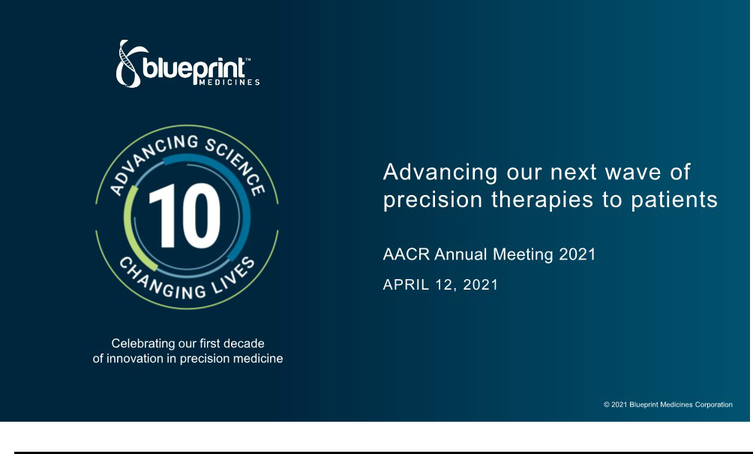

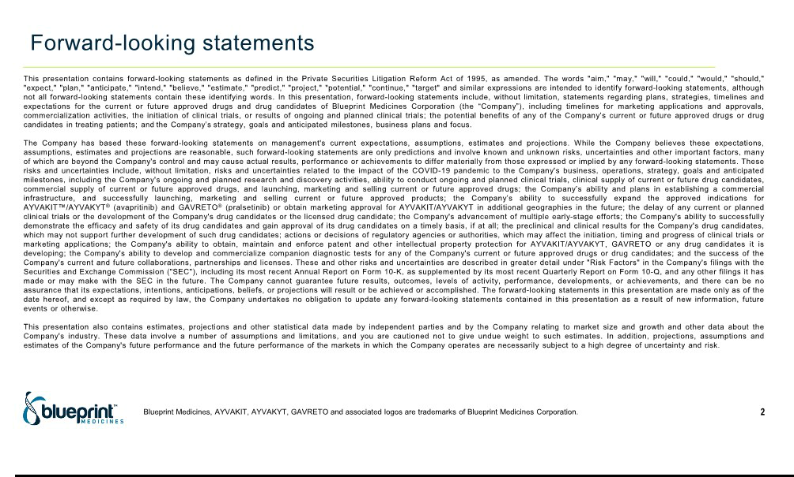

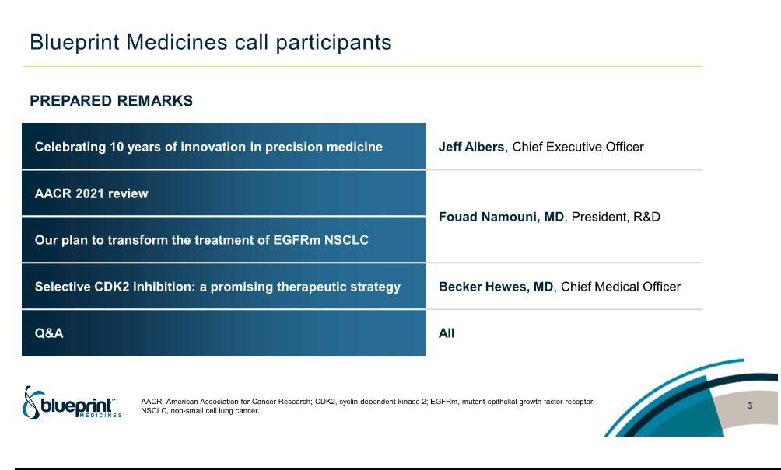

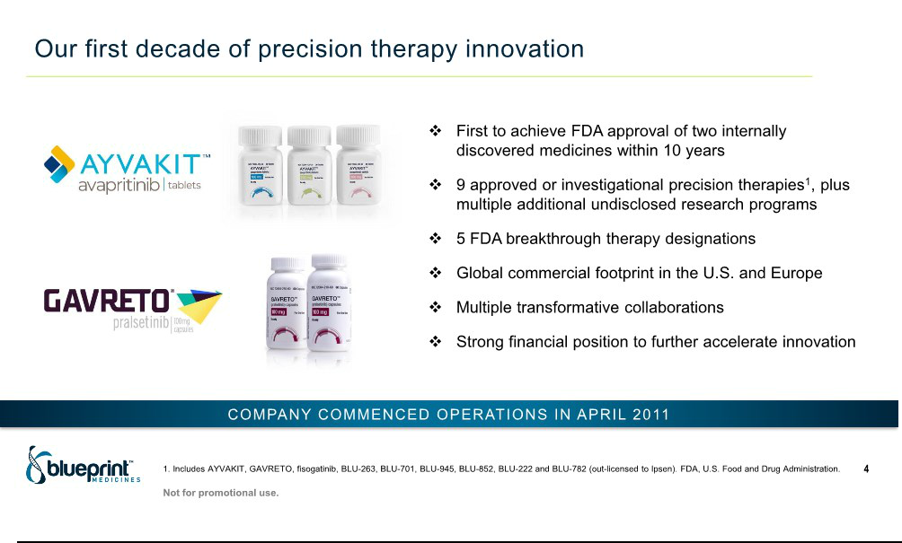

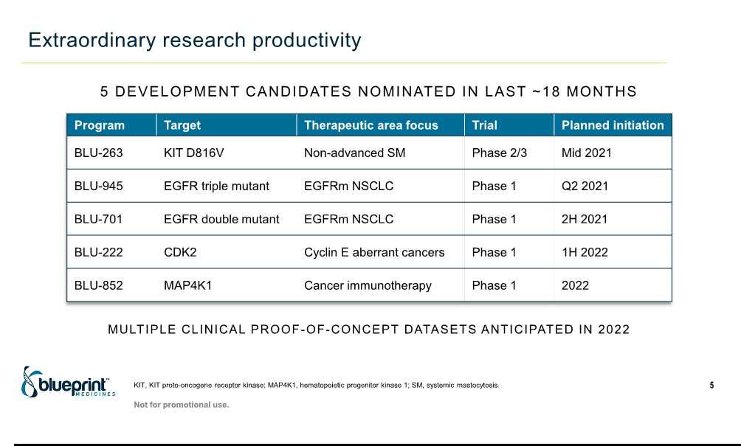

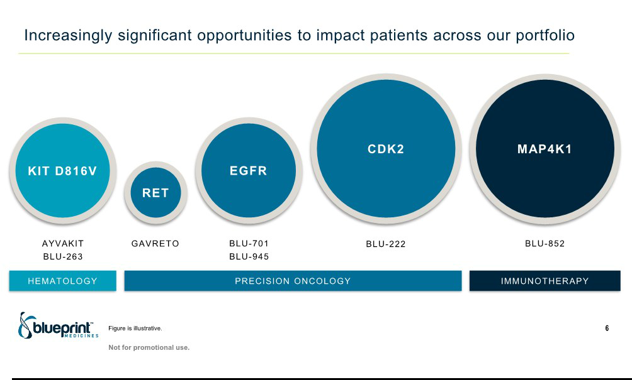

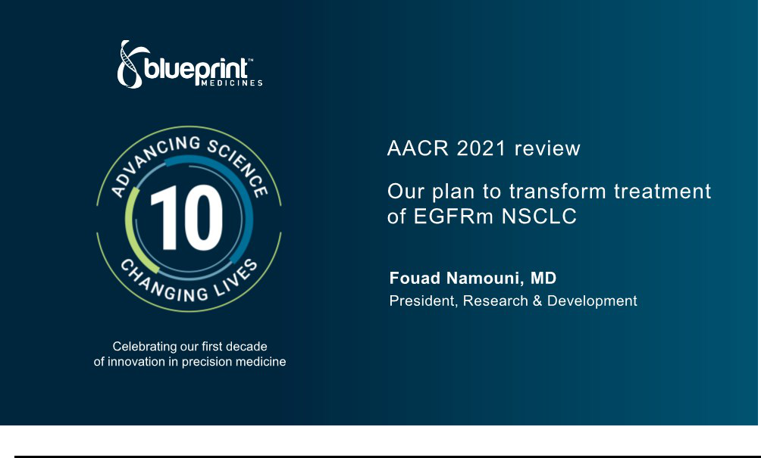

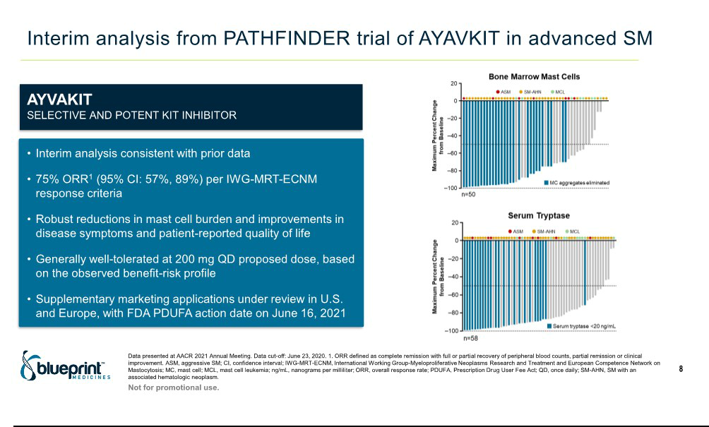

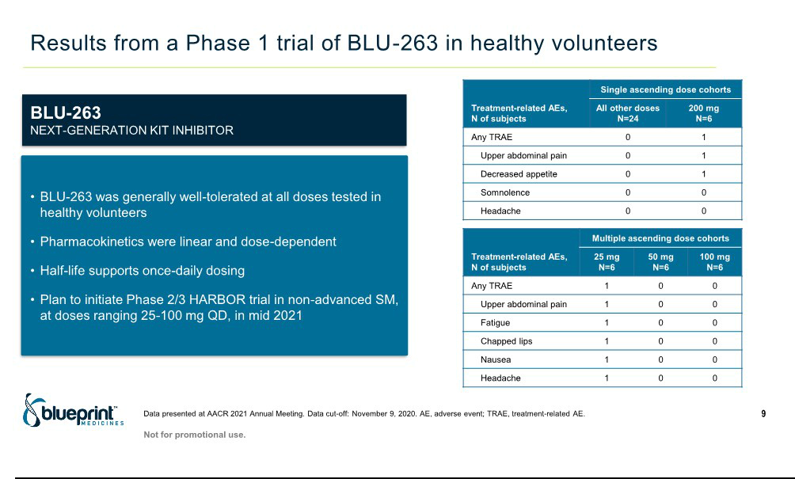

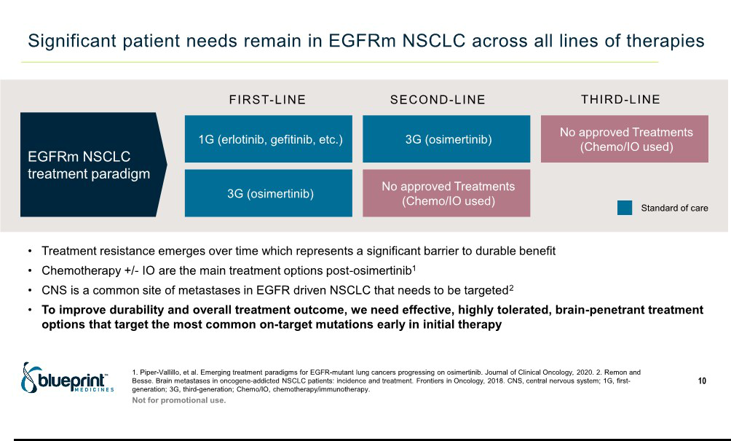

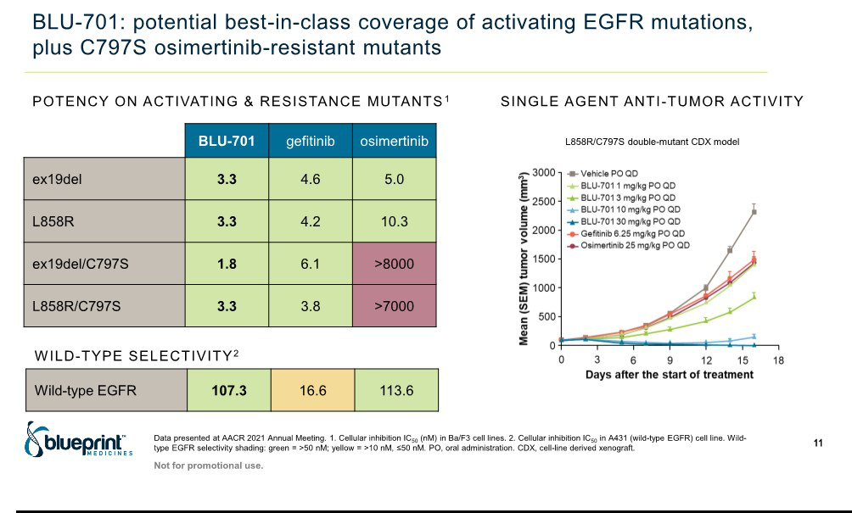

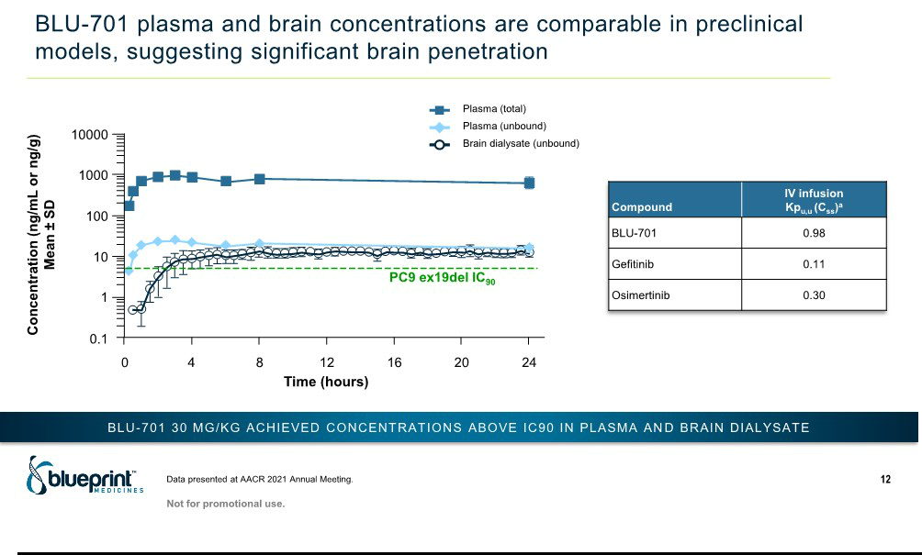

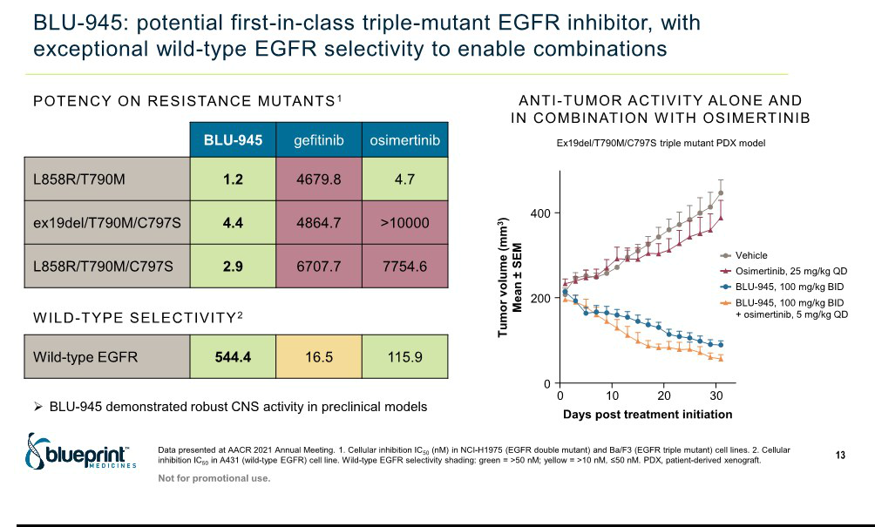

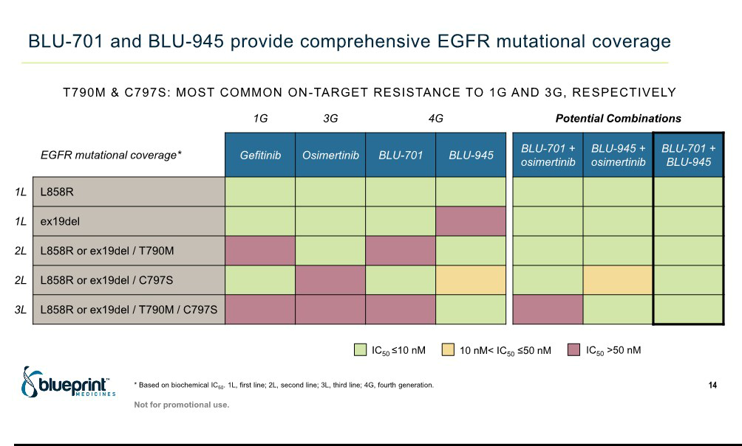

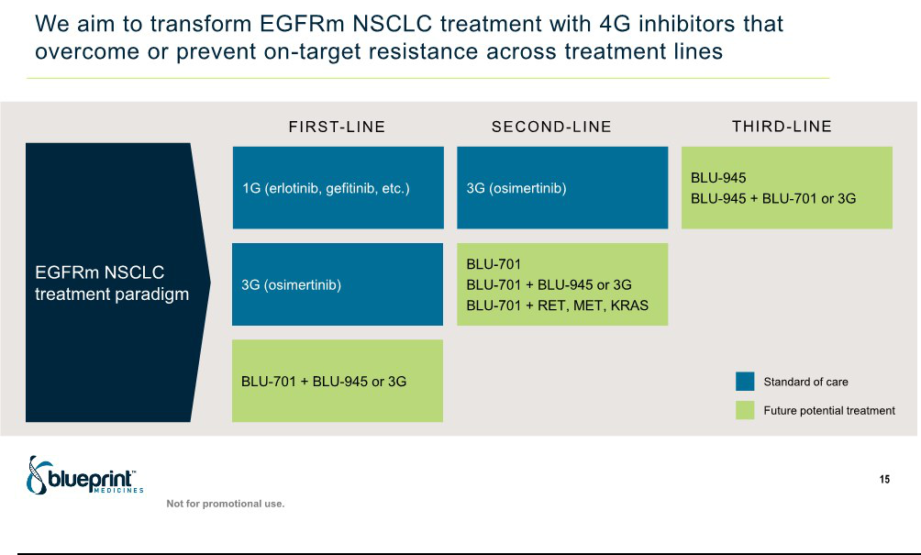

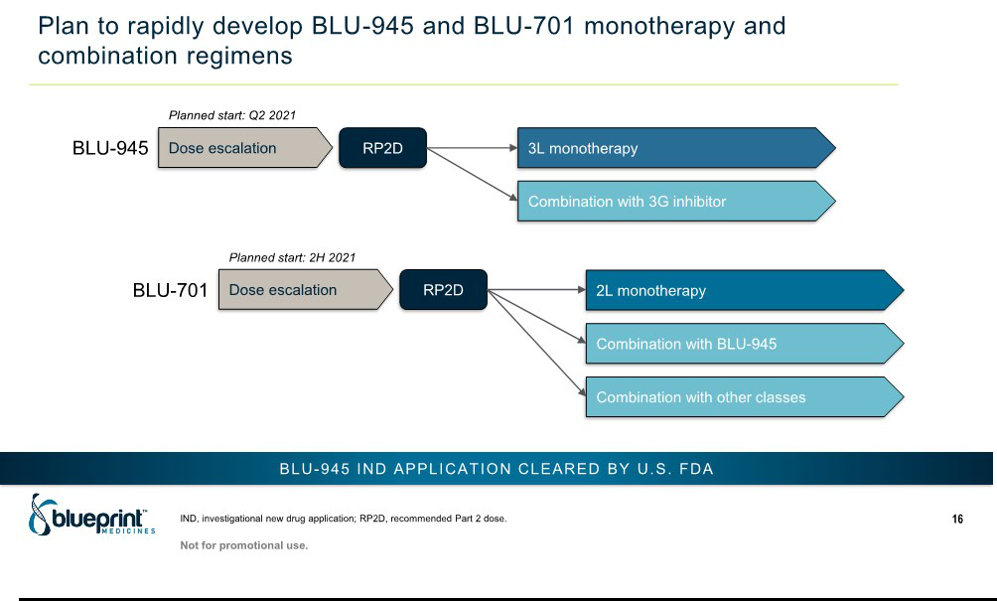

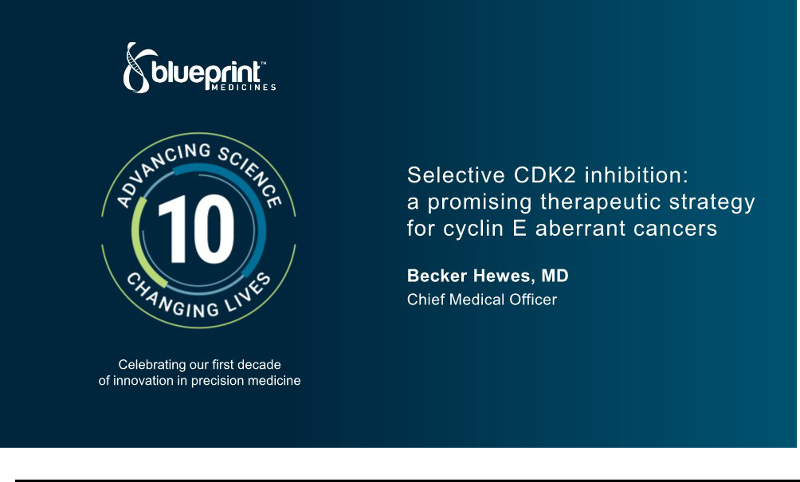

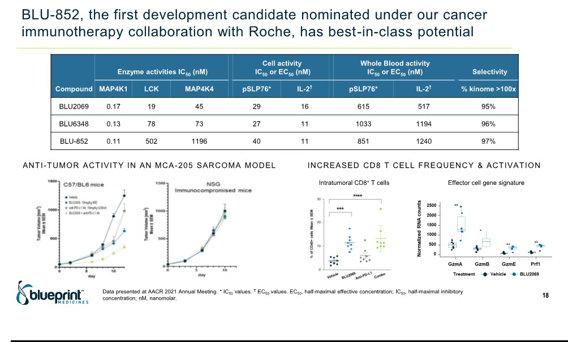

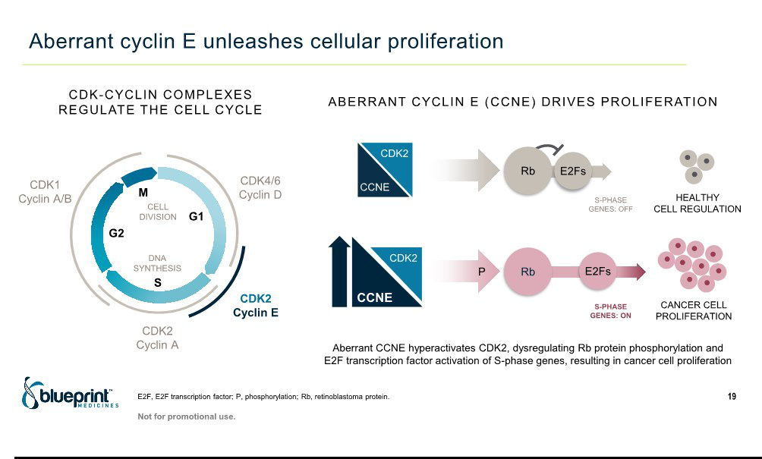

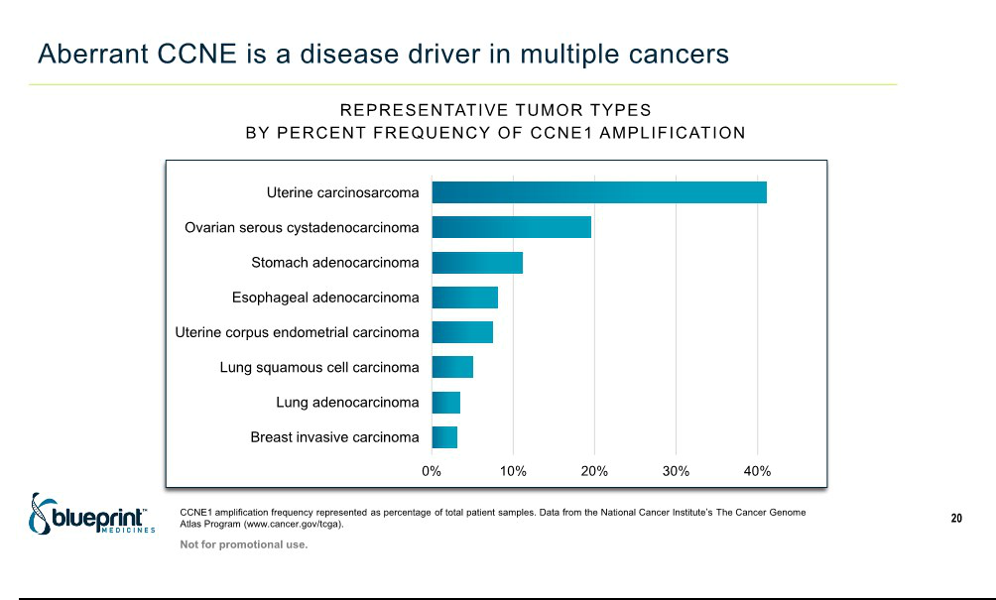

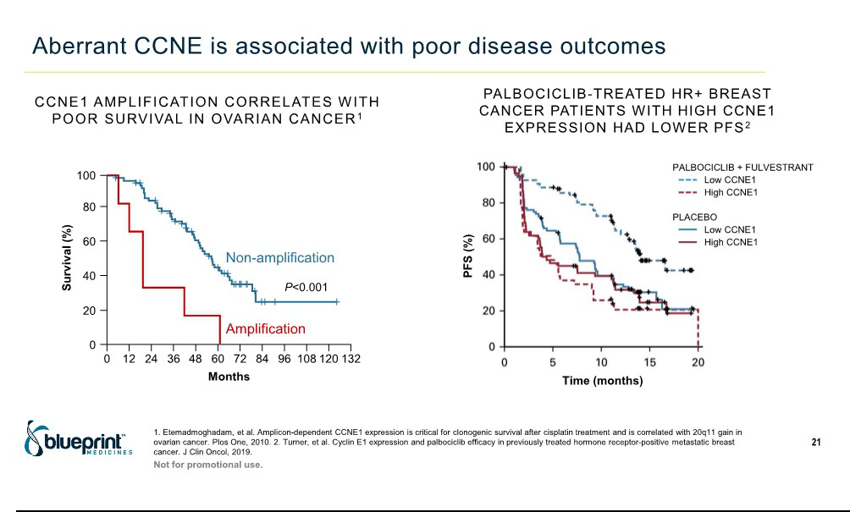

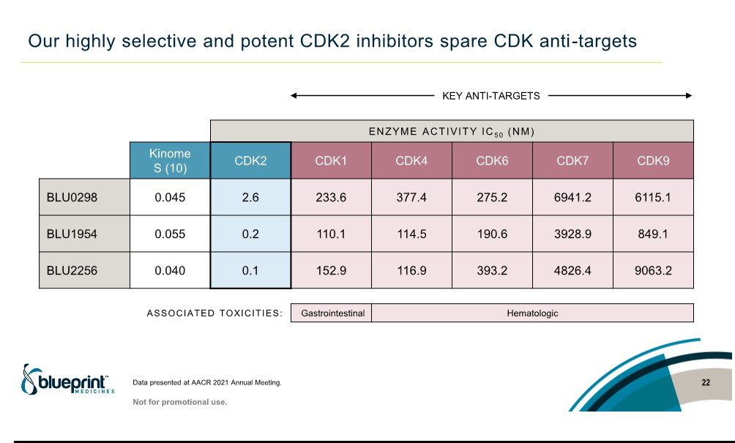

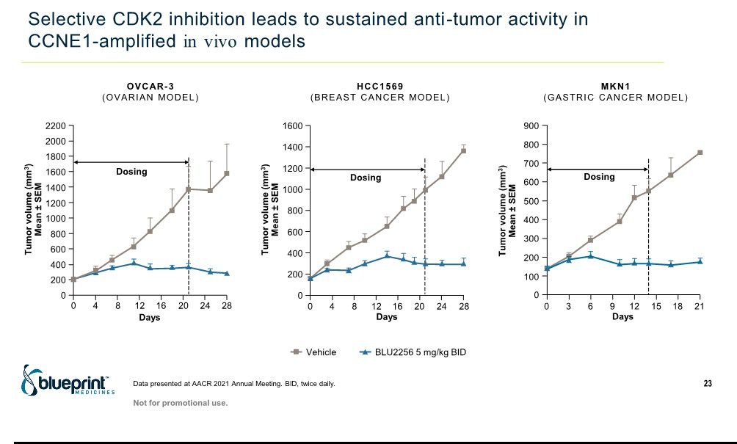

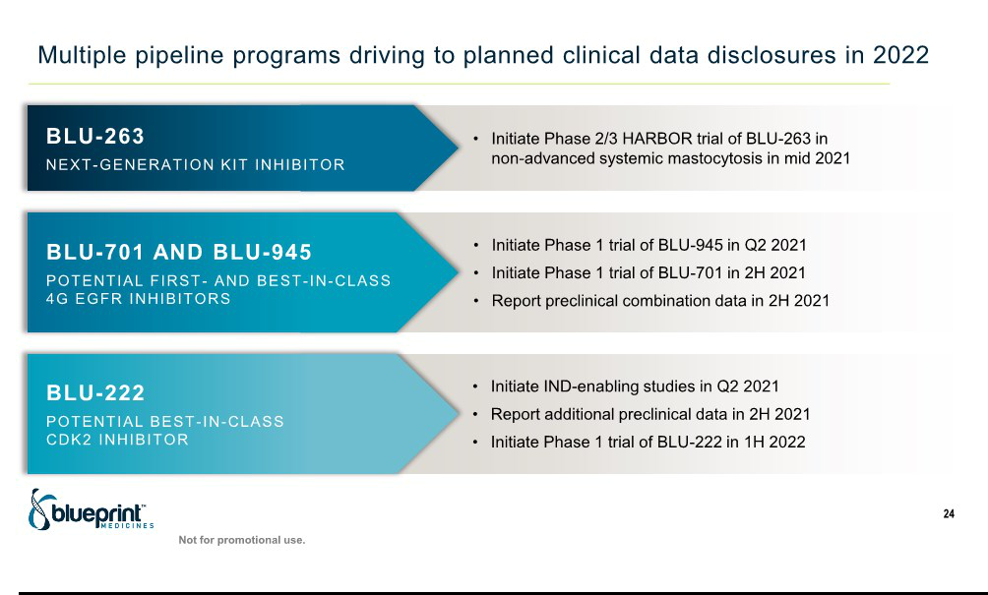

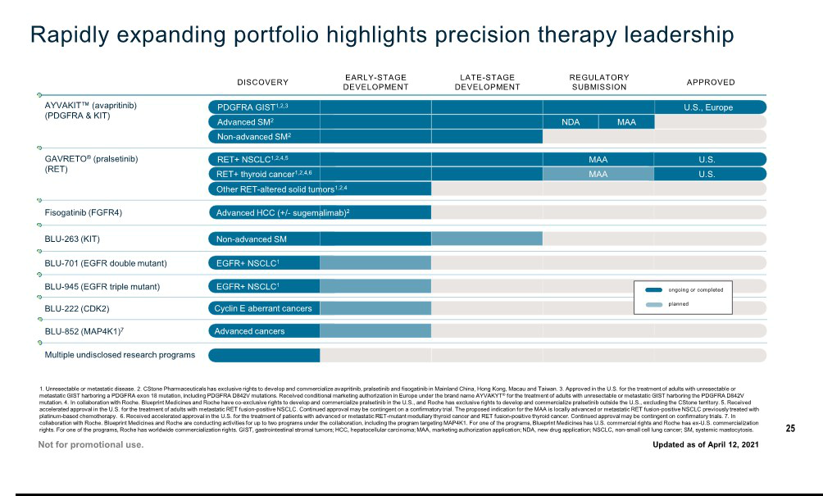

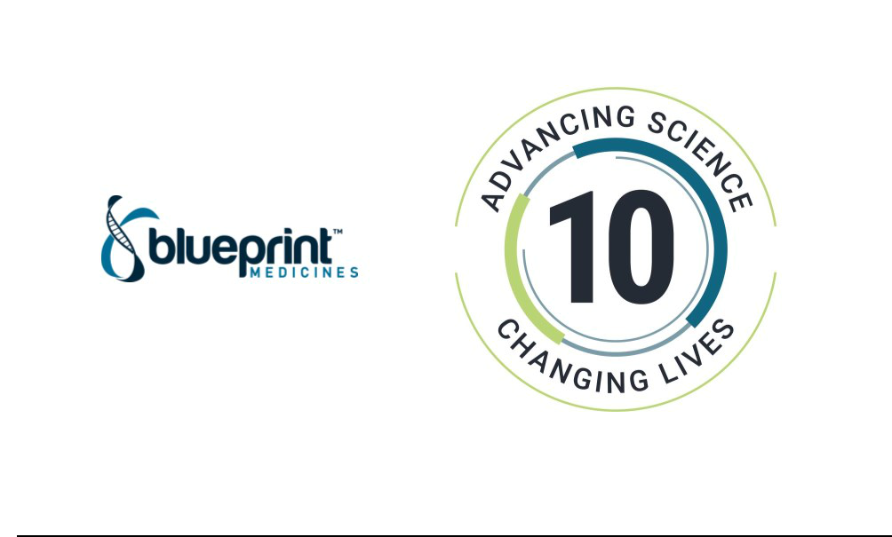

Exhibit 99.2

Blueprint Medicines Presents Preclinical Data Highlighting Broad Precision Therapy Research Pipeline

at AACR Annual Meeting 2021

-- Preclinical data presented at AACR highlight four precision therapies with first- or best-in-class potential --

-- IND application cleared by FDA for BLU-945, a triple-mutant EGFR inhibitor for EGFR-driven lung cancer --

-- Nominated BLU-222, a selective and potent CDK2 inhibitor development candidate, for cyclin E-aberrant cancers --

-- Blueprint Medicines to host investor conference call and webcast on Monday, April 12 at 8:00 a.m. ET --

CAMBRIDGE, Mass., April 10, 2021 – Blueprint Medicines Corporation (NASDAQ: BPMC) today announced data from multiple poster presentations highlighting the breadth of the company’s precision therapy pipeline at the virtual American Association for Cancer Research (AACR) Annual Meeting 2021. Collectively, the presentations, including foundational preclinical data for multiple programs, demonstrate the productivity of the company’s scientific platform. Additional presentations of clinical data for AYVAKIT™ (avapritinib) and BLU-263 will be reported on Sunday, April 11, 2021.

“Our data presentations at the AACR annual meeting showcase Blueprint Medicines’ next wave of precision therapies, which have the potential to impact large global patient populations,” said Fouad Namouni, M.D., President, Research & Development at Blueprint Medicines. “Building on the foundation of our approved medicines AYVAKIT and GAVRETO®, these presentations highlight our efforts to address significant patient needs in areas such as EGFR-driven lung cancer, cyclin E-aberrant cancers and cancer immunotherapy. As we celebrate our 10th anniversary as a company, and our rapidly expanding pipeline now includes our ninth development candidate, we look forward to continuing to leverage our productive research platform to advance potent and selective inhibitors that have the potential to enable transformative benefit for patients.”

BLU-701 and BLU-945: Double- and triple-mutant inhibitors in EGFR-driven NSCLC

Lung cancer is the leading cause of cancer death globally, and approximately 17 percent of patients with lung adenocarcinoma, the most common form of non-small cell lung cancer (NSCLC), have EGFR-driven disease. While first- and third-generation EGFR inhibitors have improved treatment outcomes for patients with EGFR-driven NSCLC, resistance inevitably emerges, with the T790M and C797S mutations being the most common on-target resistance mechanisms. Together, BLU-701 and BLU-945 are designed to provide comprehensive coverage of the most common activating and on-target resistance mutations, spare wild-type EGFR to limit toxicities driven by wild-type EGFR inhibition and treat or prevent central nervous system (CNS) metastases. Ultimately, with these characteristics, BLU-701 and BLU-945 have the potential to be used either as monotherapy or in combination, together or with other agents, to potentially overcome or prevent on-target resistance across multiple lines of treatment.

BLU-701 is a potential best-in-class, selective, potent, fourth-generation double-mutant EGFR inhibitor with activity against EGFR activating mutations and the C797S osimertinib-resistant mutation. Preclinical data presented at the conference showed strong and durable inhibition of tumor growth at doses that are EGFR wild-type sparing. BLU-701 also indicated significant CNS penetration in preclinical models, with comparable exposure in the plasma and brain, which illustrates its potential to treat or prevent CNS metastases in patients with EGFR-driven tumors. With activity also shown against the activating EGFR mutants, BLU-701 has potential to be used in both first- and second-line settings.

BLU-945 is a potential first- and best-in-class, selective, potent, fourth-generation triple-mutant EGFR inhibitor with activity against the T790M and C797S resistance mutations. BLU-945 is highly selective over wild-type EGFR and off-target kinases, highlighting its potential to enable tolerable combinations with BLU-701 or other therapies. Data presented at the conference demonstrated potent anti-tumor activity in triple-mutant osimertinib-resistant tumor models, as well as activity in a triple-mutant intracranial patient-derived xenograft model. In addition, the combination of BLU-945 with either gefitinib or osimertinib showed enhanced anti-tumor activity when compared with either gefitinib or osimertinib alone.

The preclinical data presented for BLU-701 and BLU-945 support the continued development of both candidates in patients with EGFR-driven NSCLC. An investigational new drug (IND) application for BLU-945 has been cleared by the U.S. Food and Drug Administration (FDA) and an international Phase 1 dose escalation trial is expected to begin this quarter. Future clinical development of BLU-945 in combination with other agents across multiple treatment settings is planned. BLU-701 is expected to enter clinical development later this year.

BLU-222: CDK2 inhibitor in cyclin E-aberrant cancers

Cyclin dependent kinases (CDKs) and their cyclin partners regulate the cell cycle. In subsets of patients across multiple cancer types, aberrant cyclin E (CCNE) hyperactivates CDK2, resulting in cell cycle dysregulation and tumor proliferation. Aberrant CCNE has been observed as a primary driver of disease as well as a mechanism of resistance to CDK4/6 inhibitors and other therapies. In addition, data have shown that ovarian and hormone-receptor-positive breast cancer patients with aberrant CCNE have poor outcomes. Prior drug discovery efforts targeting CDK2 have been hindered by challenges in achieving selectivity over other CDK family members associated with toxicity.

At AACR, preclinical data highlighted a set of potent and selective CDK2 inhibitors designed by Blueprint Medicines. The data showed that selective CDK2 inhibition arrested the cell cycle and blocked tumor proliferation in CCNE-amplified cell lines and demonstrated robust and sustained anti-tumor activity in vivo in models of CCNE-amplified ovarian, breast and gastric cancer. A selective CDK2 inhibitor also showed improved tolerability compared to a pan-CDK inhibitor and chemotherapy, as measured by animal body weight.

Based on this work and further optimization, Blueprint Medicines today announced the nomination of a potentially best-in-class selective and potent CDK2 inhibitor development candidate, BLU-222, which is expected to enter clinical development in the first half of 2022.

BLU-852: MAP4K1 inhibitor

MAP4K1 is a well-characterized immunokinase target involved in the regulation of immune cells; however, prior drug discovery efforts have been hindered by challenges in achieving selectivity over other MAP4K family members associated with toxicity. In January 2021, Blueprint Medicines announced the nomination of a highly selective and potent MAP4K1 inhibitor development candidate, BLU-852, with best-in-class potential.

Data presented at AACR highlighted a set of potent and highly selective MAP4K1 inhibitors designed by Blueprint Medicines, including BLU-

- The inhibitors were shown to enhance intratumoral immune cell activation, overcome T cell suppression, and reduce tumor burden both as a monotherapy and in combination with checkpoint inhibition. The data support the continued development of BLU-852 under the company’s cancer immunotherapy collaboration with Roche, with Phase 1 trial initiation anticipated in 2022.

Copies of Blueprint Medicines data presentations from the AACR annual meeting are available in the “Science—Publications and Presentations” section of the company’s website at www.BlueprintMedicines.com.

Conference Call Information

Blueprint Medicines will host a live webcast on Monday, April 12, 2021 beginning at 8:00 a.m. ET to review data for multiple research- and clinical-stage programs presented at the AACR annual meeting. To access the live call, please dial (855) 728-4793 (domestic) or (503) 343-6666 (international) and refer to conference ID 5548976. A webcast of the conference call will be available under ”Events and Presentations” in the Investors & Media section of Blueprint Medicines’ website at http://ir.blueprintmedicines.com. The archived webcast will be available on Blueprint Medicines’ website approximately two hours after the conference call and will be available for 30 days following the call.

About Blueprint Medicines

Blueprint Medicines is a global precision therapy company that invents life-changing medicines for people with cancer and hematologic disorders. Applying an approach that is both precise and agile, we create therapies that selectively target genetic drivers, with the goal of staying one step ahead across stages of disease. Since 2011, we have leveraged our research platform, including expertise in molecular targeting and world-class drug design capabilities, to rapidly and reproducibly translate science into a broad pipeline of precision therapies. Today, we are delivering our approved medicines to patients in the United States and Europe, and we are globally advancing multiple programs for genomically defined cancers, systemic mastocytosis, and cancer immunotherapy. For more information, visit www.BlueprintMedicines.com and follow us on Twitter (@BlueprintMeds) and LinkedIn.

Cautionary Note Regarding Forward-Looking Statements

This press release contains forward-looking statements within the meaning of the Private Securities Litigation Reform Act of 1995, as amended, including, without limitation, statements regarding the plans, timing, designs, implementation, enrollment and announcement of results regarding Blueprint Medicines’ ongoing and planned clinical trials for its drug candidates; the potential benefits of Blueprint Medicines’ current and future drug candidates in treating patients; and Blueprint Medicines’ strategy, goals and anticipated milestones, business plans and focus. The words “aim,” “may,” “will,” “could,” “would,” “should,” “expect,” “plan,” “anticipate,” “intend,” “believe,” “estimate,” “predict,” “project,” “potential,” “continue,” “target” and similar expressions are intended to identify forward-looking statements, although not all forward-looking statements contain these identifying words. Any forward-looking statements in this press release are based on management’s current expectations and beliefs and are subject to a number of risks, uncertainties and important factors that may cause actual events or results to differ materially from those expressed or implied by any forward-looking statements contained in this press release, including, without limitation, risks and uncertainties related to the impact of the COVID-19 pandemic to Blueprint Medicines’ business, operations, strategy, goals and anticipated milestones, including Blueprint Medicines’ ongoing and planned research and discovery activities, ability to conduct ongoing and planned clinical trials, clinical supply of current or future drug candidates, commercial supply of current or future approved products, and launching, marketing and selling current or future approved products; Blueprint Medicines’ ability and plans in establishing a commercial infrastructure, and successfully launching, marketing and selling current or future approved products, including AYVAKIT™/AYVAKYT® (avapritinib) and GAVRETO® (pralsetinib); Blueprint Medicines’ ability to successfully expand the approved indications for AYVAKIT/AYVAKYT and GAVRETO or obtain marketing approval for AYVAKIT/AYVAKYT and GAVRETO in additional geographies in the

future; the delay of any current or planned clinical trials or the development of Blueprint Medicines’ current or future drug candidates; Blueprint Medicines’ advancement of multiple early-stage efforts; Blueprint Medicines’ ability to successfully demonstrate the safety and efficacy of its drug candidates and gain approval of its drug candidates on a timely basis, if at all; the preclinical and clinical results for Blueprint Medicines’ drug candidates, which may not support further development of such drug candidates; actions of regulatory agencies, which may affect the initiation, timing and progress of clinical trials; Blueprint Medicines’ ability to develop and commercialize companion diagnostic tests for its current and future drug candidates; and the success of Blueprint Medicines’ current and future collaborations, partnerships or licensing arrangements. These and other risks and uncertainties are described in greater detail in the section entitled “Risk Factors” in Blueprint Medicines’ filings with the Securities and Exchange Commission (SEC), including Blueprint Medicines’ most recent Annual Report on Form 10-K, as supplemented by its most recent Quarterly Report on Form 10-Q and any other filings that Blueprint Medicines has made or may make with the SEC in the future. Any forward-looking statements contained in this press release represent Blueprint Medicines’ views only as of the date hereof and should not be relied upon as representing its views as of any subsequent date. Except as required by law, Blueprint Medicines explicitly disclaims any obligation to update any forward-looking statements.

Trademarks

Blueprint Medicines, AYVAKIT, AYVAKYT, GAVRETO and associated logos are trademarks of Blueprint Medicines Corporation.

Media Contact

Andrew Law

617-844-8205
media@blueprintmedicines.com

Investor Relations Contact

Kristin Hodous

617-714-6674
ir@blueprintmedicines.com

Exhibit 99.3

Blueprint Medicines Data Highlight Clinical Leadership in Systemic Mastocytosis at AACR Annual Meeting 2021

-- 75% confirmed ORR, with all responses ongoing, in PATHFINDER trial of AYVAKIT in advanced SM --

- New patient-reported outcomes data from PATHFINDER trial show AYVAKIT significantly reduced disease symptoms and improved quality of

life --

- BLU-263 was well-tolerated across all doses tested in Phase 1 healthy volunteer trial, supporting plans to initiate Phase 2/3 HARBOR trial in

non-advanced SM in mid-2021 --

  - Blueprint Medicines to host investor conference call and webcast on Monday, April 12 at 8:00 a.m. ET --

CAMBRIDGE, Mass., April 11, 2021 – Blueprint Medicines Corporation (NASDAQ: BPMC) today announced that multiple presentations across the company’s leading systemic mastocytosis (SM) program are being reported at the virtual American Association for Cancer Research (AACR) Annual Meeting 2021. The presentations focus on registrational PATHFINDER trial data of AYVAKIT™ (avapritinib) in advanced SM, PIONEER Part 1 data highlighting the impact of AYVAKIT on skin manifestations of SM, and Phase 1 trial data for BLU-263, a next-generation KIT D816V inhibitor. Blueprint Medicines is developing AYVAKIT for advanced and non-advanced SM, and BLU-263 to further address the range of patient needs in non-advanced SM and other mast cell disorders.

“Data reported at AACR reflect our commitment to transform treatment for patients living with systemic mastocytosis,” said Becker Hewes, M.D., Chief Medical Officer at Blueprint Medicines. “In the PATHFINDER trial, AYVAKIT had high response rates consistent with EXPLORER trial data, reinforcing the profound clinical benefits that can be achieved by precisely targeting the underlying driver of disease. For BLU-263, data in healthy volunteers showed a well-tolerated safety profile and support our plans to initiate the Phase 2/3 HARBOR study, which expands our development efforts into a broader population of patients with non-advanced SM. We are currently on the precipice of our first potential approval in advanced SM, and we are committed to working closely with the SM community so we may meet the needs of patients as quickly as possible.”

AYVAKIT – Highlights from the Registrational Phase 2 PATHFINDER Trial

In a pre-specified interim analysis from the PATHFINDER trial, 32 patients who primarily received a starting dose of 200 mg once daily were evaluable for response, as of a data cutoff date of June 23, 2020. Combined with Phase 1 EXPLORER trial results, these data support Blueprint Medicines’ marketing applications in advanced SM under review in the U.S. and Europe. Overall, 75 percent (95% CI: 57%, 89%) of patients had a confirmed response, which was defined as complete remission with full or partial recovery of peripheral blood counts (CR/CRh), partial remission or clinical improvement. The median time to response was two months, and all responses were ongoing at a median follow-up of 10.4 months. The CRh rate was 19 percent, with a median time to CRh of 5.6 months. These results show that responses deepened over time at a rate consistent with the EXPLORER trial.

AYVAKIT led to robust and durable benefits across a number of additional clinical activity measures. In new patient-reported outcomes data, AYVAKIT showed a statistically significant reduction in total symptom score after 40 weeks (p<0.001), as measured by the Advanced Systemic Mastocytosis Symptom Assessment Form. Treatment with AYVAKIT resulted in robust improvements in patient-reported quality of life, based on the European Organization for Research and Treatment of Cancer Quality of Life Questionnaire. Across multiple measures of mast cell burden, AYVAKIT showed profound reductions in serum tryptase, bone marrow mast cells, KIT D816V allele burden and spleen volume.

Consistent with previously disclosed data, AYVAKIT was generally well-tolerated in 62 patients enrolled in the PATHFINDER trial, and most adverse events (AEs) were reported as Grade 1 or 2. The most common AEs (≥15 percent) were peripheral edema, periorbital edema, thrombocytopenia, anemia, neutropenia, diarrhea, nausea, vomiting and fatigue. Three patients (5 percent) discontinued AYVAKIT due to treatment-related AEs, and most patients (84 percent) have remained on treatment as of the data cutoff date.

“These data reinforce the potential of avapritinib to improve the standard of care for patients with advanced systemic mastocytosis, a disease characterized by organ damage due to mast cell infiltration,” said Daniel DeAngelo, M.D., Ph.D., Chief of the Division of Leukemia at Dana-Farber Cancer Institute. “I am highly encouraged by the rapid and durable responses shown across multiple measures of mast cell burden, patient-reported symptoms as well as quality of life. Furthermore, avapritinib was generally well-tolerated, with 5 percent of patients discontinuing due to treatment-related adverse events. Since avapritinib is able to selectively target the primary driver of the disease, it has the potential to fundamentally change the outlook for patients with advanced SM.”

AYVAKIT – Statistically Significant Reductions of Aberrant CD30-Positive Mast Cells in Skin Lesions Shown in Phase 2 PIONEER Trial

In non-advanced SM, skin symptoms frequently persist and can severely impact quality of life. To assess the effects of AYVAKIT on mast cell burden in skin lesions, skin biopsies were obtained at baseline and week 12 in Part 1 of the PIONEER trial. Immunohistochemistry tests were performed to determine the proportion of aberrant mast cells in skin tissue, based on expression of CD25, CD30 and other transmembrane receptors observed in SM. Skin lesional tissue at baseline had more CD30-positive than CD25-positive mast cells. Following 12 weeks of treatment, AYVAKIT significantly reduced the proportion of aberrant CD30-positive mast cells in skin lesions compared to placebo (p=0.0082), as of a data cutoff date of December 4, 2020. These data expand on previously reported results showing the impact of AYVAKIT on skin manifestations of SM, and suggest that CD30 may be an important biomarker of aberrant mast cells in SM-related skin lesions.

BLU-263 – Safety and Pharmacokinetics Profile from Phase 1 Trial in Healthy Volunteers

A placebo-controlled, Phase 1 trial evaluated the safety, tolerability and pharmacokinetics of BLU-263 in healthy volunteers. This AACR presentation reported on single ascending dose cohorts (15 to 200 mg doses) and multiple ascending dose cohorts (25 to 100 mg once-daily doses for ten consecutive days), as of a data cutoff date of November 9, 2020. BLU-263 was well-tolerated across all doses studied, and all AEs were reported as Grade 1. Pharmacokinetic data showed dose-dependent increases in systemic exposure of BLU-263, with the half-life of BLU-263 supporting once-daily dosing. Based on these results, the company plans to evaluate BLU-263 at doses ranging from 25 to 100 mg once daily in Part 1 of the Phase 2/3 HARBOR trial in patients with non-advanced SM, which the company plans to initiate in mid-2021.

Copies of Blueprint Medicines data presentations from the AACR annual meeting are available in the “Science—Publications and Presentations” section of the company’s website at www.BlueprintMedicines.com.

Conference Call Information

Blueprint Medicines will host a live webcast on Monday, April 12, 2021 beginning at 8:00 a.m. ET to review data for multiple research- and clinical-stage programs presented at the AACR annual meeting. To access the live call, please dial (855) 728-4793 (domestic) or (503) 343-6666 (international) and refer to conference ID 5548976. A webcast of the conference call will be available under “Events and Presentations” in the Investors & Media section of Blueprint Medicines’ website at http://ir.blueprintmedicines.com. The archived webcast will be available on Blueprint Medicines’ website approximately two hours after the conference call and will be available for 30 days following the call.

About SM

SM is a rare disease driven by the KIT D816V mutation. Uncontrolled proliferation and activation of mast cells result in chronic, severe and often unpredictable symptoms for patients across the spectrum of SM. The vast majority of those affected have non-advanced (indolent or smoldering) SM, with debilitating symptoms that lead to a profound, negative impact on quality of life. A minority of patients have advanced SM, which encompasses a group of high-risk SM subtypes including aggressive SM, SM with an associated hematological neoplasm and mast cell leukemia. In addition to mast cell activation symptoms, advanced SM is associated with organ damage due to mast cell infiltration and poor survival.

Debilitating symptoms, including anaphylaxis, maculopapular rash, pruritis, diarrhea, brain fog, fatigue and bone pain, often persist across all forms of SM despite treatment with a number of symptomatic therapies. Patients often live in fear of severe, unexpected symptoms, have limited ability to work or perform daily activities, and isolate themselves to protect against unpredictable triggers. Currently, there are no approved therapies for the treatment of SM that selectively inhibit D816V mutant KIT.

About AYVAKIT (avapritinib)

AYVAKIT (avapritinib) is a kinase inhibitor approved by the U.S. Food and Drug Administration (FDA) for the treatment of adults with unresectable or metastatic gastrointestinal stromal tumors (GIST) harboring a PDGFRA exon 18 mutation, including PDGFRA D842V mutations. For more information, visit www.AYVAKIT.com. This medicine is approved in Europe under the brand name AYVAKYT® for the treatment of adults with unresectable or metastatic GIST harboring the PDGFRA D842V mutation, and in China for the treatment of adults with unresectable or metastatic PDGFRA exon 18 mutant GIST.

AYVAKIT/AYVAKYT is not approved for the treatment of any other indication, including SM, in the U.S. by the FDA, in Europe by the European Commission or in China by the National Medical Products Administration, or for any indication in any other jurisdiction by any other health authority.

Blueprint Medicines is developing AYVAKIT globally for the treatment of advanced and non-advanced SM. The FDA granted breakthrough therapy designation to AYVAKIT for the treatment of advanced SM, including the subtypes of aggressive SM, SM with an associated hematological neoplasm and mast cell leukemia, and for the treatment of moderate to severe indolent SM.

To learn about ongoing or planned clinical trials, contact Blueprint Medicines at medinfo@blueprintmedicines.com or 1-888-BLU-PRNT (1-888-258-7768). Additional information is available at www.pioneertrial.com or www.clinicaltrials.gov.

Blueprint Medicines has an exclusive collaboration and license agreement with CStone Pharmaceuticals for the development and commercialization of AYVAKIT in Mainland China, Hong Kong, Macau and Taiwan. Blueprint Medicines retains development and commercial rights for AYVAKIT in the rest of the world.

About BLU-263

BLU-263, a next-generation KIT D816V inhibitor, has the potential to expand the reach of KIT D816V-targeted therapy to a broad population of patients with non-advanced SM and related mast cell disorders. BLU-263 was designed to target D816V mutant KIT with similar sub-nanomolar potency as AYVAKIT, enhanced selectivity and minimal central nervous system penetration. BLU-263 was developed based on learnings from the AYVAKIT clinical program. The initial focus of the BLU-263 development program is non-advanced SM.

About Blueprint Medicines

Blueprint Medicines is a global precision therapy company that invents life-changing medicines for people with cancer and hematologic disorders. Applying an approach that is both precise and agile, we create therapies that selectively target genetic drivers, with the goal of staying one step ahead across stages of disease. Since 2011, we have leveraged our research platform, including expertise in molecular targeting and world-class drug design capabilities, to rapidly and reproducibly translate science into a broad pipeline of precision therapies. Today, we are delivering our approved medicines to patients in the United States and Europe, and we are globally advancing multiple programs for genomically defined cancers, systemic mastocytosis, and cancer immunotherapy. For more information, visit www.BlueprintMedicines.com and follow us on Twitter (@BlueprintMeds) and LinkedIn.

Cautionary Note Regarding Forward-Looking Statements

This press release contains forward-looking statements within the meaning of the Private Securities Litigation Reform Act of 1995, as amended, including, without limitation, statements regarding plans, timelines and expectations for interactions with the FDA and other regulatory authorities; the plans, timing, designs, implementation, enrollment and announcement of results regarding Blueprint Medicines’ ongoing and planned clinical trials for its drug candidates, including AYVAKIT and BLU-263; expectations regarding the potential benefits of AYVAKIT and BLU-263 in treating patients with SM; and Blueprint Medicines’ strategy, goals and anticipated milestones, business plans and focus. The words “aim,” “may,” “will,” “could,” “would,” “should,” “expect,” “plan,” “anticipate,” “intend,” “believe,” “estimate,” “predict,” “project,” “potential,” “continue,” “target” and similar expressions are intended to identify forward-looking statements, although not all forward-looking statements contain these identifying words. Any forward-looking statements in this press release are based on management’s current expectations and beliefs and are subject to a number of risks, uncertainties and important factors that may cause actual events or results to differ materially from those expressed or implied by any forward-looking statements contained in this press release, including, without limitation, risks and uncertainties related to the impact of the COVID-19 pandemic to Blueprint Medicines’ business, operations, strategy, goals and anticipated milestones, including Blueprint Medicines’ ongoing and planned research and discovery activities, ability to conduct ongoing and planned clinical trials, clinical supply of current or future drug candidates, commercial supply of current or future approved products, and launching, marketing and selling current or future approved products; Blueprint Medicines’ ability and plans in establishing a commercial infrastructure, and successfully launching, marketing and selling current or future approved products, including AYVAKIT and GAVRETO® (pralsetinib); Blueprint Medicines’ ability to successfully expand the approved indications for AYVAKIT and GAVRETO or obtain marketing approval for AYVAKIT and GAVRETO in additional geographies in

the future; the delay of any current or planned clinical trials or the development of Blueprint Medicines’ current or future drug candidates; Blueprint Medicines’ advancement of multiple early-stage efforts; Blueprint Medicines’ ability to successfully demonstrate the safety and efficacy of its drug candidates and gain approval of its drug candidates on a timely basis, if at all; the preclinical and clinical results for Blueprint Medicines’ drug candidates, which may not support further development of such drug candidates; actions of regulatory agencies, which may affect the initiation, timing and progress of clinical trials; Blueprint Medicines’ ability to develop and commercialize companion diagnostic tests for its current and future drug candidates; and the success of Blueprint Medicines’ current and future collaborations, partnerships or licensing arrangements. These and other risks and uncertainties are described in greater detail in the section entitled “Risk Factors” in Blueprint Medicines’ filings with the Securities and Exchange Commission (SEC), including Blueprint Medicines’ most recent Annual Report on Form 10-K, as supplemented by its most recent Quarterly Report on Form 10-Q and any other filings that Blueprint Medicines has made or may make with the SEC in the future. Any forward-looking statements contained in this press release represent Blueprint Medicines’ views only as of the date hereof and should not be relied upon as representing its views as of any subsequent date. Except as required by law, Blueprint Medicines explicitly disclaims any obligation to update any forward-looking statements.

Trademarks

Blueprint Medicines, AYVAKIT, AYVAKYT, GAVRETO and associated logos are trademarks of Blueprint Medicines Corporation.

Media Contact

Andrew Law

617-844-8205
media@blueprintmedicines.com

Investor Relations Contact

Kristin Hodous

617-714-6674
ir@blueprintmedicines.com

