UNITED STATES

SECURITIES AND EXCHANGE COMMISSION

Washington, D.C. 20549

FORM 8-K

CURRENT REPORT

Pursuant to Section 13 or 15(d)
of the Securities Exchange Act of 1934

Date of Report (Date of Earliest Event Reported): June 5, 2017

Blueprint Medicines Corporation

(Exact name of registrant as specified in its charter)

Delaware

(State or other jurisdiction

of incorporation)

001-37359

(Commission File Number)

26-3632015

(I.R.S. Employer

Identification No.)

38 Sidney Street, Suite 200

Cambridge, Massachusetts

(Address of principal executive offices)

02139

(Zip Code)

Registrant’s telephone number, including area code: (617) 374-7580

(Former name or former address, if changed since last report)

Check the appropriate box below if the Form 8-K filing is intended to simultaneously satisfy the filing obligation of the registrant under any of the following provisions:

- Written communications pursuant to Rule 425 under the Securities Act (17 CFR 230.425)

- Soliciting material pursuant to Rule 14a-12 under the Exchange Act (17 CFR 240.14a-12)

- Pre-commencement communications pursuant to Rule 14d-2(b) under the Exchange Act (17 CFR 240.14d-2(b))

- Pre-commencement communications pursuant to Rule 13e-4(c) under the Exchange Act (17 CFR 240.13e-4(c))

Indicate by check mark whether the registrant is an emerging growth company as defined in Rule 405 of the Securities Act of 1933 (§230.405 of this chapter) or Rule 12b-2 of the Securities Exchange Act of 1934 (§240.12b-2 of this chapter).

Emerging growth company ☑

If an emerging growth company, indicate by check mark if the registrant has elected not to use the extended transition period for complying with any new or revised financial accounting standards provided pursuant to Section 13(a) of the Exchange Act. ☑

Item 7.01 Regulation FD Disclosure.

On June 5, 2017, Blueprint Medicines Corporation (the “Company”) issued a press release announcing new data from its ongoing Phase 1 clinical trial evaluating BLU-285 for the treatment of advanced gastrointestinal stromal tumors (“GIST”). The press release also announced that the U.S. Food and Drug Administration has granted Breakthrough Therapy Designation to BLU-285 for the treatment of patients with unresectable or metastatic GIST harboring the PDGFRα D842V mutation. The data were presented on Monday, June 5, 2017 in an oral presentation at the 2017 American Society of Clinical Oncology (“ASCO”) Annual Meeting in Chicago, Illinois. A copy of the press release is furnished as Exhibit 99.1 to this Current Report on Form 8-K, and a copy of the presentation at the ASCO Annual Meeting is furnished as Exhibit 99.2 to this Current Report on Form 8-K.

In addition, on June 5, 2017, the Company hosted an investor event and live webcast to discuss the data presented at the ASCO Annual Meeting. A copy of the presentation from the investor event is furnished as Exhibit 99.3 to this Current Report on Form 8-K.

The information in Item 7.01 of this Current Report on Form 8-K, including Exhibits 99.1, 99.2 and 99.3, is intended to be furnished and shall not be deemed “filed” for purposes of Section 18 of the Securities Exchange Act of 1934, as amended (the “Exchange Act”), or otherwise subject to the liabilities of that section, nor shall it be deemed incorporated by reference in any filing under the Securities Act of 1933, as amended, or the Exchange Act, except as expressly set forth by specific reference in such filing.

Item 9.01 |  | Financial Statements and Exhibits.
(d) Exhibits.
 | Exhibit No. |  |  | Description
 | 99.1 |  |  | Press release issued by Blueprint Medicines Corporation on June 5, 2017
99.2 |  |  |  | Presentation by Blueprint Medicines Corporation at the ASCO Annual Meeting on June 5, 2017
99.3 |  |  |  | Presentation by Blueprint Medicines Corporation at investor event on June 5, 2017
 |  | 2

SIGNATURES

Pursuant to the requirements of the Securities Exchange Act of 1934, the registrant has duly caused this report to be signed on its behalf by the undersigned hereunto duly authorized.

 |  | BLUEPRINT MEDICINES CORPORATION
Date: June 6, 2017 |  | By: /s/ Tracey L. McCain
 |  |  | Tracey L. McCain
 |  |  | Chief Legal Officer
 |  | 3

 |  | EXHIBIT INDEX
Exhibit No. |  | Description
99.1 |  | Press release issued by Blueprint Medicines Corporation on June 5, 2017
99.2 |  | Presentation by Blueprint Medicines Corporation at the ASCO Annual Meeting on June 5, 2017
99.3 |  | Presentation by Blueprint Medicines Corporation at investor event on June 5, 2017
 |  | 4

Exhibit 99.1


Blueprint Medicines Announces New Phase 1 Clinical Data for BLU-285 in Advanced Gastrointestinal Stromal Tumors and Plans to Pursue Expedited Development in Patients with a PDGFRα D842V Mutation

– BLU-285 receives Breakthrough Therapy Designation for the treatment of patients with unresectable or metastatic

GIST harboring the PDGFRα D842V mutation –
– Encouraging clinical activity demonstrated in multiple GIST patient populations, including preliminary evidence of
prolonged progression free survival –
– Blueprint Medicines to host investor event and webcast on Monday, June 5, 2017 –

CAMBRIDGE, Mass., June 5, 2017 /PRNewswire/ – Blueprint Medicines Corporation (NASDAQ:BPMC), a leader in discovering and developing targeted kinase medicines for patients with genomically defined diseases, today announced new Phase 1 clinical data and outlined registration plans for BLU-285, a potent and highly selective PDGFRα and KIT inhibitor in development as a potential treatment for patients with advanced gastrointestinal stromal tumors (GIST). In patients with PDGFRα-driven GIST harboring a D842 mutation, the data showed an objective response rate (ORR) of 60 percent and an estimated 9-month progression free survival (PFS) of 87 percent. Among patients with treatment-resistant KIT-driven GIST, tumor reduction was observed in eight of 14 evaluable patients treated at dose levels of at least 300 mg once daily (QD). BLU-285 was well tolerated, and most adverse events (AEs) reported by investigators were Grade 1 or 2. The data will be presented today in an oral presentation during the “GIST: Imatinib and Beyond” session from 1:15 to 2:45 p.m. CT (Abstract 11011) at the 2017 ASCO Annual Meeting in Chicago.

Blueprint Medicines also announced today that the U.S. Food and Drug Administration (FDA) granted Breakthrough Therapy Designation to BLU-285 for the treatment of patients with unresectable or metastatic PDGFRα D842V-driven GIST, and the Company plans to pursue expedited development of BLU-285 in this population. Based on feedback from the FDA at a recent End-of-Phase 1 meeting, additional data from the expansion portion of the ongoing Phase 1 clinical trial of BLU-285 may be sufficient to support a New Drug Application (NDA) for the treatment of patients with PDGFRα D842V-driven GIST. Blueprint Medicines currently estimates it will complete enrollment of the PDGFRα D842V expansion cohort, which is expected to include approximately 50 patients, by the middle of 2018. The Company also plans to initiate a global, pivotal Phase 3 clinical trial of BLU-285 in the first half of 2018, with the goal of supporting the registration of BLU-285 in a broader GIST patient population.

“Advanced GIST is a devastating disease marked by rapid disease progression, and patients with PDGFRα-driven GIST and treatment-resistant KIT-driven GIST have limited or no effective treatments,” said Michael Heinrich, M.D., Oregon Health & Science University, an investigator on the clinical trial. “The new data announced today reinforce the clinical potential of BLU-285 in these populations. High response rates and prolonged progression free survival suggest BLU-285 has the potential to transform the treatment of PDGFRα D842-driven GIST. In addition, BLU-285 showed very encouraging anti-tumor activity in the treatment-resistant KIT-driven GIST population with a complex mutational burden, for whom disease control is a major treatment goal. Together, these results support efforts to expand the clinical development of BLU-285, including into earlier lines of GIST treatment."

“Blueprint Medicines is committed to advancing BLU-285 as swiftly as possible with the goal of addressing the significant medical need in advanced GIST,” said Andy Boral, M.D., Chief Medical Officer at Blueprint Medicines. “Based on the updated BLU-285 clinical data and our recent interactions with the FDA, we believe we have paths forward in PDGFRα D842-driven GIST and treatment-resistant KIT-driven GIST. Importantly, the FDA is open to considering additional data from our ongoing Phase 1 clinical study as the basis for an NDA for BLU-285 in PDGFRα D842V-driven GIST. These developments bring us closer to achieving our vision of rapidly delivering targeted kinase medicines to patients with genomically defined diseases.”

New Data from the Ongoing Phase 1 Clinical Trial of BLU-285 in Advanced GIST

BLU-285 is currently being evaluated in a Phase 1 clinical trial in patients with unresectable PDGFRα-driven GIST and patients with treatment-resistant KIT-driven GIST. Following completion of the dose escalation portion of the trial and determination of the maximum tolerated dose (MTD), Blueprint Medicines initiated the expansion portion of the trial in the first quarter of 2017.

As of the data cutoff date of April 28, 2017, 72 patients had been treated with BLU-285 in the dose escalation and expansion portions of the Phase 1 clinical trial, at eight dose levels (ranging from 30 mg QD to 600 mg QD), including 32 patients with PDGFRα-driven GIST and 40 patients with KIT-driven GIST. The median number of prior tyrosine-kinase inhibitor (TKI) regimens was 1.5 for patients with PDGFRα-driven GIST (ranging from zero to six), and four for patients with KIT-driven GIST (ranging from two to 11). Among patients with KIT-driven GIST, 36 patients (90 percent) had been treated with at least three prior TKI regimens, including 34 patients (85 percent) who had been previously treated with regorafenib.

Pharmacokinetic (PK) data demonstrated a mean half-life of more than 24 hours, supporting a once-daily dosing regimen. Consistent with previously reported preclinical data, PK data from the ongoing clinical trial suggested that exposure at dose levels ranging from 300 to 400 mg QD confers activity against a broad spectrum of disease-driving mutations.

Safety Data

As of the data cutoff date, BLU-285 was observed to be well-tolerated. Most AEs reported by investigators were Grade 1 or 2. Across all grades, AEs reported by investigators most commonly included nausea (60 percent), fatigue (53 percent), vomiting (42 percent), periorbital edema (36 percent), diarrhea (33 percent), and peripheral edema (31 percent). Investigators reported treatment-related Grade ≥3 AEs in 18 patients (25 percent). Grade ≥3 AEs occurring in two or more patients included fatigue, hypophosphatemia, anemia, nausea, vomiting and hyperbilirubinemia. Two patients experienced dose-limiting toxicities at 600 mg QD (Grade 2 hyperbilirubinemia in one patient; Grade 2 rash, Grade 2 hypertension and Grade 2 memory impairment all in one patient), leading to the determination of 400 mg QD as the MTD. Only one patient discontinued treatment with BLU-285 due to a drug-related toxicity (Grade 3 hyperbilirubinemia). An additional 20 patients discontinued treatment, including 19 patients due to progressive disease and one patient due to the investigator’s decision. Among all 72 enrolled patients, 51 remained on the trial as of the data cutoff date.

Clinical Activity Data

As of the data cutoff date, 26 patients with PDGFRα-driven GIST were evaluable for response assessment, including 23 patients with a D842V mutation, two patients with other D842 mutations, and one patient

with an exon 14 mutation who was excluded from analyses of clinical activity. In addition, 25 patients with KIT-driven GIST were evaluable for response assessment. Patients were evaluable if they had at least one centrally reviewed radiographic scan, and all reported data are based on blinded central radiographic review as per Response Evaluation Criteria in Solid Tumors (RECIST) version 1.1. Radiographic scans were also assessed by Choi criteria, a supportive method of response assessment in soft tissue sarcoma. An additional 21 enrolled patients had not been evaluated for response by the data cutoff date.

PDGFRα D842-driven GIST

·Radiographic tumor reductions were observed in 25 of 25 evaluable patients with PDGFRα D842-driven GIST. ·By RECIST criteria, 15 patients had a partial response (PR) (12 confirmed, three pending confirmation), and 10 patients had stable disease (SD), representing a preliminary objective response rate (ORR) of 60 percent and a disease control rate (DCR) of 100 percent.
·By Choi criteria, 25 patients had a PR, representing an ORR of 100 percent.

·Median PFS was not reached and 9-month PFS was estimated to be 87 percent. In contrast, historical data showed a zero percent ORR and median PFS of 2.8 months in patients with PDGFRα D842V–driven GIST treated with imatinib.¹

Treatment-resistant KIT-driven GIST

·Radiographic tumor reductions were observed in 10 of 25 evaluable patients, including patients with complex genotypes involving primary and secondary KIT mutations (e.g., mutations in exons 8, 9, 11, 13, 17 and 18).
·In patients treated at dose levels of at least 300 mg QD, eight of 14 patients had tumor reductions per RECIST, including one patient who achieved a PR.
·By RECIST criteria, two patients had a PR (one confirmed, one pending confirmation), and 12 patients had SD, representing a preliminary ORR of eight percent and a DCR of 56 percent.
·By Choi criteria, eight patients had a PR, and six patients had SD, representing a preliminary ORR of 32 percent and a DCR of 56 percent.
·Median PFS among patients treated at dose levels of at least 300 mg QD was 9.3 months. In contrast, historical data showed a zero percent ORR and median PFS of 1.8 months in patients with TKI-resistant advanced GIST re-treated with imatinib in a third-line or later setting.²

Investor Event and Webcast Information

Blueprint Medicines will host an investor event on Monday, June 5, 2017 beginning at 6:00 p.m. CT (7:00 p.m. ET) in Chicago to review the updated clinical data for BLU-285 in GIST. Formal presentations and the live webcast will begin at 6:30 p.m. CT (7:30 p.m. ET). The event can be accessed by dialing 1-855-728-4793 (domestic) or 1-503-343-6666 (international) and providing the passcode 13676007. A live webcast will also be available under “Events & Presentations” in the Investors section of Blueprint Medicines’ website at http://ir.blueprintmedicines.com. The archived webcast will be available on Blueprint Medicines’ website approximately two hours after the event concludes and will be available for 30 days following the event.

Informational Webinar for the GIST Patient Community

Blueprint Medicines will host an informational webinar for the GIST patient community on Thursday, June 22, 2017 beginning at 12:00 p.m. ET. To participate in the webinar, please dial 1-855-880-1246 (domestic) or 1-408-638-0968 (international) and refer to webinar ID 855 846 509. A live webcast of the presentation will be available at www.blueprintmedicines.com in the “Patients” section of Blueprint Medicines’ website under “Patient Community Events.” The archived webcast will be available on Blueprint Medicines’ website approximately one day after the webinar and will be available for 30 days following the webinar.

About the Phase 1 Clinical Trial for BLU-285 in PDGFRα-Driven and KIT-Driven GIST

The Phase 1 clinical trial of BLU-285 is designed to evaluate the safety and tolerability of BLU-285 in adults with advanced GIST. The trial consists of two parts, a dose-escalation portion and an expansion portion. The dose-escalation portion is complete, and the MTD has been determined to be 400 mg QD. The expansion portion is actively enrolling patients in two defined cohorts, including a cohort of patients with a PDGFRα D842V mutation, regardless of line of therapy, and a cohort of patients who have received imatinib and at least one other KIT-directed TKI. Trial objectives include assessing response, pharmacokinetics and pharmacodynamic measures. The two expansion cohorts of the trial are designed to enroll approximately 100 patients at multiple sites in the United States, United Kingdom and European Union. Please refer to www.clinicaltrials.gov for additional details related to this Phase 1 clinical trial (NCT02508532). Patients and physicians may contact the study director for more information about this Phase 1 clinical trial at studydirector@blueprintmedicines.com.

About GIST

GIST is the most common sarcoma, or tumor of bone or connective tissue, of the gastrointestinal (GI) tract. Tumors arise from cells in the wall of the GI tract and occur most often in the stomach or small intestine. Most patients are diagnosed between the ages of 50-80, and diagnosis is typically triggered by GI bleeding, incidental findings during surgery or imaging and, in rare cases, tumor rupture or GI obstruction. Approximately 80 percent of GIST patients have KIT-driven GIST, and Blueprint Medicines estimates that KIT exon 17 mutations occur in approximately 90 percent of GIST patients with KIT-driven GIST following treatment with at least two TKIs. Approximately five percent of all advanced GIST cases are driven by D842V mutant PDGFRα. Patients diagnosed with GIST at an early stage may undergo surgery. For patients with KIT-driven GIST, treatment with the currently approved frontline therapy typically leads to treatment resistance and disease progression. Treatment options for KIT-driven GIST patients whose disease progresses or develops resistance are currently limited, with approved therapies providing a progression free survival of up to six months and a response rate between five percent and seven percent. There are no effective treatment options for patients with PDGFRα D842V-driven GIST, and progression often occurs in as little as three months with available treatment options.

About BLU-285

BLU-285 is an orally available, potent and highly selective inhibitor of PDGFRα and KIT. Preclinical data have shown that BLU-285 is active across a broad spectrum of PDGFRα and KIT mutations, including PDGFRα D842V and KIT exon 17 mutations for which there are limited or no effective treatment options. Blueprint Medicines is initially developing BLU-285, an investigational medicine, for the treatment of patients with advanced GIST and advanced systemic mastocytosis. BLU-285 was discovered by Blueprint

Medicines’ research team leveraging its proprietary compound library, and the Company retains worldwide development and commercialization rights for BLU-285.

In June 2017, BLU-285 received Breakthrough Therapy Designation from the U.S. Food and Drug Administration (FDA) for the treatment of patients with unresectable or metastatic GIST harboring the PDGFRα D842V mutation. The FDA’s Breakthrough Therapy Designation is intended to expedite the development and review of a drug candidate intended to treat a serious or life-threatening disease or condition, when preliminary clinical evidence indicates that the drug candidate may demonstrate substantial improvement over existing therapies on one or more clinically significant endpoints. Previously, the FDA granted orphan drug designation to BLU-285 for the treatment of GIST. The FDA also granted Fast Track designation to BLU-285 for the treatment of patients with unresectable or metastatic GIST that progressed following treatment with imatinib and a second TKI and for the treatment of patients with unresectable or metastatic GIST in patients with the PDGFRα D842V mutation regardless of prior therapy.

About Blueprint Medicines

Blueprint Medicines is developing a new generation of targeted and potent kinase medicines to improve the lives of patients with genomically defined diseases. Its approach is rooted in a deep understanding of the genetic blueprint of cancer and other diseases driven by the abnormal activation of kinases. Blueprint Medicines is advancing four programs in clinical development for subsets of patients with gastrointestinal stromal tumors, hepatocellular carcinoma, systemic mastocytosis, non-small cell lung cancer, medullary thyroid cancer and other advanced solid tumors, as well as multiple programs in research and preclinical development. For more information, please visit www.blueprintmedicines.com.

References
- Cassier PA, Fumagalli E, Rutkowski P, et al. Outcome of Patients with Platelet-Derived Growth Factor Receptor Alpha–Mutated Gastrointestinal Stromal Tumors in the Tyrosine Kinase Inhibitor Era. Clin Cancer Res. 2012;18(16):4458–64.
² Kang YK, Ryu MH, Ryoo BY, et al. Resumption of imatinib to control metastatic or unresectable gastrointestinal stromal tumours after failure of imatinib and sunitinib (RIGHT): a randomised, placebo-controlled, phase 3 trial. Lancet Oncol. 2013;14(12):1175–82.

Cautionary Note Regarding Forward-Looking Statements

This press release contains forward-looking statements within the meaning of the Private Securities Litigation Reform Act of 1995, as amended, including, without limitation, statements regarding plans and timelines for the clinical development of BLU-285, including plans and timelines for pursuing expedited development in patients with a PDGFRα D842V mutation and plans and timelines for the initiation of a global, pivotal Phase 3 clinical trial of BLU-285; Blueprint Medicines’ ability to implement its clinical development plans for BLU-285 in advanced GIST; Blueprint Medicines’ ability to enroll patients in its ongoing Phase 1 clinical trial for BLU-285 in advanced GIST and expectations regarding the completion of enrollment of the PDGFRα D842V expansion cohort; expectations regarding current and future interactions with the U.S. Food and Drug Administration (FDA) and the impact of Breakthrough Therapy Designation on the development of BLU-285; and Blueprint Medicines’ strategy, business plans and focus. The words “may,” “will,” “could,” “would,” “should,” “expect,” “plan,” “anticipate,” “intend,” “believe,” “estimate,” “predict,” “project,” “potential,” “continue,” “target” and similar expressions are intended to identify forward-looking statements, although not all forward-looking statements contain these

identifying words. Any forward-looking statements in this press release are based on management’s current expectations and beliefs and are subject to a number of risks, uncertainties and important factors that may cause actual events or results to differ materially from those expressed or implied by any forward-looking statements contained in this press release, including, without limitation, risks and uncertainties related to the delay of any current or planned clinical trials or the development of Blueprint Medicines’ drug candidates, including BLU-285, BLU-554 and BLU-667; Blueprint Medicines’ advancement of multiple early-stage efforts; Blueprint Medicines’ ability to successfully demonstrate the safety and efficacy of its drug candidates; the preclinical and clinical results for Blueprint Medicines’ drug candidates, which may not support further development of such drug candidates; and actions of the FDA or other regulatory agencies, which may affect the initiation, timing and progress of clinical trials; Blueprint Medicines’ ability to develop and commercialize companion diagnostic tests for its current and future drug candidates, including companion diagnostic tests for BLU-554 with Ventana Medical Systems, Inc. and for BLU-285 with QIAGEN Manchester Limited; and the success of Blueprint Medicines’ rare genetic disease collaboration with Alexion Pharma Holding and its cancer immunotherapy collaboration with F. Hoffmann-La Roche Ltd and Hoffmann-La Roche Inc. These and other risks and uncertainties are described in greater detail in the section entitled “Risk Factors” in Blueprint Medicines’ Quarterly Report on Form 10-Q for the quarter ended March 31, 2017, as filed with the Securities and Exchange Commission (SEC) on May 3, 2017, and other filings that Blueprint Medicines may make with the SEC in the future. Any forward-looking statements contained in this press release represent Blueprint Medicines’ views only as of the date hereof and should not be relied upon as representing its views as of any subsequent date. Blueprint Medicines explicitly disclaims any obligation to update any forward-looking statements.

Contact

Investor Relations:
Kristin Hodous
Blueprint Medicines Corporation
617-714-6674

KHodous@blueprintmedicines.com

Media Relations:
Rachel Hutman
W20 Group
301-801-5540

rhutman@wcgworld.com

Exhibit 99.2
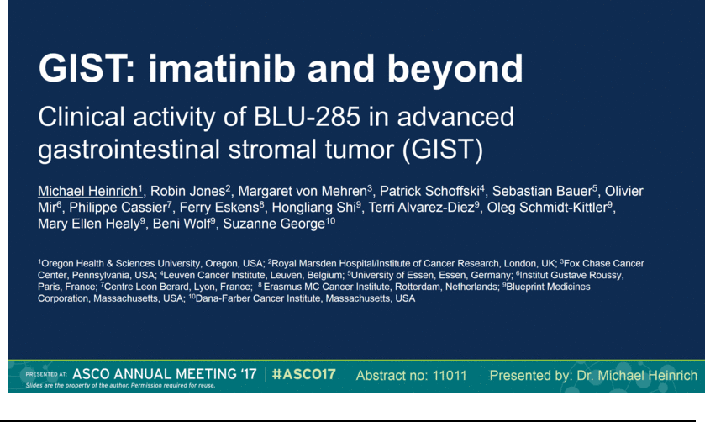

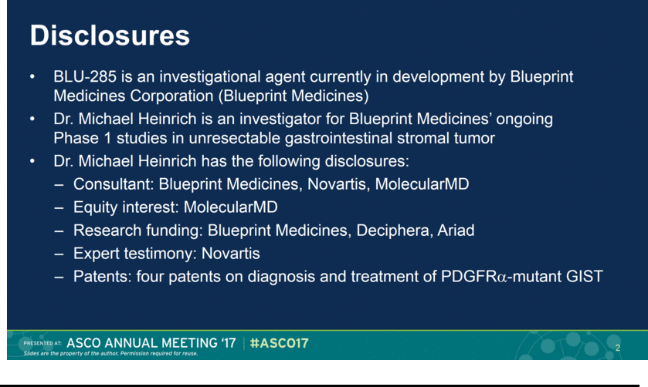

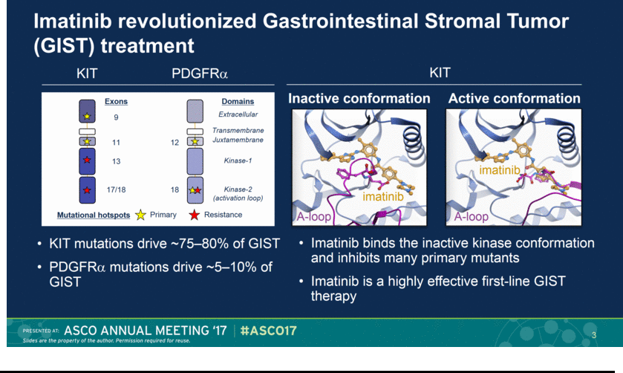

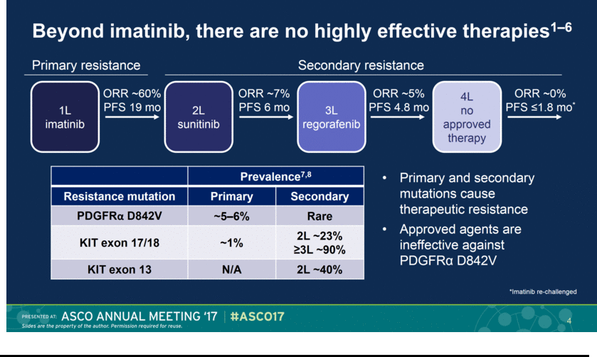

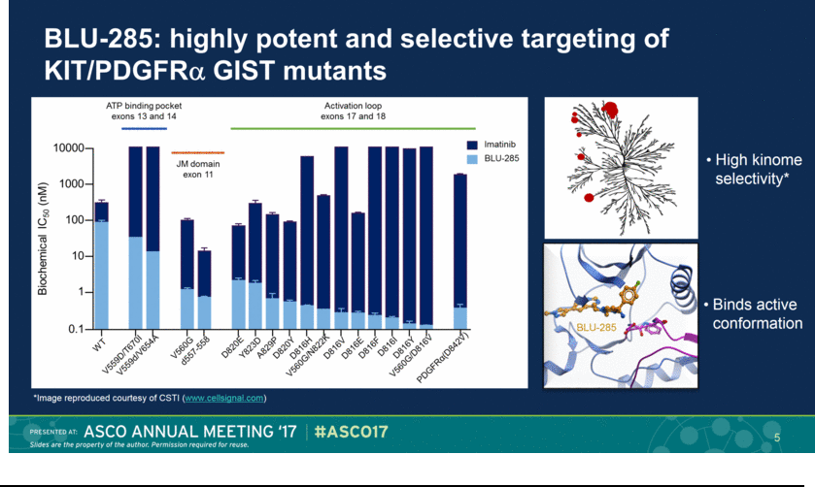

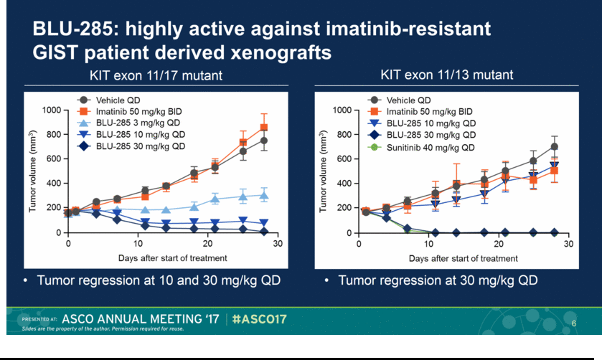

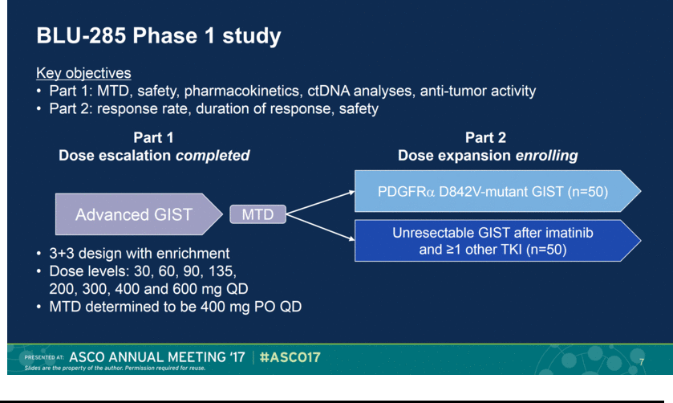

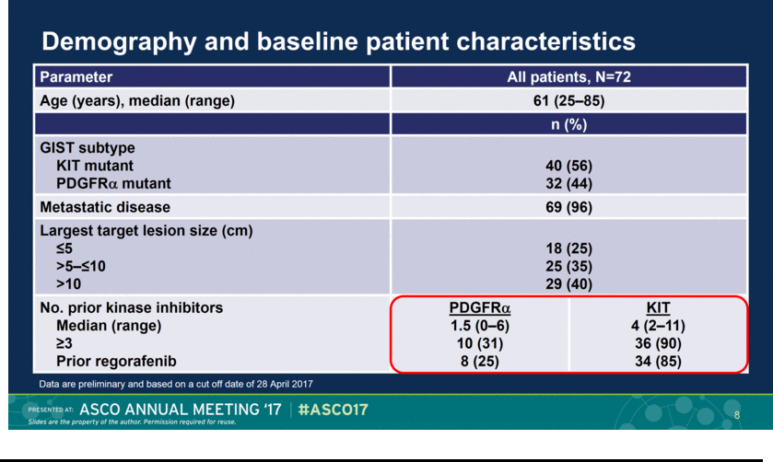

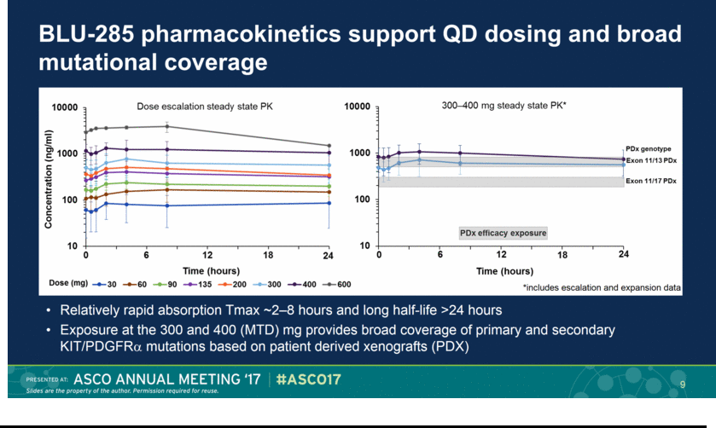

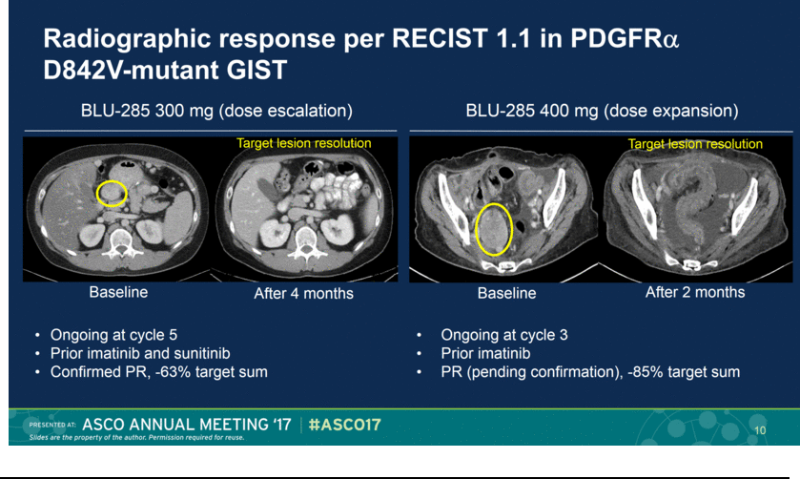

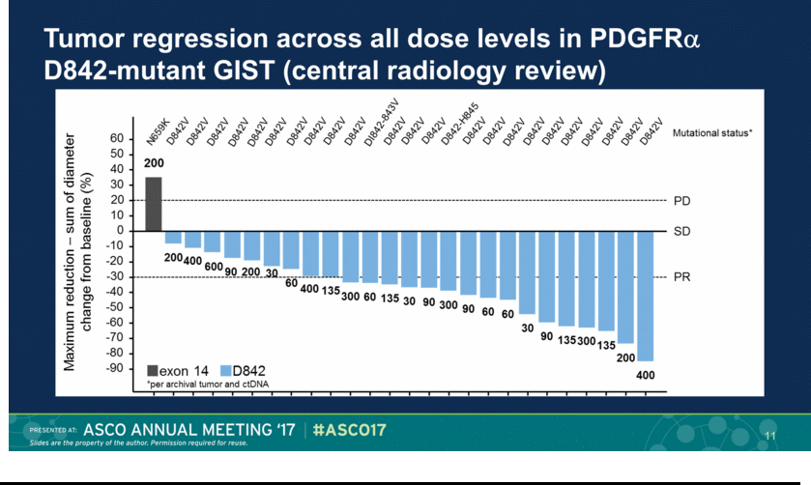

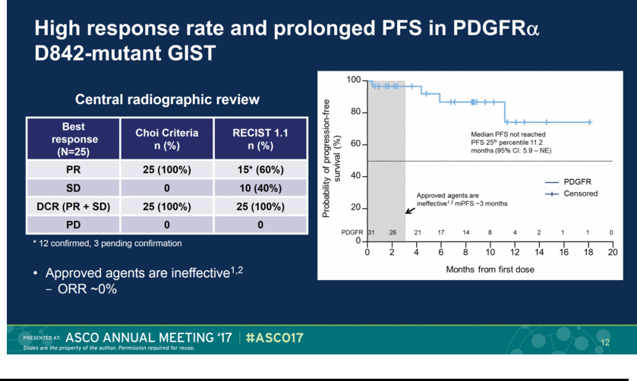

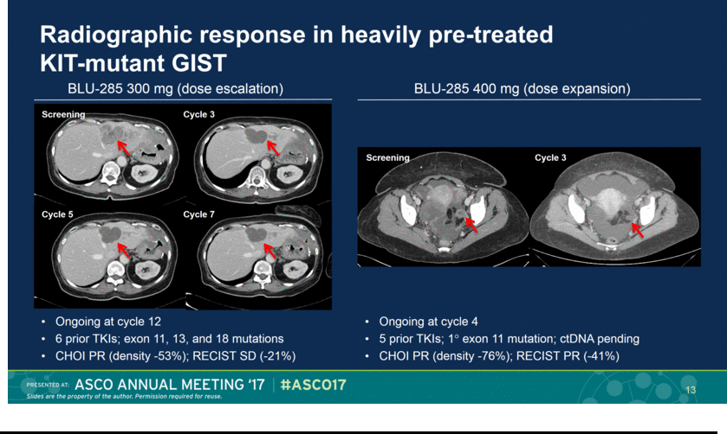

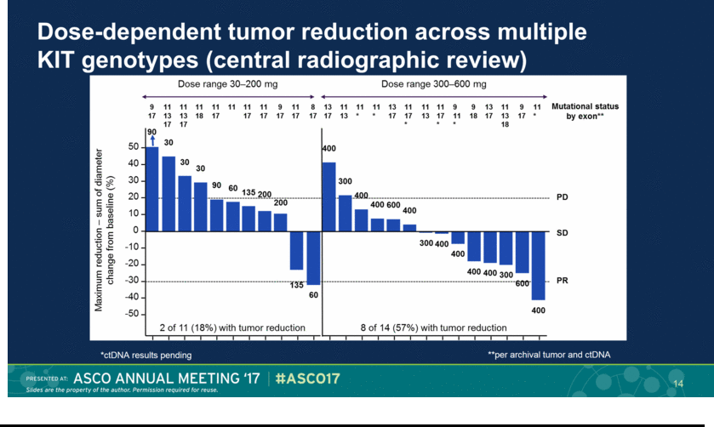

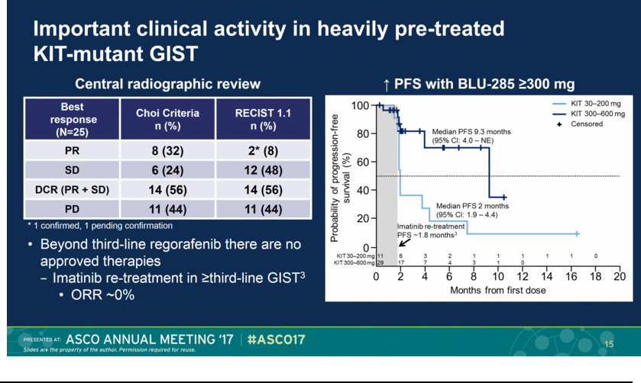

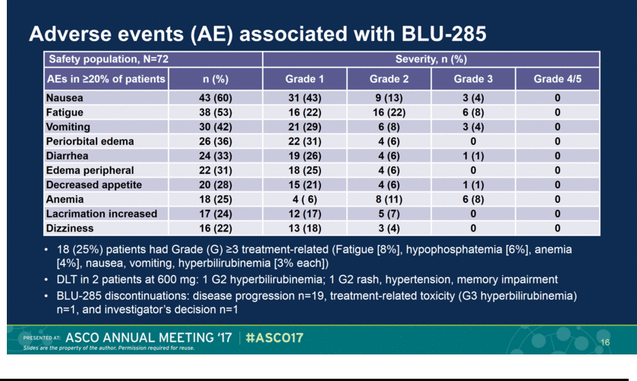

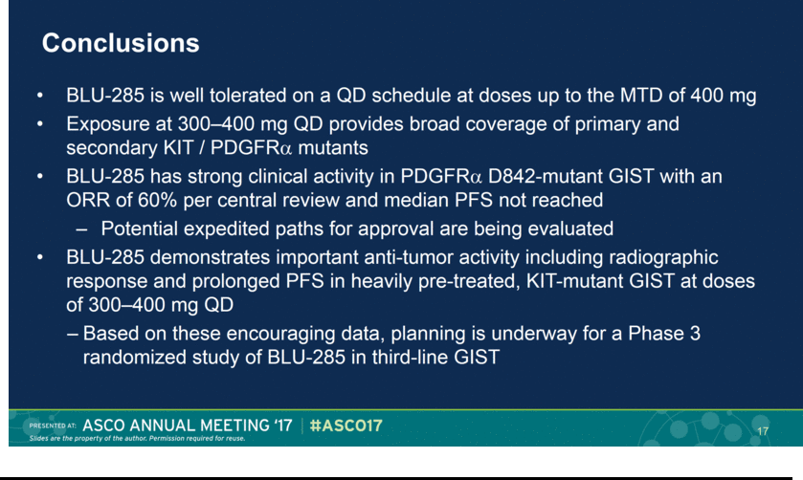

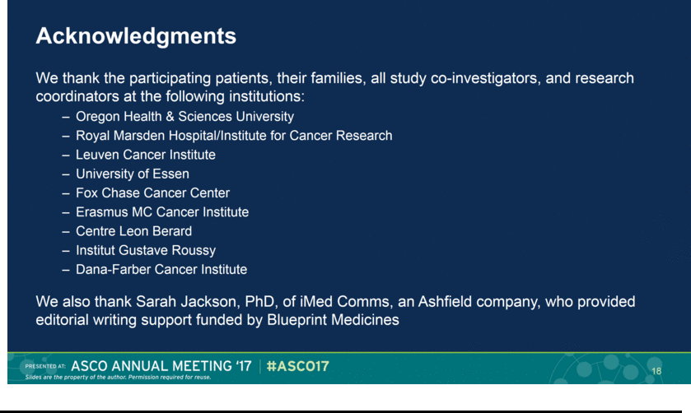

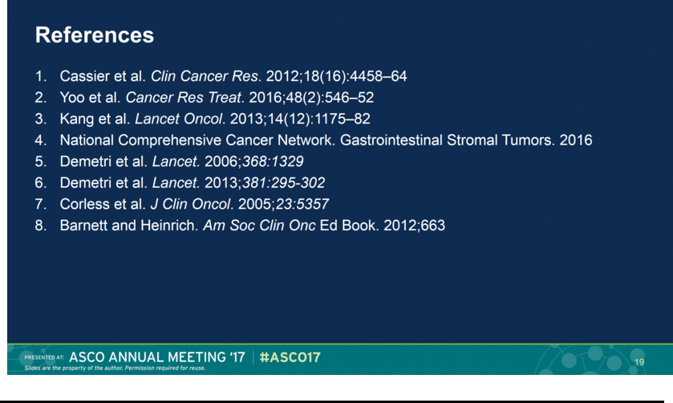

Exhibit 99.3






