UNITED STATES

SECURITIES AND EXCHANGE COMMISSION

Washington, D.C. 20549

FORM 8-K

CURRENT REPORT

Pursuant to Section 13 or 15(d)
of the Securities Exchange Act of 1934

Date of Report (Date of Earliest Event Reported): April 15, 2018

Blueprint Medicines Corporation

(Exact name of registrant as specified in its charter)

Delaware

(State or other jurisdiction

of incorporation)

001-37359

(Commission File Number)

26-3632015

(I.R.S. Employer

Identification No.)

45 Sidney Street

Cambridge, Massachusetts

(Address of principal executive offices)

02139

(Zip Code)

Registrant’s telephone number, including area code: (617) 374-7580

(Former name or former address, if changed since last report)

Check the appropriate box below if the Form 8-K filing is intended to simultaneously satisfy the filing obligation of the registrant under any of the following provisions:

- Written communications pursuant to Rule 425 under the Securities Act (17 CFR 230.425)

- Soliciting material pursuant to Rule 14a-12 under the Exchange Act (17 CFR 240.14a-12)

- Pre-commencement communications pursuant to Rule 14d-2(b) under the Exchange Act (17 CFR 240.14d-2(b))

- Pre-commencement communications pursuant to Rule 13e-4(c) under the Exchange Act (17 CFR 240.13e-4(c))

Indicate by check mark whether the registrant is an emerging growth company as defined in Rule 405 of the Securities Act of 1933 (§230.405 of this chapter) or Rule 12b-2 of the Securities Exchange Act of 1934 (§240.12b-2 of this chapter).

Emerging growth company ☐

If an emerging growth company, indicate by check mark if the registrant has elected not to use the extended transition period for complying with any new or revised financial accounting standards provided pursuant to Section 13(a) of the Exchange Act. ☐

Item 7.01 Regulation FD Disclosure.

On April 15, 2018, Blueprint Medicines Corporation (the “Company”) issued a press release announcing data from its ongoing Phase 1 clinical trial evaluating BLU-667 for the treatment of RET-altered non-small cell lung cancer, medullary thyroid cancer and other advanced solid tumors. The data were presented on Sunday, April 15, 2018 in an oral presentation during the clinical trials plenary session at the American Association for Cancer Research (“AACR”) Annual Meeting in Chicago, Illinois. A copy of the press release is furnished as Exhibit 99.1 to this Current Report on Form 8-K, and a copy of the presentation at the AACR Annual Meeting is furnished as Exhibit 99.2 to this Current Report on Form 8-K.

In addition, on April 15, 2018, the Company hosted an investor event and live webcast to discuss the data presented at the AACR Annual Meeting. A copy of the presentation from the investor event is furnished as Exhibit 99.3 to this Current Report on Form 8-K.

The information in Item 7.01 of this Current Report on Form 8-K, including Exhibits 99.1, 99.2 and 99.3, is intended to be furnished and shall not be deemed “filed” for purposes of Section 18 of the Securities Exchange Act of 1934, as amended (the “Exchange Act”), or otherwise subject to the liabilities of that section, nor shall it be deemed incorporated by reference in any filing under the Securities Act of 1933, as amended, or the Exchange Act, except as expressly set forth by specific reference in such filing.

Item 9.01 |  |  |  | Financial Statements and Exhibits.
(d) Exhibits.
 | Exhibit No. |  |  | Description
 | 99.1 |  |  | Press release issued by Blueprint Medicines Corporation on April 15, 2018
99.2 |  |  |  | Presentation by Blueprint Medicines Corporation at the AACR Annual Meeting on April 15, 2018
99.3 |  |  |  | Presentation by Blueprint Medicines Corporation at investor event on April 15, 2018
 |  |  |  | 2

SIGNATURES

Pursuant to the requirements of the Securities Exchange Act of 1934, the registrant has duly caused this report to be signed on its behalf by the undersigned hereunto duly authorized.

 | BLUEPRINT MEDICINES CORPORATION
Date: April 16, 2018 | By: /s/ Tracey L. McCain
 |  | Tracey L. McCain
 |  | Chief Legal Officer
 | 3

Exhibit 99.1


Blueprint Medicines Announces Proof-of-Concept Data for Highly Selective RET Inhibitor BLU-667 from Phase 1 ARROW Clinical Trial in Patients with RET-Altered Solid Tumors

– Broad Anti-Tumor Activity Observed across Multiple Tumor Types and RET Genotypes, with Radiographic Tumor Reductions in 84% of Evaluable Patients with RET-Altered Tumors –
– Expansion Portion of ARROW Trial Initiated and Actively Enrolling Patients Globally –
– Blueprint Medicines to Host Investor Event and Webcast on Sunday, April 15, 2018 –

CAMBRIDGE, Mass., April 15, 2018 – Blueprint Medicines Corporation (NASDAQ:BPMC), a leader in discovering and developing targeted kinase medicines for patients with genomically defined diseases, today announced proof-of-concept data from the ongoing Phase 1 ARROW clinical trial of BLU-667 in patients with RET-altered solid tumors. Designed and developed by Blueprint Medicines, BLU-667 is a potent and highly selective inhibitor targeting oncogenic RET fusions and mutations, which are key drivers across multiple cancers, including subsets of patients with non-small cell lung cancer (NSCLC) and medullary thyroid cancer (MTC). The data will be presented today in a clinical trials plenary session at the American Association for Cancer Research (AACR) Annual Meeting in Chicago, Illinois.

The data from the dose escalation portion of the ARROW trial showed broad and robust clinical activity for once-daily (QD) dosing of BLU-667 across multiple tumor types and RET genotypes, including in patients whose disease had progressed on prior multi-kinase inhibitor therapy. As of the data cutoff date of April 6, 2018, the data showed radiographic tumor reductions in 84 percent of patients with RET-altered solid tumors with measurable target lesions. In patients evaluable for response, preliminary overall response rates (ORR) were 50 percent in patients with NSCLC and 40 percent in patients with MTC. As of the data cutoff date, QD dosing of BLU-667 was well-tolerated, and most adverse events (AEs) reported by investigators were Grade 1 or 2.

“The data announced today reveal the broad clinical potential of BLU-667, a potent and highly selective RET inhibitor, and further demonstrate the power and reproducibility of Blueprint Medicines’ proprietary drug discovery platform,” said Andy Boral, M.D., Ph.D., Chief Medical Officer at Blueprint Medicines. “We believe the safety, clinical activity and pharmacodynamic results from the dose escalation portion of the Phase 1 ARROW trial demonstrate compelling proof-of-concept for BLU-667. We are particularly encouraged by the consistency of these early BLU-667 data across multiple tumor types, RET alterations and prior lines of therapy. Based on these data, we are excited to rapidly advance the global expansion portion of the trial, which will further evaluate an optimized dose of BLU-667 across a broad patient population with a focus on durability of activity.”

Data from the Ongoing Phase 1 ARROW Clinical Trial

As of the data cutoff date of April 6, 2018, 53 patients had been treated with BLU-667 in the dose escalation portion of the Phase 1 ARROW clinical trial across multiple dose levels ranging from 30 mg to 600 mg QD, including 19 patients with NSCLC, 29 patients with MTC and five patients with other solid tumors. Of these 53 patients,

27 patients (51 percent) had been previously treated with a multi-kinase inhibitor and 18 patients (34 percent) had been previously treated with an immunotherapy.

Pharmacokinetic (PK) data across all QD dose levels demonstrated rapid absorption of BLU-667 and a mean half-life greater than 12 hours, supporting a QD dosing regimen.

Preliminary Safety Data:

As of the data cutoff date, QD dosing of BLU-667 was observed to be well-tolerated. The maximum tolerated dose (MTD) for BLU-667 was determined to be 400 mg QD using a Bayesian optimal interval design. At QD dose levels up to and including the MTD, the majority of AEs reported by investigators were Grade 1 or 2. AEs reported by investigators (≥20 percent) most commonly included constipation (24 percent), increased alanine aminotransferase (ALT) (22 percent) and increased aspartate aminotransferase (20 percent). Investigators reported treatment-related Grade 3 AEs in eight patients (16 percent). Treatment-related Grade 3 AEs occurring in two or more patients included hypertension and neutropenia. There were no treatment-related Grade 4 or 5 AEs.

Across all QD dose levels up to 600 mg QD, seven patients experienced dose-limiting toxicities. Only one patient discontinued treatment with BLU-667 due to a dose-limiting toxicity (Grade 3 ALT increase). An additional 11 patients discontinued treatment, including eight patients due to progressive disease, one patient due to an AE unrelated to BLU-667 and one patient due to non-compliance. One patient passed away, and the death was deemed unrelated to BLU-667. Among all 53 enrolled patients, 41 patients (77 percent) remained on BLU-667 as of the data cutoff date. Duration of treatment ranged from 0.3 to 11.5 months.

Preliminary Clinical Activity Data:

As of the data cutoff date, 40 patients with RET-altered tumors were evaluable for response assessment, including 14 patients with NSCLC, 25 patients with MTC and one patient with papillary thyroid cancer (PTC). CT and MRI imaging was used to measure clinical activity by Response Evaluation Criteria in Solid Tumors (RECIST) version 1.1. Of the remaining 13 enrolled patients who were not evaluable for response assessment, two patients did not have RET-altered tumors, one patient died due to an AE unrelated to BLU-667 prior to any response assessment and 10 recently enrolled patients had not been evaluated for response by the data cutoff date.

Across all evaluable patients, the preliminary ORR was 45 percent. Responses were observed in patients previously treated with multi-kinase therapy, immunotherapy and chemotherapy.

RET-altered NSCLC
- 85% of NSCLC patients with measurable target lesions had radiographic tumor reductions.
- Seven patients achieved a partial response (PR) (five confirmed, two pending confirmation), representing a preliminary ORR of 50 percent.
- Responses were observed in patients with the most common RET alterations in NSCLC, including RET-KIF5B and RET-CCDC6 fusions.
- Preliminary evidence of anti-tumor activity in the brain was observed in metastatic NSCLC.

RET-altered MTC
- 83% of MTC patients with measurable target lesions had radiographic tumor reductions.
- One patient achieved a confirmed complete response, nine patients achieved a PR (five confirmed, four pending confirmation), representing a preliminary ORR of 40 percent.

- Responses were observed in patients with the most common activating RET mutations in MTC, including the RET-M918T mutation.

Other RET-altered solid tumors
- One patient with RET-altered PTC achieved a PR (pending confirmation).

Based on the favorable tolerability and encouraging clinical activity observed for BLU-667 to date, Blueprint Medicines initiated and is actively enrolling patients in the global expansion portion of the ARROW trial.

Investor Event and Webcast Information

Blueprint Medicines will host an investor event on Sunday, April 15, 2018 beginning at 7:00 p.m. CT (8:00 p.m. ET) in Chicago to review the preliminary clinical data presented at AACR for BLU-667. Formal presentations and the live webcast will begin at 7:30 p.m. CT (8:30 p.m. ET). The event can be accessed by dialing 1-855-728-4793 (domestic) or 1-503-343-6666 (international) and providing the passcode 6080608. A live webcast will also be available under “Events & Presentations” in the Investors section of Blueprint Medicines' website at http://ir.blueprintmedicines.com. The archived webcast will be available on Blueprint Medicines' website approximately two hours after the event concludes and will be available for 30 days following the event.

About the Phase 1 ARROW Clinical Trial of BLU-667

ARROW is a Phase 1 clinical trial of BLU-667 designed to evaluate the safety and tolerability of BLU-667 in multiple ascending doses in adults with RET-altered NSCLC, MTC and other advanced solid tumors. The trial consists of two parts: a dose escalation portion and an expansion portion. Enrollment in the dose escalation portion is complete, and the expansion portion has been initiated and is actively enrolling patients in four defined cohorts at the MTD of 400mg QD: (1) RET-altered NSCLC patients previously treated with a tyrosine kinase inhibitor (TKI),

- RET-altered NSCLC patients who have not previously received any TKI treatment, (3) patients with medullary thyroid cancer, and (4) patients with other RET-altered solid tumors. Trial objectives include assessing response, pharmacokinetics, pharmacodynamics and safety.

Patients and physicians interested in the ARROW trial can contact the Blueprint Medicines study team at studydirector@blueprintmedicines.com or 1-617-714-6707. More information about the ARROW trial is also available at www.arrowtrial.com or www.clinicaltrials.gov (Identifier: NCT03037385).

About RET-Altered NSCLC, MTC and Other Solid Tumors

RET activating fusions and mutations are a key disease driver in multiple cancers, including NSCLC and MTC. RET fusions are implicated in approximately 1-2% of patients with NSCLC, while RET mutations are implicated in approximately 60% of patients with MTC. In addition, genomic analyses published by scientists at Blueprint Medicines have identified RET fusions at low frequencies in colon and breast cancer. Currently, there are no approved therapies that selectively target RET-driven cancers, though there are several approved multi-kinase inhibitors with RET activity being evaluated in clinical trials. Thus far, clinical activity attributable to RET inhibition has been uncertain for these inhibitors, likely due to insufficient inhibition of RET and off-target toxicities.

About BLU-667

BLU-667 is an orally available, potent and highly selective inhibitor designed to target RET fusions, mutations and predicted resistance mutations. Blueprint Medicines is developing BLU-667, an investigational medicine, for the treatment of patients with RET-altered NSCLC, MTC and other solid tumors. BLU-667 was discovered by Blueprint Medicine’s research team leveraging its proprietary compound library, and Blueprint Medicines retains worldwide development and commercialization rights for BLU-667.

About Blueprint Medicines

Blueprint Medicines is developing a new generation of targeted and potent kinase medicines to improve the lives of patients with genomically defined diseases. Its approach is rooted in a deep understanding of the genetic blueprint of cancer and other disease driven by the abnormal activation of kinases. Blueprint Medicines is advancing multiple programs in clinical development for subsets of patients with gastrointestinal stromal tumors, hepatocellular carcinoma, systemic mastocytosis, non-small cell lung cancer, medullary thyroid cancer and other advanced solid tumors, as well as multiple programs in research and preclinical development. For more information, please visit www.blueprintmedicines.com.

Cautionary Note Regarding Forward-Looking Statements

This press release contains forward-looking statements within the meaning of the Private Securities Litigation Reform Act of 1995, as amended, including, without limitation, statements regarding plans and timelines for the clinical development of BLU-667, including plans and timelines for advancing the expansion portion of the Phase 1 ARROW trial; expectations regarding the safety and efficacy of BLU-667 and the potential benefits of BLU-667 in treating patients with RET-altered cancers; plans to advance a QD dosing regimen for BLU-667; plans and timelines for activating additional clinical sites in the Phase 1 ARROW trial; expectations regarding enrollment in the expansion portion of the Phase 1 ARROW trial; and Blueprint Medicines’ strategy, business plans and focus. The words “may,” “will,” “could,” “would,” “should,” “expect,” “plan,” “anticipate,” “intend,” “believe,” “estimate,” “predict,” “project,” “potential,” “continue,” “target” and similar expressions are intended to identify forward-looking statements, although not all forward-looking statements contain these identifying words. Any forward-looking statements in this press release are based on management’s current expectations and beliefs and are subject to a number of risks, uncertainties and important factors that may cause actual events or results to differ materially from those expressed or implied by any forward-looking statements contained in this press release, including, without limitation, risks and uncertainties related to the delay of any current or planned clinical trials or the development of Blueprint Medicines' drug candidates, including avapritinib, BLU-554, BLU-667 and BLU-782; Blueprint Medicines' advancement of multiple early-stage efforts; Blueprint Medicines' ability to successfully demonstrate the safety and efficacy of its drug candidates; the preclinical and clinical results for Blueprint Medicines' drug candidates, which may not support further development of such drug candidates; and actions of regulatory agencies, which may affect the initiation, timing and progress of clinical trials; Blueprint Medicines' ability to develop and commercialize companion diagnostic tests for its current and future drug candidates, including companion diagnostic tests for BLU-554 for FGFR4-driven HCC, avapritinib for PDGFRα D842V-driven GIST and BLU-667 for RET-driven NSCLC; and the success of Blueprint Medicines' cancer immunotherapy collaboration with F. Hoffmann-La Roche Ltd and Hoffmann-La Roche Inc. These and other risks and uncertainties are described in greater detail in the section entitled “Risk Factors” in Blueprint Medicines’ Annual Report on Form 10-K for the year ended December 31, 2017, as filed with the Securities and Exchange Commission

(SEC) on February 21, 2018, and other filings that Blueprint Medicines has made or may make with the SEC in the future. Any forward-looking statements contained in this press release represent Blueprint Medicines’ views only as of the date hereof and should not be relied upon as representing its views as of any subsequent date. Blueprint Medicines explicitly disclaims any obligation to update any forward-looking statements.

Investor and Media Relations Contacts

Kristin Hodous
617-714-6674
KHodous@blueprintmedicines.com

Jim Baker
617-844-8236
JBaker@blueprintmedicines.com

Exhibit 99.2
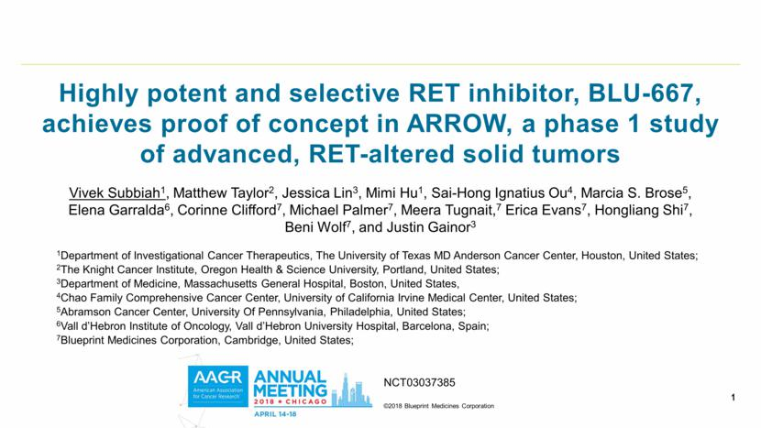

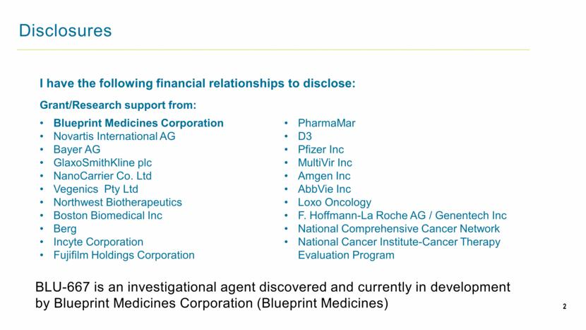

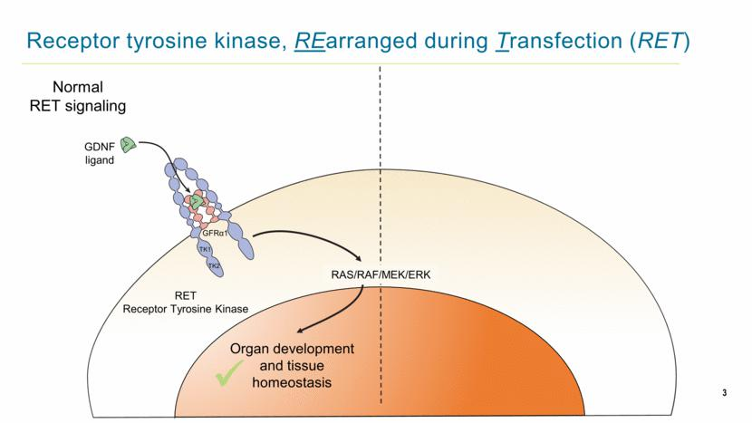

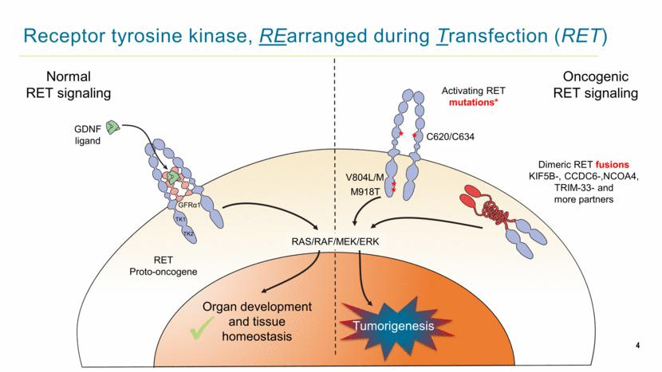

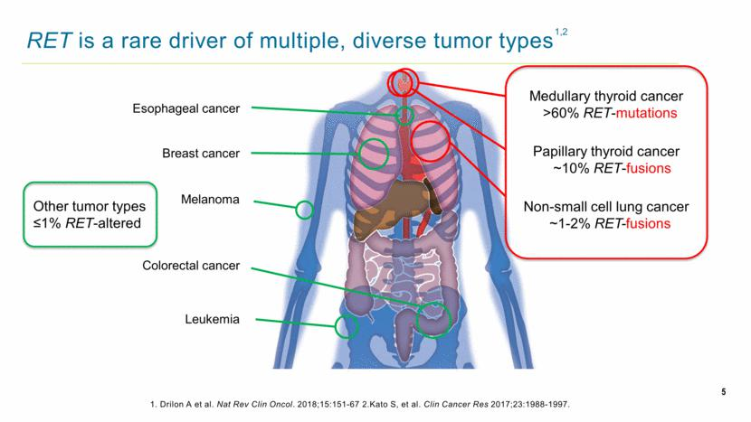

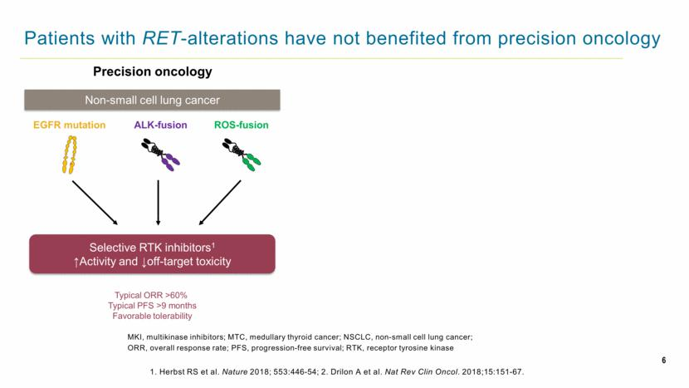

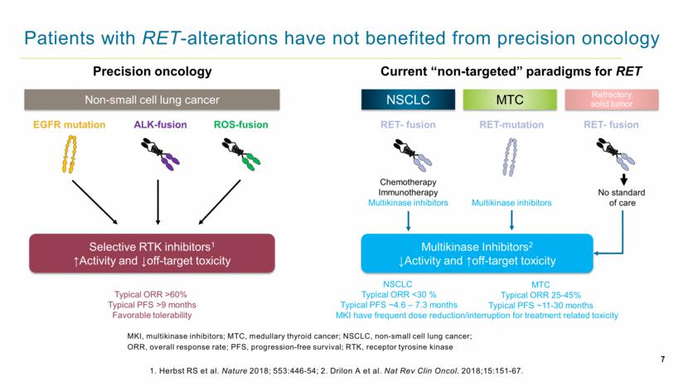

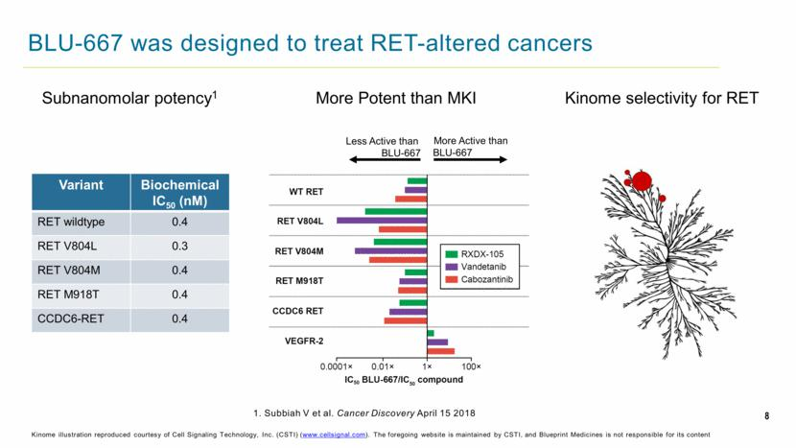

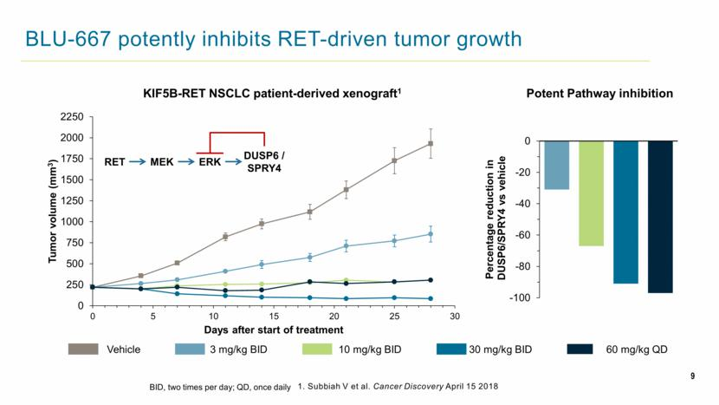

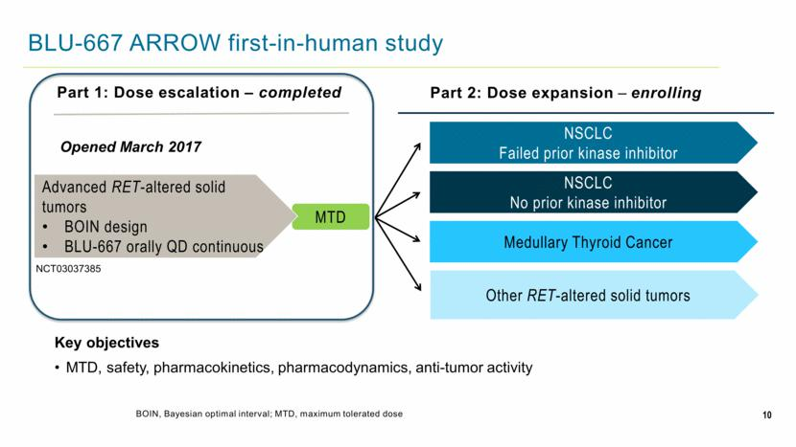

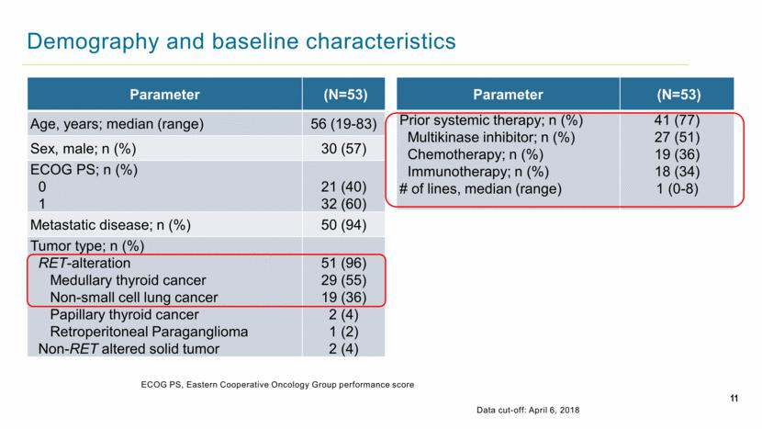

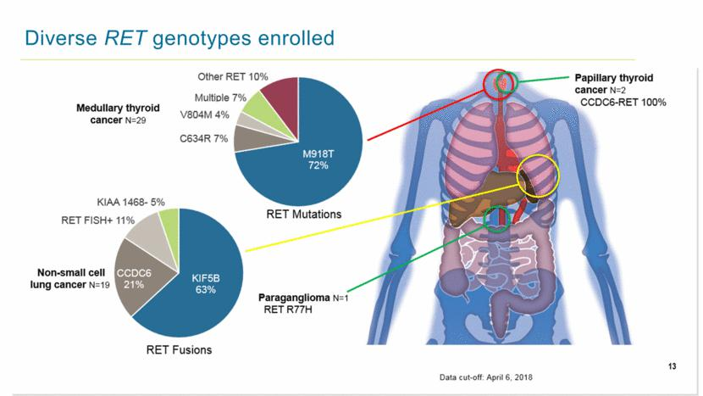

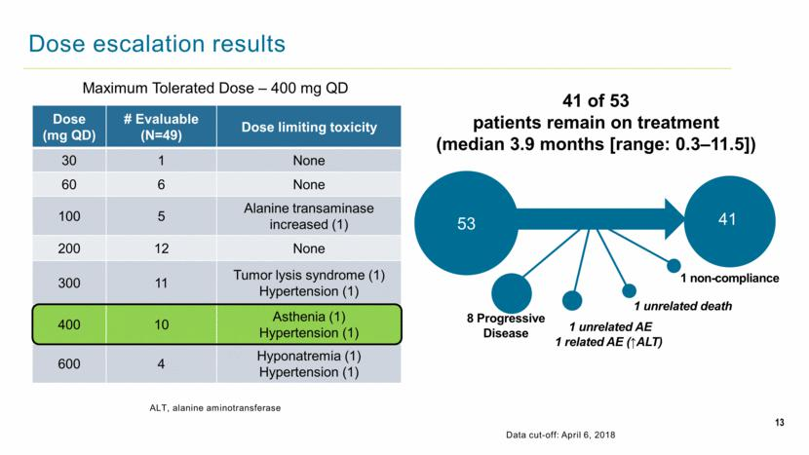

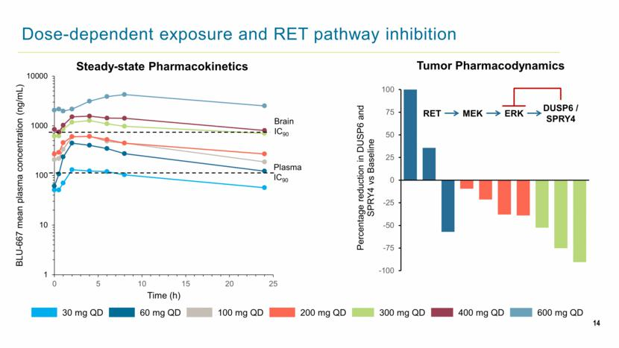

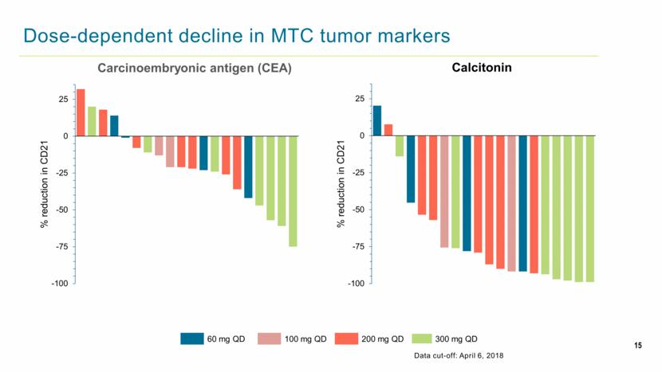

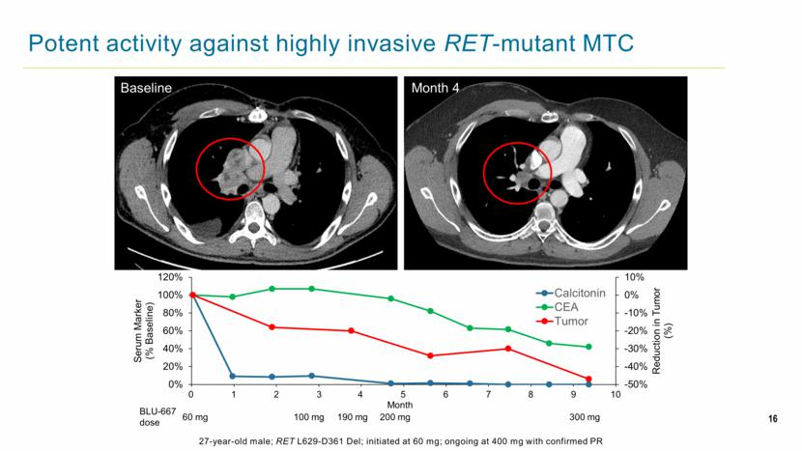

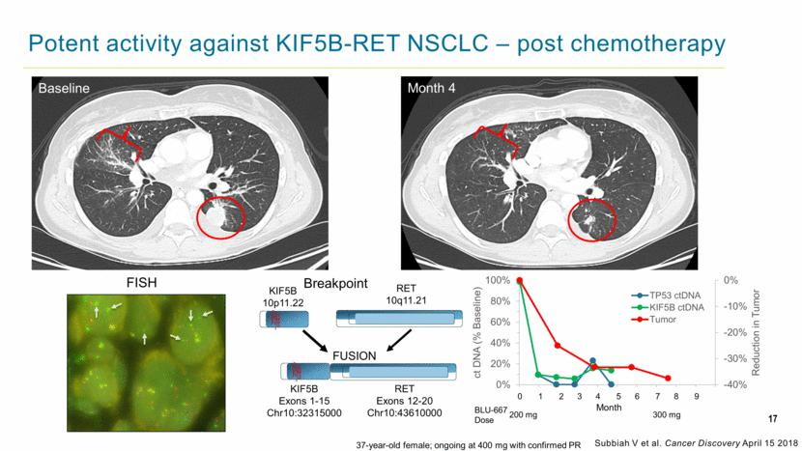

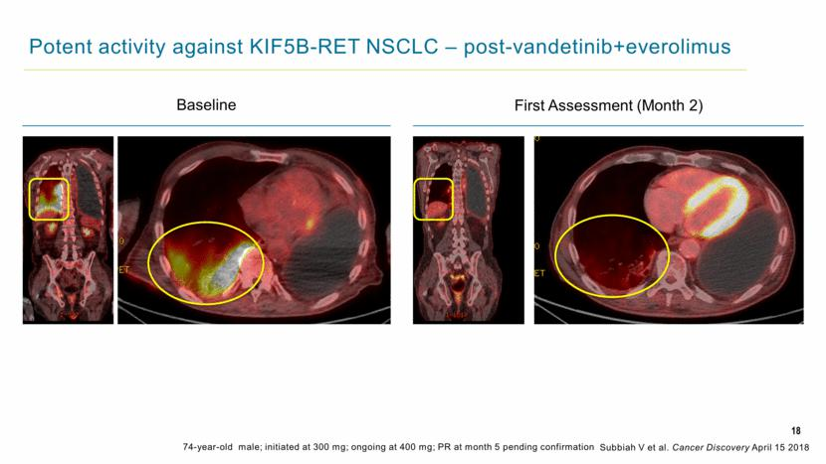

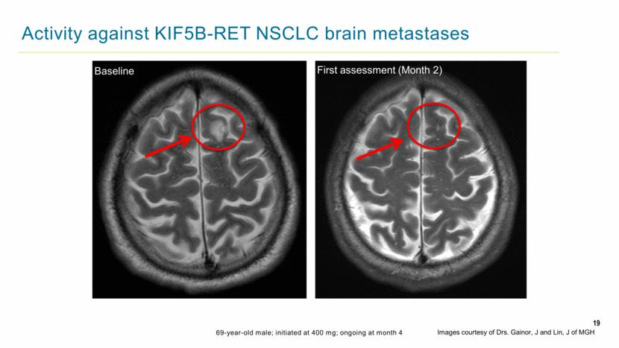

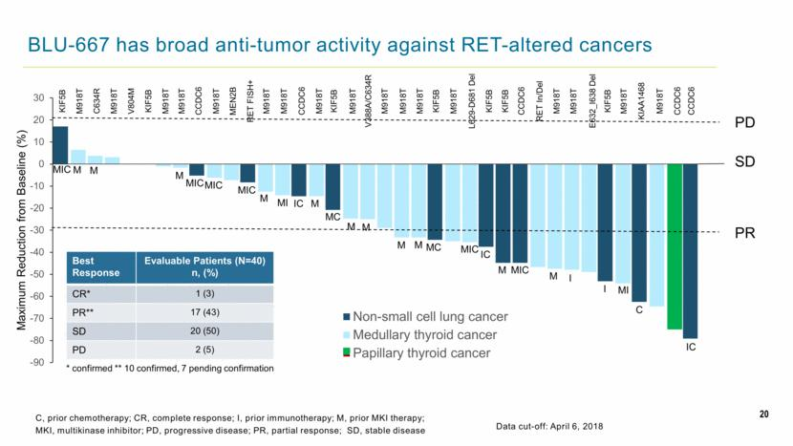

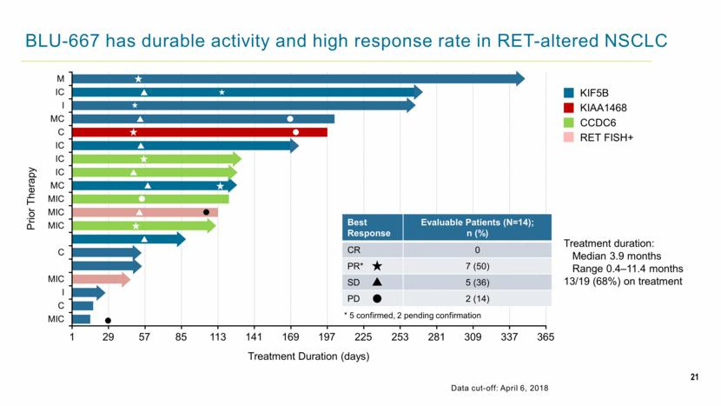

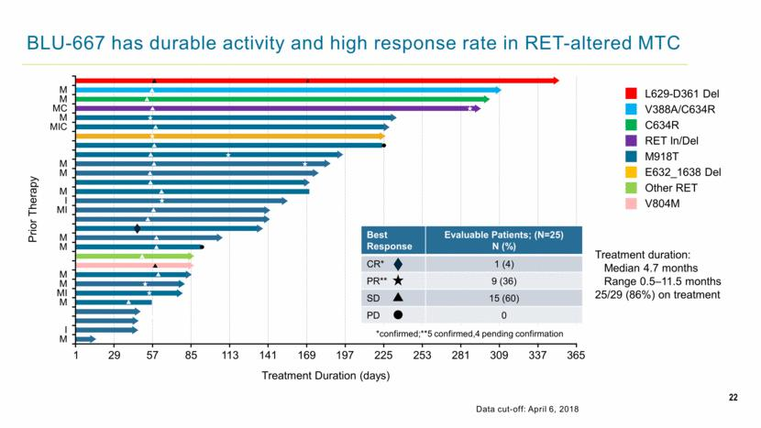

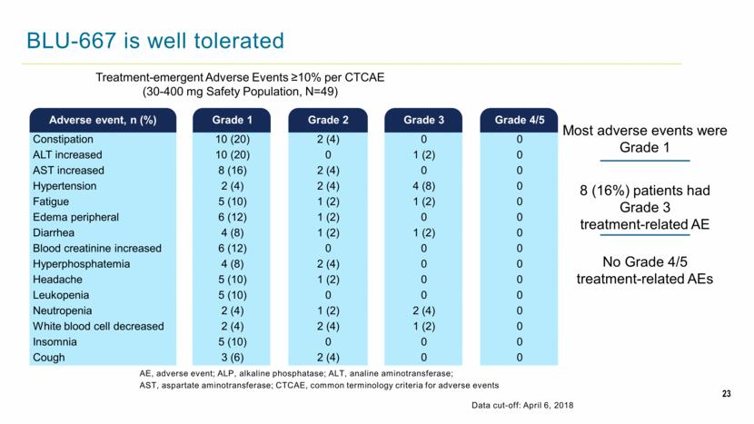

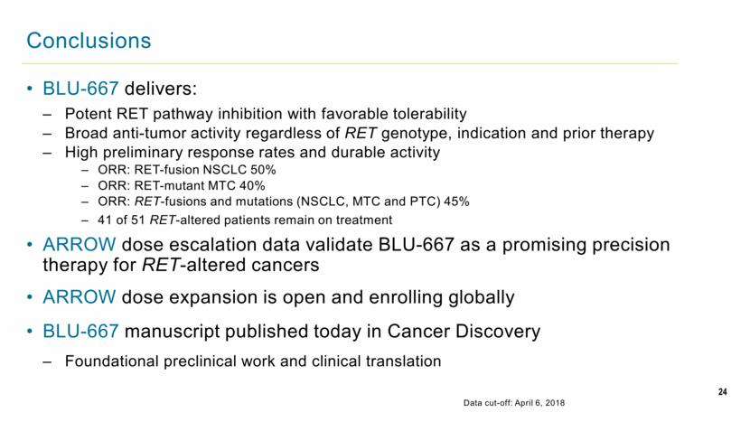

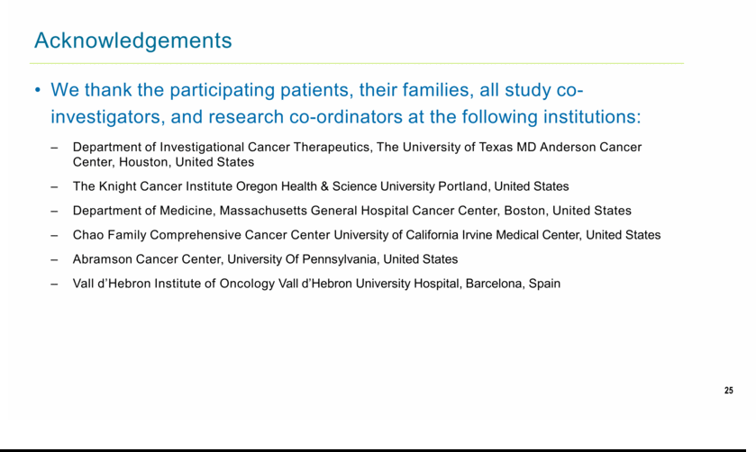

Exhibit 99.3




