UNITED STATES

SECURITIES AND EXCHANGE COMMISSION

Washington, D.C. 20549

FORM 8-K

CURRENT REPORT

Pursuant to Section 13 or 15(d)
of the Securities Exchange Act of 1934

Date of Report (Date of Earliest Event Reported): December 10, 2017

Blueprint Medicines Corporation

(Exact name of registrant as specified in its charter)

Delaware

(State or other jurisdiction

of incorporation)

001-37359

(Commission File Number)

26-3632015

(I.R.S. Employer

Identification No.)

38 Sidney Street, Suite 200

Cambridge, Massachusetts

(Address of principal executive offices)

02139

(Zip Code)

Registrant’s telephone number, including area code: (617) 374-7580

(Former name or former address, if changed since last report)

Check the appropriate box below if the Form 8-K filing is intended to simultaneously satisfy the filing obligation of the registrant under any of the following provisions:

- Written communications pursuant to Rule 425 under the Securities Act (17 CFR 230.425)

- Soliciting material pursuant to Rule 14a-12 under the Exchange Act (17 CFR 240.14a-12)

- Pre-commencement communications pursuant to Rule 14d-2(b) under the Exchange Act (17 CFR 240.14d-2(b))

- Pre-commencement communications pursuant to Rule 13e-4(c) under the Exchange Act (17 CFR 240.13e-4(c))

Indicate by check mark whether the registrant is an emerging growth company as defined in Rule 405 of the Securities Act of 1933 (§230.405 of this chapter) or Rule 12b-2 of the Securities Exchange Act of 1934 (§240.12b-2 of this chapter).

Emerging growth company ☑

If an emerging growth company, indicate by check mark if the registrant has elected not to use the extended transition period for complying with any new or revised financial accounting standards provided pursuant to Section 13(a) of the Exchange Act. ☑

Item 7.01 Regulation FD Disclosure.

On December 10, 2017, Blueprint Medicines Corporation (the “Company”) issued a press release announcing new data from its ongoing Phase 1 clinical trial evaluating avapritinib (formerly known as BLU-285) for the treatment of advanced systemic mastocytosis. The data were presented on Sunday, December 10, 2017 in an oral presentation during the plenary session at the American Society of Hematology (“ASH”) Annual Meeting in Atlanta, Georgia. A copy of the press release is furnished as Exhibit 99.1 to this Current Report on Form 8-K, and a copy of the presentation at the ASH Annual Meeting is furnished as Exhibit 99.2 to this Current Report on Form 8-K.

In addition, on December 11, 2017, the Company hosted an investor conference call and live webcast to discuss the data presented at the ASH Annual Meeting and provide a corporate update. A copy of the presentation from the conference call is furnished as Exhibit 99.3 to this Current Report on Form 8-K.

The information in Item 7.01 of this Current Report on Form 8-K, including Exhibits 99.1, 99.2 and 99.3, is intended to be furnished and shall not be deemed “filed” for purposes of Section 18 of the Securities Exchange Act of 1934, as amended (the “Exchange Act”), or otherwise subject to the liabilities of that section, nor shall it be deemed incorporated by reference in any filing under the Securities Act of 1933, as amended, or the Exchange Act, except as expressly set forth by specific reference in such filing.

Item 9.01 |  | Financial Statements and Exhibits.
(d) Exhibits.
Exhibit No. |  | Description
99.1 |  | Press release issued by Blueprint Medicines Corporation on December 10, 2017
99.2 |  | Presentation by Blueprint Medicines Corporation at the ASH Annual Meeting on December 10, 2017
99.3 |  | Presentation by Blueprint Medicines Corporation at investor conference call on December 11, 2017
 |  | 2

 |  |  | EXHIBIT INDEX
Exhibit No. |  |  | Description
99.1 |  |  | Press release issued by Blueprint Medicines Corporation on December 10, 2017
99.2 |  |  | Presentation by Blueprint Medicines Corporation at the ASH Annual Meeting on December 10, 2017
99.3 |  |  | Presentation by Blueprint Medicines Corporation at investor conference call on December 11, 2017
 |  |  | 3

SIGNATURES

Pursuant to the requirements of the Securities Exchange Act of 1934, the registrant has duly caused this report to be signed on its behalf by the undersigned hereunto duly authorized.

 | BLUEPRINT MEDICINES CORPORATION
Date: December 11, 2017 | By: /s/ Tracey L. McCain
 |  | Tracey L. McCain
 |  | Chief Legal Officer
 | 4

Exhibit 99.1
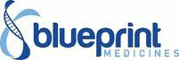

Blueprint Medicines Announces New Data from Ongoing Phase 1 Clinical Trial of Avapritinib (BLU-285) in Patients with Advanced Systemic Mastocytosis Showing Evidence of Strong Clinical Activity

– Overall Response Rate of 72 Percent and Disease Control Rate of 100 Percent Reported – – Plan to Engage Global Regulatory Authorities in First Half 2018 on Registration Pathway – – Blueprint Medicines to Host Investor Conference Call and Webcast on Monday, December 11, at 6:00 a.m. ET –

CAMBRIDGE, Mass., December 10, 2017 – Blueprint Medicines Corporation (NASDAQ:BPMC), a leader in discovering and developing targeted kinase medicines for patients with genomically defined diseases, today announced new data from its ongoing Phase 1 clinical trial of avapritinib (formerly known as BLU-285), a potent and highly selective KIT and PDGFRα inhibitor in development for patients with advanced systemic mastocytosis (SM). The new data from the dose escalation portion of the Phase 1 trial showed strong clinical activity regardless of advanced SM subtype, prior treatment with midostaurin or the presence of additional mutations.

As of the data cutoff date of October 4, 2017, the data showed an overall response rate (ORR) of 72 percent and a disease control rate (DCR) of 100 percent in patients evaluable for response, based on the International Working Group-Myeloproliferative Neoplasms Research and Treatment and European Competence Network on Mastocytosis (IWG-MRT-ECNM) consensus criteria. As of the data cutoff date, avapritinib was well-tolerated and most adverse events (AEs) reported by investigators were Grade 1 or 2. In addition, there were no discontinuations due to treatment-related adverse events, and 30 of 32 patients remained on treatment with a median treatment duration of nine months. The data will be presented today in an oral presentation during the Plenary Scientific Session at the 59th American Society of Hematology Annual Meeting and Exposition (ASH) in Atlanta, Georgia.

Based on these data, Blueprint Medicines plans to engage global regulatory authorities in the first half of 2018 to obtain input on registration pathways for avapritinib in patients with advanced SM and patients with indolent and smoldering SM. Subject to regulatory feedback, the Company anticipates initiating a registration-enabling clinical trial of avapritinib in patients with advanced SM in the first half of 2018 and a dose escalation and proof-of-concept clinical trial of avapritinib in patients with indolent and smoldering SM in the second half of 2018. In addition, Blueprint Medicines continues to enroll patients in the expansion portion of the ongoing Phase 1 clinical trial in patients with advanced SM with the goal of generating additional data in 2018.

“The new clinical trial results for avapritinib reported at the ASH plenary scientific session represent an exciting milestone for the systemic mastocytosis community. The data showed a remarkably high response rate and a favorable tolerability profile, suggesting avapritinib has the potential to transform the treatment of this devastating rare disease,” said Daniel J. DeAngelo, M.D., Ph.D., Director of Clinical and Translational Research, Adult Leukemia at Dana-Farber Cancer Institute, Associate Professor of Medicine at Harvard Medical School, and an investigator on the Phase 1 trial. “The data also provide strong evidence that selective inhibition of D816V mutant KIT, a disease-driver present in nearly all patients across the spectrum of SM, is a potentially important treatment strategy that may offer patients improved outcomes. These data strongly support continued development of avapritinib in a broad population of patients with SM.”

“We are extremely encouraged by the tolerability and clinical activity of avapritinib observed to date, which increase our confidence and reinforce our commitment to rapidly advance its development across the spectrum of SM,” said Andy Boral, M.D., Ph.D., Chief Medical Officer at Blueprint Medicines. “We look forward to engaging with global regulatory authorities in the first half of 2018 to obtain feedback on a potential registration pathway. In addition, based on data showing a favorable tolerability profile and strong clinical activity from the lowest dose levels tested, we plan to expand our clinical development program to address the full spectrum of SM, including advanced, smoldering and indolent forms of the disease, over the course of 2018.”

New Data from the Ongoing Phase 1 Clinical Trial of Avapritinib in Advanced SM

As of the data cutoff date of October 4, 2017, 32 patients had been treated with avapritinib in the dose escalation portion of the Phase 1 clinical trial at seven dose levels (ranging from 30 mg to 400 mg once daily (QD)), including 17 patients with aggressive SM (ASM), nine patients with advanced SM with an associated hematologic neoplasm (SM-AHN) and three patients with mast cell leukemia (MCL). The KIT D816V mutation was confirmed in 28 patients. Overall, 22 patients (69 percent) previously received anti-neoplastic therapy, including four patients (13 percent) who previously received midostaurin.

Based on pharmacokinetic (PK) data, avapritinib demonstrated a mean half-life of greater than 20 hours, supporting a QD dosing regimen.

Blueprint Medicines has selected 300 mg QD as the recommended part two dose (RP2D) for the expansion portion of this trial, which was initiated in the second quarter of 2017. A maximum tolerated dose of avapritinib in advanced SM was not determined.

Safety Data

As of the data cutoff date, avapritinib was generally well-tolerated. Most AEs reported by investigators were Grade 1 or 2. The most common treatment-emergent AEs reported by investigators (≥20 percent) across all grades included periorbital edema (59 percent), fatigue (41 percent), peripheral edema (34 percent), nausea (28 percent), anemia (28 percent), thrombocytopenia (28 percent), abdominal pain, diarrhea, respiratory tract infection, dizziness and headache (22 percent each). Investigators reported treatment-related Grade ≥3 AEs in 16 patients (50 percent), with only one treatment-related Grade ≥3 AE occurring in more than 10 percent of patients (neutropenia, 13 percent).

No patients discontinued treatment due to a treatment-related AE. Two patients discontinued treatment with avapritinib, including one patient with ASM who had progressive disease with transformation to acute myeloid leukemia and one patient with SM-AHN and no identified KIT mutation (i.e., wild-type KIT). Overall, 30 of 32 patients enrolled in the dose escalation portion of the trial remained on treatment as of the data cutoff date, with a median duration of 9 months (range 4 to 19 months).

Clinical Activity Data

IWG-MRT-ECNM Response Assessment

The IWG-MRT-ECNM criteria comprise a rigorous assessment of clinical response in patients with advanced SM. These criteria include objective measures of bone marrow mast cell burden, serum tryptase and improvement in organ damage as measured by a clinical improvement (CI) finding.

As of the data cutoff date, 18 patients had advanced SM and were evaluable for response by the IWG-MRT-ECNM criteria.

Across all 18 evaluable patients with advanced SM, the data showed an ORR of 72 percent and a complete response (CR) + partial response (PR) rate of 56 percent. A detailed summary of response data is provided below.

Avapritinib in Patients with Advanced SM; Assessment of Response per IWG-MRT-ECNM Criteria

Best Response, Number of Patients (%)* | ASM (n=7) | SM-AHN (n=8) | MCL (n=3) | Overall (n=18)
CR | 2 (29%) | 0 | 0 | 2 (11%)
PR | 3 (43%) | 4 (50%) | 1 (33%) | 8 (44%)
Clinical improvement (CI) | 1 (14%) | 1 (13%) | 1 (33%) | 3 (17%)
Stable disease (SD) | 1 (14%) | 3 (38%) | 1 (33%) | 5 (28%)
ORR (CR + PR + CI) | 6 (86%) | 5 (63%) | 2 (67%) | 13 (72%)
CR + PR | 5 (71%) | 4 (50%) | 1 (33%) | 10 (56%)

*Responses pending confirmation: ASM: 2 CR; SM-AHN: 3 PR

Additional Clinical Assessments

In addition, results from individual components of the IWG-MRT-ECNM were reported as of the data cutoff date. Clinically meaningful improvements were observed in all evaluable patients, across all subtypes of advanced SM and at all avapritinib dose levels evaluated.

All 32 enrolled patients had decreases in serum tryptase greater than 50 percent.
All 25 patients who had bone marrow mast cell infiltrate of at least 5 percent at baseline (measured by bone marrow biopsy) showed decreases in bone marrow mast cell burden. In this group, 21 patients had at least a 50 percent decrease, and 15 patients achieved a CR for bone marrow mast cell burden.

All 25 patients with centrally reviewed radiographic scans showed decreases in spleen volume. In this group, 14 patients had at least a 35 percent reduction in spleen volume.

In addition, rash improved in 13 of 15 patients with urticaria pigmentosa at baseline, based on investigator assessments. Urticaria pigmentosa is an allergy-mediated rash common in SM patients.

Conference Call Information

Blueprint Medicines will host a conference call and webcast on Monday, December 11, 2017 at 6:00 a.m. ET to discuss the avapritinib (BLU-285) clinical data presented at ASH and provide an update on its broader preclinical and clinical pipeline.

To participate in the conference call, please dial 1-855-728-4793 (domestic) or 1-503-343-6666 (international) and refer to conference ID 4072589. A live webcast will be available under "Events and Presentations" in the Investors section of Blueprint

Medicines' website at http://ir.blueprintmedicines.com. A replay of the webcast will be available approximately two hours after the conference call and will be available for 30 days following the call.

About the Phase 1 Clinical Trial for Avapritinib (BLU-285) in Advanced SM

The Phase 1 clinical trial of avapritinib is designed to evaluate the safety and tolerability of avapritinib in adults with advanced SM. The trial consists of two parts, a dose escalation portion and an expansion portion. The dose escalation portion is complete, and Blueprint Medicines selected 300 mg QD as the RP2D for the dose expansion portion of the trial. The expansion portion is actively enrolling patients in three defined cohorts for specific subtypes of advanced SM, including ASM, SM‑AHN and MCL. Trial objectives include assessing safety and tolerability, response per IWG-MRT-ECNM criteria and additional clinical outcome measures of mast cell burden, organ function and disease symptoms. The Phase 1 clinical trial is designed to enroll approximately 60 patients, including approximately 35 patients in expansion cohorts, at multiple sites in the United States and the European Union. Please refer

to www.clinicaltrials.gov for additional details related to this Phase 1 clinical trial. For more information, contact the study director for this Phase 1 clinical trial at studydirector@blueprintmedicines.com.

About SM

There are several forms of SM, including indolent SM, smoldering SM and more advanced forms of SM, which include ASM, SM-AHN and MCL. SM is a hematological clonal disorder characterized by the buildup of mast cells, which are immune cells that produce histamine and other mediators of the body's inflammatory and allergic responses. In patients with SM, mast cells release high levels of these mediators, causing symptoms that range from mild to life-threatening symptoms, including pain, nausea, rash, fever, fatigue and anaphylaxis. In patients with advanced SM, including ASM, SM-AHN and MCL, mast cell infiltration in bone marrow, liver and other vital organs can eventually lead to organ dysfunction and shortened life expectancy, with a median overall survival of three to five years. Patients with indolent SM do not have a shortened life expectancy, but they do suffer from a broad range of acute and chronic symptoms that negatively impact their quality of life. There are no approved treatments that target D816V mutant KIT, which is the primary driver of disease in approximately 90 to 95 percent of SM patients, and there is a clear need for more effective therapies for patients with advanced SM and for patients with indolent SM who have a heavy symptom burden.

About Avapritinib (BLU-285)

Avapritinib is an orally available, potent and highly selective inhibitor of KIT and PDGFRα. Preclinical data have shown that avapritinib is active across a broad spectrum of KIT and PDGFRα mutations, including KIT D816V, PDGFRα D842V and KIT exon 17 mutations for which there are limited or no effective treatment options. Blueprint Medicines is initially developing avapritinib, an investigational medicine, for the treatment of patients with advanced gastrointestinal stromal tumors (GIST) and advanced SM. Avapritinib was discovered by Blueprint Medicines' research team leveraging its proprietary compound library, and the Company retains worldwide development and commercialization rights for avapritinib.

In June 2017, avapritinib received Breakthrough Therapy Designation from the U.S. Food and Drug Administration (FDA) for the treatment of patients with unresectable or metastatic GIST harboring the PDGFRα D842V mutation. The FDA's Breakthrough Therapy Designation is intended to expedite the development and review of a drug candidate intended to treat a serious or life-threatening disease or condition, when preliminary clinical evidence indicates that the drug candidate may demonstrate substantial improvement over existing therapies on one or more clinically significant endpoints. Previously, the FDA granted orphan drug designation to avapritinib for the treatment of GIST and mastocytosis. The FDA also granted Fast Track designation to avapritinib for the treatment of patients with unresectable or metastatic GIST that progressed following treatment with imatinib and a second tyrosine kinase inhibitor and for the treatment of patients with unresectable or metastatic GIST in patients with the PDGFRα D842V mutation regardless of prior therapy. In addition, the European Commission has granted orphan drug designation to avapritinib for the treatment of GIST.

About Blueprint Medicines

Blueprint Medicines is developing a new generation of targeted and potent kinase medicines to improve the lives of patients with genomically defined diseases. Its approach is rooted in a deep understanding of the genetic blueprint of cancer and other diseases driven by the abnormal activation of kinases. Blueprint Medicines is advancing four programs in clinical development for subsets of patients with gastrointestinal stromal tumors, hepatocellular carcinoma, systemic mastocytosis, non-small cell lung cancer, medullary thyroid cancer and other advanced solid tumors, as well as multiple programs in research and preclinical development. For more information, please visit www.blueprintmedicines.com.

Cautionary Note Regarding Forward-Looking Statements

This press release contains forward-looking statements within the meaning of the Private Securities Litigation Reform Act of 1995, as amended, including, without limitation, statements regarding plans and timelines for the clinical development of avapritinib (formerly known as BLU-285), including plans and timelines for initiating a registration-enabling clinical trial for avapritinib in patients with advanced SM and a dose escalation and proof-of-

concept clinical trial for avapritinib in patients with indolent and smoldering SM; Blueprint Medicines’ ability to implement its clinical development plans for avapritinib in advanced SM; expectations regarding current and future interactions with global regulatory authorities, including the FDA, and the impact of Breakthrough Therapy Designation on the development of avapritinib; and Blueprint Medicines’ strategy, business plans and focus. The words “may,” “will,” “could,” “would,” “should,” “expect,” “plan,” “anticipate,” “intend,” “believe,” “estimate,” “predict,” “project,” “potential,” “continue,” “target” and similar expressions are intended to identify forward-looking statements, although not all forward-looking statements contain these identifying words. Any forward-looking statements in this press release are based on management’s current expectations and beliefs and are subject to a number of risks, uncertainties and important factors that may cause actual events or results to differ materially from those expressed or implied by any forward-looking statements contained in this press release, including, without limitation, risks and uncertainties related to the delay of any current or planned clinical trials or the development of Blueprint Medicines' drug candidates, including BLU-285, BLU-554 and BLU-667; Blueprint Medicines' advancement of multiple early-stage efforts; Blueprint Medicines' ability to successfully demonstrate the safety and efficacy of its drug candidates; the preclinical and clinical results for Blueprint Medicines' drug candidates, which may not support further development of such drug candidates; and actions of regulatory agencies, which may affect the initiation, timing and progress of clinical trials; Blueprint Medicines' ability to develop and commercialize companion diagnostic tests for its current and future drug candidates, including companion diagnostic tests for BLU-554 for FGFR4-driven HCC, BLU-285 for PDGFRα D842V-driven GIST and BLU-667 for RET-driven non-small cell lung cancer; and the success of Blueprint Medicines' cancer immunotherapy collaboration with F. Hoffmann-La Roche Ltd and Hoffmann-La Roche Inc. These and other risks and uncertainties are described in greater detail in the section entitled “Risk Factors” in Blueprint Medicines’ Quarterly Report on Form 10-Q for the quarter ended September 30, 2017, as filed with the Securities and Exchange Commission (SEC) on October 31, 2017, and other filings that Blueprint Medicines may make with the SEC in the future. Any forward-looking statements contained in this press release represent Blueprint Medicines’ views only as of the date hereof and should not be relied upon as representing its views as of any subsequent date. Blueprint Medicines explicitly disclaims any obligation to update any forward-looking statements.

Media and Investor Relations Contacts

Kristin Hodous
617 714 6674

khodous@blueprintmedicines.com

Jim Baker
617 844 8236

jbaker@blueprintmedicines.com

Exhibit 99.2
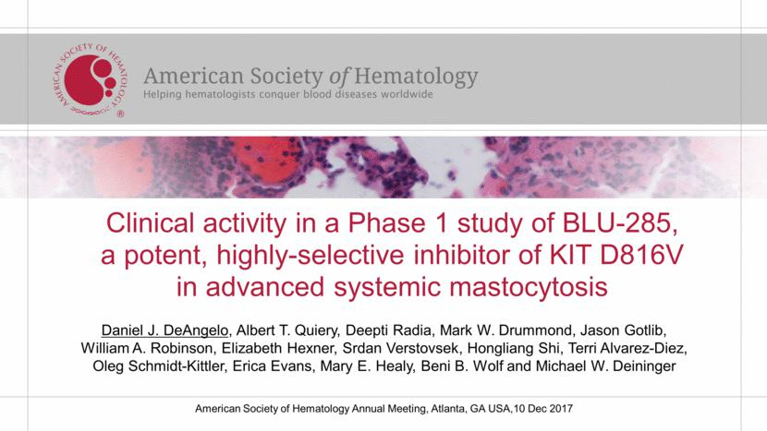

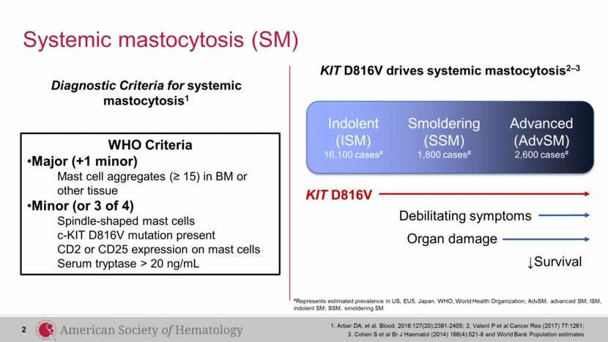

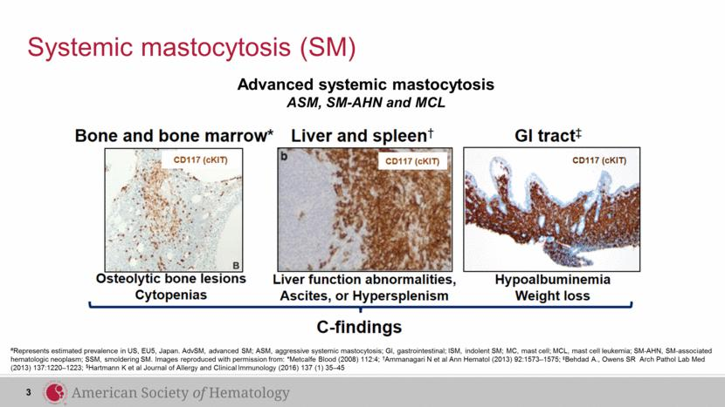

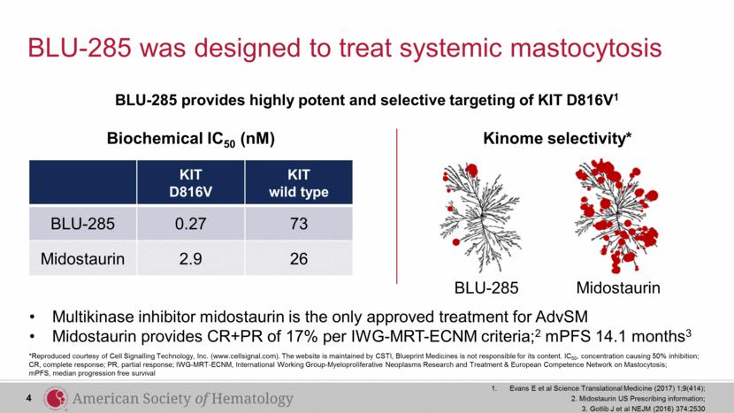

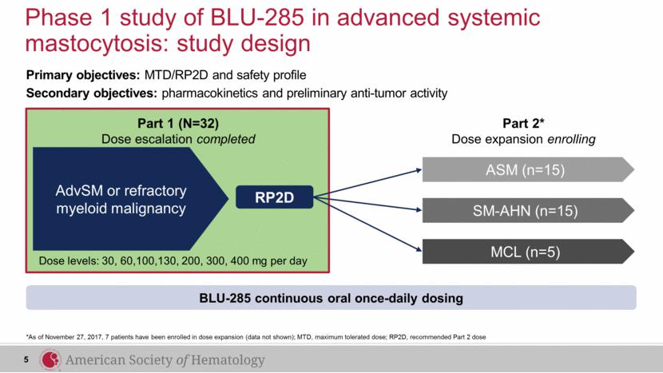

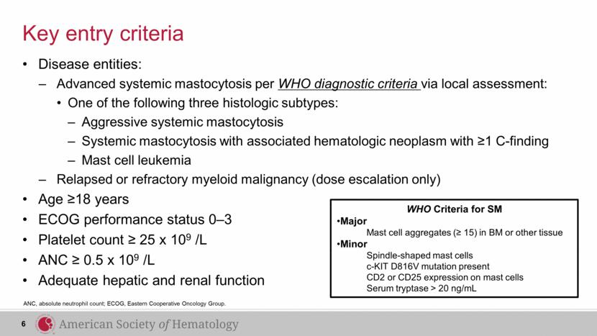

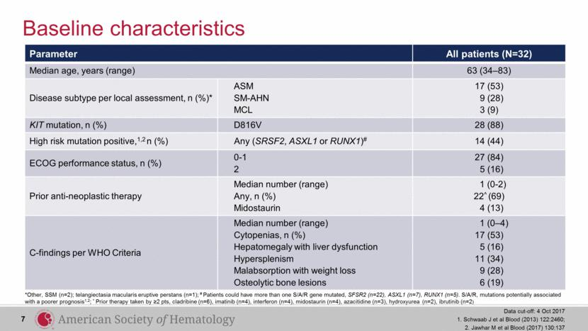

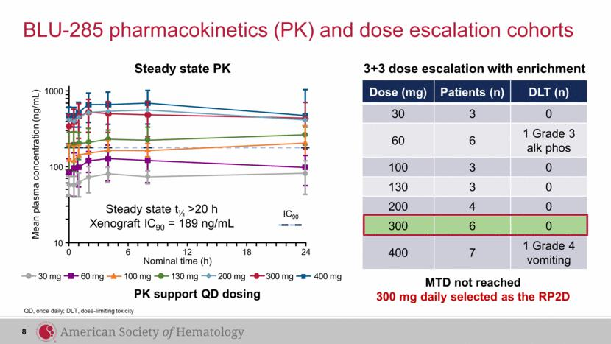

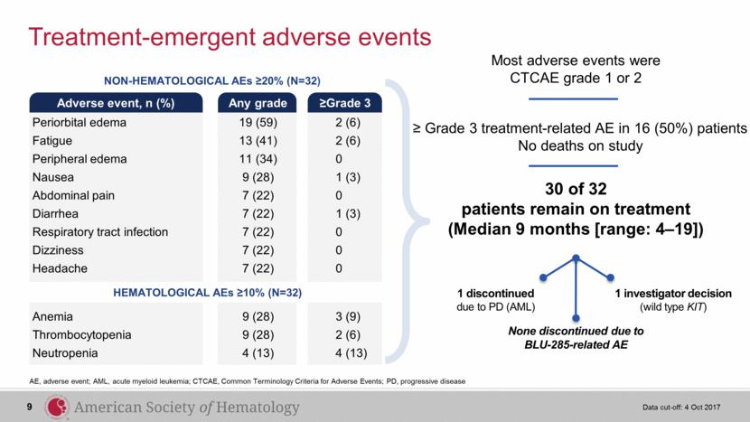

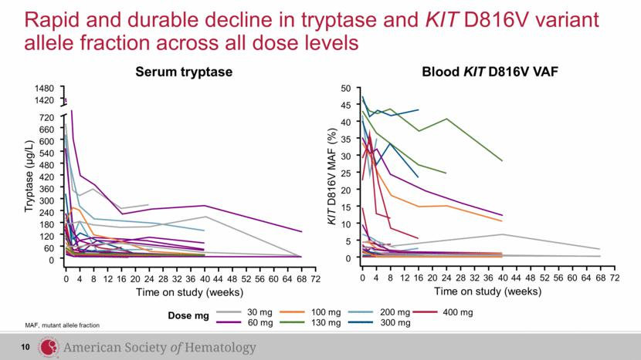

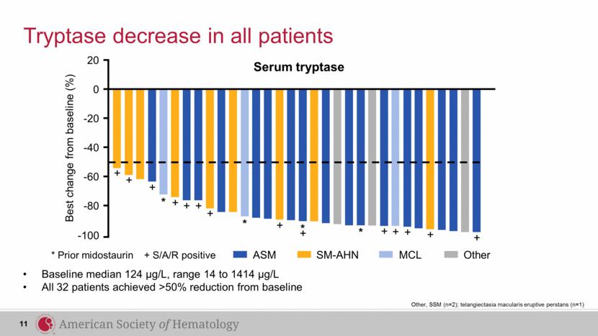

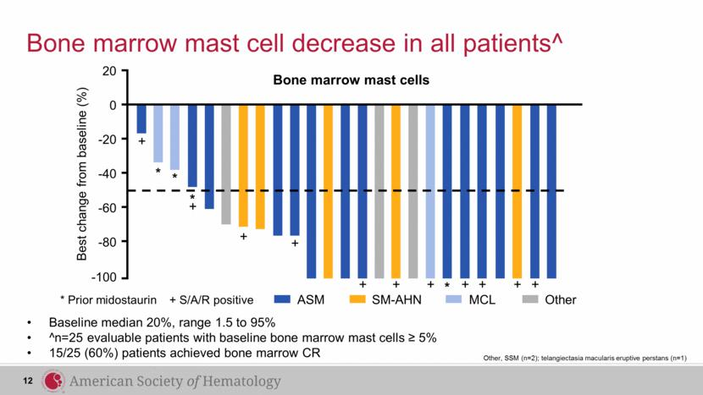

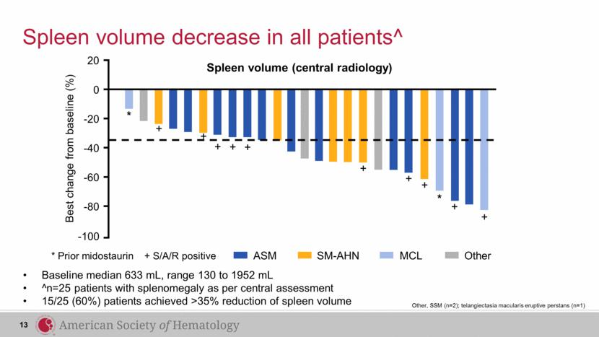

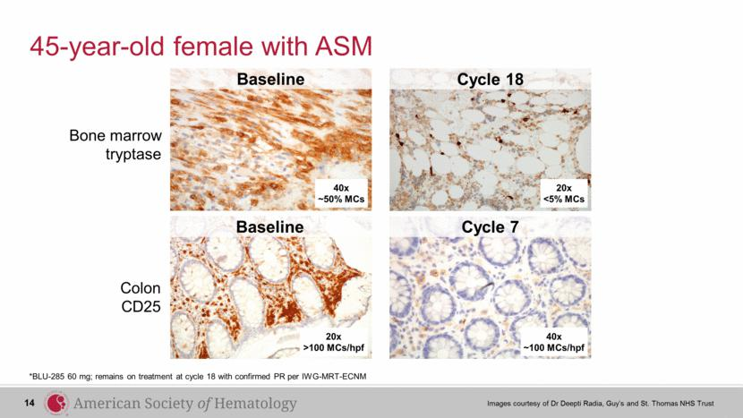

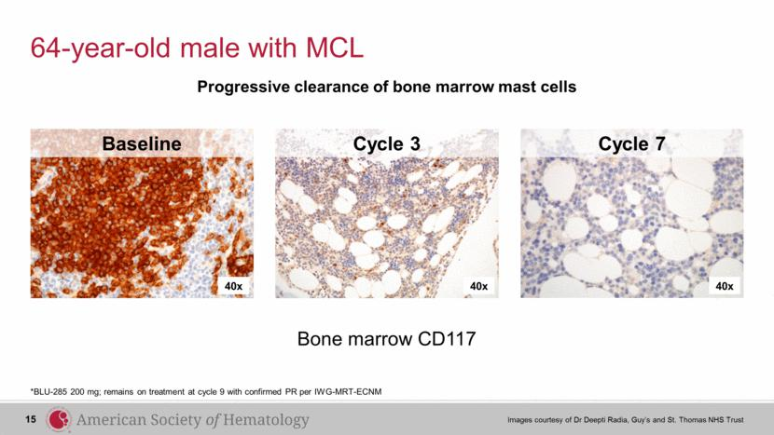

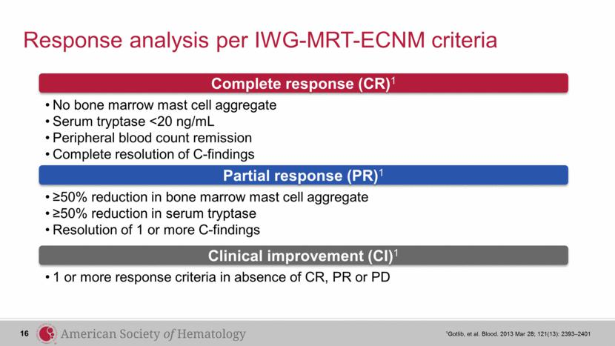

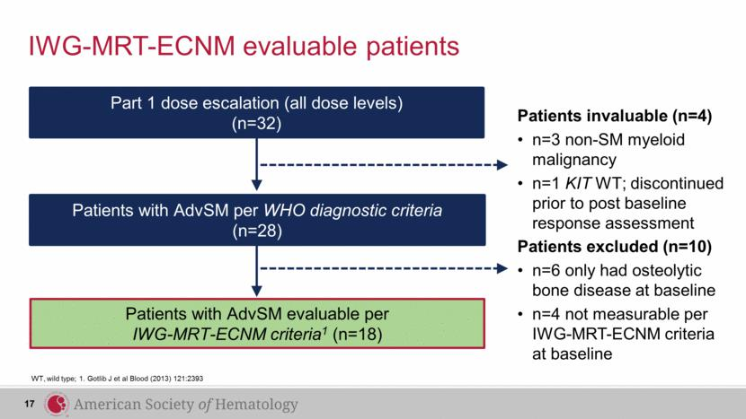

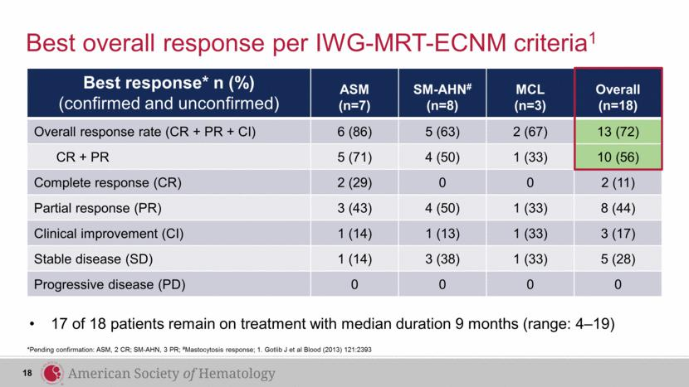

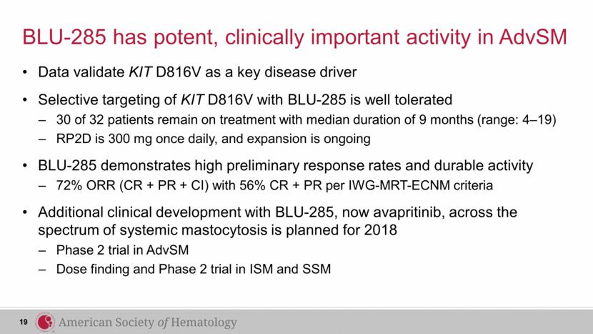

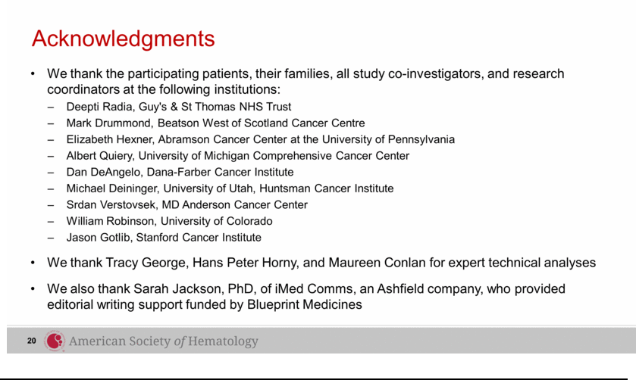

Exhibit 99.3




