UNITED STATES

SECURITIES AND EXCHANGE COMMISSION
Washington, D.C. 20549

FORM 8-K

CURRENT REPORT

Pursuant to Section 13 or 15(d)

of the Securities Exchange Act of 1934

Date of Report (Date of Earliest Event Reported): April 1, 2020

Blueprint Medicines Corporation

(Exact name of registrant as specified in its charter)

Delaware

(State or other jurisdiction

of incorporation)

001-37359

(Commission File Number)

26-3632015

(I.R.S. Employer

Identification No.)

45 Sidney Street

Cambridge, Massachusetts

(Address of principal executive offices)

02139

(Zip Code)

Registrant’s telephone number, including area code: (617) 374-7580

(Former name or former address, if changed since last report)

Check the appropriate box below if the Form 8-K filing is intended to simultaneously satisfy the filing obligation of the registrant under any of the following provisions:

- Written communications pursuant to Rule 425 under the Securities Act (17 CFR 230.425)

- Soliciting material pursuant to Rule 14a-12 under the Exchange Act (17 CFR 240.14a-12)

- Pre-commencement communications pursuant to Rule 14d-2(b) under the Exchange Act (17 CFR 240.14d-2(b))

- Pre-commencement communications pursuant to Rule 13e-4(c) under the Exchange Act (17 CFR 240.13e-4(c))

Indicate by check mark whether the registrant is an emerging growth company as defined in Rule 405 of the Securities Act of 1933 (§230.405 of this chapter) or Rule 12b-2 of the Securities Exchange Act of 1934 (§240.12b-2 of this chapter).

Emerging growth company ☐

If an emerging growth company, indicate by check mark if the registrant has elected not to use the extended transition period for complying with any new or revised financial accounting standards provided pursuant to Section 13(a) of the Exchange Act. ☐

Securities registered pursuant to Section 12(b) of the Exchange Act:

Title of each class | Trading symbol(s) | Name of each exchange on which registered
Common stock, par value $0.001 per share | BPMC | Nasdaq Global Select Market

Item 7.01 Regulation FD Disclosure.

Blueprint Medicines Corporation (the “Company”) from time to time presents and/or distributes to the investment community at various industry and other conferences slide presentations to provide updates and summaries of its business. The Company is posting to the “Investors & Media” portion of its website at http://ir.blueprintmedicines.com/ a copy of its current corporate slide presentation. A copy of the presentation is furnished as Exhibit 99.1 to this Current Report on Form 8-K.

The information in Item 7.01 of this Current Report on Form 8-K, including Exhibit 99.1 attached hereto, is intended to be furnished and shall not be deemed “filed” for purposes of Section 18 of the Securities Exchange Act of 1934, as amended (the “Exchange Act”), or otherwise subject to the liabilities of that section, nor shall it be deemed incorporated by reference in any filing under the Securities Act of 1933, as amended, or the Exchange Act, except as expressly set forth by specific reference in such filing.

Item 8.01 Other Events.

On April 1, 2020, the Company issued a press release reporting the achievement of a number of key milestones, including the top-line data from the Phase 1/2 ARROW trial in patients with RET mutant medullary thyroid cancer, the completion of the rolling new drug application submission for pralsetinib for RET fusion-positive non-small cell lung cancer, and the submission of an investigational new drug application for BLU-263 for the treatment of patients with indolent systemic mastocytosis. A copy of the press release is filed herewith as Exhibit 99.2 to this Current Report on Form 8-K and incorporated herein by reference.

Item 9.01 Financial Statements and Exhibits.

(d) Exhibits.
 | Exhibit No. |  |  | Description
 | 99.1 |  |  | Corporate slide presentation of Blueprint Medicines Corporation dated April 1, 2020
99.2 |  |  |  | Press release issued by Blueprint Medicines Corporation on April 1, 2020
104 |  |  |  | Cover Page Interactive Data File (embedded within the Inline XBRL document)
 |  |  | 2

SIGNATURES

Pursuant to the requirements of the Securities Exchange Act of 1934, the registrant has duly caused this report to be signed on its behalf by the undersigned hereunto duly authorized.

BLUEPRINT MEDICINES CORPORATION

Date: April 1, 2020 By: /s/ Jeffrey W. Albers

Jeffrey W. Albers

Chief Executive Officer

3

Exhibit 99.1


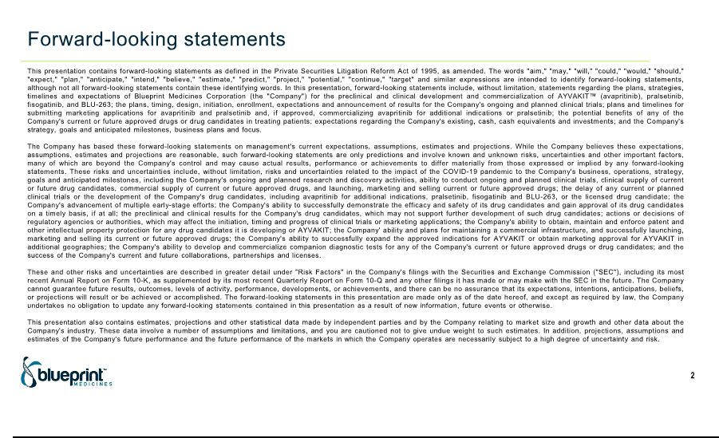

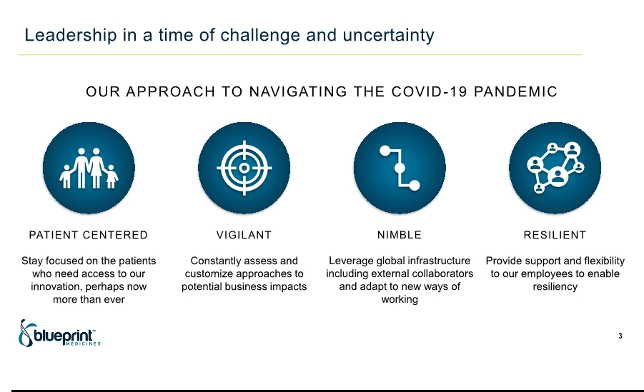

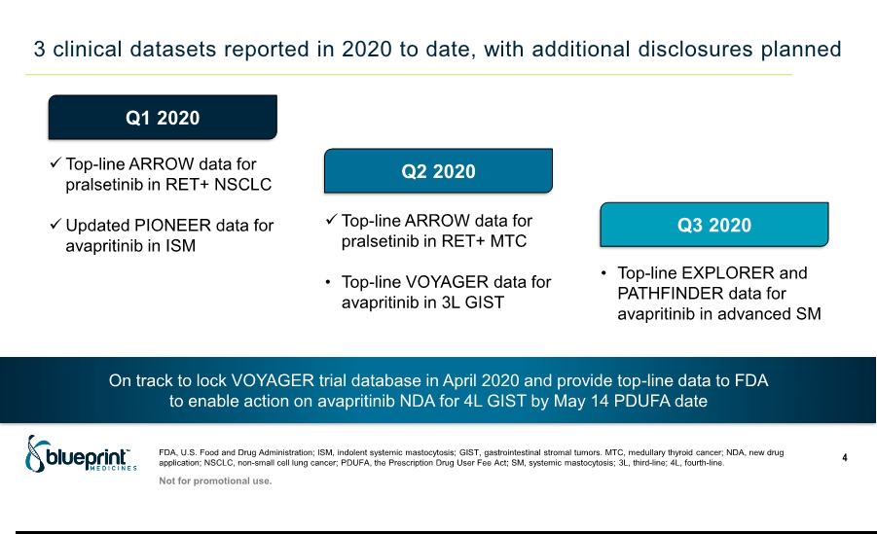

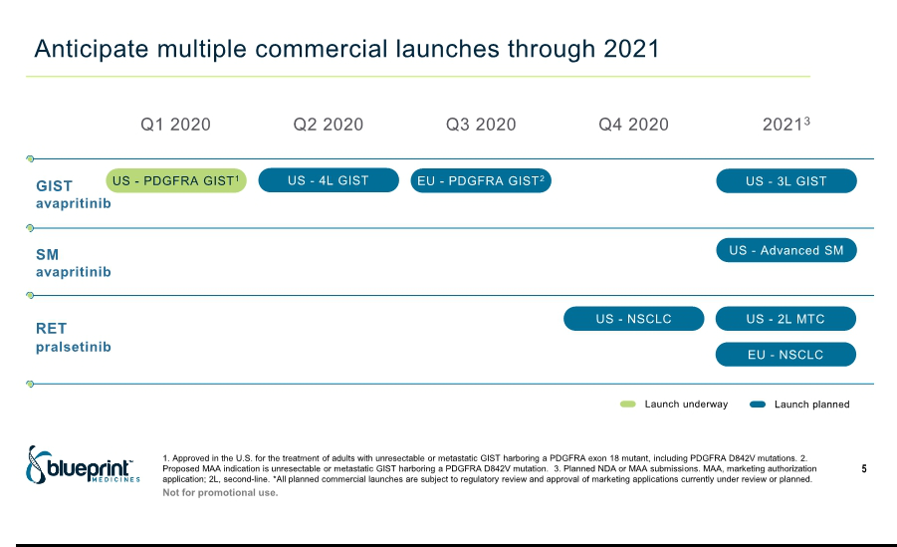

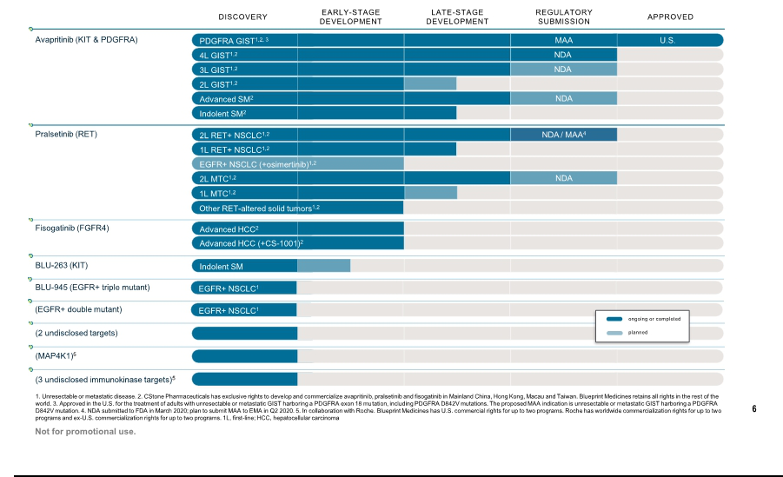

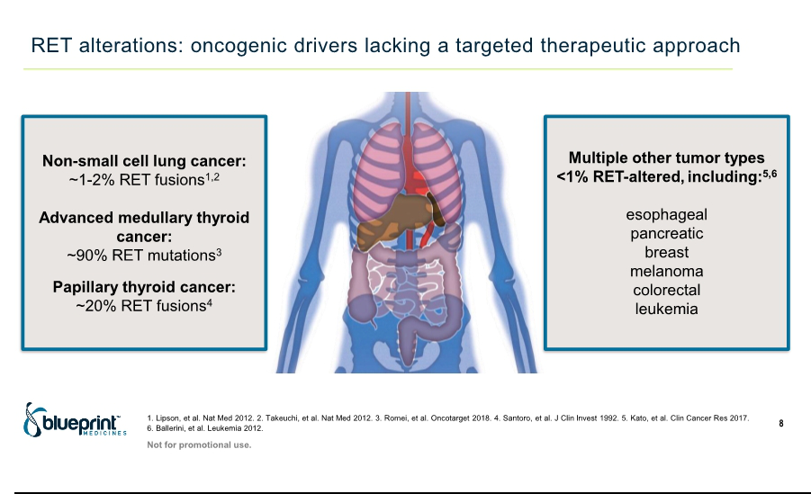

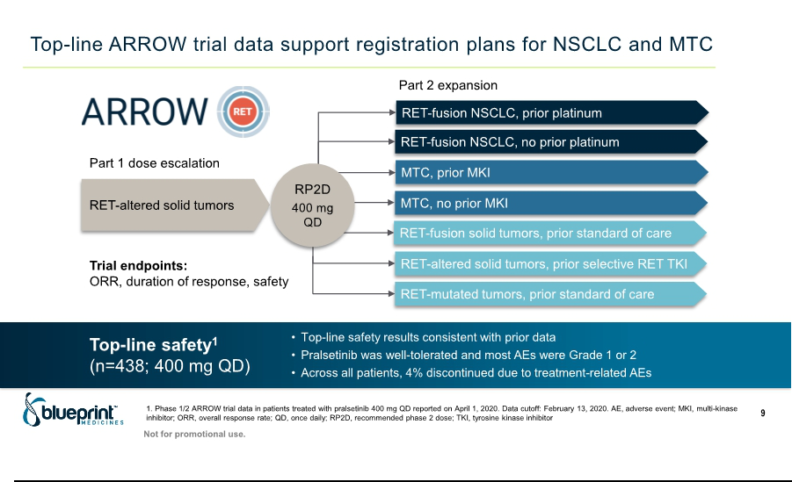

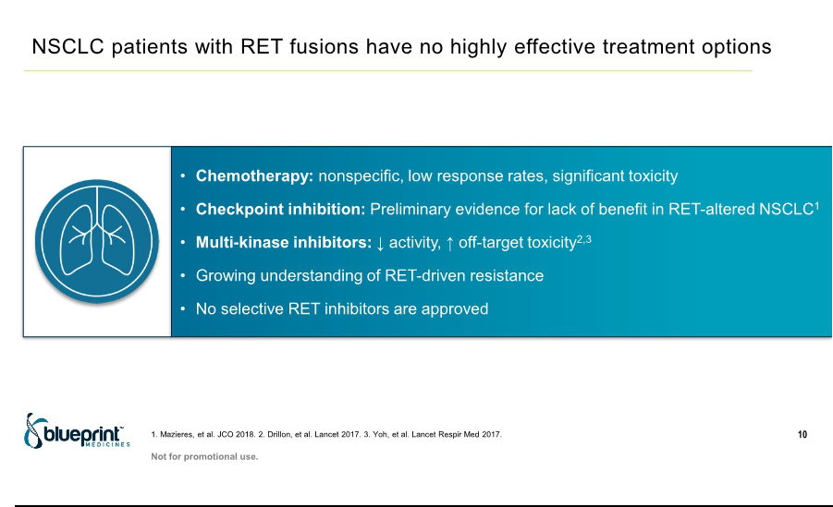

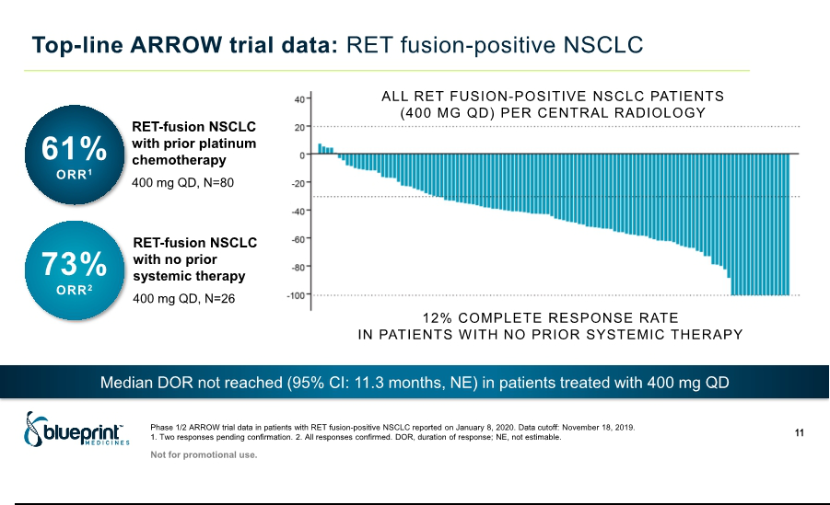

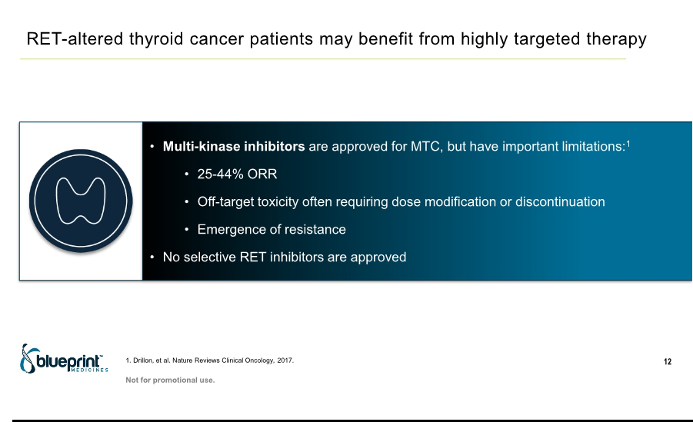

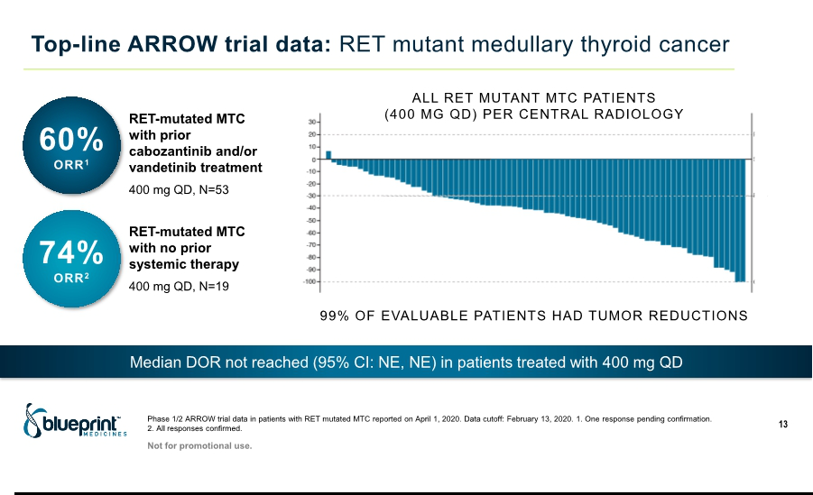

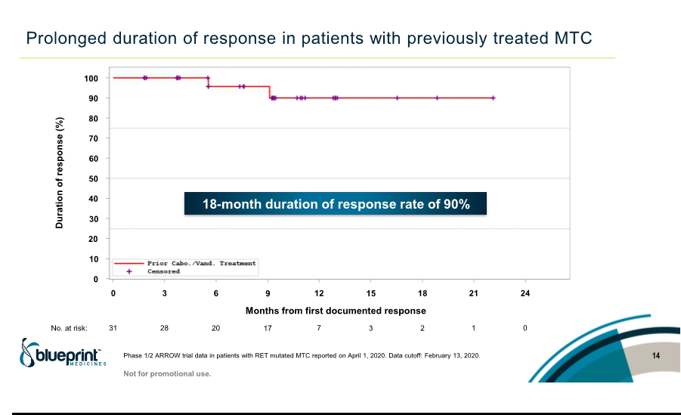

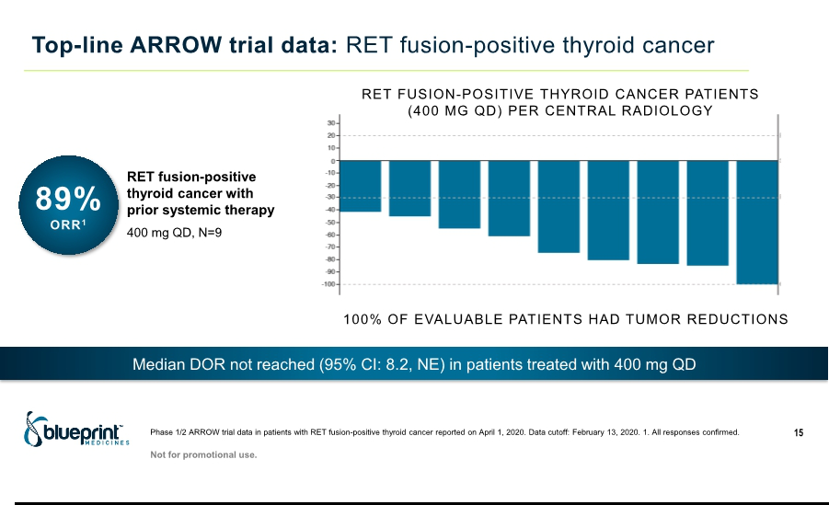

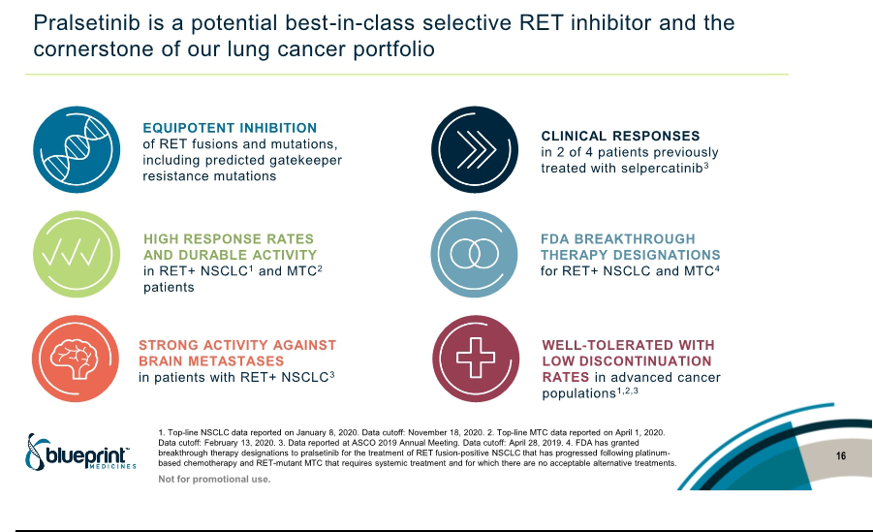

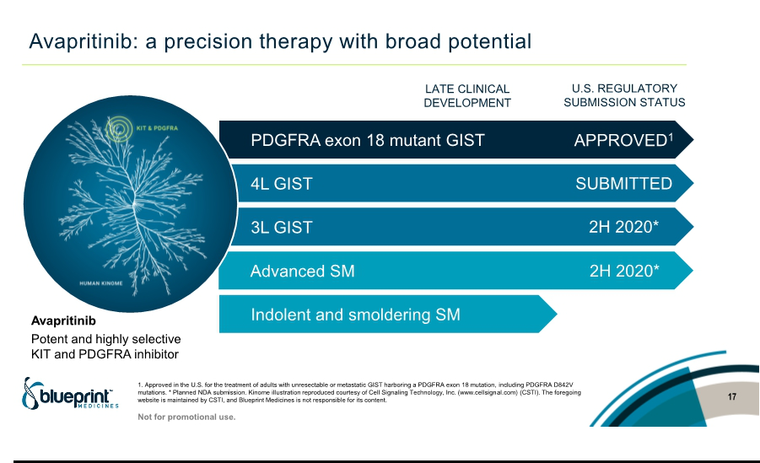

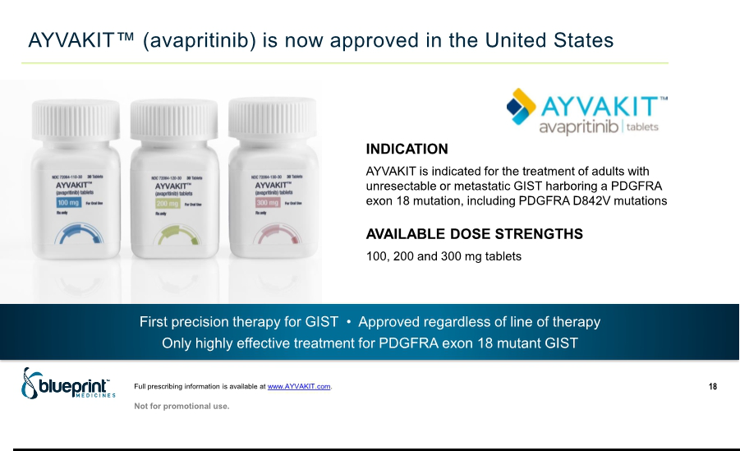

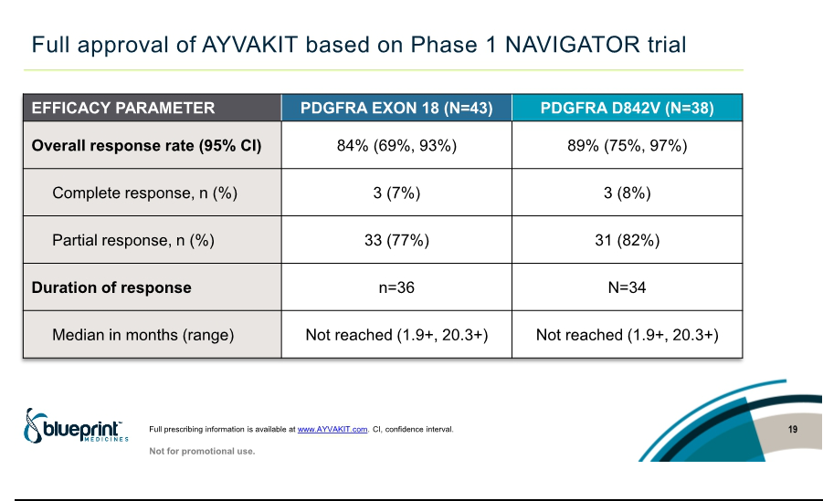

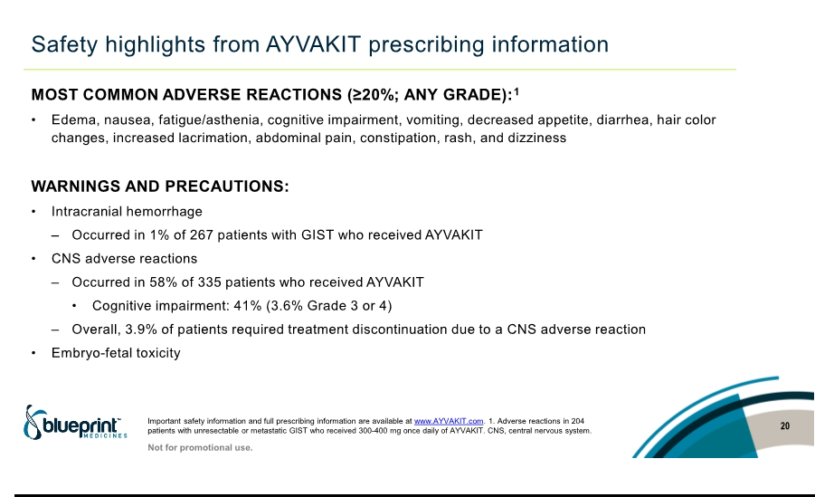

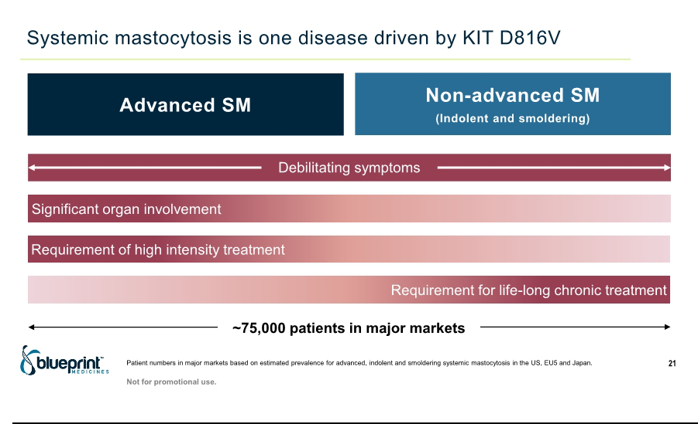

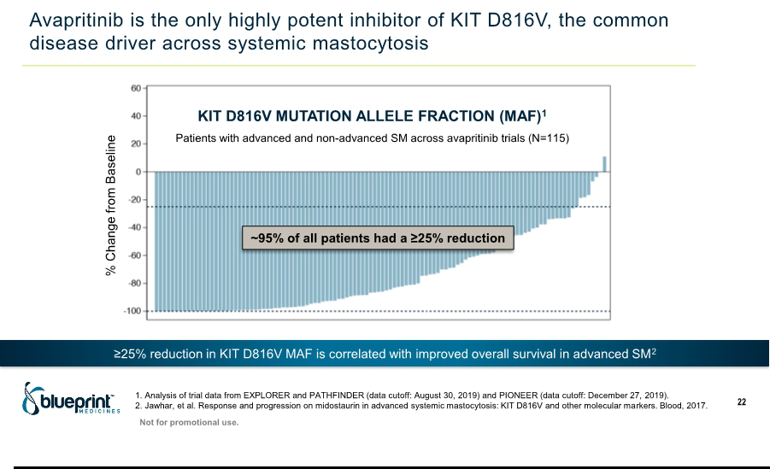

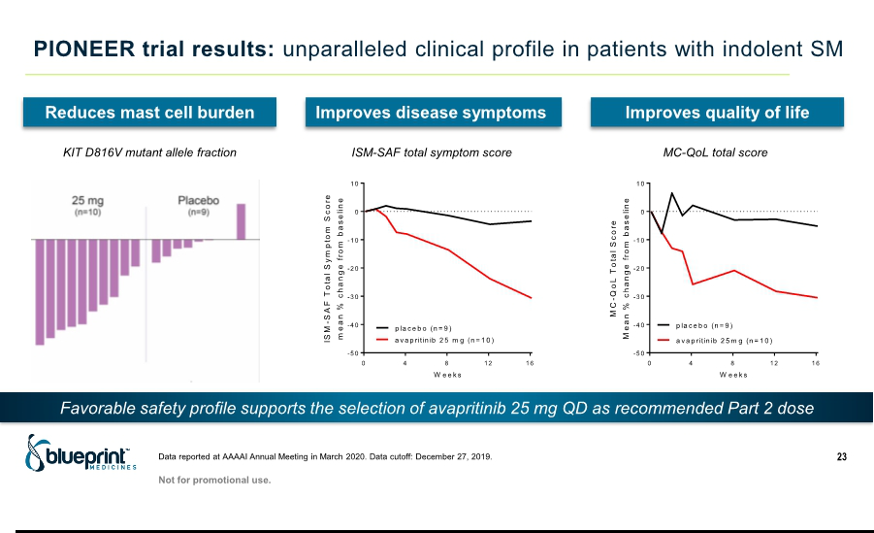

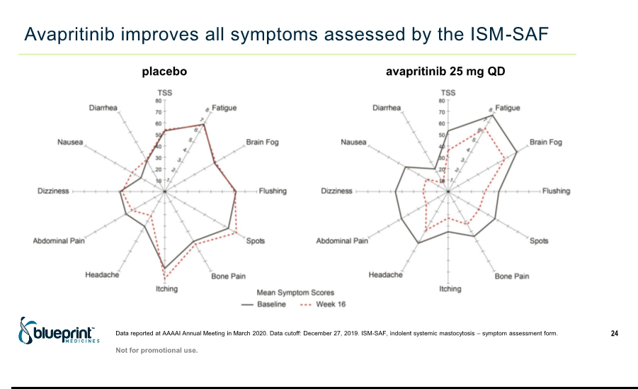

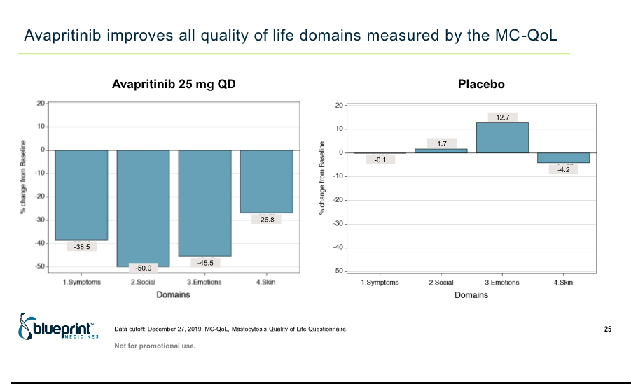

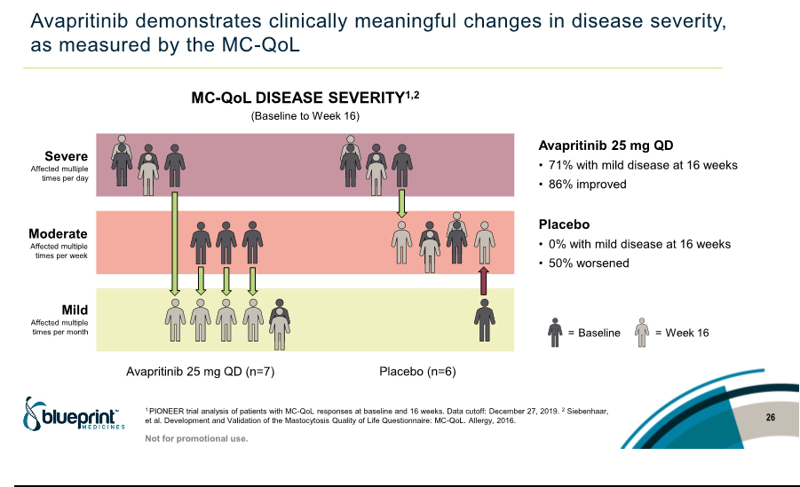

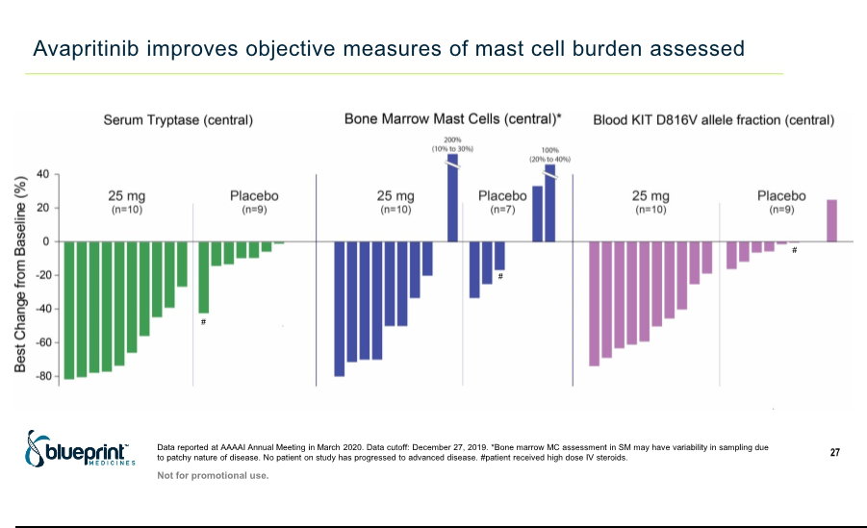

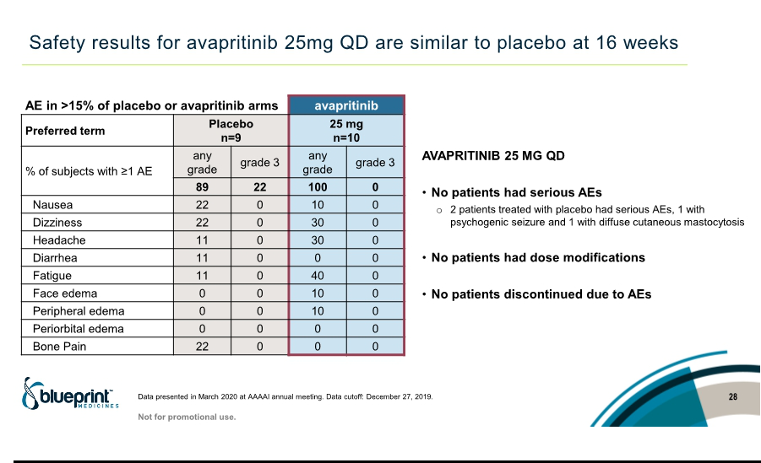

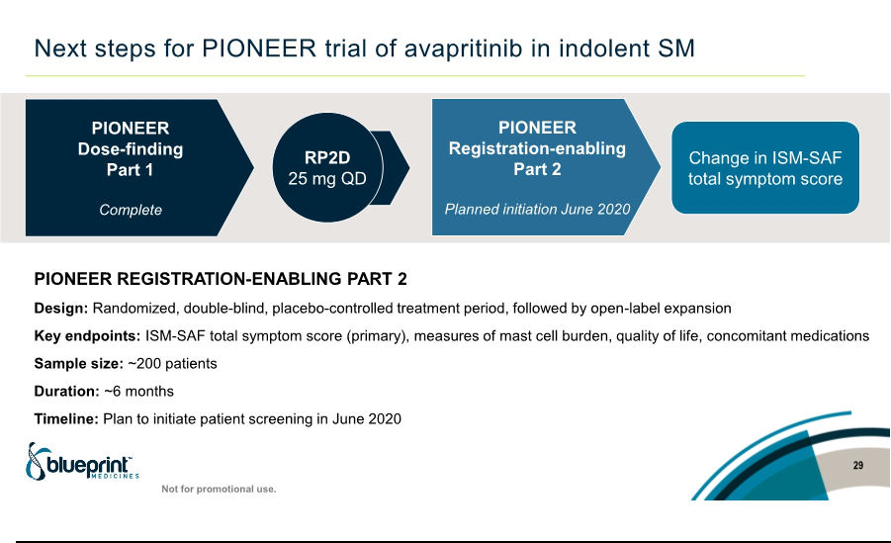

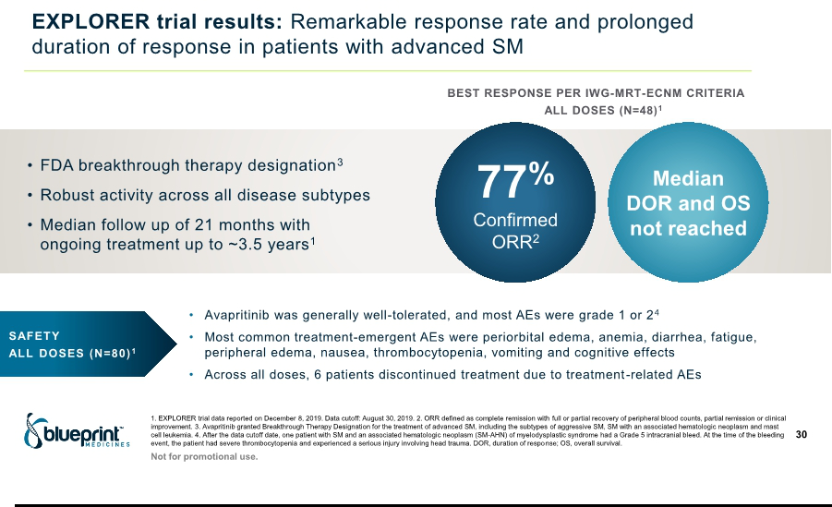

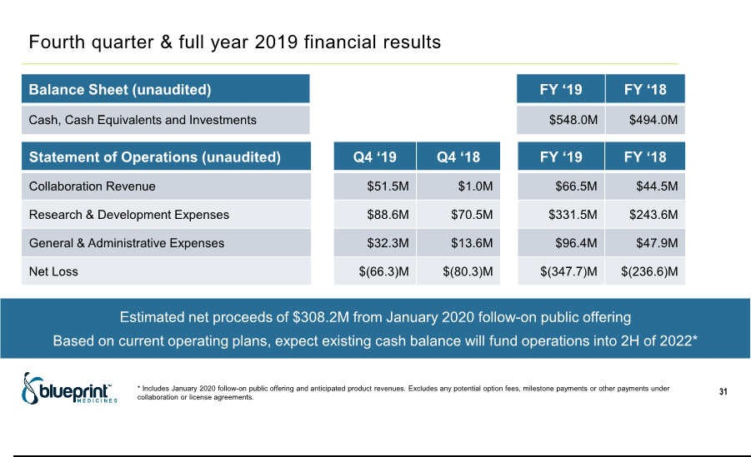

Exhibit 99.2

Blueprint Medicines Announces the Achievement of Key Portfolio Milestones

- Top-line ARROW trial data for pralsetinib show 60% overall response rate and 18-month duration of response rate of 90% in previously treated RET-mutant medullary thyroid cancer; plan to submit NDA to FDA in Q2 2020 --

--74% overall response rate in treatment-naïve RET-mutant medullary thyroid cancer
and 89% overall response rate in RET fusion-positive thyroid cancer --

-- NDA submitted to FDA for pralsetinib for RET fusion-positive non-small cell lung cancer --

-- IND application for BLU-263 in indolent systemic mastocytosis submitted to FDA --

CAMBRIDGE, Mass., April 1, 2020 – Blueprint Medicines Corporation (NASDAQ: BPMC), a precision therapy company focused on genomically defined cancers, rare diseases and cancer immunotherapy, today announced the achievement of key milestones reflecting portfolio-wide progress against the company’s 2020 goals. These milestones include the compilation of top-line data for pralsetinib in patients with RET-mutant medullary thyroid cancer (MTC), supporting plans to submit a new drug application (NDA) to the U.S. Food and Drug Administration (FDA) in the second quarter of 2020.

“As our company and the communities we serve face the COVID-19 pandemic, I am exceptionally proud of our team’s nimbleness and persistency in advancing multiple therapies across our portfolio for the patients who need them,” said Andy Boral, M.D., Ph.D., Chief Medical Officer at Blueprint Medicines. “I am particularly encouraged that we have advanced pralsetinib toward registration across multiple tumor types and have made strong progress on the avapritinib program, with a compelling dataset in patients with systemic mastocytosis reported last month. The top-line data announced today demonstrate the potential of pralsetinib to be a best-in-class therapy for patients with RET-altered thyroid cancers, with deep and durable responses in both the first-line and relapsed settings.”

Top-line Data from Phase 1/2 ARROW Trial in RET-Altered Thyroid Cancers

Top-line results announced today support Blueprint Medicines’ plans to submit an NDA for pralsetinib in patients with RET-mutant MTC previously treated with an approved multi-kinase inhibitor (MKI) in the second quarter of 2020. The registration endpoints are overall response rate (ORR) and duration of response (DOR), based on independent central radiology and Response Evaluation Criteria in Solid Tumors version 1.1 (RECIST 1.1) criteria.

Top-line efficacy data were reported for patients treated with pralsetinib who were evaluable for response assessment per RECIST 1.1, as determined by blinded independent central review. All patients received the proposed indicated dose of 400 mg once daily (QD). All results were as of a data cutoff date of February 13, 2020.

In 53 patients with RET-mutant MTC previously treated with cabozantinib or vandetanib, the ORR was 60 percent (95% CI: 46-74%) with one response pending confirmation. Nearly all patients (98 percent) had tumor shrinkage. The median DOR was not reached (95% CI: not estimable, not estimable), and the 18-month DOR rate was 90 percent (95% CI: 77-100%).

In addition, the top-line data showed robust clinical activity in treatment-naïve patients, supporting the potential of pralsetinib across lines of therapy. In 19 patients with RET-mutant MTC who had not received prior systemic treatment, the confirmed ORR was 74 percent (95% CI: 49-91%), and all patients had tumor shrinkage. The median DOR was not reached (95% CI: 7 months, not estimable), with 12 of 14 responders remaining in response for up to 15 months as of the data cutoff date.

In nine patients with RET fusion-positive thyroid cancer, the confirmed ORR was 89 percent (95% CI: 52-100%), and all patients
had tumor shrinkage. The median DOR was not reached (95% CI: 8 months, not estimable), with seven of eight responders remaining in response for up to 20 months as of the data cutoff date.

Top-line safety data were consistent with those previously reported. Pralsetinib was well-tolerated, and most treatment-related adverse events (AEs) were Grade 1 or 2. Across all patients enrolled in the ARROW trial treated at the proposed indicated dose of 400 mg QD (N=438), only 4 percent discontinued treatment with pralsetinib due to treatment-related AEs.

Blueprint Medicines plans to present the full data at a scientific meeting this year.

NDA Submission for Pralsetinib for RET Fusion-Positive NSCLC

Blueprint Medicines completed the rolling NDA submission for pralsetinib for RET fusion-positive non-small cell lung cancer (NSCLC). Blueprint Medicines requested priority review for the application, which, if granted, could result in a six-month review process.

Top-line Data from Phase 3 VOYAGER Trial in Third-Line GIST

Blueprint Medicines plans to lock the VOYAGER trial database in April and provide top-line data to the FDA for avapritinib in third-line gastrointestinal stromal tumor (GIST), to enable the FDA to take action on the proposed fourth-line GIST indication by the May 14, 2020 PDUFA date.

Submission of IND Application for BLU-263

Blueprint Medicines submitted an investigational new drug (IND) application to the FDA for BLU-263, a next-generation KIT inhibitor, for the treatment of patients with indolent systemic mastocytosis (SM). With its drug candidates avapritinib and BLU-263, Blueprint Medicines is pursuing a comprehensive strategy to address a broad population of patients with SM and other mast cell disorders.

About RET-Altered Solid Tumors

RET activating fusions and mutations are key disease drivers in many cancer types, including NSCLC and MTC. RET fusions are implicated in approximately 1 to 2 percent of patients with NSCLC and approximately 10 to 20 percent of patients with papillary thyroid cancer, while RET mutations are implicated in approximately 90 percent of patients with advanced MTC. In addition, oncogenic RET alterations are observed at low frequencies in colorectal, breast, pancreatic and other cancers, and RET fusions have been observed in patients with treatment-resistant EGFR-mutant NSCLC.

Currently, there are no approved therapies that selectively target RET-driven cancers, although there are several approved MKIs with RET activity being evaluated in clinical trials. To date, clinical activity attributable to RET inhibition has been uncertain for these approved MKIs, likely due to insufficient inhibition of RET and off-target toxicities. There is a need for precision therapies that provide durable clinical benefit by selectively targeting RET alterations and anticipated resistance mutations.

About Pralsetinib

Pralsetinib is an investigational, once-daily oral precision therapy specifically designed for highly potent and selective targeting of oncogenic RET alterations. Blueprint Medicines is developing pralsetinib for the treatment of patients with RET-altered NSCLC, MTC and other solid tumors. The FDA has granted Breakthrough Therapy Designation to pralsetinib for the treatment of

RET fusion-positive NSCLC that has progressed following platinum-based chemotherapy, and RET mutation-positive MTC that requires systemic treatment and for which there are no acceptable alternative treatments.

Pralsetinib was designed by Blueprint Medicines’ research team, leveraging the company’s proprietary compound library. In preclinical studies, pralsetinib consistently demonstrated sub-nanomolar potency against the most common RET fusions, activating mutations and predicted resistance mutations. In addition, pralsetinib

demonstrated markedly improved selectivity for RET compared to pharmacologically relevant kinases, including approximately 90-fold improved potency for RET versus VEGFR2. By suppressing primary and secondary mutants, pralsetinib has the potential to overcome and prevent the emergence of clinical resistance. Blueprint Medicines believes this approach will enable durable clinical responses across a diverse range of RET alterations, with a favorable safety profile.

Blueprint Medicines has an exclusive collaboration and license agreement with CStone Pharmaceuticals for the development and commercialization of pralsetinib and certain other drug candidates in Mainland China, Hong Kong, Macau and Taiwan. Blueprint Medicines retains development and commercial rights for pralsetinib in the rest of the world.

About Blueprint Medicines

Blueprint Medicines is a precision therapy company striving to improve human health. With a focus on genomically defined cancers, rare diseases and cancer immunotherapy, we are developing transformational medicines rooted in our leading expertise in protein kinases, which are proven drivers of disease. Our uniquely targeted, scalable approach empowers the rapid design and development of new treatments and increases the likelihood of clinical success. We have one FDA-approved precision therapy and are currently advancing multiple investigational medicines in clinical development, along with a number of research programs. For more information, visit www.BlueprintMedicines.com and follow us on Twitter (@BlueprintMeds) and LinkedIn.

Cautionary Note Regarding Forward-Looking Statements

This press release contains forward-looking statements within the meaning of the Private Securities Litigation Reform Act of 1995, as amended, including, without limitation, statements regarding plans and timelines for the development of pralsetinib and BLU-263, including the timing, design, implementation, initiation, enrollment, plans and announcement of results regarding Blueprint Medicines’ ongoing and planned clinical trials for pralsetinib and BLU-263; plans and timelines for submitting marketing applications for pralsetinib; the potential benefits of Blueprint Medicines’ current and future approved drugs or drug candidates in treating patients; Blueprint Medicines’ strategy, goals and anticipated milestones, business plans and focus. The words “aim,” “may,” “will,” “could,” “would,” “should,” “expect,” “plan,” “anticipate,” “intend,” “believe,” “estimate,” “predict,” “project,” “potential,” “continue,” “target” and similar expressions are intended to identify forward-looking statements, although not all forward-looking statements contain these identifying words. Any forward-looking statements in this press release are based on management’s current expectations and beliefs and are subject to a number of risks, uncertainties and important factors that may cause actual events or results to differ materially from those expressed or implied by any forward-looking statements contained in this press release, including, without limitation, risks and uncertainties related to the impact of the COVID-19 pandemic to Blueprint Medicines’ business, operations, strategy, goals and anticipated milestones, including Blueprint Medicines’ ongoing and planned research and discovery activities, ability to conduct ongoing and planned clinical trials, clinical supply of current or future drug candidates, commercial supply of current or future approved products, and launching, marketing and selling current or future approved products; Blueprint Medicines’ ability and plan in establishing a commercial infrastructure, and successfully launching, marketing and selling its approved product; the delay of any current or planned clinical trials or the development of Blueprint Medicines’ drug candidates or licensed drug candidate; Blueprint Medicines’ advancement of multiple early-stage efforts; Blueprint Medicines’ ability to successfully demonstrate the safety and efficacy of its drug candidates and gain approval of its drug candidates on a timely basis, if at all; the preclinical and clinical results for Blueprint Medicines’ drug candidates, which may not support further development of such drug candidates; actions of regulatory agencies, which may affect the initiation, timing and progress of clinical trials; Blueprint Medicines’ ability to develop and commercialize companion diagnostic tests for its current and future drug candidates; and the success of Blueprint Medicines’ current and future collaborations or licensing arrangements. These and other risks and uncertainties are described in greater detail in the section entitled “Risk Factors” in Blueprint Medicines’ filings with the Securities and Exchange Commission (SEC), including Blueprint Medicines’ most recent Annual Report on Form 10-K, as supplemented by its most recent Quarterly Report on Form 10-Q and any other filings that Blueprint Medicines has made or may make with the SEC in the future. Any forward-looking

statements contained in this press release represent Blueprint Medicines’ views only as of the date hereof and should not be relied upon as representing its views as of any subsequent date. Except as required by law, Blueprint Medicines explicitly disclaims any obligation to update any forward-looking statements.

Investor Relations Contact

Kristin Hodous
617-714-6674
ir@blueprintmedicines.com

Media Relations Contact

Andrew Law
617-844-8205
media@blueprintmedicines.com

