UNITED STATES

SECURITIES AND EXCHANGE COMMISSION
Washington, D.C. 20549

FORM 8-K

CURRENT REPORT

Pursuant to Section 13 or 15(d)

of the Securities Exchange Act of 1934

Date of Report (Date of Earliest Event Reported): January 13, 2020

Blueprint Medicines Corporation

(Exact name of registrant as specified in its charter)

Delaware

(State or other jurisdiction

of incorporation)

001-37359

(Commission File Number)

26-3632015

(I.R.S. Employer

Identification No.)

45 Sidney Street

Cambridge, Massachusetts

(Address of principal executive offices)

02139

(Zip Code)

Registrant’s telephone number, including area code: (617) 374-7580

(Former name or former address, if changed since last report)

Check the appropriate box below if the Form 8-K filing is intended to simultaneously satisfy the filing obligation of the registrant under any of the following provisions:

- Written communications pursuant to Rule 425 under the Securities Act (17 CFR 230.425)

- Soliciting material pursuant to Rule 14a-12 under the Exchange Act (17 CFR 240.14a-12)

- Pre-commencement communications pursuant to Rule 14d-2(b) under the Exchange Act (17 CFR 240.14d-2(b))

- Pre-commencement communications pursuant to Rule 13e-4(c) under the Exchange Act (17 CFR 240.13e-4(c))

Indicate by check mark whether the registrant is an emerging growth company as defined in Rule 405 of the Securities Act of 1933 (§230.405 of this chapter) or Rule 12b-2 of the Securities Exchange Act of 1934 (§240.12b-2 of this chapter).

Emerging growth company ☐

If an emerging growth company, indicate by check mark if the registrant has elected not to use the extended transition period for complying with any new or revised financial accounting standards provided pursuant to Section 13(a) of the Exchange Act. ☐

Securities registered pursuant to Section 12(b) of the Exchange Act:

Title of each class | Trading symbol(s) | Name of each exchange on which registered
Common stock, par value $0.001 per share | BPMC | Nasdaq Global Select Market

Item 7.01 Regulation FD Disclosure.

Blueprint Medicines Corporation (the “Company”) from time to time presents and/or distributes to the investment community at various industry and other conferences slide presentations to provide updates and summaries of its business. The Company is posting to the “Investors & Media” portion of its website at http://ir.blueprintmedicines.com/ a copy of its current corporate slide presentation. A copy of the presentation is furnished as Exhibit 99.1 to this Current Report on Form 8-K.

The information in Item 7.01 of this Current Report on Form 8-K, including Exhibit 99.1 attached hereto, is intended to be furnished and shall not be deemed “filed” for purposes of Section 18 of the Securities Exchange Act of 1934, as amended (the “Exchange Act”), or otherwise subject to the liabilities of that section, nor shall it be deemed incorporated by reference in any filing under the Securities Act of 1933, as amended, or the Exchange Act, except as expressly set forth by specific reference in such filing.

Item 8.01 Other Events.

On January 13, 2020, the Company issued a press release announcing its corporate goals for 2020. A copy of the press release is filed herewith as Exhibit 99.2 to this Current Report on Form 8-K and incorporated herein by reference.

Item 9.01 Financial Statements and Exhibits.

(d) Exhibits.
Exhibit No. |  |  | Description
99.1 |  |  | Corporate slide presentation of Blueprint Medicines Corporation dated January 13, 2020
99.2 |  |  | Press release issued by Blueprint Medicines Corporation on January 13, 2020
104 |  |  | Cover Page Interactive Data File (embedded within the Inline XBRL document)
 |  | 2

SIGNATURES

Pursuant to the requirements of the Securities Exchange Act of 1934, the registrant has duly caused this report to be signed on its behalf by the undersigned hereunto duly authorized.

BLUEPRINT MEDICINES CORPORATION

Date: January 13, 2020 By: /s/ Jeffrey W. Albers

Jeffrey W. Albers

Chief Executive Officer

3

Exhibit 99.1


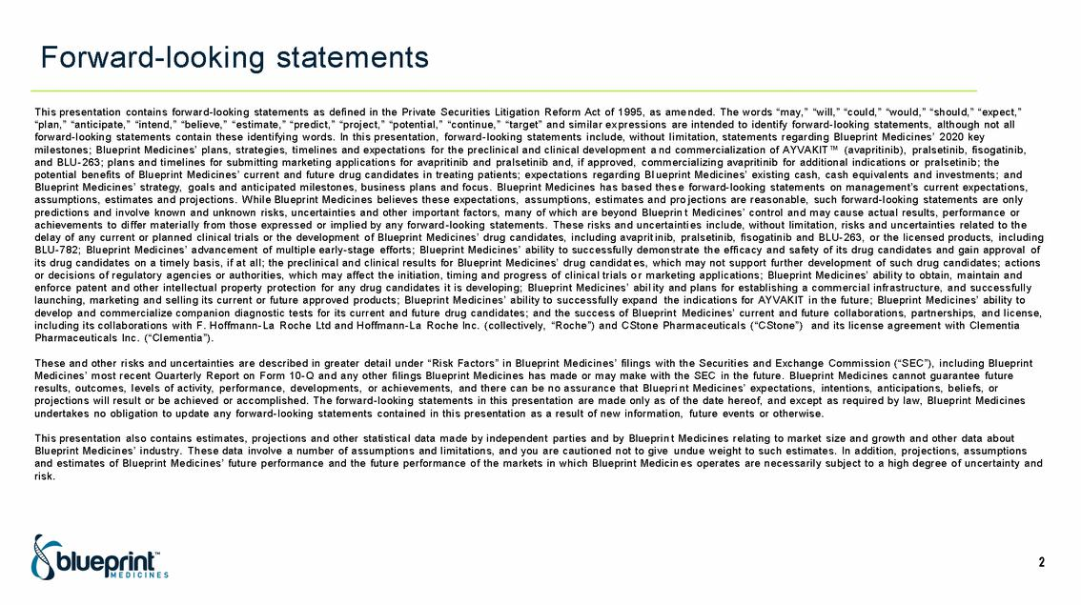

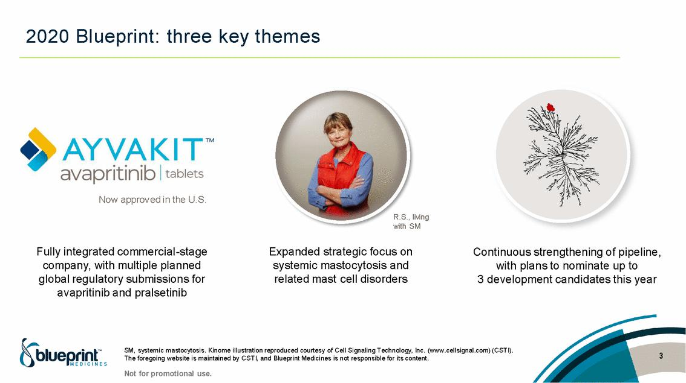

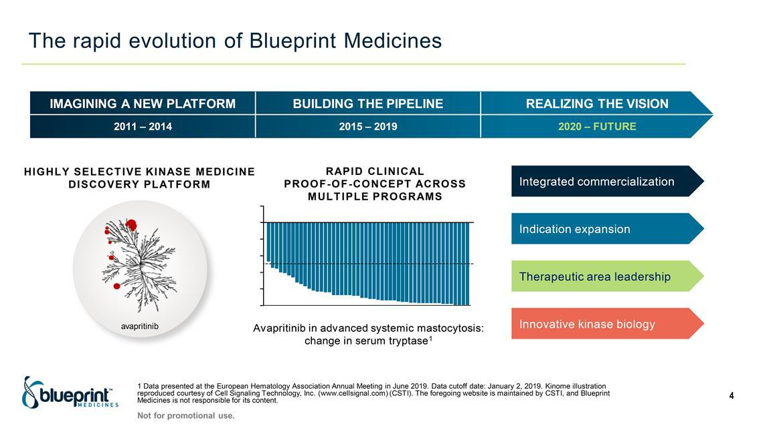

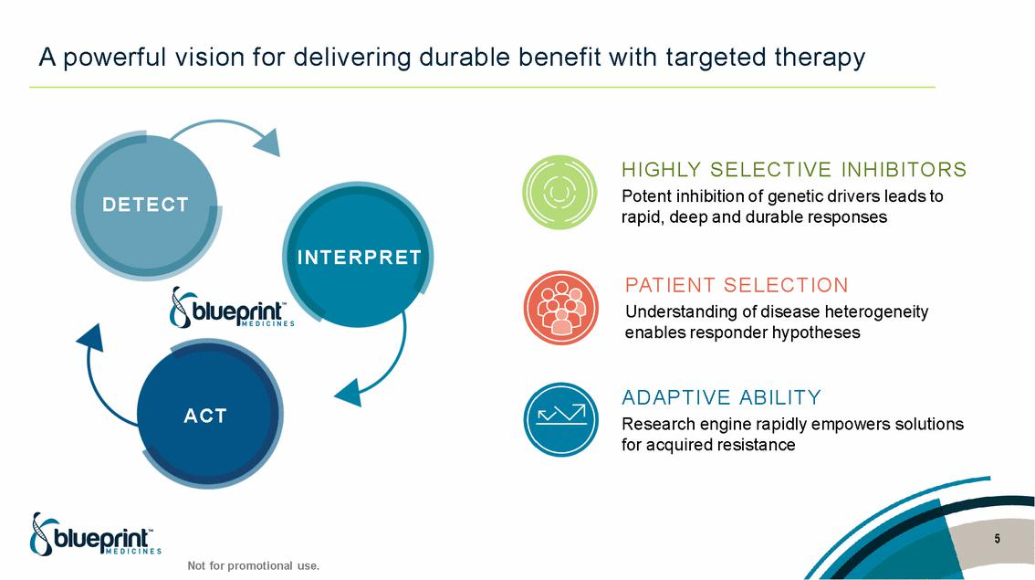

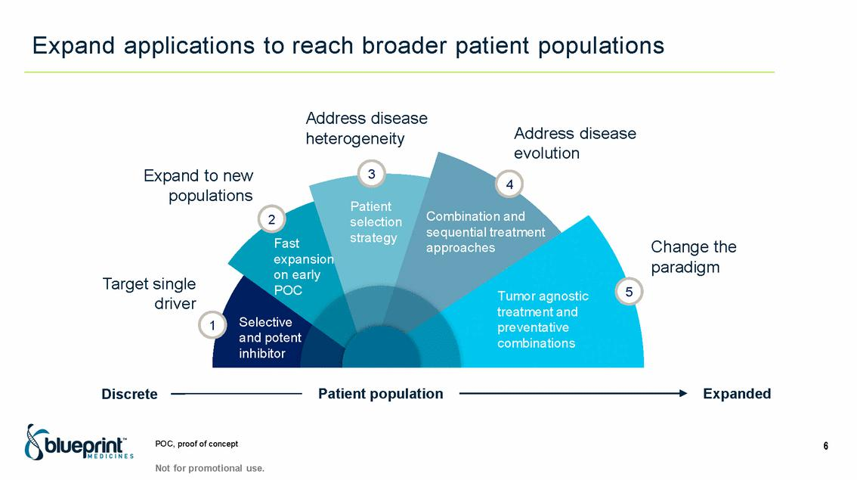

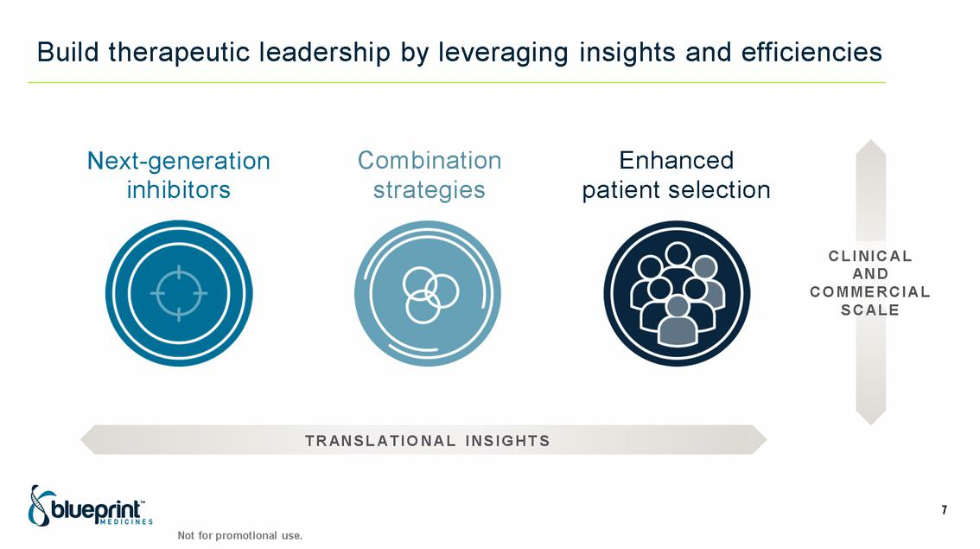

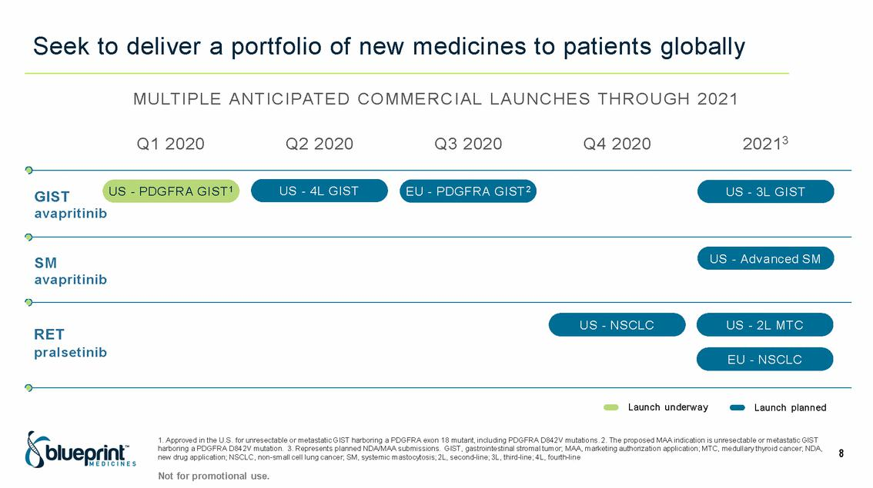

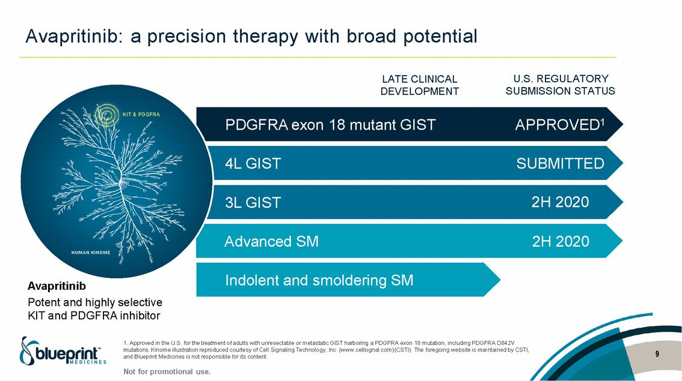

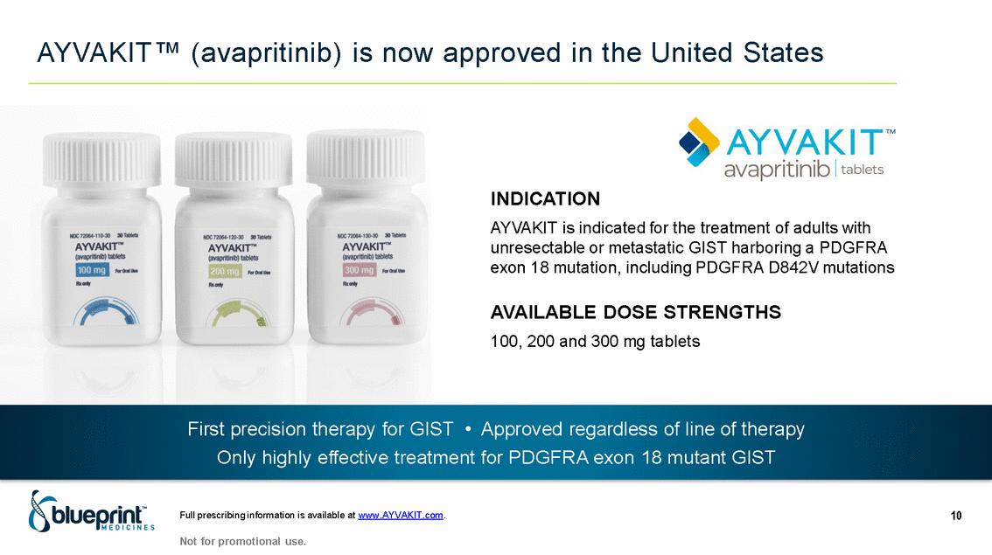

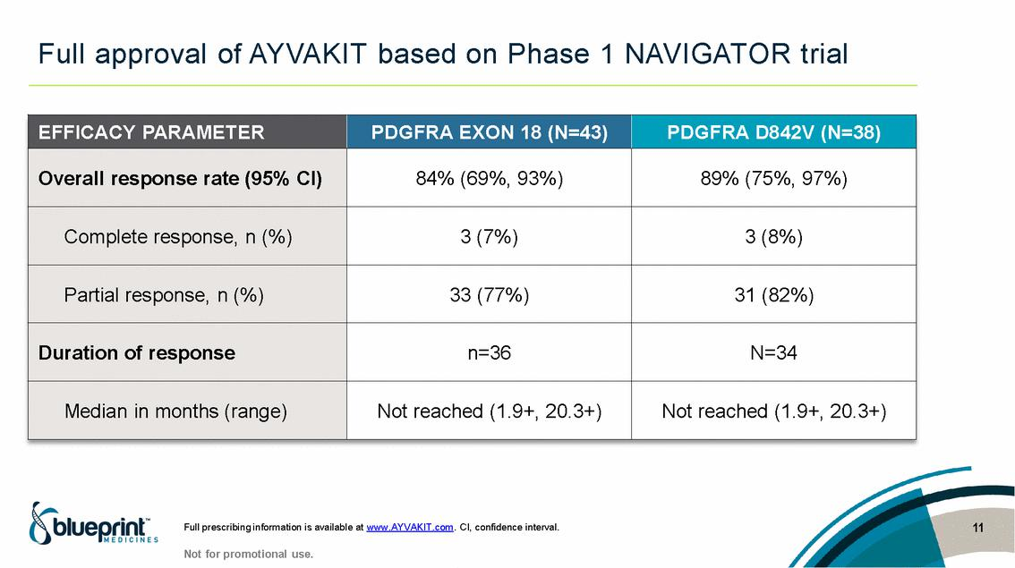

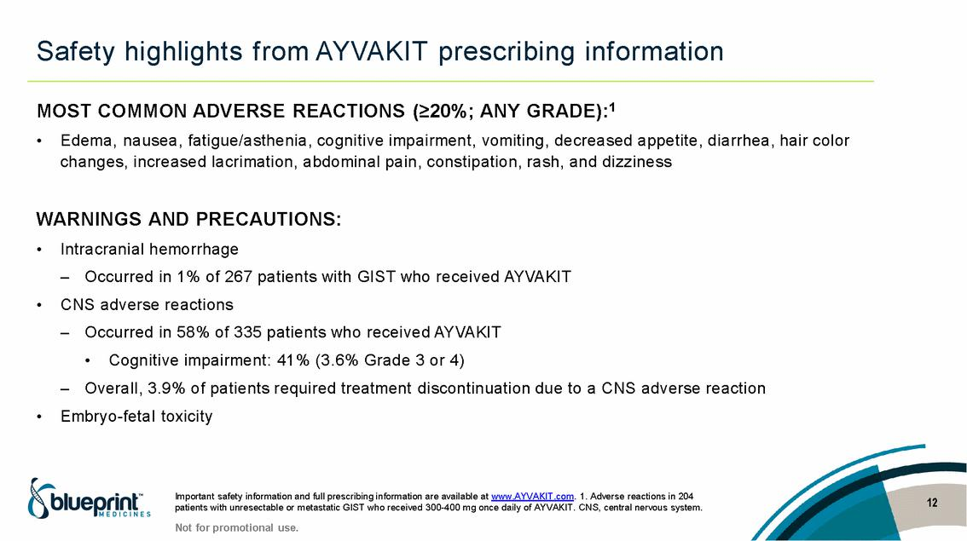

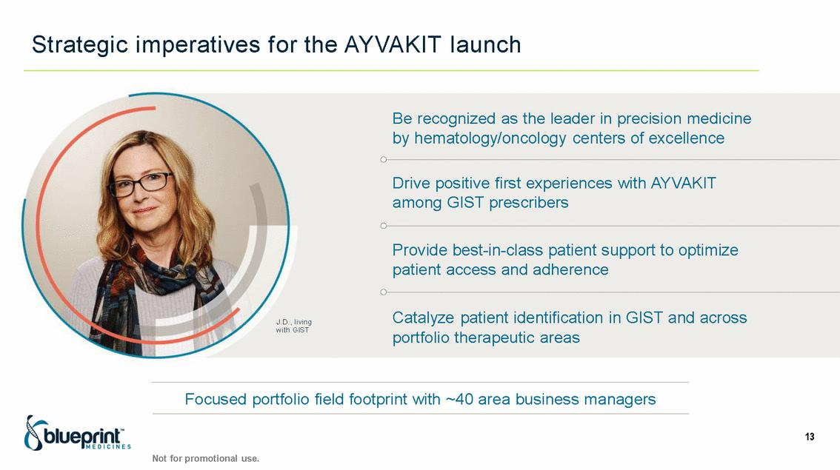

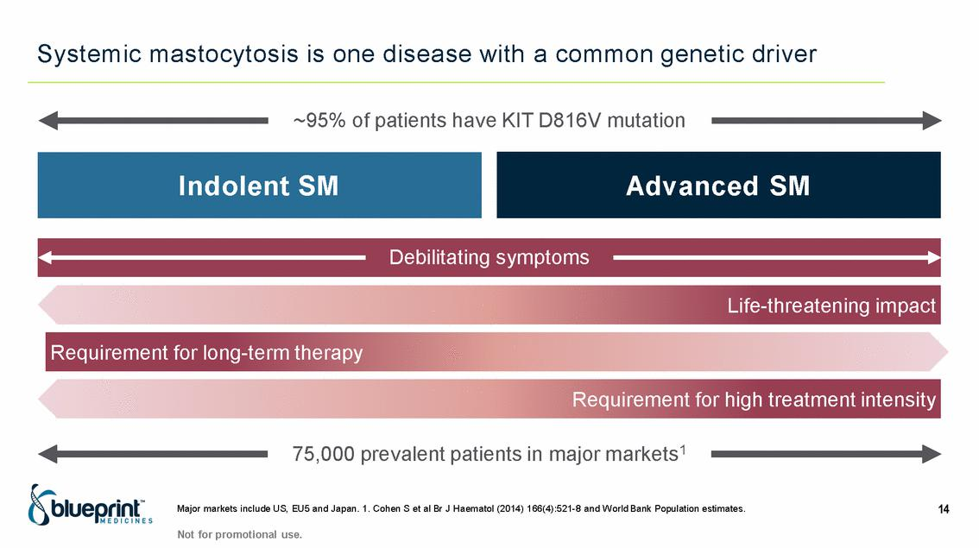

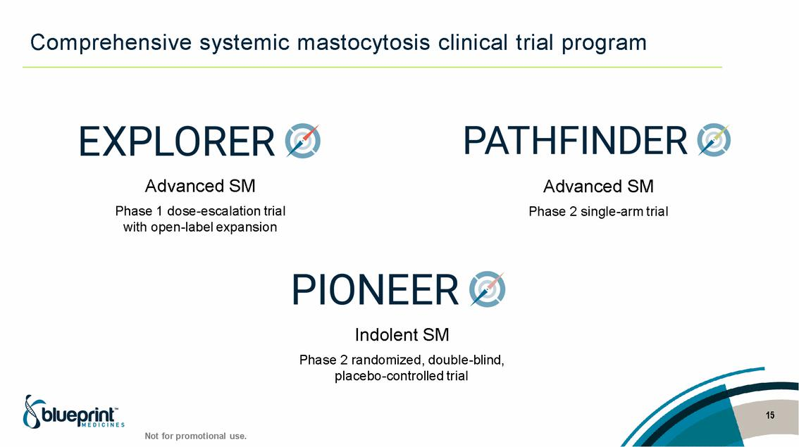

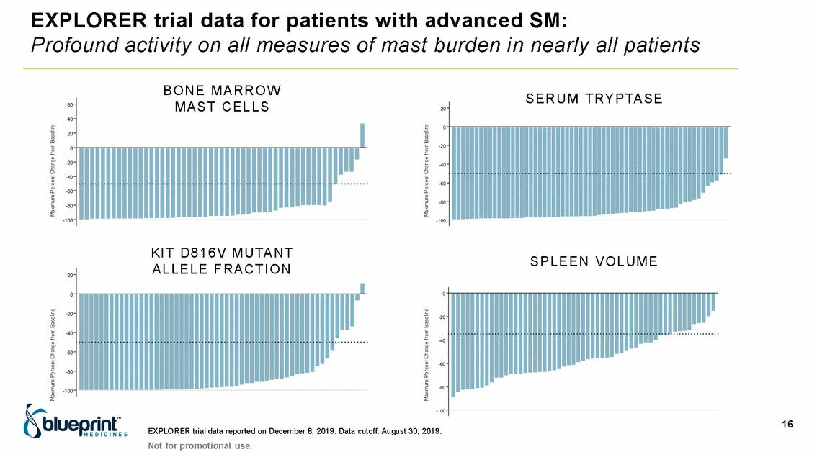

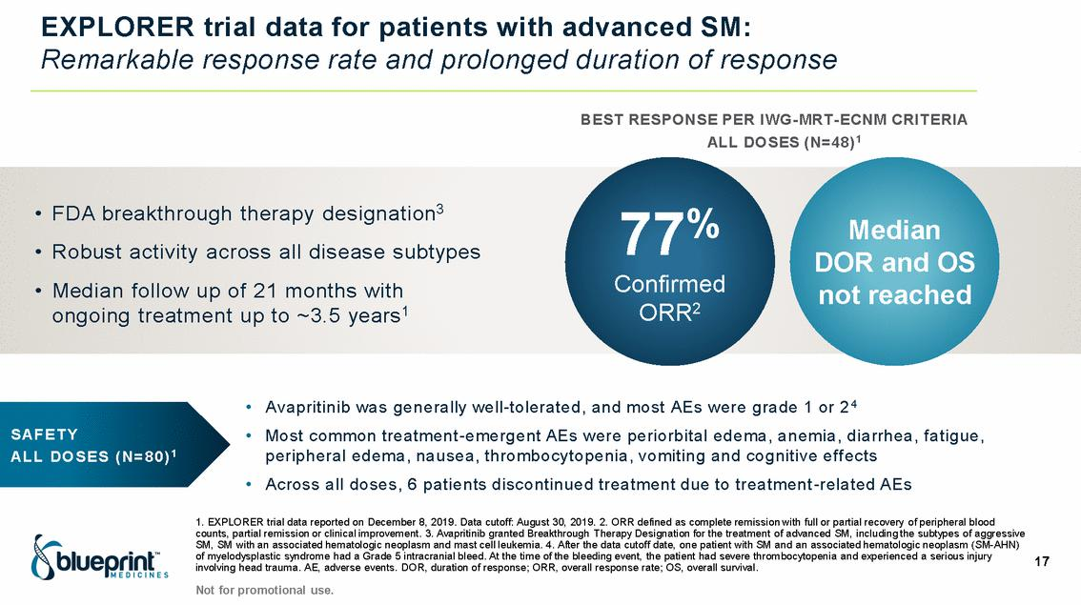

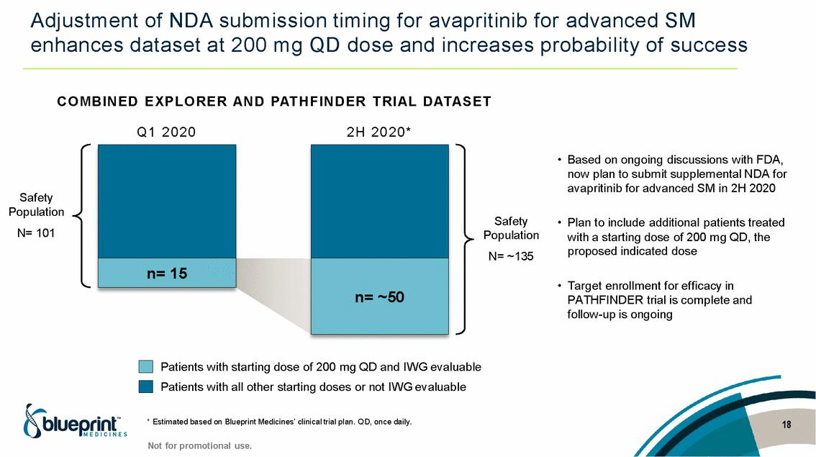

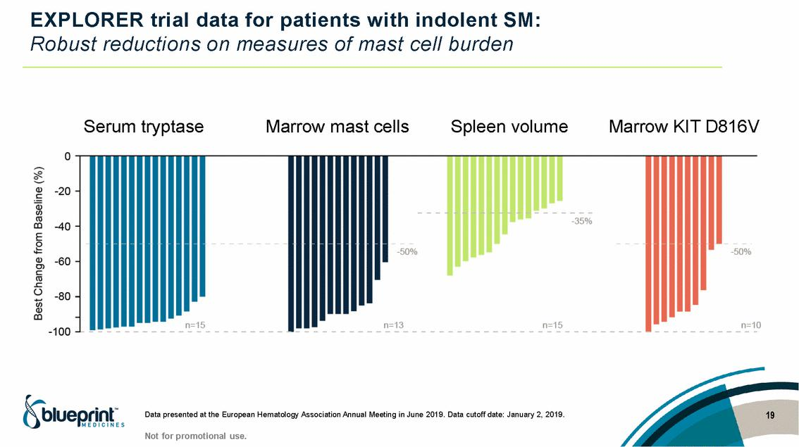

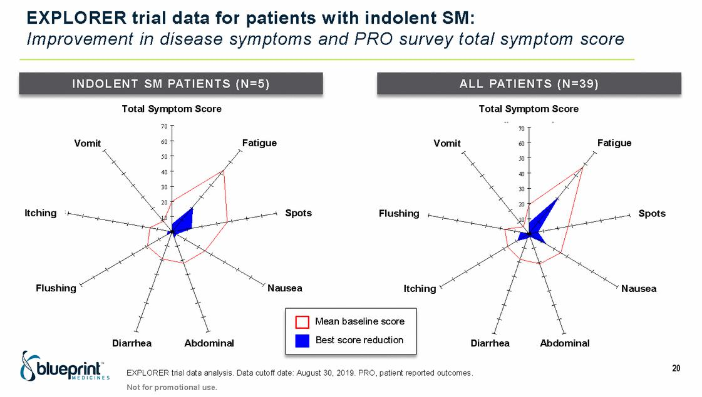

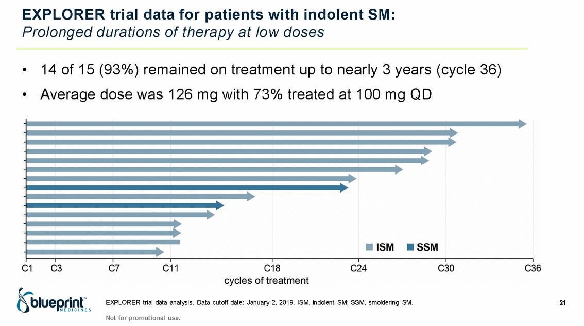

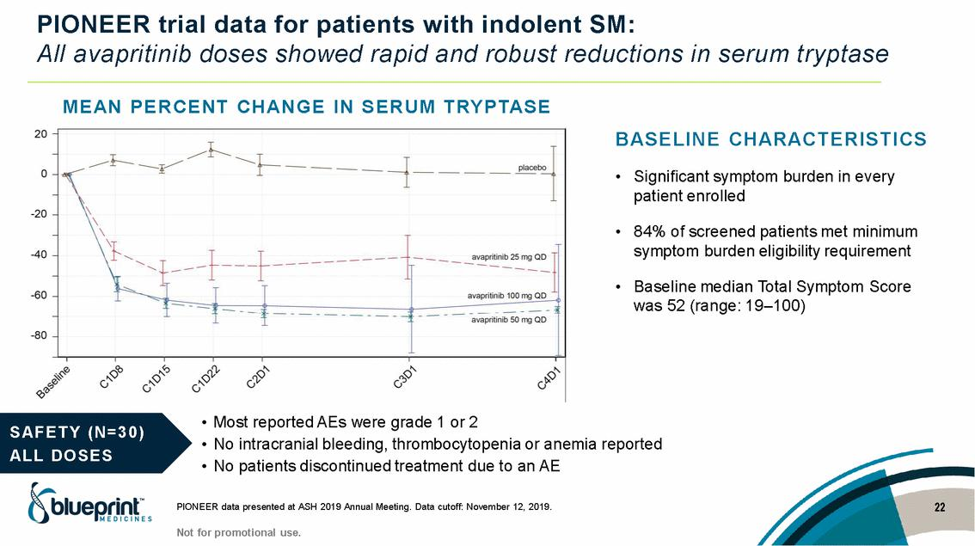

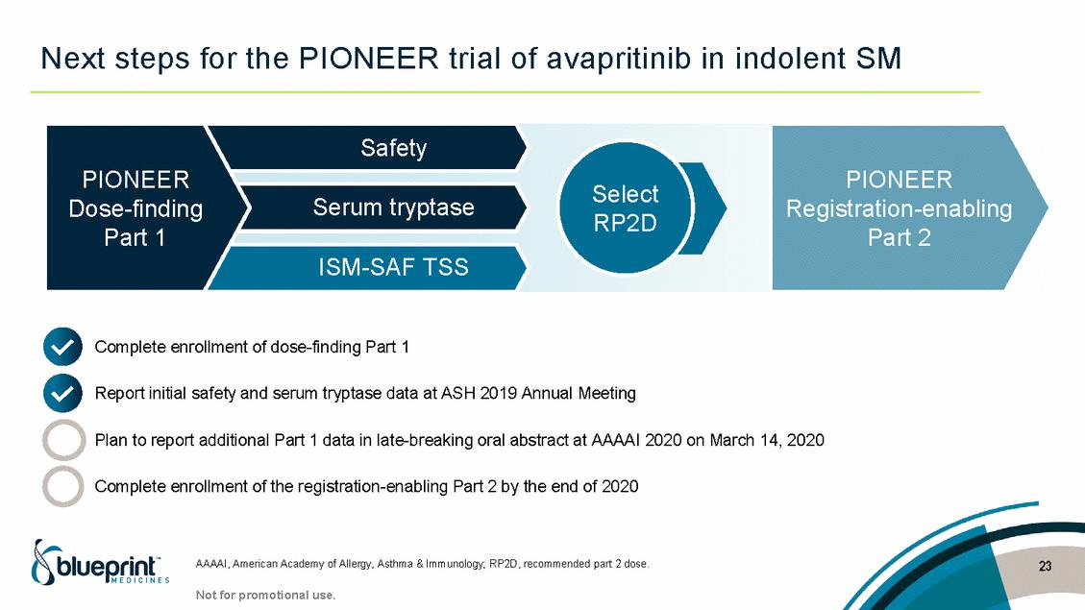

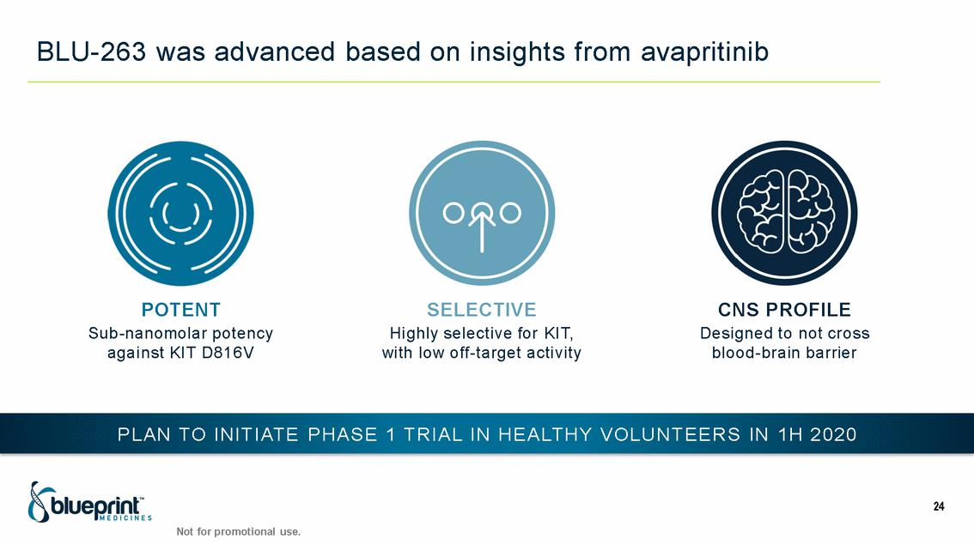

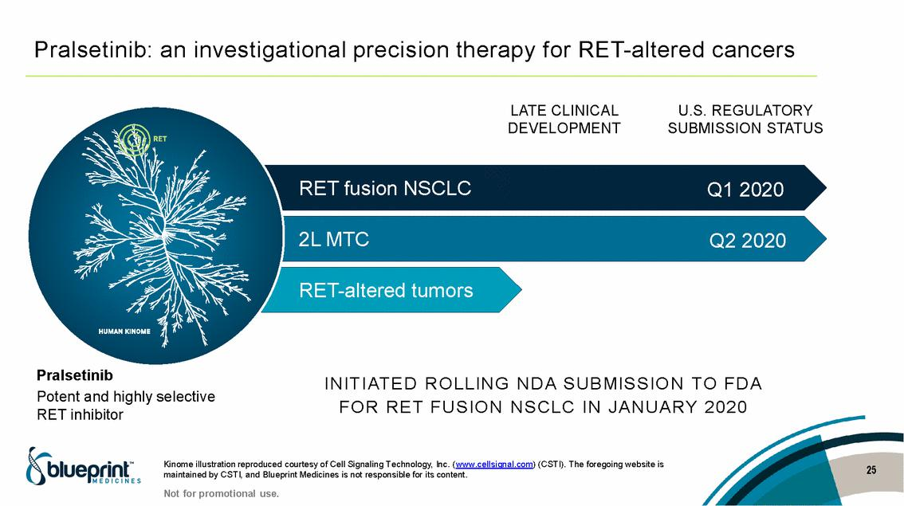

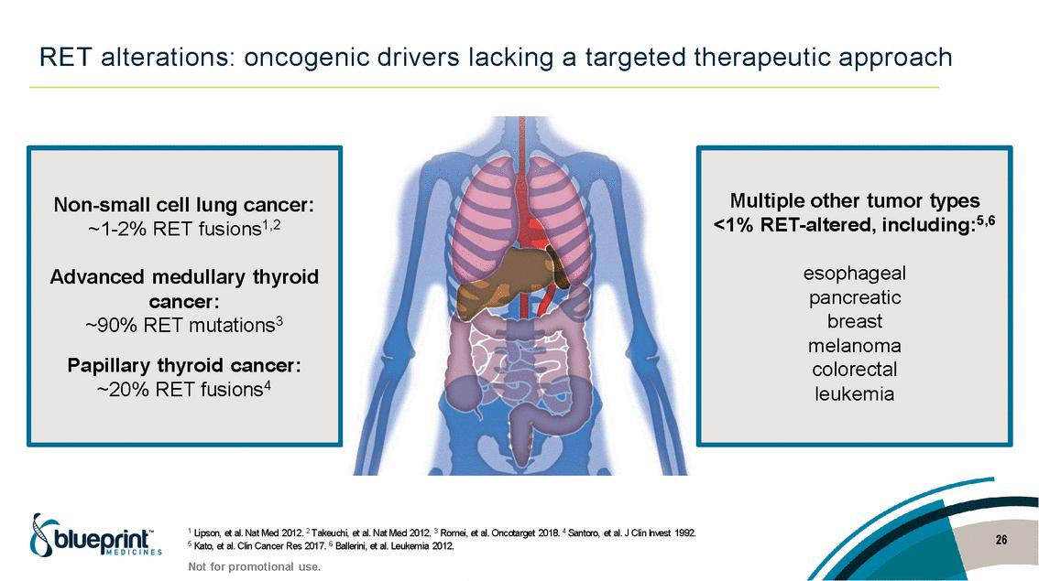

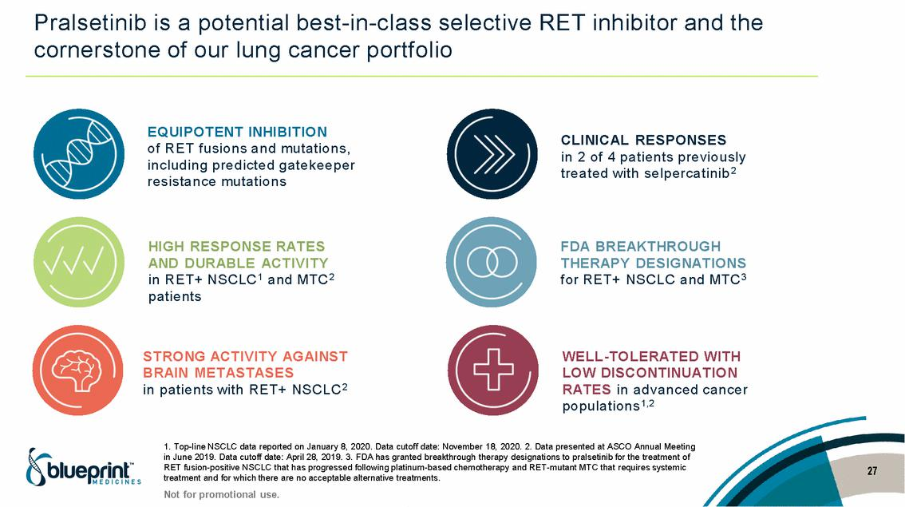

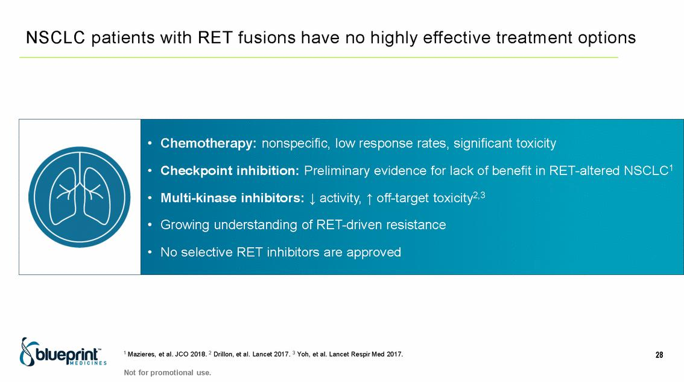

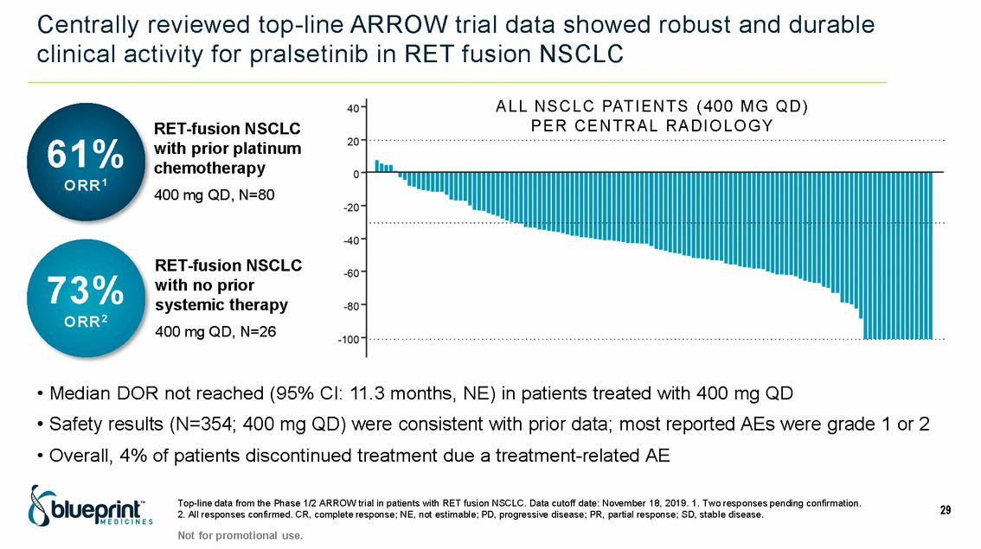

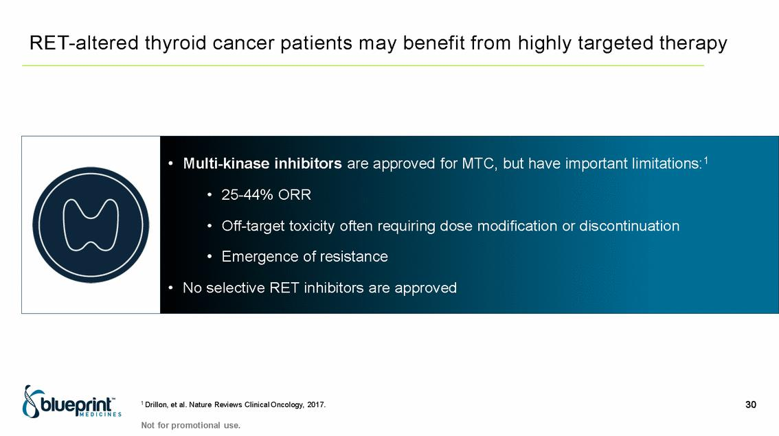

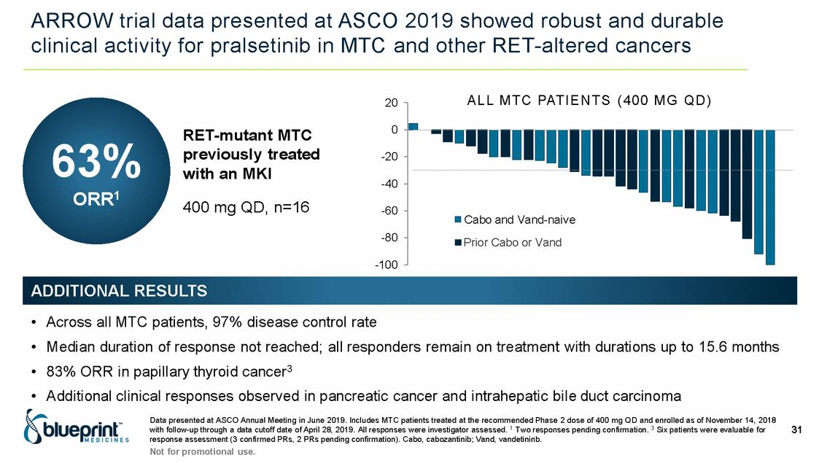

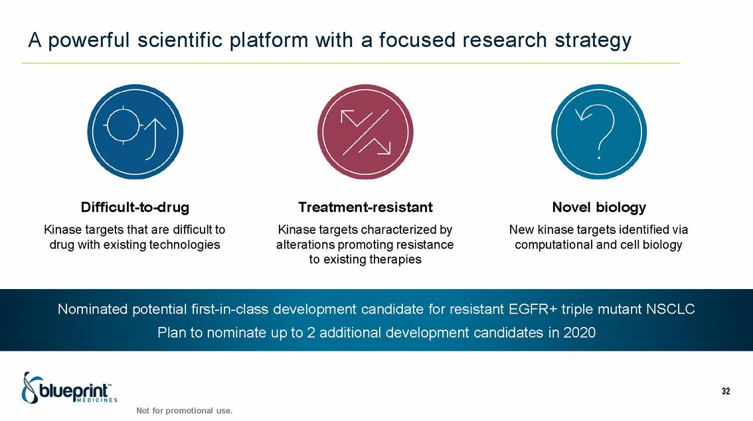

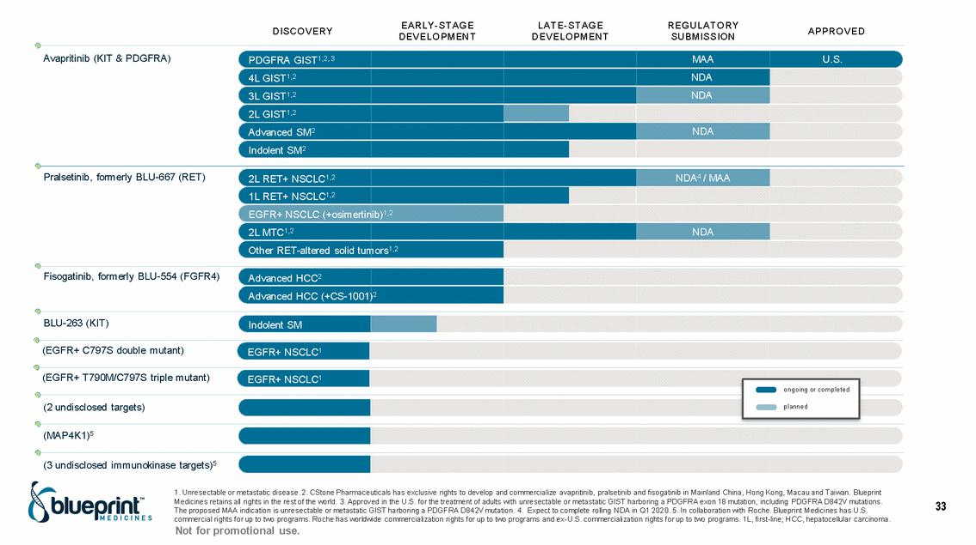

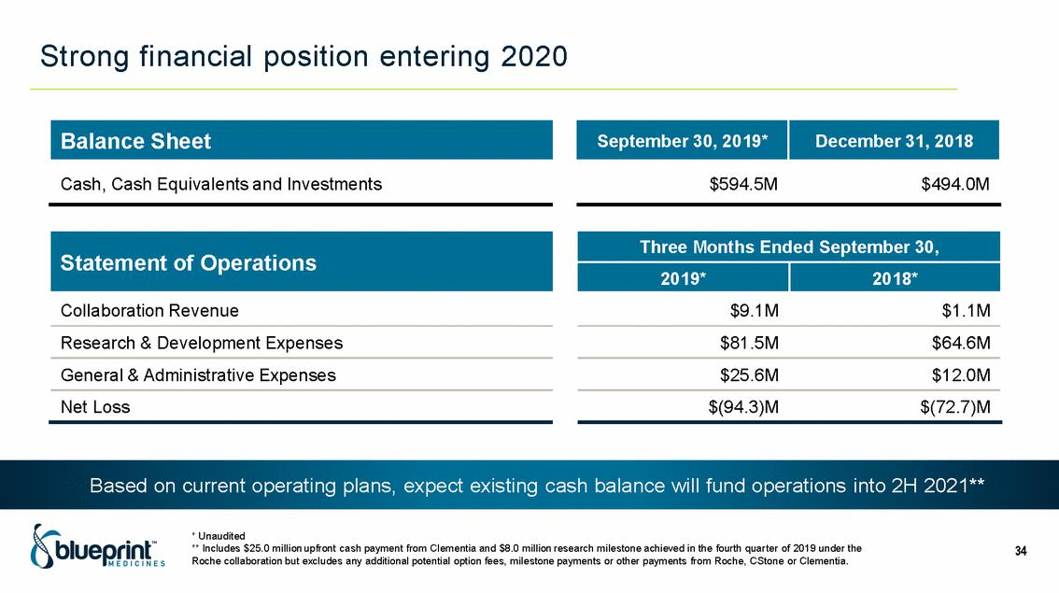

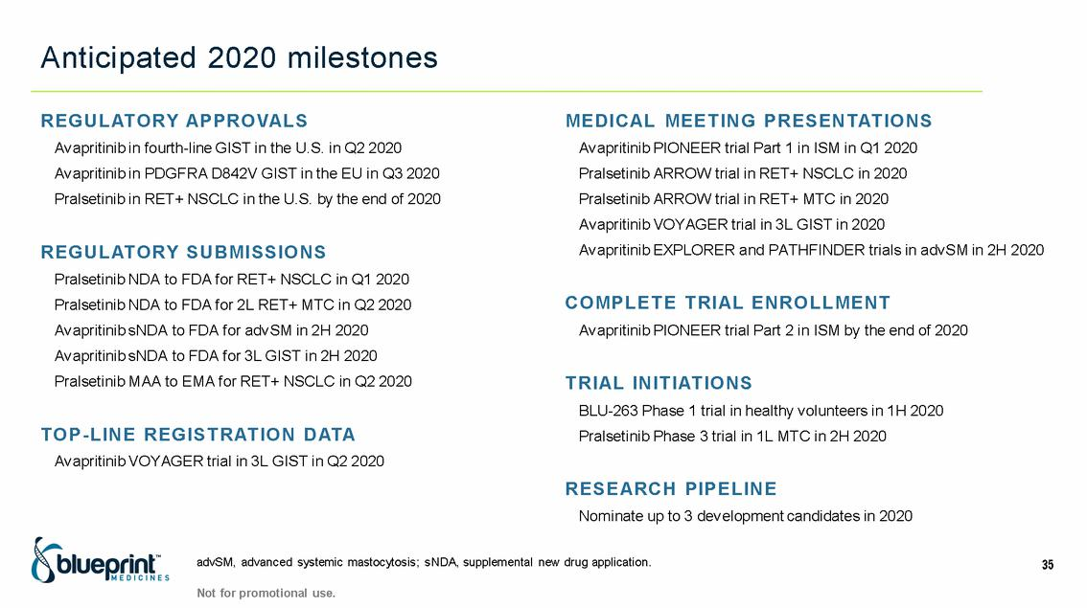

Exhibit 99.2

Blueprint Medicines Announces 2020 Corporate Goals

-- U.S. launch of AYVAKIT™ (avapritinib) for PDGFRA Exon 18 mutant GIST now underway --

- Multiple marketing applications for avapritinib and pralsetinib currently under review or planned for submission in 2020, including 5 in the U.S. and 2 in the EU --

-- Expanded strategic focus on systemic mastocytosis and related mast cell disorders,

with comprehensive clinical development programs for avapritinib and BLU-263 ongoing or planned --

- Nominated potential first-in-class development candidate for resistant EGFR-positive triple mutant NSCLC, with plans to strengthen pipeline with nomination of up to 2 additional development candidates in 2020 --

CAMBRIDGE, Mass., January 13, 2020 /PRNewswire/ -- Blueprint Medicines Corporation (NASDAQ: BPMC), a precision therapy company focused on genomically defined cancers, rare diseases and cancer immunotherapy, today announced corporate goals for 2020, which provide a path to achieve the company’s “2020 Blueprint” strategy for launching its global commercial business.

“2020 is off to a great start for Blueprint Medicines with the recent FDA approval of our first medicine and a U.S. launch now underway. As we complete our evolution into a fully-integrated biopharmaceutical company this year, we will also aim to bring a second product to market, expand across multiple indications and extend our global commercial footprint with our first anticipated regulatory approval in Europe,” said Jeff Albers, Chief Executive Officer of Blueprint Medicines. “In addition, our future growth will be fueled by an expanded strategic focus on systemic mastocytosis and related mast cell disorders, which represent a large population of underserved patients with significant medical needs. This focus is anchored by avapritinib, which is now FDA-approved for the treatment of PDGFRA exon 18 mutant GIST. Avapritinib was specifically designed to treat the underlying cause of systemic mastocytosis and has demonstrated remarkable and consistent clinical activity across the spectrum of the disease.”

RECENT PORTFOLIO MILESTONES AND 2020 GOALS

Avapritinib: gastrointestinal stromal tumors (GIST)

- In January 2020, announced the U.S. Food and Drug Administration (FDA) granted a full approval to AYVAKIT for the treatment of adults with unresectable or metastatic GIST harboring a PDGFRA exon 18 mutation, including PDGFRA D842V mutations. Read the press release here and visit www.AYVAKIT.com for full Prescribing Information.

2020 goals:

- Report top-line data from the Phase 3 VOYAGER trial of avapritinib in third-line GIST in the second quarter of 2020

- Gain regulatory approval and launch avapritinib in fourth-line GIST in the U.S. in the second quarter of 2020
- Gain regulatory approval and launch avapritinib in PDGFRA D842V GIST in Europe in the third quarter of 2020
- Present the registration dataset from the VOYAGER trial of avapritinib in third-line GIST in 2020
- Submit a supplemental new drug application (NDA) to the FDA for third-line GIST in the second half of 2020

Avapritinib and BLU-263: systemic mastocytosis (SM) and other mast cell disorders

- Today announced an update on the planned submission of a supplemental NDA to the FDA for avapritinib for advanced SM. Based on ongoing discussions with the FDA, the company plans to focus its supplemental

NDA on data from patients in the Phase 1 EXPLORER and Phase 2 PATHFINDER trials who started at the proposed indicated dose of 200 mg once daily (QD), supported by pooled data from all doses. To allow for a sufficient number of patients and follow-up, Blueprint Medicines now plans to submit the supplemental NDA to the FDA in the second half of 2020.

- In December 2019, reported initial data from Part 1 of the PIONEER trial of avapritinib in patients with indolent SM. The data showed rapid and robust reductions in serum tryptase, a measure of mast cell burden, in patients treated with 25, 50 or 100 mg QD of avapritinib. All dose levels of avapritinib tested were well-tolerated, and no patients discontinued treatment due to an adverse event (AE). Read the press release here.

- Today announced updated data from Part 1 of the PIONEER trial have been accepted for presentation as a late-breaking oral abstract at the American Academy of Allergy, Asthma & Immunology 2020 Annual Meeting in Philadelphia on March 14, 2020.

2020 goals:

- Present updated data from Part 1 of the PIONEER trial of avapritinib in indolent SM in the first quarter of 2020
- Initiate a Phase 1 trial of BLU-263 in healthy volunteers in the first half of 2020
- Submit a supplemental NDA to FDA for avapritinib for advanced SM in the second half of 2020
- Present updated data from the EXPLORER and PATHFINDER trials of avapritinib in advanced SM in the second half of 2020

- Complete enrollment of Part 2 of the PIONEER trial of avapritinib in indolent SM by the end of 2020

Pralsetinib: RET-altered cancers

- In January 2020, reported top-line data from the Phase 1/2 ARROW trial of pralsetinib in RET fusion-positive non-small cell lung cancer (NSCLC) as of a data cutoff date of November 18, 2019 in patients treated with the proposed indicated dose of 400 mg QD. In patients with previously treated RET fusion-positive NSCLC, the overall response rate (ORR) was 61 percent (95% CI: 50-72%) per central review (two responses pending confirmation), and the median duration of response was not reached. In patients with treatment-naïve RET fusion-positive NSCLC, the ORR was 73 percent (95% CI: 52-88%) per central review (all responses confirmed), with 12 percent of patients achieving a complete response. Pralsetinib was well-tolerated, and most reported AEs were Grade 1 or 2 with only four percent of patients discontinuing treatment with pralsetinib due to treatment-related AEs. In addition, the company announced it had initiated a rolling NDA submission to the FDA for pralsetinib for the treatment of RET fusion-positive NSCLC. Read the press release here.

- Today announced the activation of the first trial site for the company’s Phase 3 AcceleRET Lung trial of pralsetinib in patients with first-line RET fusion-positive NSCLC. More information about the trial is available at www.clinicaltrials.gov (NCT04222972).

2020 goals:

- Complete the submission of a rolling NDA to the FDA for pralsetinib for RET fusion-positive NSCLC in the first quarter of 2020

- Submit an NDA to the FDA for pralsetinib for previously treated RET-mutant medullary thyroid cancer (MTC) in the second quarter of 2020

- Submit an MAA to EMA for pralsetinib for RET fusion-positive NSCLC in the second quarter of 2020
- Present registration datasets from the Phase 1/2 ARROW trial of pralsetinib in RET fusion-positive NSCLC and RET-mutant MTC in 2020

- Initiate a Phase 3 trial of pralsetinib in first-line RET-mutant MTC in the second half of 2020

- Gain regulatory approval and launch pralsetinib in RET fusion-positive NSCLC in the U.S. by the end of 2020

Research portfolio

- In November 2019, at Blueprint Medicines’ first R&D Day, announced four new research programs enabled by the company’s integrated precision medicine platform. Read the press release here.

- Today announced the nomination of a potential first-in-class development candidate for the treatment of resistant EGFR-positive triple mutant NSCLC.

2020 goals:

- Nominate up to two additional development candidates by the end of 2020

About Blueprint Medicines

Blueprint Medicines is a precision therapy company striving to improve human health. With a focus on genomically defined cancers, rare diseases and cancer immunotherapy, we are developing transformational medicines rooted in our leading expertise in protein kinases, which are proven drivers of disease. Our uniquely targeted, scalable approach empowers the rapid design and development of new treatments and increases the likelihood of clinical success. We have one FDA-approved precision therapy and are currently advancing multiple investigational medicines in clinical development, along with multiple research programs. For more information, visit www.BlueprintMedicines.com and follow us on Twitter (@BlueprintMeds) and LinkedIn.

Cautionary Note Regarding Forward-Looking Statements

This press release contains forward-looking statements within the meaning of the Private Securities Litigation Reform Act of 1995, as amended, including, without limitation, statements regarding Blueprint Medicines’ 2020 goals and anticipated milestones; plans and timelines for the development of avapritinib, pralsetinib, fisogatinib, and BLU-263; plans and timelines for submitting marketing applications for avapritinib and pralsetinib and, if approved, commercializing avapritinib and pralsetinib; the potential benefits of Blueprint Medicines' current and future drug candidates in treating patients; and Blueprint Medicines’ strategy, goals and anticipated milestones, business plans and focus. The words “aim,” “may,” “will,” “could,” “would,” “should,” “expect,” “plan,” “anticipate,” “intend,” “believe,” “estimate,” “predict,” “project,” “potential,” “continue,” “target” and similar expressions are intended to identify forward-looking statements, although not all forward-looking statements contain these identifying words. Any forward-looking statements in this press release are based on management’s current expectations and beliefs and are subject to a number of risks, uncertainties and important factors that may cause actual events or results to differ materially from those expressed or implied by any forward-looking statements contained in this press release, including, without limitation, risks and uncertainties related to Blueprint Medicines’ ability and plan in establishing a commercial infrastructure, and successfully launching, marketing and selling its approved product; Blueprint Medicines’ ability to successfully expand the indication for AYVAKIT in the future; the delay of any current or planned clinical trials or the development of Blueprint Medicines’ drug candidates or licensed product candidate; Blueprint Medicines’ advancement of multiple early-stage efforts; Blueprint Medicines’ ability to successfully demonstrate the safety and efficacy of its drug candidates and gain approval of its drug candidates on a timely basis, if at all; the preclinical and clinical results for Blueprint Medicines’ drug candidates, which may not support further development of such drug candidates; actions of regulatory agencies, which may affect the initiation, timing and progress of clinical trials; Blueprint Medicines’ ability to develop and commercialize companion diagnostic tests for its current and future drug candidates; and the success of Blueprint Medicines’ current and future collaborations or licensing arrangements, including its cancer immunotherapy collaboration with F. Hoffmann-La Roche Ltd and Hoffmann-La Roche Inc., its collaboration with CStone Pharmaceuticals and its license to

Clementia Pharmaceuticals. These and other risks and uncertainties are described in greater detail in the section entitled “Risk Factors” in Blueprint Medicines’ filings with the Securities and Exchange Commission (SEC), including Blueprint Medicines’ most recent Quarterly Report on Form 10-Q and any other filings that Blueprint Medicines has made or may make with the SEC in the future. Any forward-looking statements contained in this press release represent Blueprint Medicines’ views only as of the date hereof and should not be relied upon as representing its views as of any subsequent date. Except as required by law, Blueprint Medicines explicitly disclaims any obligation to update any forward-looking statements.

Investor and Media Contact

Jim Baker

617-844-8236
media@bluepsrintmedicines.com

Investor Contact

Kristin Hodous

617-714-6674
ir@blueprintmedicines.com

