UNITED STATES

SECURITIES AND EXCHANGE COMMISSION

Washington, D.C. 20549

FORM 8-K

CURRENT REPORT

Pursuant to Section 13 or 15(d)
of the Securities Exchange Act of 1934

Date of Report (Date of Earliest Event Reported): September 10, 2017

Blueprint Medicines Corporation

(Exact name of registrant as specified in its charter)

Delaware

(State or other jurisdiction

of incorporation)

001-37359

(Commission File Number)

26-3632015

(I.R.S. Employer

Identification No.)

38 Sidney Street, Suite 200

Cambridge, Massachusetts

(Address of principal executive offices)

02139

(Zip Code)

Registrant’s telephone number, including area code: (617) 374-7580

(Former name or former address, if changed since last report)

Check the appropriate box below if the Form 8-K filing is intended to simultaneously satisfy the filing obligation of the registrant under any of the following provisions:

- Written communications pursuant to Rule 425 under the Securities Act (17 CFR 230.425)

- Soliciting material pursuant to Rule 14a-12 under the Exchange Act (17 CFR 240.14a-12)

- Pre-commencement communications pursuant to Rule 14d-2(b) under the Exchange Act (17 CFR 240.14d-2(b))

- Pre-commencement communications pursuant to Rule 13e-4(c) under the Exchange Act (17 CFR 240.13e-4(c))

Indicate by check mark whether the registrant is an emerging growth company as defined in Rule 405 of the Securities Act of 1933 (§230.405 of this chapter) or Rule 12b-2 of the Securities Exchange Act of 1934 (§240.12b-2 of this chapter).

Emerging growth company ☑

If an emerging growth company, indicate by check mark if the registrant has elected not to use the extended transition period for complying with any new or revised financial accounting standards provided pursuant to Section 13(a) of the Exchange Act. ☑

Item 7.01 Regulation FD Disclosure.

On September 10, 2017, Blueprint Medicines Corporation (the “Company”) issued a press release announcing new data from its ongoing Phase 1 clinical trial evaluating BLU-554 for the treatment of advanced hepatocellular carcinoma. The data were presented on Sunday, September 10, 2017 in an oral presentation at the European Society for Medical Oncology (“ESMO”) 2017 Congress in Madrid, Spain. A copy of the press release is furnished as Exhibit 99.1 to this Current Report on Form 8-K, and a copy of the presentation at the ESMO 2017 Congress is furnished as Exhibit 99.2 to this Current Report on Form 8-K.

In addition, on September 11, 2017, the Company hosted an investor conference call and live webcast to discuss the data presented at the ESMO 2017 Congress. A copy of the presentation from the conference call is furnished as Exhibit 99.3 to this Current Report on Form 8-K.

The information in Item 7.01 of this Current Report on Form 8-K, including Exhibits 99.1, 99.2 and 99.3, is intended to be furnished and shall not be deemed “filed” for purposes of Section 18 of the Securities Exchange Act of 1934, as amended (the “Exchange Act”), or otherwise subject to the liabilities of that section, nor shall it be deemed incorporated by reference in any filing under the Securities Act of 1933, as amended, or the Exchange Act, except as expressly set forth by specific reference in such filing.

Item 9.01 |  | Financial Statements and Exhibits.
(d) Exhibits.
 | Exhibit No. |  |  | Description
 | 99.1 |  |  | Press release issued by Blueprint Medicines Corporation on September 10, 2017
99.2 |  |  |  | Presentation by Blueprint Medicines Corporation at the ESMO 2017 Congress on September 10, 2017
99.3 |  |  |  | Presentation by Blueprint Medicines Corporation at investor conference call on September 11, 2017
 |  | 2

 |  |  | EXHIBIT INDEX
Exhibit No. |  |  | Description
99.1 |  |  | Press release issued by Blueprint Medicines Corporation on September 10, 2017
99.2 |  |  | Presentation by Blueprint Medicines Corporation at the ESMO 2017 Congress on September 10, 2017
99.3 |  |  | Presentation by Blueprint Medicines Corporation at investor conference call on September 11, 2017
 |  | 3

SIGNATURES

Pursuant to the requirements of the Securities Exchange Act of 1934, the registrant has duly caused this report to be signed on its behalf by the undersigned hereunto duly authorized.

 | BLUEPRINT MEDICINES CORPORATION
Date: September 11, 2017 | By: /s/ Tracey L. McCain
 |  | Tracey L. McCain
 |  | Chief Legal Officer

4

Exhibit 99.1


Blueprint Medicines Announces New Data from Ongoing Phase 1 Clinical Trial of BLU-554 in Patients with Advanced Hepatocellular Carcinoma

– Encouraging Clinical Activity Observed in Heavily Pre-Treated Patients with FGFR4-Driven HCC –
– Data Support Patient Selection Strategy for First Potential Biomarker-Driven Treatment
Approach in HCC –
– Blueprint Medicines to Host Investor Conference Call and Webcast on
Monday, September 11, at 7:00 a.m. ET –

CAMBRIDGE, Mass., September 10, 2017 – Blueprint Medicines Corporation (NASDAQ:BPMC), a leader in discovering and developing targeted kinase medicines for patients with genomically defined diseases, today announced updated data from its ongoing Phase 1 clinical trial of BLU-554, a potent and highly selective inhibitor of fibroblast growth factor receptor 4 (FGFR4) for the treatment of patients with advanced hepatocellular carcinoma (HCC). As of a data cutoff date of August 18, 2017, BLU-554 demonstrated a 16 percent objective response rate

(ORR) in patients with FGFR4-driven HCC. In addition, 49 percent of patients with FGFR4-driven HCC had radiographic tumor reduction. BLU-554 was well-tolerated and most adverse events (AEs) reported by investigators were Grade 1 or 2. The data will be presented today in an oral presentation at the European Society for Medical Oncology (ESMO) 2017 Congress in Madrid, Spain.

“Patients with hepatocellular carcinoma face a very poor prognosis with few therapeutic options,” said Richard Kim, M.D., Associate Professor, Moffit Cancer Center, an investigator for the study. “The new BLU-554 data announced today show that in heavily pre-treated patients, BLU-554 demonstrated encouraging clinical activity, with approximately half of patients with FGFR4-driven HCC having tumor shrinkage. These data compare well to historical data for currently approved agents showing response rates of approximately 10 percent or less, and BLU-554 has the potential to change the treatment paradigm for patients with FGFR4-driven HCC.”

“We are encouraged by the updated BLU-554 Phase 1 data presented at ESMO, which build on our prior clinical experience and suggest that BLU-554 may offer meaningful benefit to patients with FGFR4-driven HCC,” said Andy Boral, M.D., Ph.D., Chief Medical Officer of Blueprint Medicines. “These data speak to BLU-554’s potential as the first biomarker-driven targeted therapy for liver cancer. The higher frequency of tumor reduction in patients with FGFR4-driven HCC confirm the importance of aberrantly activated FGFR4 signaling in driving a subset of patients’ disease and demonstrate BLU-554’s ability to modulate the FGFR4 pathway.”

Updated Data from the Ongoing Phase 1 Clinical Trial

BLU-554 is currently being evaluated in a Phase 1 clinical trial in patients with advanced HCC. Following the completion of the dose escalation portion of the trial and determination of the maximum tolerated dose (MTD) of 600 mg once daily (QD), Blueprint Medicines initiated the expansion portion of the trial.

As of the data cutoff of August 18, 2017, 77 patients had been treated with BLU-554 in the dose escalation and expansion portions of the Phase 1 clinical trial at five dose levels (ranging from 140 mg QD to 900 mg QD), including 44 patients with FGFR4-driven HCC. FGFR4-driven HCC was defined as at least

one percent tumor expression of FGF19, the FGFR4 ligand, as measured by an immunohistochemistry (IHC) assay. In general, the enrolled population was heavily pretreated: 82 percent received prior tyrosine kinase inhibitor (TKI) treatment, 23 percent received prior immunotherapy, and 91 percent received prior systemic therapy.

Pharmacokinetic (PK) analysis demonstrated rapid oral absorption across all dose levels, with a mean half-life of approximately 17 hours and exposure in the expected therapeutic range based on HCC xenograft models. Collectively, these data support a once-daily dosing regimen.

Safety Data

As of the data cutoff of August 18, 2017, the majority of AEs reported by investigators were Grade 1 or 2. Across all grades, the most common AEs reported by investigators related to BLU-554 included diarrhea (71%), nausea (42%), vomiting (36%), transaminase elevation (AST 34% and ALT 32%) and fatigue (29%). Grade 3 or higher AEs related to BLU-554 occurring in five or more patients included anemia, diarrhea and transaminase elevation (AST and ALT). Among all 77 patients treated with BLU-554, 58 patients discontinued treatment with BLU-554, including 42 patients due to disease progression, 11 patients due to treatment-related AEs, three patients who withdrew consent and two patients due to the investigator’s decision.

Clinical Activity Data

As of the data cutoff of August 18, 2017, 67 patients were evaluable for response assessment. An additional 10 patients were treated with BLU-554 as of the data cutoff date but were not evaluable for response assessment. Response was assessed using the Response Evaluation Criteria In Solid Tumors (RECIST) version 1.1.

In patients with FGFR4-driven HCC (n=38), the data showed an ORR of 16 percent (95 percent confidence interval 6-31 percent). In addition, 49 percent of patients had radiographic tumor reduction, and clinical activity was observed regardless of disease etiology or geography. As of the data cutoff date:

- One patient had an unconfirmed complete response.
- Five patients had a partial response, with four confirmed and one unconfirmed.
- An additional 20 patients had stable disease, representing a disease control rate of 68 percent.
- No responses were observed in patients without FGFR4 pathway activation (n=29).

Among all 77 patients treated with BLU-554, 19 remained on treatment as of the data cutoff date, including 15 patients with FGFR4-driven HCC. Median progression free survival was 3.7 months among patients with FGFR4-driven HCC.

In addition, five TKI-naïve patients with FGFR4-driven HCC were evaluable for response assessment as of the data cutoff date. Within this group, preliminary evidence of prolonged disease control was observed. Two TKI-naïve patients remain on treatment as of the data cutoff with a duration of treatment of 11.4 months and 12.3 months, respectively.

Clinical Development Plans for BLU-554

Blueprint Medicines plans to continue to enroll and follow the cohort of patients with FGFR4-driven HCC in the ongoing Phase 1 clinical trial to further evaluate the safety and clinical activity of BLU-554 in this population. In addition, the Company plans to initiate an additional cohort in this clinical trial in the first quarter of 2018 to evaluate BLU-554 in TKI-naïve patients with FGFR4-driven HCC. Blueprint Medicines also plans to explore opportunities to conduct a clinical trial to evaluate BLU-554 in combination with an immune checkpoint inhibitor.

Conference Call Information

Blueprint Medicines will host a conference call and webcast on Monday, September 11, 2017 at 7:00 a.m. ET (1:00 p.m. CET) to discuss the BLU-554 clinical data presented at ESMO. To participate in the conference call, please dial 1-855-728-4793 (domestic) or 1-503-343-6666 (international) and refer to conference ID 73748225. A live webcast of the presentation will also be available under “Events & Presentations” in the Investors section of Blueprint Medicines’ website at http://ir.blueprintmedicines.com/. The archived webcast will be available on Blueprint Medicines’ website approximately two hours after the event concludes and will be available for 30 days following the event.

About the Phase 1 Clinical Trial for BLU-554 in Advanced HCC

Blueprint Medicines’ Phase 1 clinical trial for BLU-554 is designed to evaluate the safety and tolerability of BLU-
- The dose-escalation portion of the Phase 1 clinical trial was completed, and the maximum tolerated dose (MTD) was determined to be 600 mg QD. Blueprint Medicines is currently enrolling the expansion portion of the Phase 1 clinical trial at the MTD. The primary objective of the expansion portion of the Phase 1 clinical trial is to continue to evaluate the safety and tolerability of BLU-554. Secondary objectives include assessing clinical activity by Response Evaluation Criteria in Solid Tumors version 1.1, as well as evaluating the PK of BLU-554 and pharmacodynamic markers of BLU-554 activity. The expansion portion of the Phase 1 clinical trial is designed to enroll approximately

- patients in expansion cohorts with QD dosing, at multiple sites in the United States, European Union and Asia. Please refer to www.clinicaltrials.gov for additional details related to this Phase 1 clinical trial. For more information, please contact the study director for this Phase 1 clinical trial at studydirector@blueprintmedicines.com.

About HCC

Liver cancer is the second leading cause of cancer-related deaths worldwide, with HCC accounting for most liver cancers. In the United States, HCC is the fastest rising cause of cancer-related death. Over the past two decades, the incidence of HCC has tripled while the five-year survival rate has remained below 12 percent. The highest incidence of HCC occurs in regions with endemic hepatitis B virus, including Southeast Asia and sub-Saharan Africa. Treatment options for patients with advanced HCC are limited, with the currently approved first-line therapy typically providing time to progression of less than six months and overall survival of less than one year. FGF19 is the ligand that activates FGFR4, a receptor that promotes hepatocyte proliferation and regulates bile acid homeostasis in the liver. Blueprint Medicines estimates that approximately 30 percent of patients with HCC have tumors with aberrantly activated FGFR4 signaling.

About BLU-554

BLU-554 is an orally available, potent, irreversible inhibitor of FGFR4 discovered and being developed by Blueprint Medicines. BLU-554 was specifically designed by Blueprint Medicines to inhibit FGFR4 with exquisite selectivity, thereby sparing the paralogs FGFR1, FGFR2 and FGFR3. Blueprint Medicines is developing BLU-554, an investigational medicine, for the treatment of patients with FGFR4-driven HCC. The Company retains worldwide development and commercialization rights for BLU-554. In addition, Blueprint Medicines and Ventana Medical Systems, Inc. are developing an IHC assay as a companion diagnostic test for use with BLU-554 to identify HCC patients with aberrantly active FGFR4 signaling as indicated by FGF19 protein overexpression.

About Blueprint Medicines

Blueprint Medicines is developing a new generation of targeted and potent kinase medicines to improve the lives of patients with genomically defined diseases. Its approach is rooted in a deep understanding of the genetic blueprint of cancer and other diseases driven by the abnormal activation of kinases. Blueprint Medicines is advancing four programs in clinical development for subsets of patients with gastrointestinal stromal tumors, hepatocellular carcinoma, systemic mastocytosis, non-small cell lung cancer, medullary thyroid cancer and other advanced solid tumors, as well as multiple programs in research and preclinical development. For more information, please visit www.blueprintmedicines.com.

Cautionary Note Regarding Forward-Looking Statements

This press release contains forward-looking statements within the meaning of the Private Securities Litigation Reform Act of 1995, as amended, including, without limitation, statements regarding plans and timelines for the clinical development of BLU-554, including plans and timelines for clinical trials evaluating BLU-554 in TKI-naïve patients with FGFR4-driven HCC or BLU-554 in combination with an immune checkpoint inhibitor; Blueprint Medicines’ ability to implement its clinical development plans for BLU-554 in advanced HCC; Blueprint Medicines’ ability to enroll patients in its ongoing Phase 1 clinical trial for BLU-554 in advanced HCC; and Blueprint Medicines’ strategy, business plans and focus. The words "may," "will," "could," "would," "should," "expect," "plan," "anticipate," "intend," "believe," "estimate," "predict," "project," "potential," "continue," "target" and similar expressions are intended to identify forward-looking statements, although not all forward-looking statements contain these identifying words. Any forward-looking statements in this press release are based on management’s current expectations and beliefs and are subject to a number of risks, uncertainties and important factors that may cause actual events or results to differ materially from those expressed or implied by any forward-looking statements contained in this press release, including, without limitation, risks and uncertainties related to the delay of any current or planned clinical trials or the development of Blueprint Medicines’ drug candidates, including BLU-285, BLU-554 and BLU-667; Blueprint Medicines’ advancement of multiple early-stage efforts; Blueprint Medicines’ ability to successfully demonstrate the safety and efficacy of its drug candidates; the preclinical and clinical results for Blueprint Medicines’ drug candidates, which may not support further development of such drug candidates; and actions of the FDA or other regulatory agencies, which may affect the initiation, timing and progress of clinical trials; Blueprint Medicines’ ability to develop and commercialize companion diagnostic tests for its current and future drug candidates, including companion diagnostic tests for BLU-554 with Ventana Medical Systems, Inc. and for BLU-285 with QIAGEN Manchester Limited; and the success of Blueprint Medicines’ cancer immunotherapy collaboration with F. Hoffmann-La Roche Ltd and Hoffmann-La Roche Inc. These and other risks and uncertainties are described in greater detail in the section entitled "Risk Factors" in

Blueprint Medicines’ Quarterly Report on Form 10-Q for the quarter ended June 30, 2017, as filed with the Securities and Exchange Commission (SEC) on August 2, 2017, and other filings that Blueprint Medicines may make with the SEC in the future. Any forward-looking statements contained in this press release represent Blueprint Medicines’ views only as of the date hereof and should not be relied upon as representing its views as of any subsequent date. Blueprint Medicines explicitly disclaims any obligation to update any forward-looking statements.

Media and Investor Relations Contacts

Kristin Hodous
617-714-6674
KHodous@blueprintmedicines.com

Jim Baker
617-844-8236
JBaker@blueprintmedicines.com

Exhibit 99.2
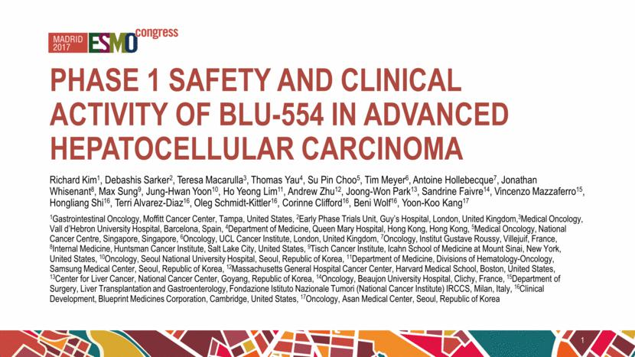

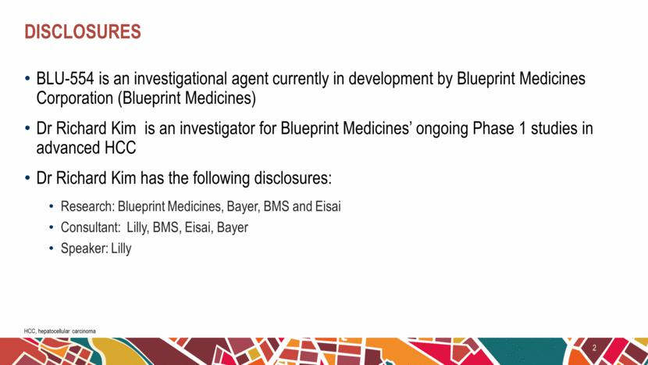

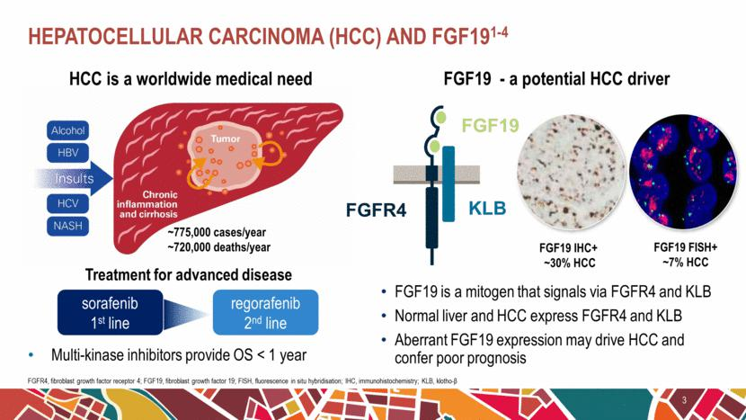

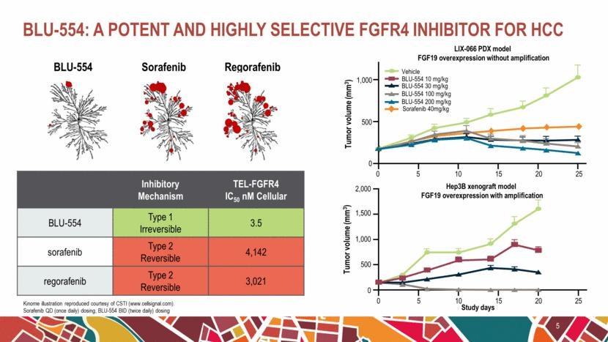

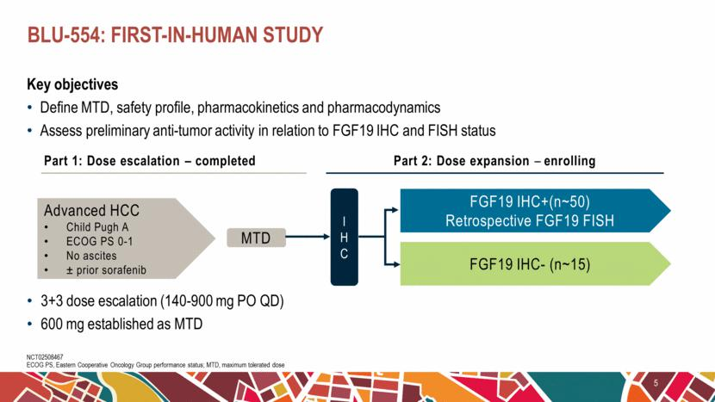

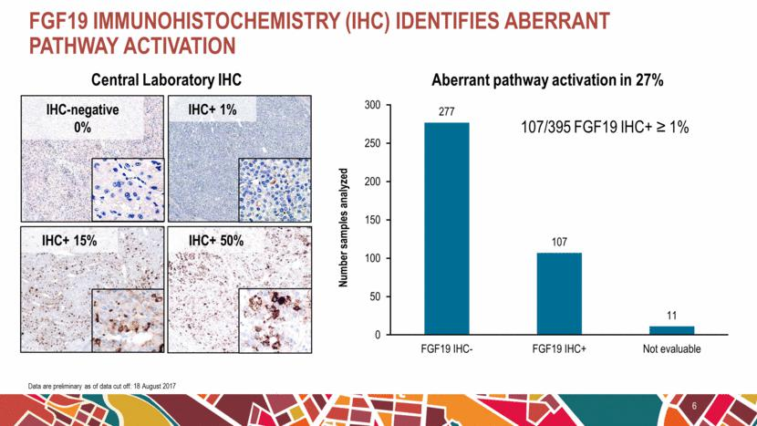

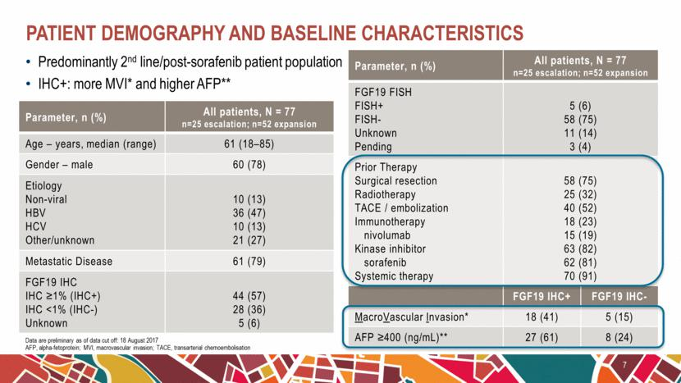

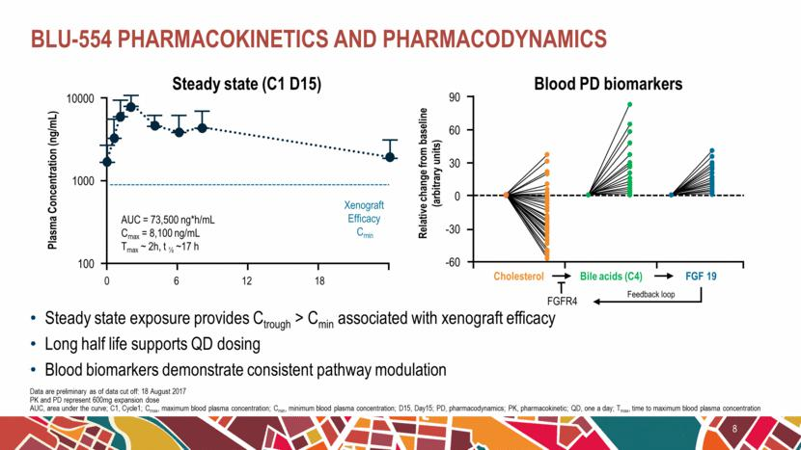

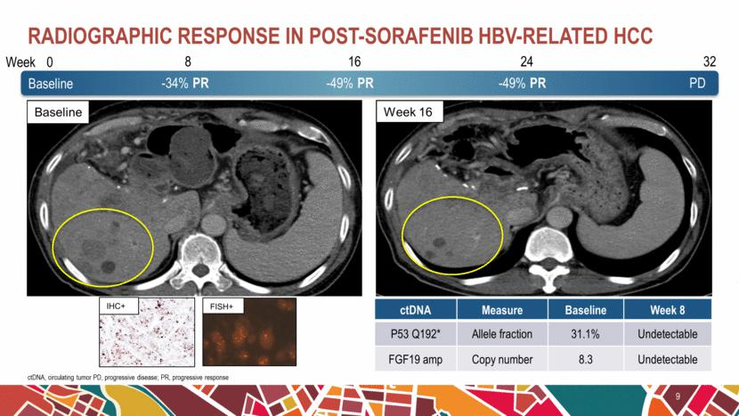

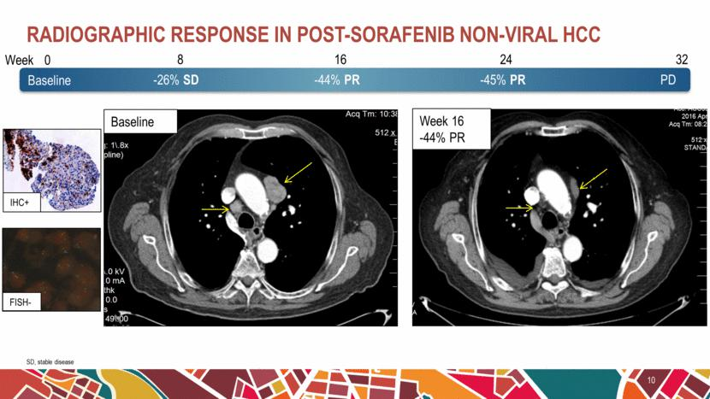

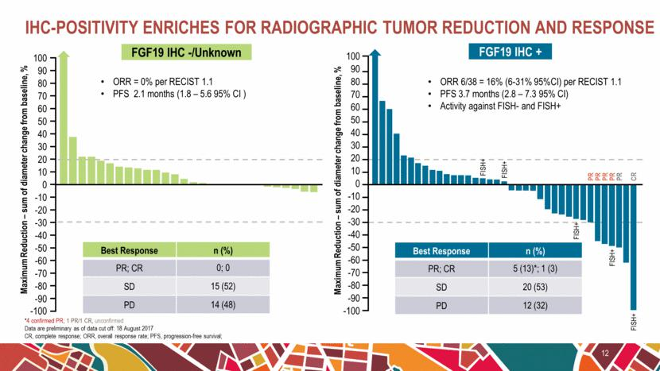

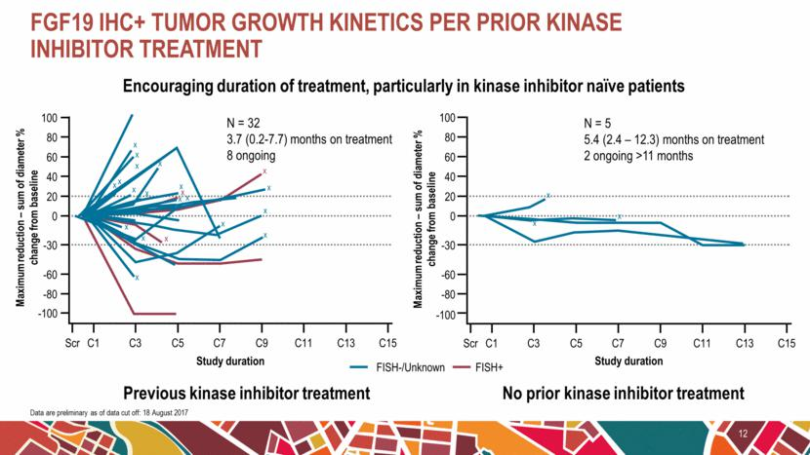

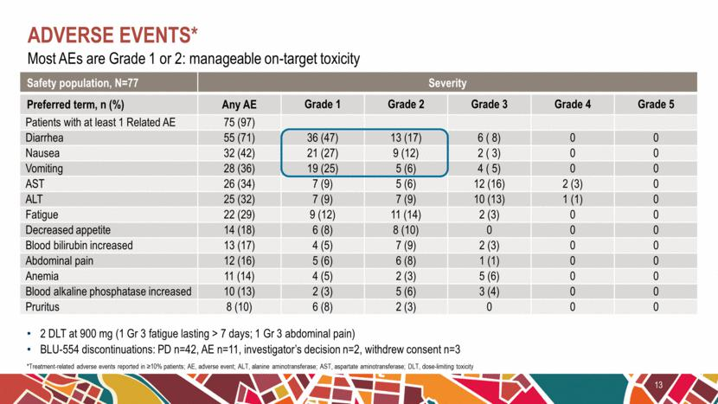

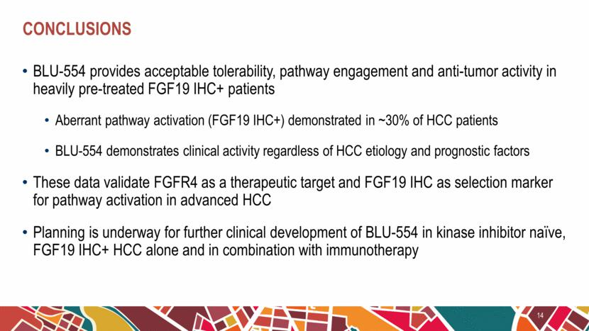

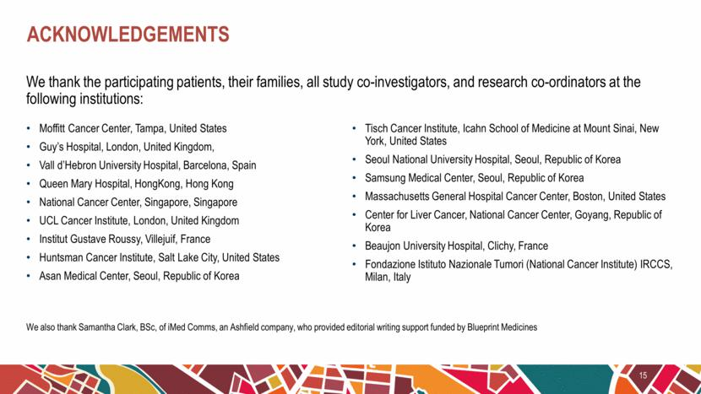

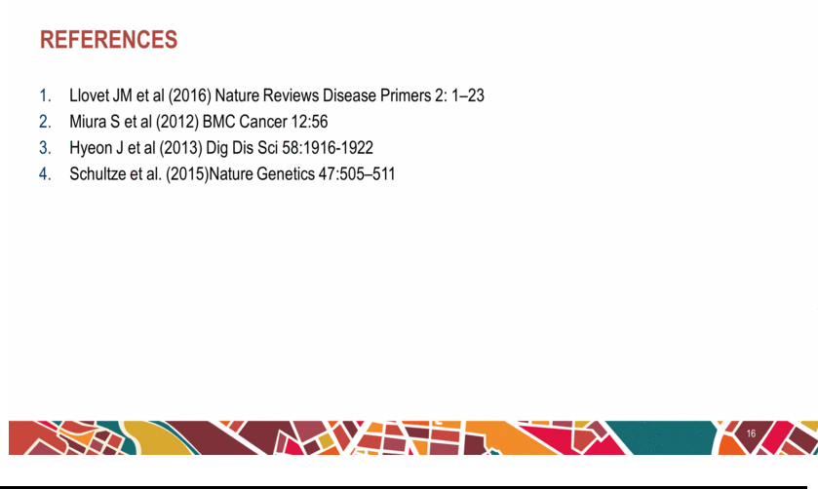

Exhibit 99.3






