UNITED STATES

SECURITIES AND EXCHANGE COMMISSION
Washington, D.C. 20549

FORM 8-K

CURRENT REPORT

Pursuant to Section 13 or 15(d)

of the Securities Exchange Act of 1934

Date of Report (Date of Earliest Event Reported): March 16, 2020

Blueprint Medicines Corporation

(Exact name of registrant as specified in its charter)

Delaware

(State or other jurisdiction

of incorporation)

001-37359

(Commission File Number)

26-3632015

(I.R.S. Employer

Identification No.)

45 Sidney Street

Cambridge, Massachusetts

(Address of principal executive offices)

02139

(Zip Code)

Registrant’s telephone number, including area code: (617) 374-7580

(Former name or former address, if changed since last report)

Check the appropriate box below if the Form 8-K filing is intended to simultaneously satisfy the filing obligation of the registrant under any of the following provisions:

- Written communications pursuant to Rule 425 under the Securities Act (17 CFR 230.425)

- Soliciting material pursuant to Rule 14a-12 under the Exchange Act (17 CFR 240.14a-12)

- Pre-commencement communications pursuant to Rule 14d-2(b) under the Exchange Act (17 CFR 240.14d-2(b))

- Pre-commencement communications pursuant to Rule 13e-4(c) under the Exchange Act (17 CFR 240.13e-4(c))

Indicate by check mark whether the registrant is an emerging growth company as defined in Rule 405 of the Securities Act of 1933 (§230.405 of this chapter) or Rule 12b-2 of the Securities Exchange Act of 1934 (§240.12b-2 of this chapter).

Emerging growth company ☐

If an emerging growth company, indicate by check mark if the registrant has elected not to use the extended transition period for complying with any new or revised financial accounting standards provided pursuant to Section 13(a) of the Exchange Act. ☐

Securities registered pursuant to Section 12(b) of the Exchange Act:

Title of each class | Trading symbol(s) | Name of each exchange on which registered
Common stock, par value $0.001 per share | BPMC | Nasdaq Global Select Market

Item 7.01 Regulation FD Disclosure.

On March 16, 2020, Blueprint Medicines Corporation (the “Company”) is hosting an investor conference call and webcast to report updated data from the dose-finding portion (part 1) of its ongoing Phase 2 PIONEER clinical trial in patients with indolent systemic mastocytosis. A copy of the presentation from the investor conference call and webcast is furnished as Exhibit 99.1 to this Current Report on Form 8-K.

The information in Item 7.01 of this Current Report on Form 8-K, including Exhibit 99.1 attached hereto, is intended to be furnished and shall not be deemed “filed” for purposes of Section 18 of the Securities Exchange Act of 1934, as amended (the “Exchange Act”), or otherwise subject to the liabilities of that section, nor shall it be deemed incorporated by reference in any filing under the Securities Act of 1933, as amended, or the Exchange Act, except as expressly set forth by specific reference in such filing.

Item 8.01 Other Events.

On March 16, 2020, the Company issued a press release reporting updated data from part 1 of the PIONEER clinical trial in patients with indolent systemic mastocytosis. A copy of the press release is filed herewith as Exhibit 99.2 to this Current Report on Form 8-K and incorporated herein by reference.

Item 9.01 Financial Statements and Exhibits.

(d) Exhibits.
Exhibit No. |  |  | Description
99.1 |  |  | Corporate slide presentation of Blueprint Medicines Corporation dated March 16, 2020
99.2 |  |  | Press release issued by Blueprint Medicines Corporation on March 16, 2020
104 |  |  | Cover Page Interactive Data File (embedded within the Inline XBRL document)
 |  | 2

SIGNATURES

Pursuant to the requirements of the Securities Exchange Act of 1934, the registrant has duly caused this report to be signed on its behalf by the undersigned hereunto duly authorized.

BLUEPRINT MEDICINES CORPORATION

Date: March 16, 2020 By: /s/ Jeffrey W. Albers

Jeffrey W. Albers

Chief Executive Officer

3

Exhibit 99.1
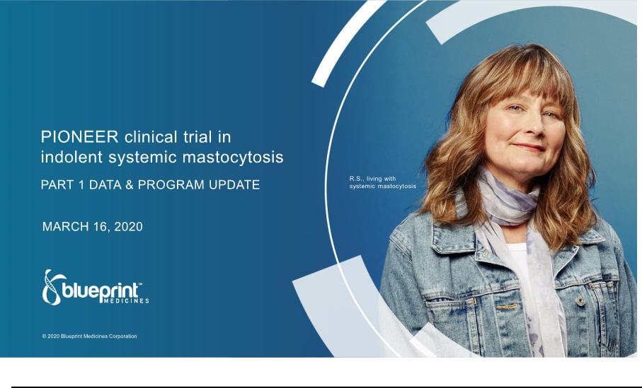

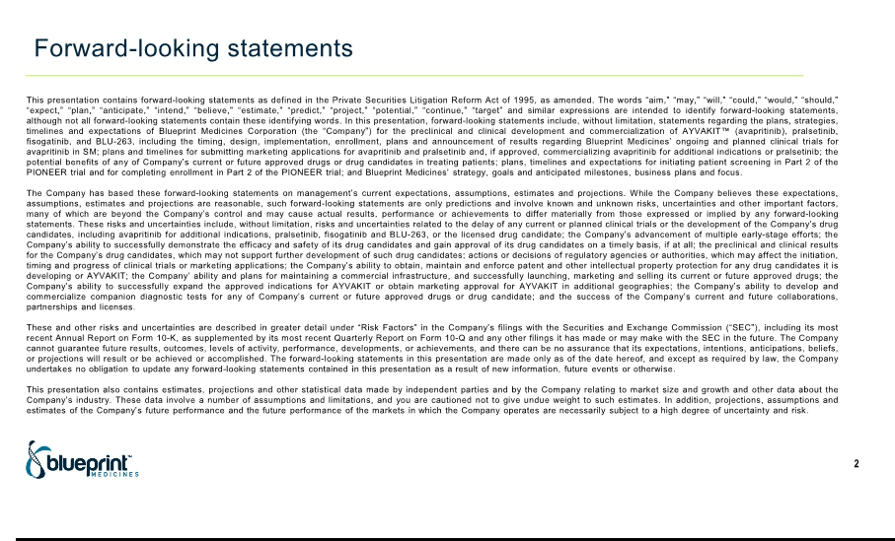

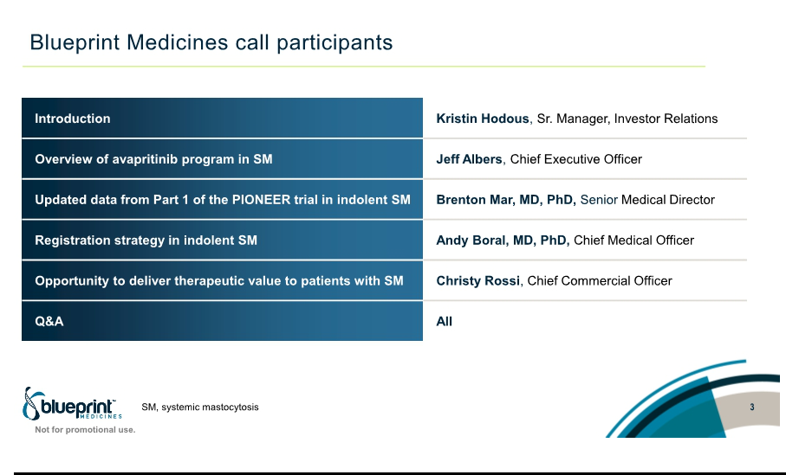

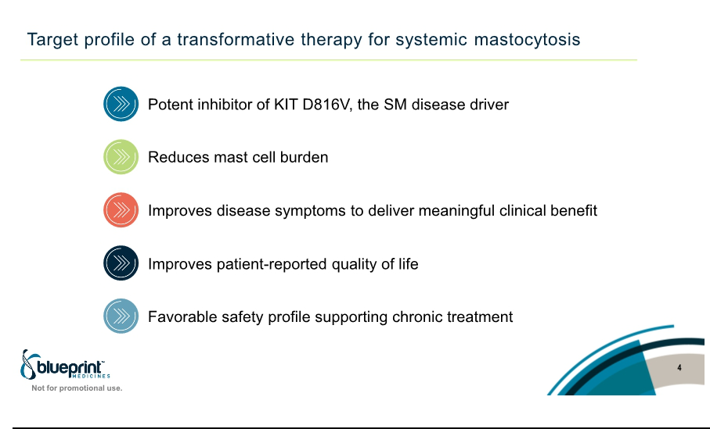

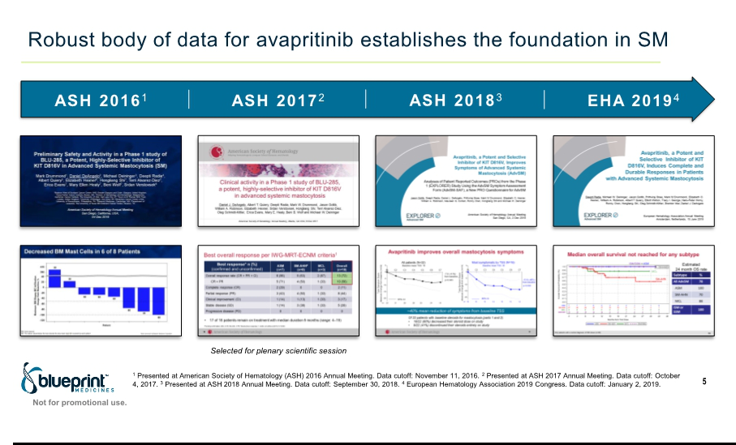

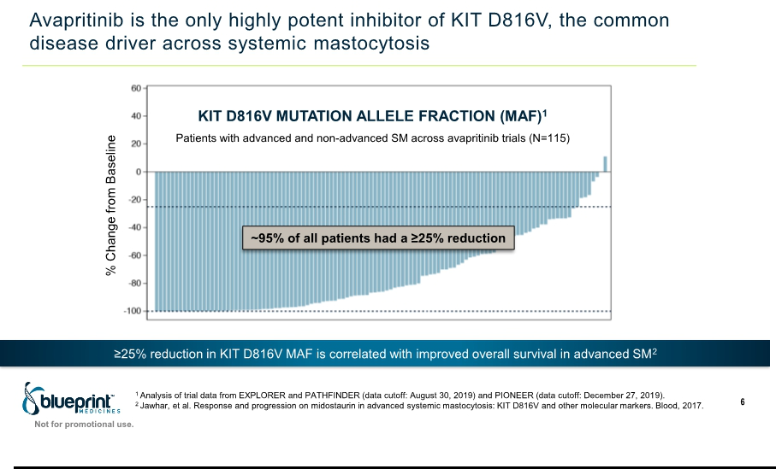

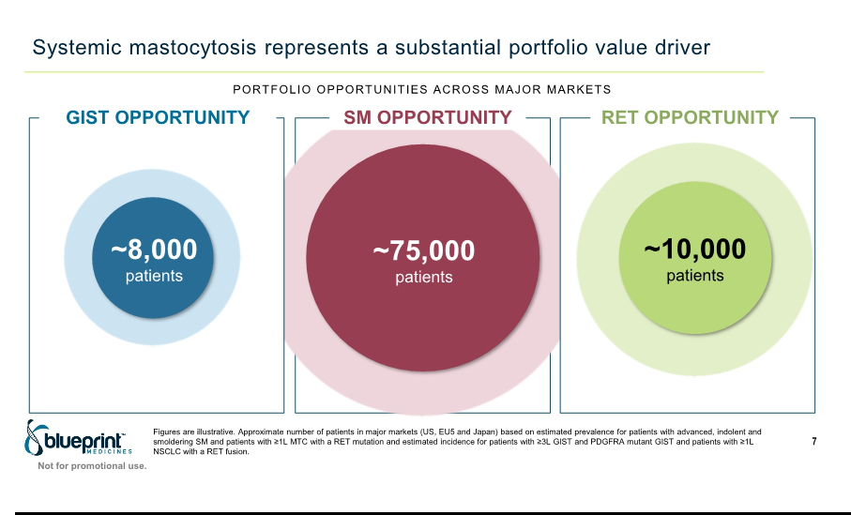

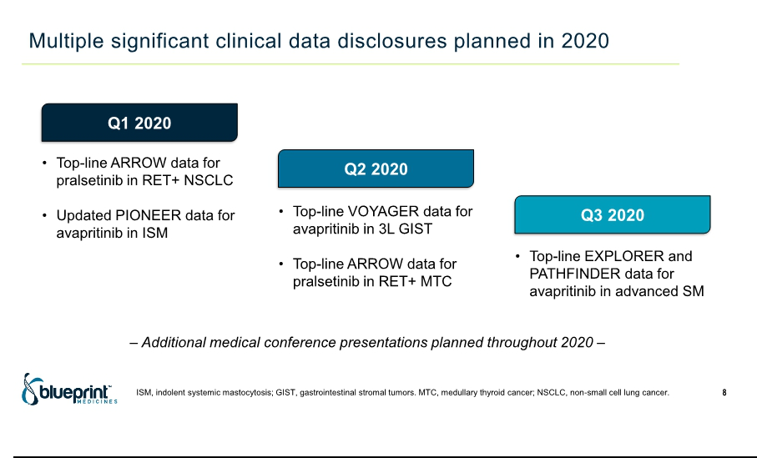

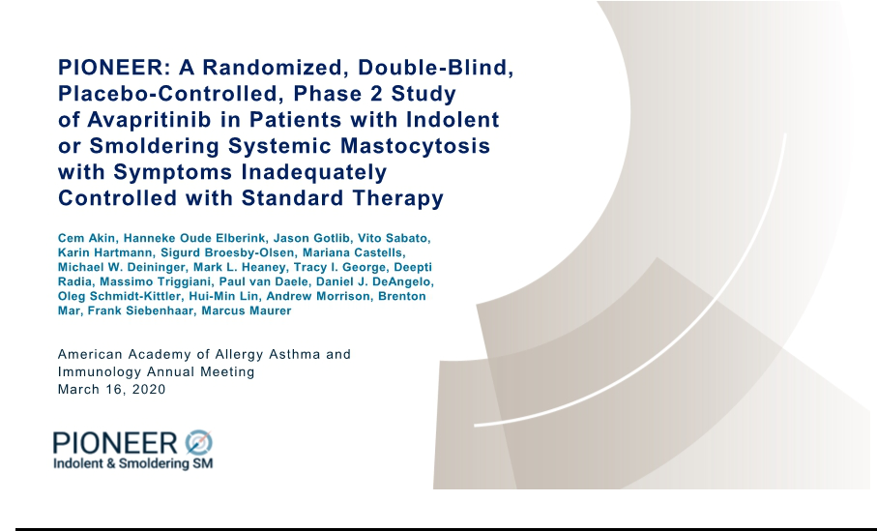

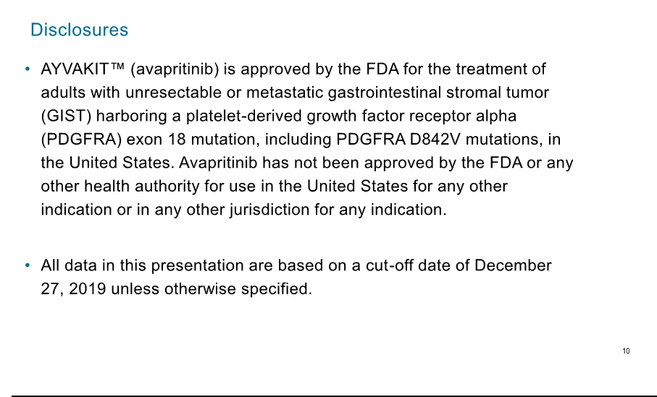

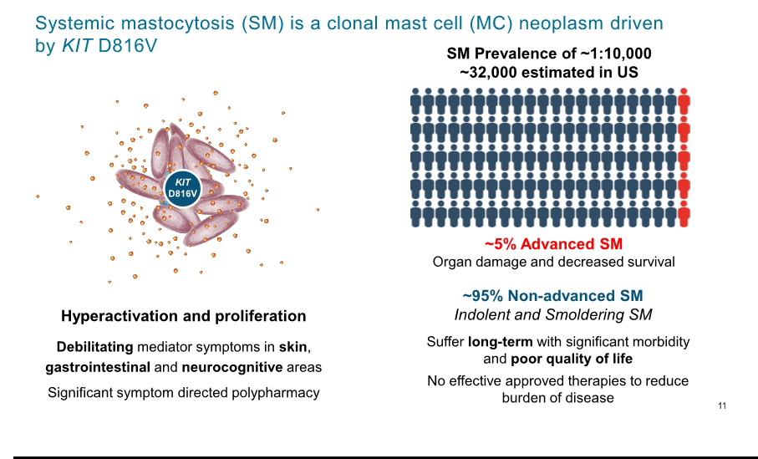

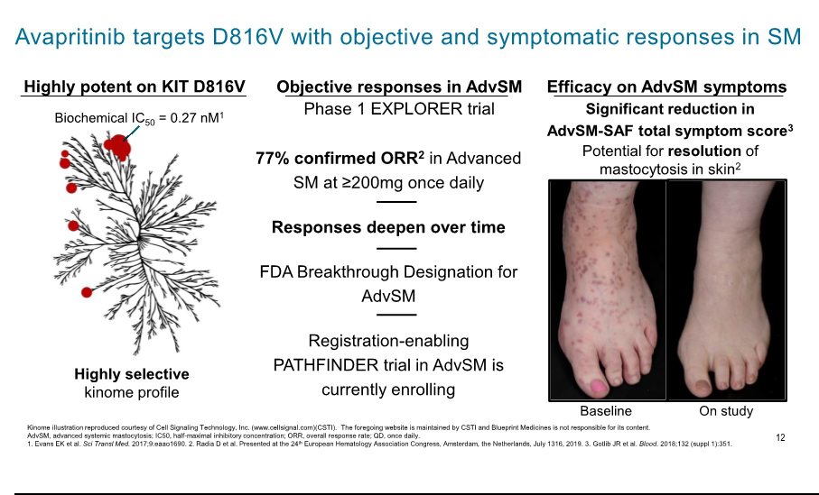

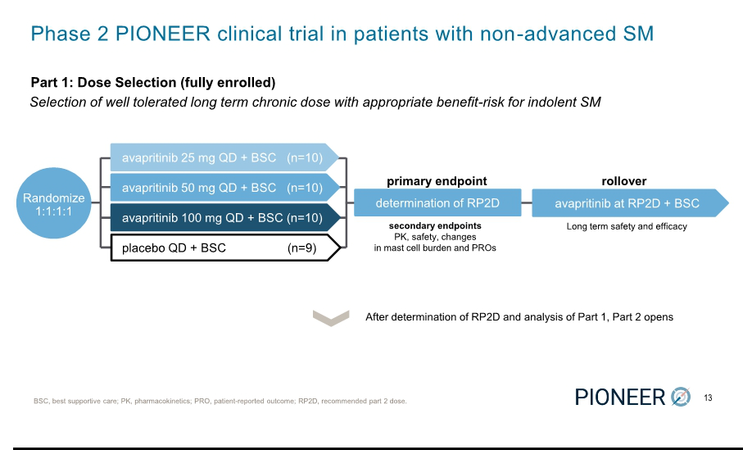

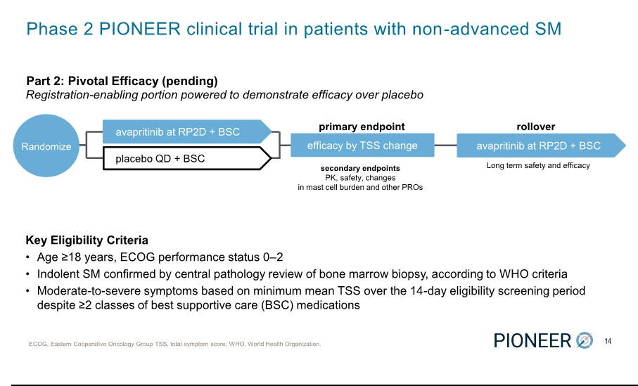

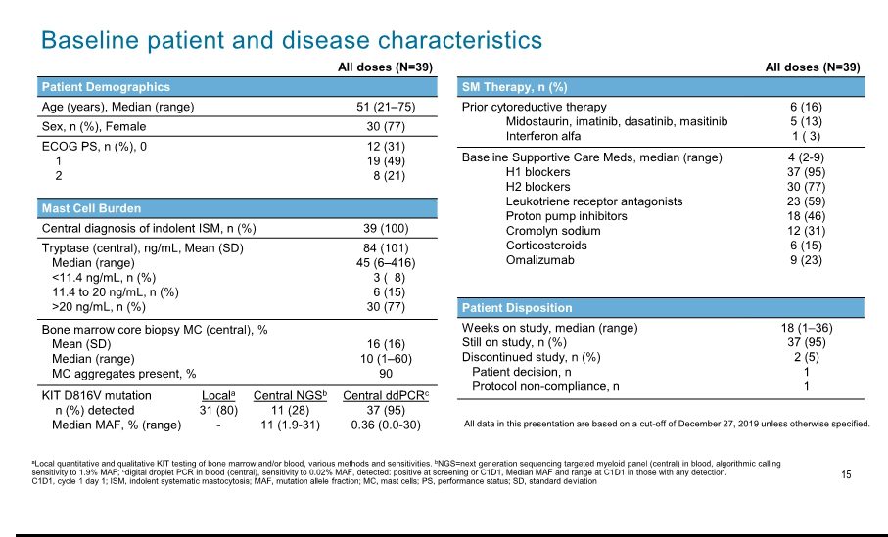

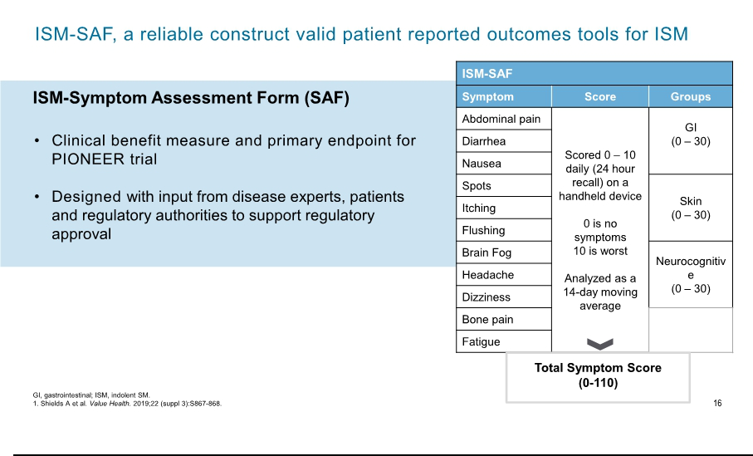

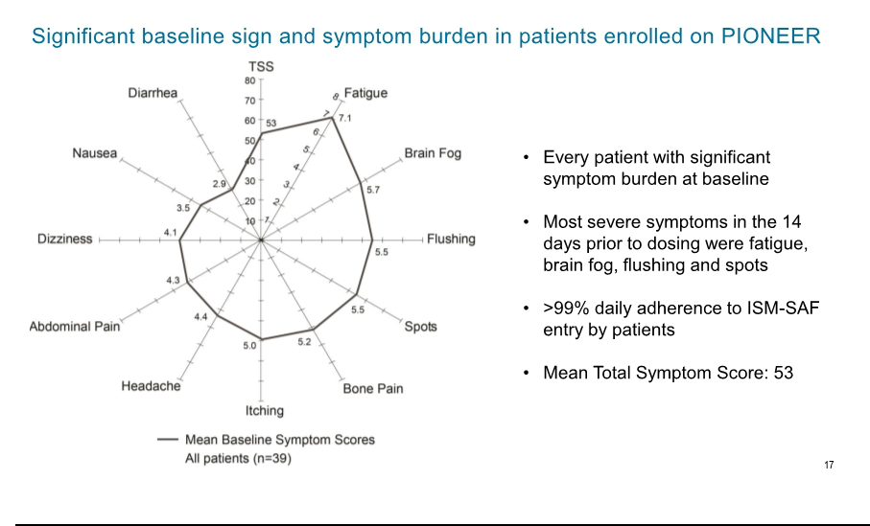

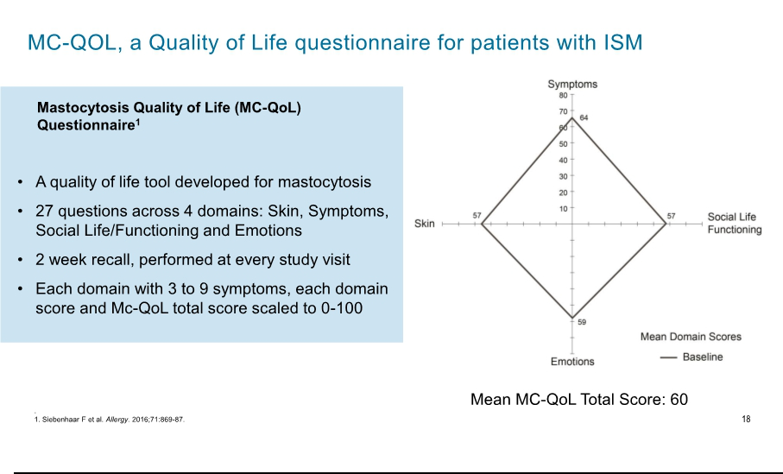

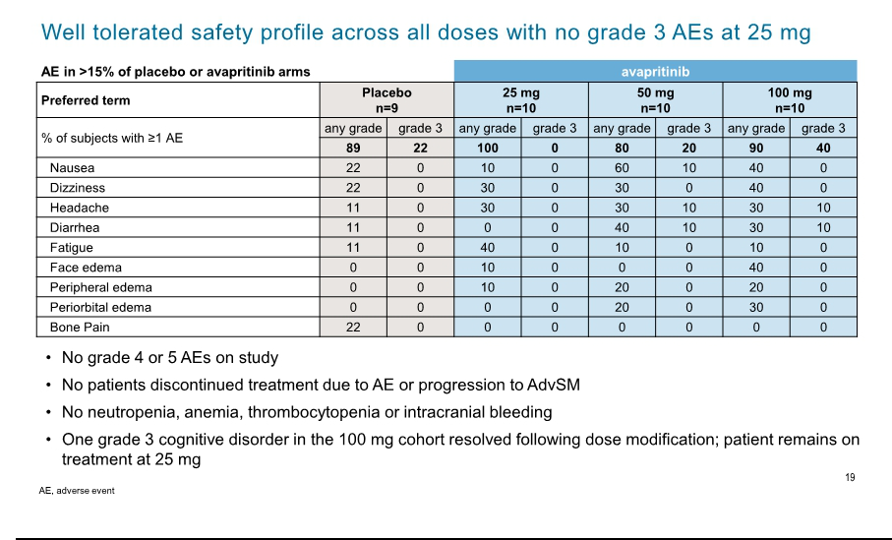

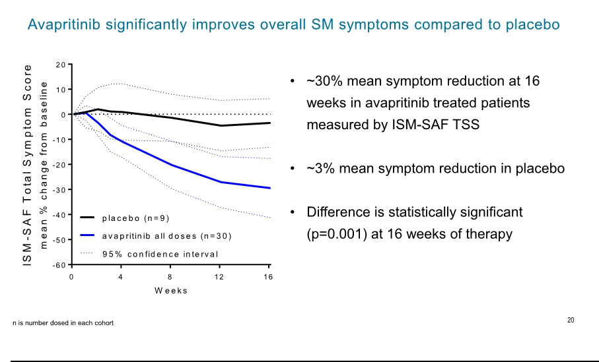

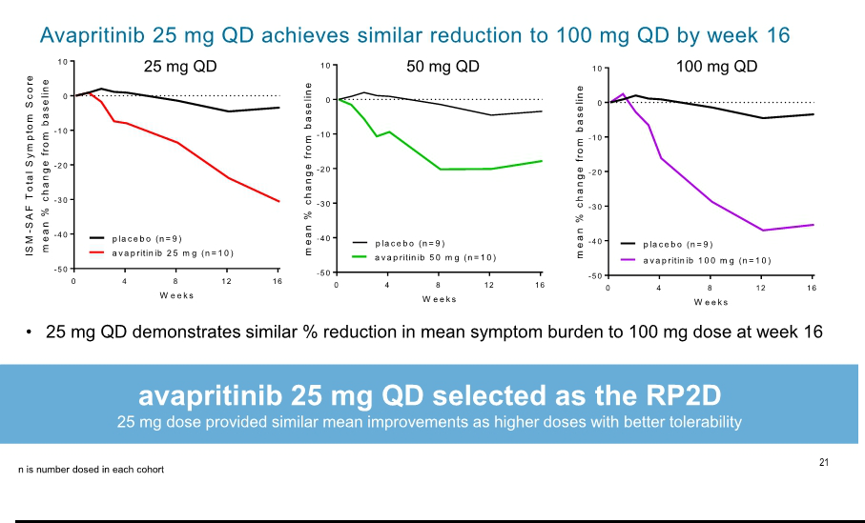

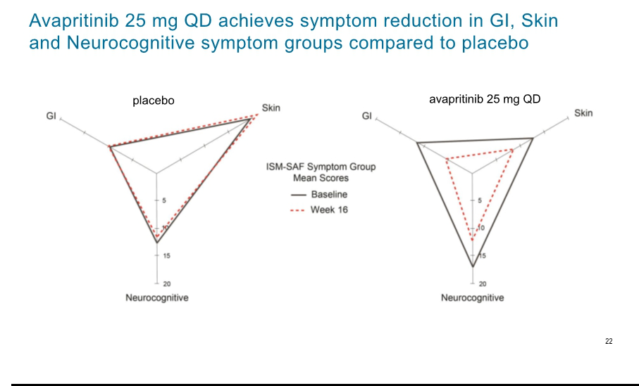

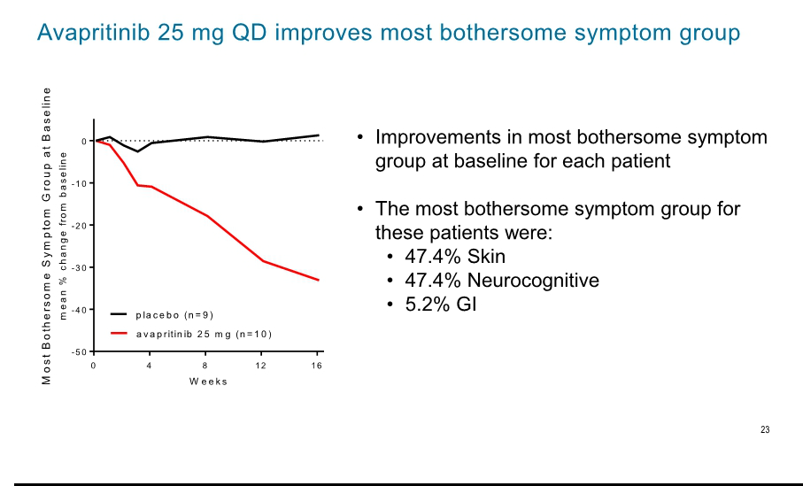

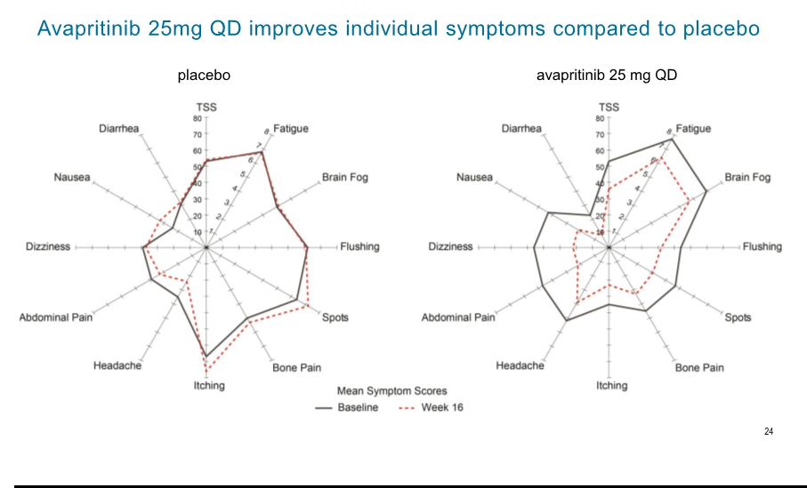

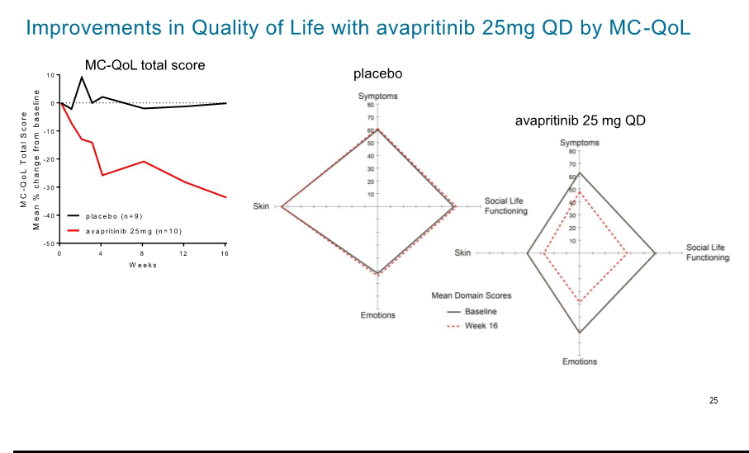

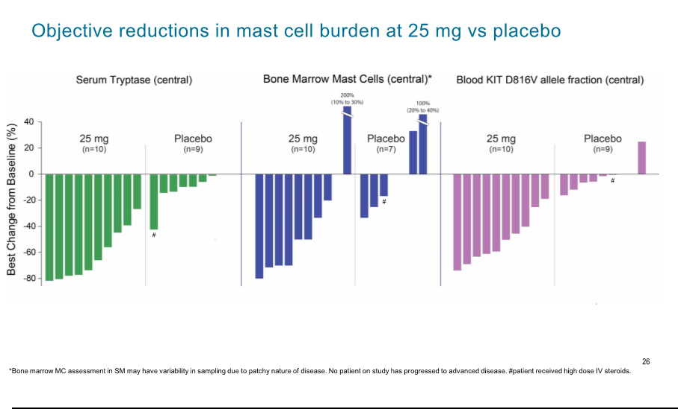

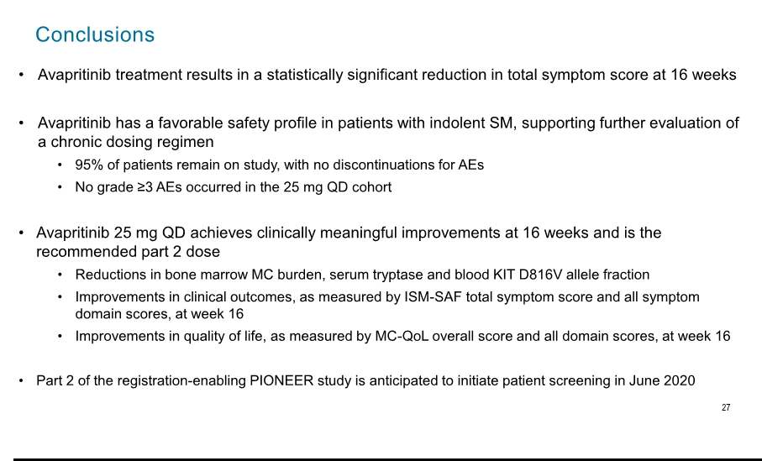

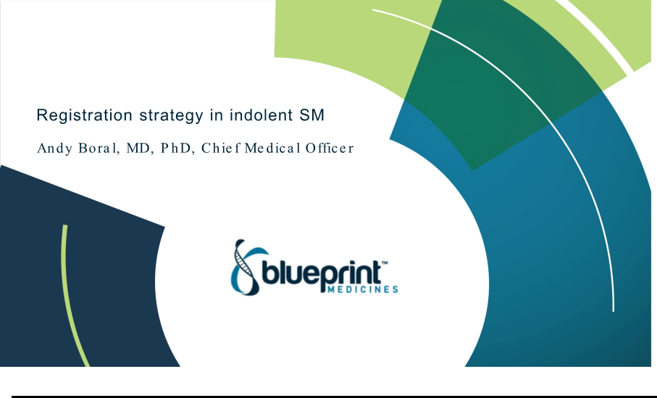

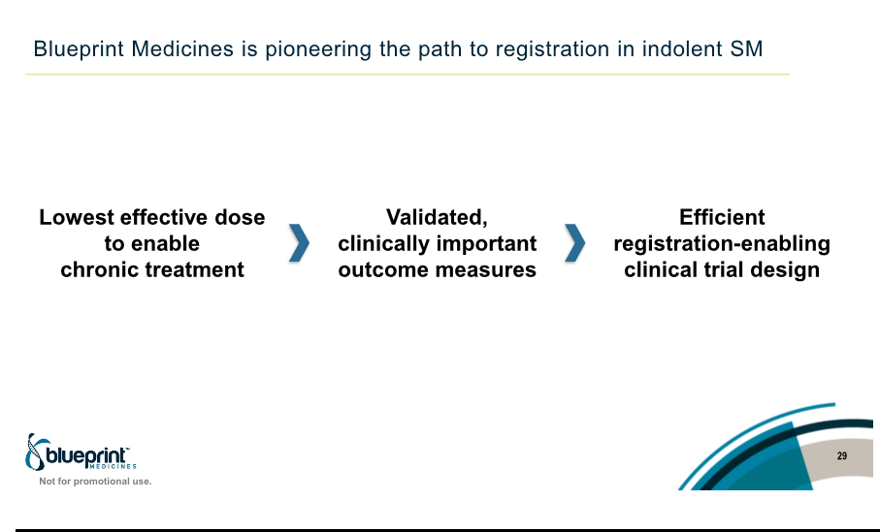

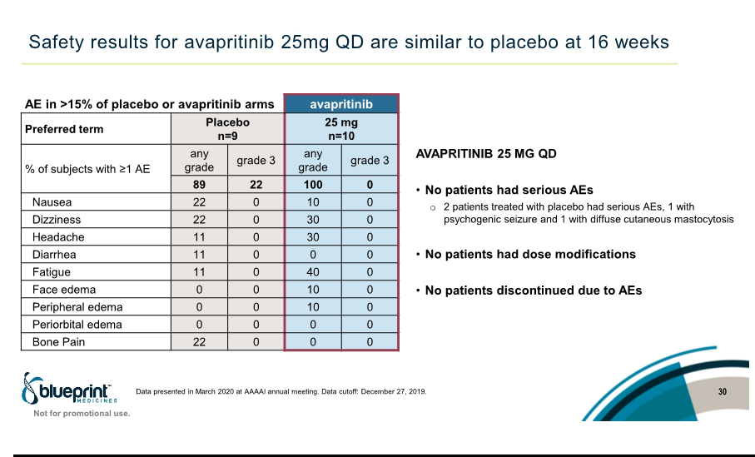

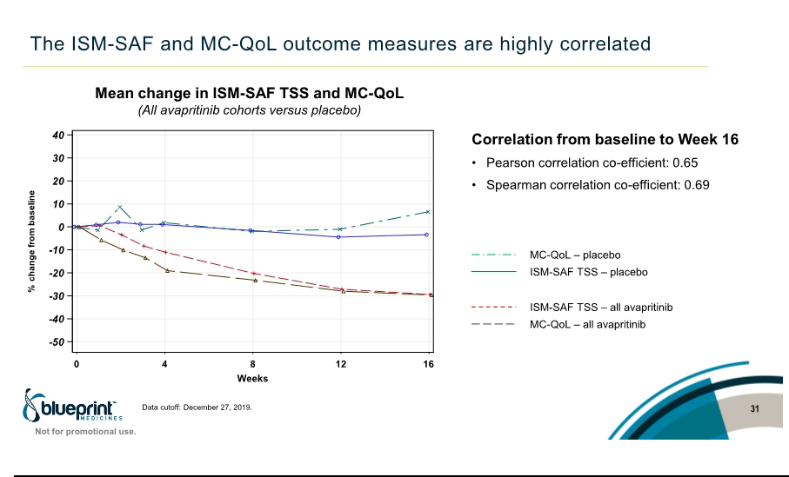

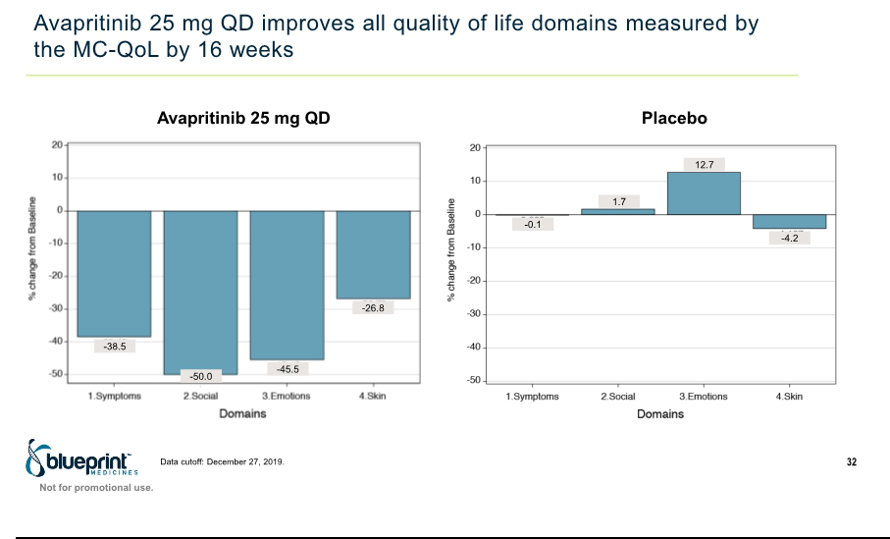

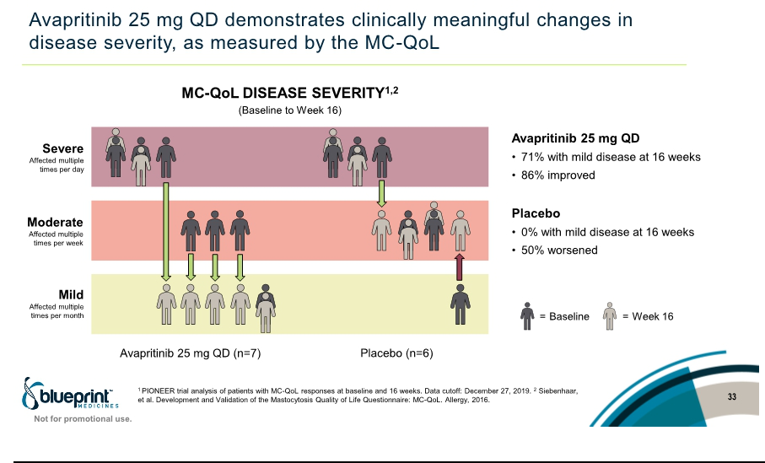

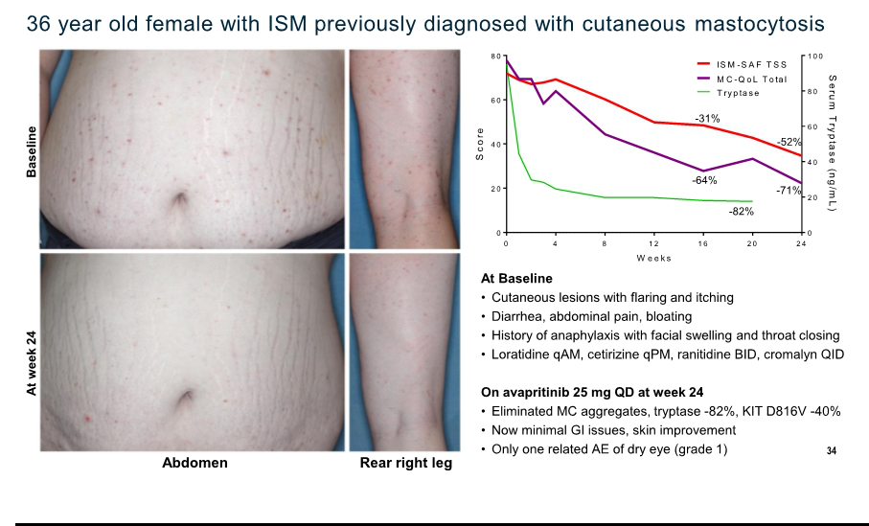

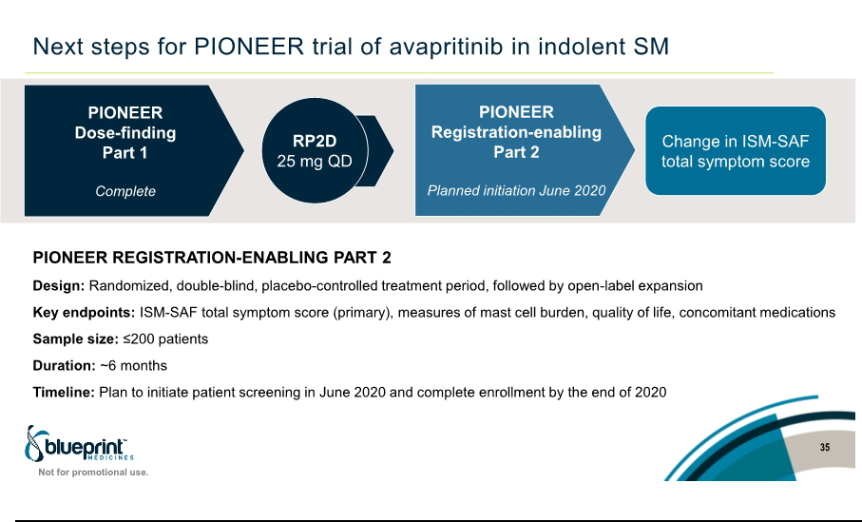

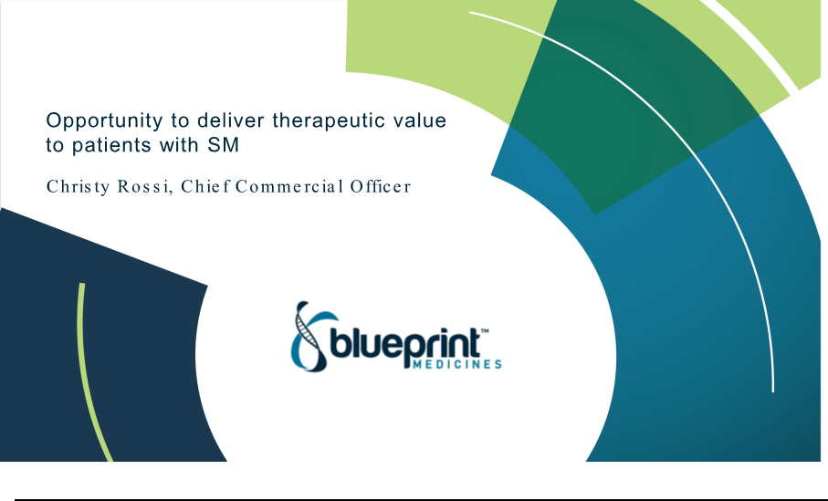

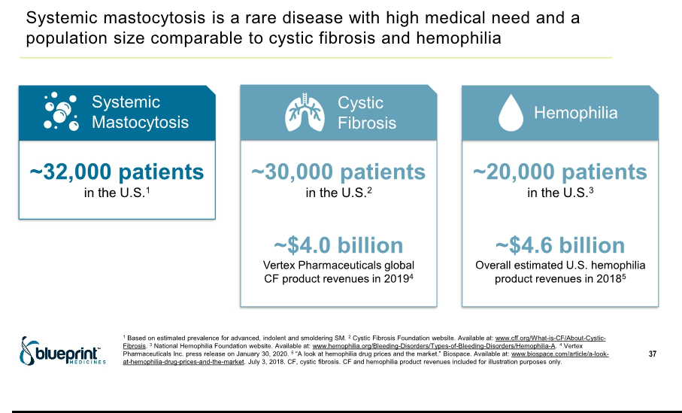

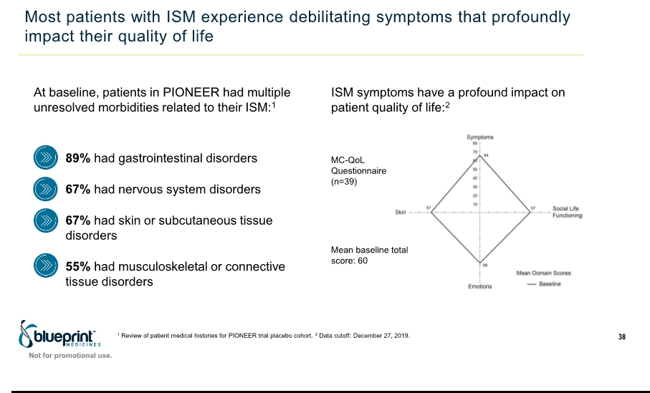

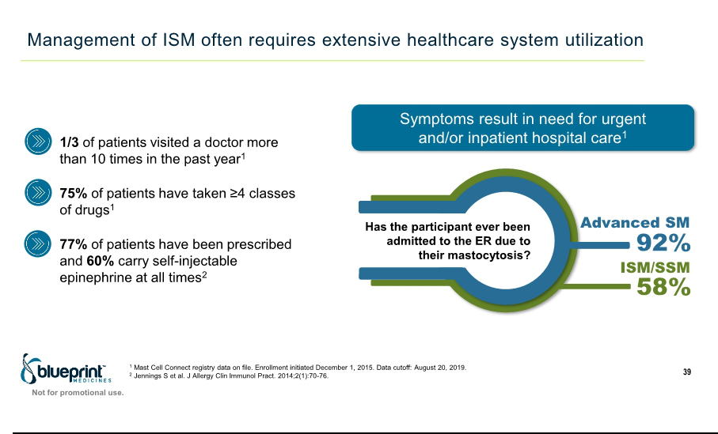

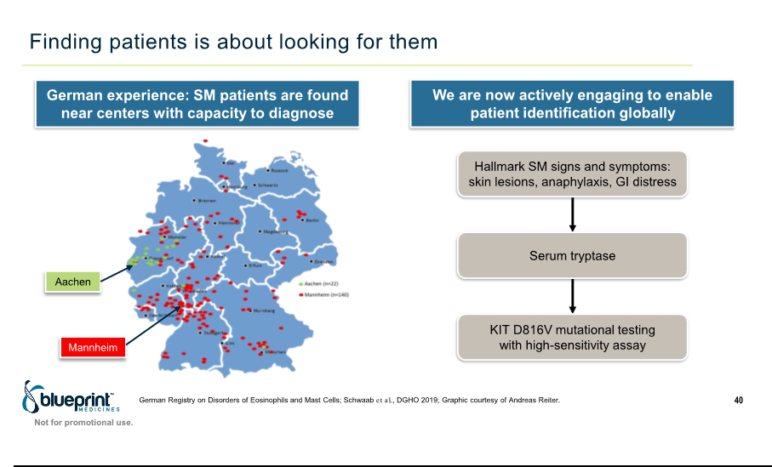

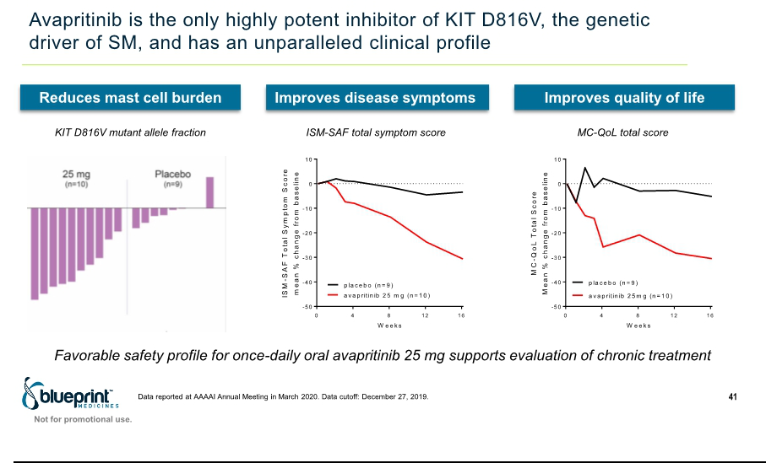



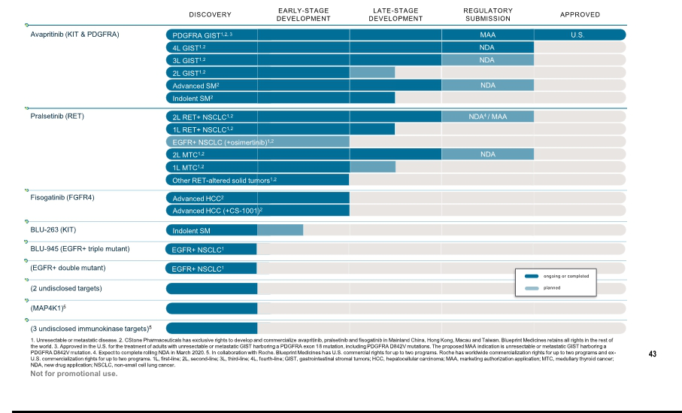

Exhibit 99.2

Blueprint Medicines Announces Part 1 Results from PIONEER Trial Showing Broad Activity of Avapritinib Across Measures of Mast Cell Burden, Clinical Outcomes and Quality of Life in Indolent Systemic Mastocytosis

      - Avapritinib showed a statistically significant improvement in patient-reported outcomes, the primary measure of clinical benefit in PIONEER --

  - Avapritinib was well-tolerated across all three doses; no patient discontinuations due to AEs --

- 25 mg QD selected as recommended Part 2 dose, based on consistent and clinically important improvements across multiple measures of

efficacy and a well-tolerated safety profile --

    - Blueprint Medicines to host investor conference call and webcast today at 7:30 a.m. ET --

CAMBRIDGE, Mass., March 16, 2020 – Blueprint Medicines Corporation (NASDAQ: BPMC), a precision therapy company focused on genomically defined cancers, rare diseases and cancer immunotherapy, today announced updated results from the Phase 2 PIONEER trial of avapritinib in patients with indolent systemic mastocytosis (SM) showing significant clinical improvements versus placebo. In Part 1 of the PIONEER trial, patients treated with avapritinib showed a statistically significant mean decline of approximately 30 percent in total symptom score (TSS) at 16 weeks, as measured by the Indolent SM Symptom Assessment Form (ISM-SAF), and reductions in symptom scores have deepened over time. In addition, patients treated with avapritinib achieved consistent improvements across objective measures of mast cell burden and patient-reported quality of life. Avapritinib was well-tolerated with no patients discontinuing treatment due to adverse events (AEs). Based on the full Part 1 data, 25 mg once daily (QD) has been selected as the recommended Part 2 dose (RP2D). Results from this data presentation will be available on an American Academy of Allergy, Asthma & Immunology (AAAAI) virtual forum, which

was established following the cancellation of the 2020 AAAAI Annual Meeting: https://education.aaaai.org/annual-meeting-abstracts/.

SM is a rare disease driven by the KIT D816V mutation and characterized by uncontrolled mast cell proliferation and activation. The disorder can lead to debilitating symptoms and life-threatening complications. Avapritinib is a potent and highly selective inhibitor of D816V mutant KIT.

“Indolent SM causes devastating symptoms that wreak havoc on patients’ lives, often involves a high polypharmacy burden, and may result in frequent urgent care visits and hospitalizations,” said Cem Akin, M.D., Ph.D., Professor of Medicine at the University of Michigan and an investigator on the PIONEER trial. “These data show the promise of avapritinib to offer sustained, clinically meaningful improvements across multiple measures of disease, including quality of life and reductions in mast cell burden, and a well-tolerated safety profile. Avapritinib has the potential to advance treatment beyond symptomatic therapies and fundamentally change the way we manage this debilitating disease.”

“Avapritinib was specifically designed to inhibit D816V mutant KIT, with the goal of delivering transformative benefit to patients,” said Andy Boral, M.D., Ph.D., Chief Medical Officer at Blueprint Medicines. “In indolent SM, these placebo-controlled data are the first to show consistent clinical activity across multiple measures of disease, from mast cell burden to clinical outcomes and quality of life. The results continue to build our confidence that by potently targeting the underlying cause of the disorder, we are enabling profound benefits across the spectrum of SM.”

Blueprint Medicines plans to initiate patient screening for the registration-enabling Part 2 of the PIONEER trial in June 2020. Part 2 is designed to evaluate the efficacy of avapritinib at the RP2D versus placebo. Blueprint Medicines anticipates completing enrollment in Part 2 of the PIONEER trial by the end of 2020.

Highlights from the Part 1 PIONEER Trial Data in Indolent SM

Part 1 of the PIONEER trial was designed to determine the RP2D by evaluating three doses of avapritinib (25 mg, 50 mg and 100 mg QD) versus placebo. Key eligibility criteria include adults with indolent SM confirmed by central pathology review and moderate-to-severe symptom burden despite best supportive care medicines. Overall, 39 patients were enrolled in Part 1 across four concurrent cohorts, consisting of 10 patients each in the avapritinib dose cohorts and nine patients in the placebo cohort.

Patient-reported outcomes (PRO) data were collected using the ISM-SAF, which was designed with input from disease experts, patients and regulatory authorities to support registration. All results are as of a data cutoff date of December 27, 2019.

Baseline Patient Characteristics

Patients had high symptom burden at baseline, with a mean ISM-SAF TSS of 53 on a scale of 0 to 110. Eight patients (21 percent) had an Eastern Cooperative Oncology Group Performance Status of 2, reflecting the inability to carry out any work activities. Patients received a median of four best supportive care medicines at baseline (range: 2-9). Median serum tryptase was 45 micrograms per liter (the upper limit of normal is 11.4 micrograms per liter). A high sensitivity polymerase chain reaction assay on peripheral blood detected the KIT D816V mutation in 37 patients (95 percent).

Clinical Activity

Avapritinib showed broad activity across measures of mast cell burden, the PRO clinical benefit measure and quality of life. The consistency of results observed across multiple measures of disease burden support the further evaluation of avapritinib in indolent SM. At 16 weeks, patients had a statistically significant reduction in ISM-SAF TSS, with a mean improvement of approximately 30 percent across all avapritinib dose cohorts compared to approximately 3 percent in the placebo cohort (p=0.001). As of the data cutoff date, 37 patients (95 percent) have remained on study with a median follow-up of 18 weeks.

Results from the 25 mg QD dose cohort show important clinical activity, including meaningful declines in serum tryptase, bone marrow mast cells and KIT D816V allele burden. Treatment with avapritinib led to consistent reductions in the ISM-SAF TSS, gastrointestinal domain, skin domain and each individual symptom. Symptom improvements in patients treated at 25 mg QD continued to deepen over time.

Mean Percent Changes in ISM-SAF at 16 Weeks

 | Avapritinib, 25 mg QD | Placebo
TSS | -31% | -3%
Skin domain | -37% | +3%
Gastrointestinal domain | -25% | +6%
Neurological symptoms | -26% | -8%


Data from the Mastocytosis Quality of Life (MC-QoL) questionnaire, a PRO tool developed for mast cell disorders, show improvements in
quality of life for patients receiving avapritinib and support the results observed with the ISM-SAF. Patients in the 25 mg QD dose
cohort had a mean reduction of 34 percent in the total MC-QoL score and improvements in all four domains assessed (symptoms, social life
functioning, emotions and skin). A 7 percent increase from baseline was observed in the placebo cohort.

Safety

The safety profile of avapritinib supports chronic dosing in indolent SM. All doses of avapritinib were well-tolerated and no patients discontinued treatment due to AEs. No patients treated with avapritinib in the 25 mg QD dose cohort had serious AEs, Grade 3 or higher AEs, or dose modifications. In the placebo cohort, two patients (22 percent) had Grade 3 AEs, one with seizure and one with diffuse cutaneous mastocytosis; these events also met criteria for serious AEs.

Conference Call Information

PIONEER trial data were previously accepted as a late-breaking oral abstract at the 2020 AAAAI Annual Meeting. Due to the cancellation of the AAAAI Annual Meeting, Blueprint Medicines is reporting the data during an investor conference call and webcast today at 7:30 a.m. ET.

To access the live call, please dial (855) 728-4793 (domestic) or (503) 343-6666 (international), and refer to conference ID 1590639. A webcast of the conference call will be available in the Investors & Media section of Blueprint Medicines’

website at http://ir.blueprintmedicines.com. The archived webcast will be available on Blueprint Medicines’ website approximately two hours after the conference call and will be available for 30 days following the call.

About SM

SM is a rare disease driven by the KIT D816V mutation. Uncontrolled proliferation and activation of mast cells result in chronic, severe and often unpredictable symptoms for patients across the spectrum of SM. The vast majority of those affected have non-advanced (indolent or smoldering) SM, with debilitating symptoms that lead to a profound, negative impact on quality of life. A minority of patients have advanced SM, which encompasses a group of high-risk SM subtypes including aggressive SM, SM with an associated hematologic neoplasm and mast cell leukemia. In addition to mast cell activation symptoms, advanced SM is associated with organ damage due to mast cell infiltration and poor overall survival.

Debilitating symptoms associated with SM, including anaphylaxis, maculopapular rash, pruritis, brain fog, fatigue and bone pain, often persist despite treatment with a number of symptomatic therapies. Patients often live in fear of attacks, have limited ability to work or perform daily activities, or isolate themselves to protect against unpredictable triggers. Currently, there are no approved therapies that selectively inhibit D816V mutant KIT.

About AYVAKIT™ (avapritinib)

AYVAKIT™ (avapritinib) is a kinase inhibitor approved by the FDA for the treatment of adults with unresectable or metastatic gastrointestinal stromal tumor (GIST) harboring a PDGFRA exon 18 mutation, including PDGFRA D842V mutations. For more information, visit AYVAKIT.com.

Avapritinib is not approved for the treatment of any other indication, including SM, in the U.S. or any other jurisdiction by the FDA or any other health authority.

About the Clinical Development Program for Avapritinib

Avapritinib is an oral precision therapy that selectively and potently inhibits KIT and PDGFRA mutant kinases. Blueprint Medicines is pursuing a broad clinical development program for avapritinib for advanced, smoldering and indolent SM, as well as across multiple lines of GIST treatment.

Avapritinib is uniquely designed to selectively bind and inhibit D816V mutant KIT, the common driver of disease in approximately 95 percent of all SM patients. Preclinical studies have shown avapritinib potently inhibited KIT D816V at sub-nanomolar potencies with minimal off-target activity. In addition, avapritinib has demonstrated broad inhibition of KIT and PDGFRA mutations associated with GIST, including potent activity against activation loop mutations that are associated with resistance to currently approved therapies.

The FDA has granted Breakthrough Therapy Designation to avapritinib for two indications: one for the treatment of advanced SM, including the subtypes of aggressive SM, SM with an associated hematologic neoplasm and mast cell leukemia, and one for the treatment of unresectable or metastatic GIST harboring the PDGFRA D842V mutation.

Patients and clinicians interested in ongoing or planned clinical trials can contact the Blueprint Medicines study director at studydirector@blueprintmedicines.com or 1-617-714-6707. Additional details are available at www.blueprintclinicaltrials.com or www.clinicaltrials.gov.

About the Phase 2 PIONEER Trial

PIONEER is a randomized, double-blind, placebo-controlled, registration-enabling trial evaluating avapritinib in patients with indolent and smoldering SM. The trial includes three parts: dose-finding Part 1, registration-enabling Part 2 and long-term treatment Part 3. All patients who complete Parts 1 or 2 will have an opportunity to continue to receive treatment with avapritinib in Part 3. Key trial endpoints include the change in patient-reported disease symptoms as measured by the ISM-SAF TSS, quantitative measures of mast cell burden and safety. Part 1 has completed patient enrollment. Blueprint Medicines plans to initiate patient screening for Part 2 in June 2020 at sites in the United States, Canada and European Union. Additional details are available at www.blueprintclinicaltrials.com/SM/ or www.clinicaltrials.gov.

About Blueprint Medicines

Blueprint Medicines is a precision therapy company striving to improve human health. With a focus on genomically defined cancers, rare diseases and cancer immunotherapy, we are developing transformational medicines rooted in our leading expertise in protein kinases, which are proven drivers of disease. Our uniquely targeted, scalable approach empowers the rapid design and development of new treatments and increases the likelihood of clinical success. We have one FDA-approved precision therapy and are currently advancing multiple investigational medicines in clinical development, along with a number of research programs. For more information, visit www.BlueprintMedicines.com and follow us on Twitter (@BlueprintMeds) and LinkedIn.

Cautionary Note Regarding Forward-Looking Statements

This press release contains forward-looking statements within the meaning of the Private Securities Litigation Reform Act of 1995, as amended, including, without limitation, statements regarding plans and timelines for the development of its drug candidates, including the timing, design, implementation, enrollment, plans and announcement of results regarding Blueprint Medicines’ ongoing and planned clinical trials for avapritinib in SM; plans, timelines and expectations for initiating patient screening in Part 2 of the PIONEER trial and for completing enrollment in Part 2 of the PIONEER trial; expectations regarding the potential benefits of avapritinib in treating patients with SM; and Blueprint Medicines’ strategy, goals and anticipated milestones, business plans and focus. The words “aim,” “may,” “will,” “could,” “would,” “should,” “expect,” “plan,” “anticipate,” “intend,” “believe,” “estimate,” “predict,” “project,” “potential,” “continue,” “target” and similar expressions are intended to identify forward-looking statements, although not all forward-looking statements contain these identifying words. Any forward-looking statements in this press release are based on management’s current expectations and beliefs and are subject to a number of risks, uncertainties and important factors that may cause actual events or results to differ materially from those expressed or implied by any forward-looking statements contained in this press release, including, without limitation, risks and uncertainties related to Blueprint Medicines’ ability and plans in continuing to establish a commercial infrastructure and successfully launching, marketing and selling any current or future approved products; Blueprint Medicines’ ability to successfully expand the approved indications for AYVAKIT or obtain marketing approval for AYVAKIT in additional geographies in the future; the delay of any current or planned clinical trials or the development of Blueprint Medicines’ drug candidates, including any drug candidates licensed to third parties; Blueprint Medicines’ advancement of multiple early-stage efforts; Blueprint Medicines’ ability to successfully demonstrate the safety and efficacy of its drug candidates and gain approval of its drug candidates on a timely basis, if at all; the preclinical and clinical results for Blueprint Medicines’ drug candidates, which may not support further development of such drug candidates; actions of regulatory agencies, which may affect the initiation, timing and progress of clinical trials; Blueprint Medicines’ ability to develop and commercialize companion diagnostic tests for its current and future drug candidates; and the success of Blueprint Medicines’ current and future collaborations or licensing arrangements. These and other risks and uncertainties are described in greater detail in the section entitled “Risk Factors” in Blueprint Medicines’ filings with the Securities and Exchange Commission (SEC), including Blueprint Medicines’ most recent Annual Report on Form 10-K, as supplemented by its most recent Quarterly Report on Form 10-Q and any other filings that Blueprint Medicines has made or may make with the SEC in the future. Any forward-looking statements contained in this press release represent Blueprint Medicines’ views only as of the date hereof and should not be relied upon as representing its views as of any subsequent date. Except as required by law, Blueprint Medicines explicitly disclaims any obligation to update any forward-looking statements.

Investor Relations Contact

Kristin Hodous
617-714-6674

ir@blueprintmedicines.com

Media Relations Contact

Andrew Law
617-844-8205

media@blueprintmedicines.com

