UNITED STATES

SECURITIES AND EXCHANGE COMMISSION
Washington, D.C. 20549

FORM 8-K

CURRENT REPORT

Pursuant to Section 13 or 15(d)

of the Securities Exchange Act of 1934

Date of Report (Date of Earliest Event Reported): January 8, 2021

Blueprint Medicines Corporation

(Exact name of registrant as specified in its charter)

Delaware

(State or other jurisdiction

of incorporation)

001-37359

(Commission File Number)

26-3632015

(I.R.S. Employer

Identification No.)

45 Sidney Street

Cambridge, Massachusetts

(Address of principal executive offices)

02139

(Zip Code)

Registrant’s telephone number, including area code: (617) 374-7580

(Former name or former address, if changed since last report)

Check the appropriate box below if the Form 8-K filing is intended to simultaneously satisfy the filing obligation of the registrant under any of the following provisions:

- Written communications pursuant to Rule 425 under the Securities Act (17 CFR 230.425)

- Soliciting material pursuant to Rule 14a-12 under the Exchange Act (17 CFR 240.14a-12)

- Pre-commencement communications pursuant to Rule 14d-2(b) under the Exchange Act (17 CFR 240.14d-2(b))

- Pre-commencement communications pursuant to Rule 13e-4(c) under the Exchange Act (17 CFR 240.13e-4(c))

Indicate by check mark whether the registrant is an emerging growth company as defined in Rule 405 of the Securities Act of 1933 (§230.405 of this chapter) or Rule 12b-2 of the Securities Exchange Act of 1934 (§240.12b-2 of this chapter).

Emerging growth company ☐

If an emerging growth company, indicate by check mark if the registrant has elected not to use the extended transition period for complying with any new or revised financial accounting standards provided pursuant to Section 13(a) of the Exchange Act. ☐

Securities registered pursuant to Section 12(b) of the Exchange Act:

Title of each class | Trading symbol(s) | Name of each exchange on which registered
Common stock, par value $0.001 per share | BPMC | Nasdaq Global Select Market

Item 1.01 Entry into a Material Definitive Agreement.

Amendment – Roche Immunotherapy Collaboration

On January 8, 2021, Blueprint Medicines Corporation (the “Company”) entered into a ninth amendment to its collaboration and license agreement, as amended, with F. Hoffmann-La Roche Ltd and Hoffmann-La Roche Inc. (collectively, “Roche”), related to the discovery, development and commercialization of small molecule therapeutics targeting kinases in cancer immunotherapy. Pursuant to the amendment, the Company and Roche agreed to modify certain time periods related to Roche’s option rights for one of the collaboration programs and agreed to terminate two of the other collaboration programs, including certain mechanics related to the wind-down of activities for such terminated targets. As a result of the amendment, the parties are currently conducting activities for up to two programs under the collaboration, including the previously announced program for the kinase target MAP4K1, which is believed to play a role in T cell regulation. Subject to the terms of the agreement, as amended, in addition to upfront and milestone payments previously received, the Company is eligible to receive up to approximately $323 million in contingent option fees and milestone payments related to specified research, pre-clinical, clinical, regulatory and sales-based milestones.

The foregoing description of the material terms of the ninth amendment to the collaboration and license agreement with Roche is qualified in its entirety by reference to the complete text of such amendment, which the Company intends to file, with confidential terms redacted, with the Securities and Exchange Commission (“SEC”) as an exhibit to the Company’s Annual Report on Form 10-K for the year ended December 31, 2020.

Item 5.02 Departure of Directors or Certain Officers; Election of Directors; Appointment of Certain Officers; Compensatory Arrangements of Certain Officers.

Transition of Anthony L. Boral, M.D., Ph.D. from Chief Medical Officer to Executive Vice President, Clinical Development

Effective as of January 11, 2021, the Company entered into a first amendment to employment agreement with Anthony L. Boral, M.D., Ph.D. pursuant to

which Dr. Boral will transition from the role of Chief Medical Officer into the role of Executive Vice President, Clinical Development. In this role, Dr. Boral will advise on clinical development, regulatory and business development strategy across the Company’s portfolio. Pursuant to the terms of the amendment, Dr. Boral will devote 60% of his full working time and efforts to the business and affairs of the Company, Dr. Boral’s annual base salary will be reduced to $286,196, and he will be eligible for an annual performance bonus targeted at 35% of his annualized base salary.

The foregoing description of the first amendment to employment agreement with Dr. Boral is qualified in its entirety by reference to the complete text of such amendment, a copy of which is attached as Exhibit 10.1 to this Current Report on Form 8-K.

Appointment of Becker Hewes, M.D. as Chief Medical Officer

Effective as of January 11, 2021, the board of directors of the Company promoted Becker Hewes, M.D., the Company’s Senior Vice President, Clinical Development, to succeed Dr. Boral and serve as Chief Medical Officer, and the Company entered into an amended and restated employment agreement with Dr. Hewes, which provides for “at will” employment. As Chief Medical Officer, Dr. Hewes will be responsible for clinical development, clinical operations, pharmacovigilance, translational medicine and biostatistics.

Dr. Hewes brings 20 years of industry and clinical experience in oncology and hematology, including achieving the approval of three tyrosine kinase inhibitors. Dr. Hewes, age 55, previously served as Senior Vice President, Clinical Development, of the Company from May 2020 to January 2021. Prior to joining the Company, Dr. Hewes served as Chief Medical Officer of Repertoire Immune Medicines (formerly Torque Therapeutics) (“Repertoire”) from February 2017 to May 2020, where he built Repertoire’s multidisciplinary clinical and biomarker team and advanced its lead immuno-oncology programs into clinical development. From June 2013 to February 2017, Dr. Hewes served as Executive Director of Translational Clinical Oncology at the Novartis Institutes for BioMedical Research where he led clinical development and translational medicine efforts for multiple early-stage oncology programs through clinical proof-of-concept, including Kisqali® (ribociclib), a targeted therapy approved to treat breast cancer, and other programs combining novel therapies. Prior to that, he held roles of increasing responsibility related to clinical development in oncology and hematology within AstraZeneca PLC, Genzyme Corporation and Wyeth Pharmaceuticals, including leading registration programs

for Bosulif® (bosutinib) and Torisel® (temsirolimus) for chronic myelogenous leukemia and mantle cell lymphoma, respectively. Before joining industry, he conducted immuno-oncology research at the Emory Vaccine Center while treating patients as a pediatric oncologist at Children’s Healthcare of Atlanta. Dr. Hewes holds an M.D. from the Georgetown University School of Medicine and a B.S. from Vanderbilt University.

Pursuant to the terms of his amended and restated employment agreement, Dr. Hewes is entitled to an annual base salary of $462,000, effective as of January 1, 2021. Dr. Hewes is also eligible for an annual performance bonus targeted at 45% of his annualized base salary. In addition, pursuant to the terms of his amended and restated employment agreement,

2

if Dr. Hewes’ employment is terminated by the Company without cause or by Dr. Hewes for good reason, and subject to Dr. Hewes’ execution of a release of potential claims against the Company, Dr. Hewes will be entitled to receive: (i) a lump sum in cash in an amount equal to 12 months of base salary and (ii) a monthly cash payment for 12 months for medical and dental benefits or Dr. Hewes’ COBRA health continuation period, whichever ends earlier. However, in the event
that Dr. Hewes’ employment is terminated by the Company without cause, or Dr. Hewes terminates his employment with the Company for good reason, in either case within 12 months following the occurrence of a sale event (as defined in his amended and restated employment agreement), in lieu of the severance payments and benefits described in the preceding sentence and subject to Dr. Hewes’ execution of a release of potential claims against the Company, Dr. Hewes will be entitled to receive: (i) a lump sum in cash in an amount equal to the sum of 12 months of Dr. Hewes’ base salary then in effect plus Dr. Hewes’ target annual incentive compensation for the year in which the termination occurs, (ii) a monthly cash payment for 12 months for medical and dental benefits or Dr. Hewes’ COBRA health continuation period, whichever ends earlier, and (iii) full and immediate vesting and exercisability of all time-based stock options and other time-based stock-based awards held by Dr. Hewes.

In connection with Dr. Hewes’ appointment as Chief Medical Officer, Dr. Hewes entered into the Company’s standard form of indemnification agreement, a copy of which was filed as Exhibit 10.12 to the Company’s Registration Statement on Form S-1 (File No. 333-202938) filed with the Securities and Exchange Commission on March 23, 2015. Pursuant to the terms of the indemnification agreement, the Company may be required, among other things, to indemnify Dr. Hewes for some expenses, including attorneys’ fees, judgments, fines and settlement amounts incurred by his in any action or proceeding arising out of his service as one of our officers. Dr.

Hewes has also previously entered into a confidentiality, assignment and non-competition agreement that contains, among other things, non-competition and non-solicitation provisions that apply during the term of Dr. Hewes’ employment and for 12 months thereafter.

Dr. Hewes has no family relationship with any of the executive officers or directors of the Company. There are no arrangements or understandings between Dr.

Hewes and any other person pursuant to which he was appointed as an officer of the Company.

The foregoing description of the amended and restated employment agreement with Dr. Hewes is qualified in its entirety by reference to the complete text of such agreement, a copy of which is attached as Exhibit 10.2 to this Current Report on Form 8-K.

Item 7.01 Regulation FD.

From time to time, the Company presents and/or distributes to the investment community at various industry and other conferences slide presentations to provide updates and summaries of its business. The Company is posting to the “Investors & Media” portion of its website at http://ir.blueprintmedicines.com/ a copy of its current corporate slide presentation. A copy of the presentation is furnished as Exhibit 99.1 to this Current Report on Form 8-K.

The information in Item 7.01 of this Current Report on Form 8-K, including Exhibit 99.1 attached hereto, is intended to be furnished and shall not be deemed “filed” for purposes of Section 18 of the Securities Exchange Act of 1934, as amended (the “Exchange Act”), or otherwise subject to the liabilities of that section, nor shall it be deemed incorporated by reference in any filing under the Securities Act of 1933, as amended, or the Exchange Act, except as expressly set forth by specific reference in such filing.

Item 8.01 Other Events.

On January 11, 2021, the Company issued a press release announcing its corporate goals for 2021 and certain other business updates. A copy of the press release is filed herewith as Exhibit 99.2 to this Current Report on Form 8-K and incorporated herein by reference.

Item 9.01 Financial Statements and Exhibits.

(d) Exhibits.
Exhibit No. | Description
10.1# | First Amendment to Employment Agreement, dated January 11, 2021, by and between Blueprint Medicines Corporation and Anthony L. Boral,
 | M.D., Ph.D.
10.2# | Amended and Restated Employment Agreement, dated January 11, 2021, by and between the Registrant and Becker Hewes, M.D.
99.1 | Corporate slide presentation of Blueprint Medicines Corporation dated January 11, 2021
99.2 | Press release issued by Blueprint Medicines Corporation on January 11, 2021
104 | Cover Page Interactive Data File (embedded within the Inline XBRL document and incorporated as Exhibit 101)

# Indicates management contract or compensatory plan or arrangement.

3

SIGNATURES

Pursuant to the requirements of the Securities Exchange Act of 1934, the registrant has duly caused this report to be signed on its behalf by the undersigned hereunto duly authorized.

BLUEPRINT MEDICINES CORPORATION

Date: January 11, 2021 By: /s/ Jeffrey W. Albers

Jeffrey W. Albers

Chief Executive Officer

4

Exhibit 10.1

FIRST AMENDMENT TO EMPLOYMENT AGREEMENT

This First Amendment to Employment Agreement (the “First Amendment”) between Blueprint Medicines Corporation, a Delaware corporation (the “Company”), and Anthony L. Boral (the “Executive”), is effective as of January 11, 2021 (the “Amendment Effective Date”). Capitalized terms used and not defined herein shall have the meanings ascribed to such terms in the Employment Agreement (as defined below).

WHEREAS, the Company and the Executive are parties to the Employment Agreement dated as of November 6, 2015 (the “Employment Agreement”); and

WHEREAS, the Company and the Executive desire to amend the Employment Agreement as set forth below in connection with the mutually agreed upon reduction in the amount of the Executive’s time that will be devoted to the Company;

NOW, THEREFORE, for good and valuable consideration, the receipt of which is hereby confirmed, the Company and the Executive agree that the Employment Agreement is amended effective as of the Amendment Effective Date, as follows:

- Section 1(b) of the Employment Agreement shall be replaced in its entirety with the following:

“Position and Duties. The Executive shall serve as Executive Vice President, Clinical Development, of the Company. As Executive Vice President, Clinical Development, the Executive shall report to, and perform services for the Company as determined by, the Company’s President, Research and Development (“President, R&D”) or another executive designated by the Company. The Executive acknowledges and agrees that his role as Executive Vice President, Clinical Development, may change from time to time, and such changes shall not constitute “Good Reason” as defined herein unless they are made without his consent and constitute a material diminution in the Executive’s responsibilities, authority or duties, in the aggregate, as Executive Vice President, Clinical Development. The Executive will devote sixty percent (60%) of his full working time and efforts to the business and affairs of the Company. The Executive may engage in outside professional activities including by serving on other boards of directors, provided such activities do not pose a conflict of interest and are approved in advance by the Board of Directors of the Company (the “Board”). The Executive may also engage in religious, charitable, or other community activities as long as such services and activities do not materially interfere with the performance of his duties to the Company as provided in this Agreement.”

- Section 2(a) of the Employment Agreement shall be replaced in its entirety with the following:

“Base Salary. The Executive’s annualized base salary shall be $286,196. The Executive’s annualized base salary shall be reviewed annually and may be subject to increase but not decrease (other than for any mutually agreed-upon reduction in the amount of the Executive’s time that will be devoted to the Company) while serving in the

role as Executive Vice President, Clinical Development. The annualized base salary in effect at any given time is referred to herein as “Base Salary.” The Base Salary shall be payable in a manner that is consistent with the Company’s usual payroll practices for senior executives.”

- Section 2(b) of the Employment Agreement shall be replaced in its entirety with the following:

“Incentive Compensation. During the Term, the Executive shall be eligible to earn cash incentive compensation as determined by the Board or the Compensation Committee of the Board from time to time. Beginning with the performance period for the year ending December 31, 2021, Executive’s target annual incentive compensation shall be 35% of his Base Salary (the “Target Incentive Compensation”), and the Board shall weigh its bonus determination as follows: 60% on Company performance and 40% on Executive’s individual performance. For the avoidance of doubt, for the year ended December 31, 2020, the Executive shall remain eligible to earn incentive compensation based on Executive’s previously determined target annual incentive compensation for such year, which is 45% of his Base Salary, with the Board weighing the bonus determination as 75% on Company performance and 25% on Executive’s individual performance. To earn any incentive compensation, the Executive must be employed by the Company on the day such incentive compensation is paid.”

- Section 2(d) of the Employment Agreement shall be replaced in its entirety with the following:

“Other Benefits. The Executive shall be eligible to participate in or receive benefits under the Company’s employee benefit plans in effect from time to time to the extent such plans apply to part-time employees working a 60% schedule, subject to the plans’ respective terms and conditions.”

- Section 2(e) of the Employment Agreement shall be replaced in the entirety with the following:

“Vacation. The Executive shall be entitled to accrue paid vacation during the Term in accordance with the Company’s applicable policy, pro-rated based on his part-time schedule.

- In Section 3(c)(iii) of the Employment Agreement, “CEO” shall be replaced with “President, R&D.”

- Section 3(e)(i) of the Employment Agreement shall be replaced in its entirety with:

  - 2 -

“a material diminution in the Executive’s responsibilities, authority or duties, in the aggregate, without the Executive’s consent.”

- The Executive hereby gives his express written consent in this First Amendment for the terms described herein. Accordingly, the Executive acknowledges and agrees that the terms set forth herein shall not be the basis of a “Good Reason” trigger as defined in the Employment Agreement, and therefore the Executive shall not be eligible to resign for Good Reason as a result of any such terms or in connection with the negotiation, execution and delivery of this First Amendment, and shall not be eligible to receive the Severance Amount and monthly COBRA cash payment as detailed in Section 4(b) of the Employment Agreement based on any resignation.

- To the extent that there is any inconsistency between the terms and conditions of this First Amendment and the terms and conditions of the Employment Agreement, the terms and conditions of this First Amendment shall prevail.

- The Executive hereby reaffirms his obligations under the terms of the Non-Solicitation, Non-Competition, Confidentiality and Assignment Agreement, dated as of November 22, 2014 by and between the Company and the Executive (the “Restrictive Covenant Agreement”), the terms of which are hereby are incorporated by reference as material terms of this First Amendment.

- This First Amendment may be executed in any number of counterparts, each of which when so executed and delivered shall be taken to be an original, but such counterparts shall together constitute one and the same document. Counterparts may be delivered via facsimile, electronic mail (including pdf or any electronic signature complying with the U.S. Federal ESIGN Act of 2000) or other transmission method, and any counterpart so delivered shall be deemed to have been duly and validly delivered and be valid and effective for all purposes.

- Except as amended hereby, the Employment Agreement remains in full force and effect, and the Employment Agreement, as amended hereby, together with the Executive’s written consent to the Company dated August 18, 2020, represent the entire agreement among the Executive and the Company, and there are no other agreements, written or oral, relating to the subject matter hereof. All references in the Employment Agreement to “this Agreement” (including “hereof,” “herein” and similar words or phrases) shall mean the Employment Agreement, as amended by this First Amendment.

[Signature page follows.]

- 3 -

IN WITNESS WHEREOF, the undersigned have executed this First Amendment as of the Amendment Effective

Date.

BLUEPRINT MEDICINES CORPORATION

By: /s/ Jeffrey W. Albers

Name: Jeffrey W. Albers
Title: President and Chief Executive Officer

EXECUTIVE

/s/ Anthony L. Boral

Anthony L. Boral

- 4 -

Exhibit 10.2

AMENDED AND RESTATED

EMPLOYMENT AGREEMENT

This amended and restated employment agreement (“Agreement”) is between Blueprint Medicines Corporation, a Delaware corporation (the “Company”), and L. Becker Hewes, M.D. (the “Executive”) and is effective as of January 11, 2021 (the “Effective Date”).

WHEREAS, the Company and the Executive are parties to an employment agreement, effective as of May 20, 2020 (the “Original Employment Agreement”);

WHEREAS, the Company and the Executive desire to enter into this Agreement to replace the Original Employment Agreement; and

WHEREAS, the Company desires to employ the Executive and the Executive desires to be employed by the Company on the terms and conditions contained herein.

NOW, THEREFORE, in consideration of the mutual covenants and agreements herein contained and other good and valuable consideration, the receipt and sufficiency of which is hereby acknowledged, the parties agree as follows:

- Employment.

  - Term. The term of this Agreement shall commence on the Effective Date and continue until terminated in accordance with the provisions of Section 3 (the “Term”). Notwithstanding anything to the contrary in this Agreement, the Executive’s employment with the Company will be “at will,” meaning that the Executive’s employment may be terminated by the Company or the Executive at any time and for any reason, subject to the terms of this Agreement.

  - Position and Duties. During the Term, the Executive shall serve as the Chief Medical Officer of the Company, and shall have such duties as are consistent with such position. The Executive shall report to the President, Research & Development, of the Company (the “President, R&D”) or another executive designated by the Company. The Executive shall devote his full working time and efforts to the business and affairs of the Company. Notwithstanding the foregoing, the Executive may serve on other boards of directors, with the approval of the Board of Directors of the Company (the “Board”), or engage in religious, charitable or other activities as long as such services and activities are approved by the Board and do not materially interfere with the Executive’s performance of his duties to the Company as provided in this Agreement.

- Compensation and Related Matters.

  - Base Salary. Effective January 1, 2021, the Executive’s annualized base salary shall be $462,000.00. The Executive’s base salary shall be re-determined annually by the Board or the Compensation Committee of the Board and shall be subject to increase but not decrease while Executive is serving in the Chief Medical Officer role. The annualized base salary in effect at any given time is referred to herein as “Base Salary.” The Base Salary shall be

1

payable in a manner that is consistent with the Company’s usual payroll practices for senior executives.

- Sign-On Bonus. In connection with the commencement of Executive’s employment with the Company as Senior Vice President, Clinical Development, on May 20, 2020 (the “Start Date”), Executive previously received a one-time sign-on bonus of $75,000.00 (the “Sign-On Bonus”), subject to legally required tax withholdings. Executive acknowledges and agrees that (i) if within 12 months of the Start Date, the Executive either (A) is terminated for Cause (as defined below) or (B) terminates his employment, for any reason, and regardless of whether Executive has Good Reason (as defined in this Agreement) to terminate his employment, Executive shall repay the entire Sign-On Bonus in accordance with the Company’s policies then in effect concerning such bonuses, and (ii) if at any time after the first 12 months of employment after the Start Date but within 24 month of the Start Date the Executive either (A) is terminated for Cause or (B) terminates his employment, for any reason, and regardless of whether Executive has Good Reason to terminate his employment, Executive shall repay 50% of the Sign-On Bonus in accordance with the Company’s policies then in effect concerning such bonuses.

- Equity. The Executive may be eligible to receive future equity awards under the Company’s 2015 Stock Option and Incentive Plan (as amended and/or restated from time to time) or such other equity plan as then in effect, in the sole discretion of the Board or the Compensation Committee of the Board.

- Incentive Compensation. During the Term, the Executive shall be eligible to earn cash incentive compensation as determined by the Board or the Compensation Committee of the Board from time to time. Executive’s target annual incentive compensation shall be 45% of his Base Salary (the “Target Incentive Compensation”). The Board shall weigh its bonus determination as follows: 75% on Company performance and 25% on Executive’s individual performance. To earn incentive compensation, the Executive must be employed by the Company on the day such incentive compensation is paid. For the avoidance of doubt, for the year ended December 31, 2020, the Executive shall be eligible to earn incentive compensation pro-rated for the period of time Executive was employed at the Company during the 2020 calendar year based on Executive’s target incentive compensation set forth in the Original Employment Agreement, provided Executive remains employed by the Company on the day such incentive compensation is paid.

- Expenses. The Executive shall be entitled to receive prompt reimbursement for all reasonable expenses incurred by the Executive during the Term in performing services hereunder, in accordance with the policies and procedures then in effect and established by the Company for its senior executive officers.

- Other Benefits. During the Term, the Executive shall be eligible to participate in or receive benefits under the Company’s employee benefit plans in effect from time to time, subject to the terms of such plans.

2

  - Vacation. During the Term, the Executive shall be entitled to accrue paid vacation in accordance with the Company’s applicable policy.

- Termination. During the Term, the Executive’s employment hereunder may be terminated without any breach of this Agreement under the following circumstances:

  - Death. The Executive’s employment hereunder shall terminate upon his death.

  - Disability. The Company may terminate the Executive’s employment if he is disabled and unable to perform the essential functions of his then existing position or positions under this Agreement with or without reasonable accommodation for a period of 180 days (which need not be consecutive) in any 12-month period. If any question shall arise as to whether during any period the Executive is disabled so as to be unable to perform the essential functions of the Executive’s then-existing position or positions with or without reasonable accommodation, the Executive may, and at the request of the Company shall, submit to the Company a certification in reasonable detail by a physician selected by the Company to whom the Executive or the Executive’s guardian has no reasonable objection as to whether the Executive is so disabled or how long such disability is expected to continue, and such certification shall for the purposes of this Agreement be conclusive of the issue. The Executive shall cooperate with any reasonable request of the physician in connection with such certification. If such question shall arise and the Executive shall fail to submit such certification, the Company’s determination of such issue shall be binding on the Executive. Nothing in this Section 3(b) shall be construed to waive the Executive’s rights, if any, under existing law including, without limitation, the Family and Medical Leave Act of 1993, 29 U.S.C. §260l et seq. and the Americans with Disabilities Act, 42 U.S.C. §12101 et seq.

  - Termination by Company for Cause. The Company may terminate the Executive’s employment hereunder for Cause. For purposes of this Agreement, “Cause” shall mean: (i) conduct by the Executive constituting a material act of misconduct in connection with the performance of his duties, including, without limitation, misappropriation of funds or property of the Company or any of its subsidiaries or affiliates other than the occasional, customary and de minimis use of Company property for personal purposes; (ii) the commission by the Executive of any felony or a misdemeanor involving moral turpitude, deceit, dishonesty or fraud, or any conduct by the Executive that would reasonably be expected to result in material injury or reputational harm to the Company or any of its subsidiaries and affiliates if he were retained in his position; (iii) continued non-performance by the Executive of his duties hereunder (other than by reason of the Executive’s physical or mental illness, incapacity or disability) which has continued for more than 30 days following written notice of such non-performance from the President, R&D or the Chief Executive Officer of the Company; (iv) a material breach by the Executive of any of the provisions contained in Section 7 of this Agreement; (v) a material violation by the Executive of the Company’s written employment policies; or (vi) the Executive’s failure to cooperate with a bona fide internal investigation or an investigation by regulatory or law enforcement authorities, after being instructed by the Company to cooperate, or the willful destruction of or failure to preserve documents or other materials that Executive

3

knows are relevant to such investigation, or the inducement of others to fail to cooperate or to produce documents or other materials in connection with such investigation.

  - Termination by the Company Without Cause. The Company may terminate the Executive’s employment at any time without Cause. Any termination by the Company of the Executive’s employment under this Agreement which does not constitute a termination for Cause under Section 3(c) and does not result from the death or disability of the Executive under Section 3(a) or (b) shall be deemed a termination by the Company without Cause.

  - Termination by the Executive. The Executive may terminate his employment hereunder at any time for any reason, including but not limited to Good Reason. For purposes of this Agreement, “Good Reason” shall mean that the Executive has complied with the “Good Reason Process” (hereinafter defined) following the occurrence of any of the following events without the Executive’s express written consent: (i) a material diminution in the Executive’s responsibilities, authority or duties; (ii) a material diminution in the Executive’s Base Salary and/or Target Incentive Compensation (unless such diminution is in connection with a proportional reduction in compensation to all or substantially all of the Company’s employees); (iii) a material change of more than 50 miles in the geographic location at which the Executive provides services to the Company; or (iv) the material breach of this Agreement by the Company. “Good Reason Process” shall mean that (i) the Executive reasonably determines in good faith that a “Good Reason” condition has occurred; (ii) the Executive notifies the Company in writing of the first occurrence of the Good Reason condition within 60 days of the first occurrence of such condition; (iii) the Executive cooperates in good faith with the Company’s efforts, for a period not less than 30 days following such notice (the “Cure Period “) to remedy the condition;

- notwithstanding such efforts, the Good Reason condition continues to exist; and (v) the Executive terminates his employment within 60 days after the end of the Cure Period. If the Company cures the Good Reason condition during the Cure Period, Good Reason shall be deemed not to have occurred.

  - Notice of Termination. Except for termination as specified in Section 3(a), any termination of the Executive’s employment by the Company or by the Executive shall be communicated by written Notice of Termination to the other party hereto. For purposes of this Agreement, a “Notice of Termination” shall mean a notice which shall indicate the specific termination provision in this Agreement relied upon.

  - Date of Termination. “Date of Termination” shall mean: (i) if the Executive’s employment is terminated by his death, the date of his death; (ii) if the Executive’s employment is terminated on account of disability under Section 3(b) or by the Company for Cause under Section 3(c), the date on which Notice of Termination is given; (iii) if the Executive’s employment is terminated by the Company under Section 3(d), the date on which a Notice of Termination is given; (iv) if the Executive’s employment is terminated by the Executive under Section 3(e) without Good Reason, 30 days after the date on which a Notice of Termination is given, and (v) if the Executive’s employment is terminated by the Executive under Section 3(e) with Good Reason, the date on which a Notice of Termination is given after the end of the Cure Period. Notwithstanding the foregoing, in the event that the Executive gives a

4

Notice of Termination to the Company, the Company may unilaterally accelerate the Date of Termination and such acceleration shall not result in a termination by the Company for purposes of this Agreement.

  - Consent to Amended and Restated Employment Agreement. The Executive hereby gives his express written consent to this Agreement which amends and restates the Original Employment Agreement. Accordingly, the Executive acknowledges and agrees that none of the terms hereof shall serve as the basis of a “Good Reason” trigger as defined in this Agreement or the Original Employment Agreement, and therefore the Executive shall not be eligible to resign for Good Reason as a result of any terms, or in connection with the negotiation, execution and delivery, of this Agreement.

- Compensation Upon Termination.

  - Termination Generally. If the Executive’s employment with the Company is terminated for any reason, the Company shall pay or provide to the Executive (or to his authorized representative or estate) (i) any Base Salary earned, and any unused vacation accrued, through the Date of Termination, and any unpaid expense reimbursements (subject to, and in accordance with, Section 2(e) of this Agreement), payable on or before the time required by applicable law but in no event more than 30 days after the Executive’s Date of Termination; and (ii) any vested benefits the Executive may have under any employee benefit plan of the Company through the Date of Termination, which vested benefits shall be paid and/or provided in accordance with the terms of such employee benefit plans (collectively, the “Accrued Benefit”).

  - Termination by the Company Without Cause or by the Executive with Good Reason. During the Term, if the Executive’s employment is terminated by the Company without Cause as provided in Section 3(d), or the Executive terminates his employment for Good Reason as provided in Section 3(e), then the Company shall pay the Executive his Accrued Benefit. In addition and provided that the Date of Termination does not occur within the Protection Period as defined in Section 5 hereof, subject to the Executive signing a separation agreement containing, among other provisions, a general release of claims in favor of the Company and related persons and entities, confidentiality, return of property and non-disparagement, and a noncompetition agreement with terms substantially similar to the Restrictive Covenants Agreement (defined in Section 7 hereof), such separation agreement to be in a form and manner satisfactory to the Company (the “Separation Agreement and Release”) and the Separation Agreement and Release becoming irrevocable, all within 60 days after the Date of Termination:

    - the Company shall pay the Executive an amount equal to one (1) times the Executive’s Base Salary (the “Severance Amount”), provided in the event the Executive is entitled to any payments pursuant to the Restrictive Covenants Agreement, the Severance Amount will be reduced by the amount the Executive is paid pursuant to the Restrictive Covenants Agreement (the “Restrictive Covenants Agreement Setoff”); and

5

- if the Executive was participating in the Company’s group health plan immediately prior to the Date of Termination and elects COBRA health continuation, then the Company shall pay to the Executive a monthly cash payment for twelve (12) months or the Executive’s COBRA health continuation period, whichever ends earlier, in an amount equal to the monthly employer contribution that the Company would have made to provide health insurance to the Executive if the Executive had remained employed by the Company.

The amounts payable under this Section 4(b) shall be paid out in substantially equal installments in accordance with the Company’s payroll practice over twelve (12) months commencing within 60 days after the Date of Termination; provided, however, that if the 60-day period begins in one calendar year and ends in a second calendar year, the Severance Amount shall begin to be paid in the second calendar year by the last day of such 60-day period; provided, further, that the initial payment shall include a catch-up payment to cover amounts retroactive to the day immediately following the Date of Termination. Each payment pursuant to this Agreement is intended to constitute a separate payment for purposes of Treasury Regulation Section l.409A-2(b)(2).

The receipt of severance payments and benefits pursuant to Section 4 will be subject to Executive not violating the Restrictive Covenants Agreement and the Separation Agreement and Release. In the event Executive breaches any of the provisions of either such agreement, in addition to all other available legal and equitable remedies, the Company shall have the right to terminate or suspend all continuing payments and benefits to which Executive may otherwise be entitled pursuant to Section 4 (including without limitation the Severance Amount) without affecting the Executive’s release or Executive’s obligations under the Separation Agreement and Release.

- Sale Event Payment. This Section 5 is intended to assure and encourage in advance the Executive’s continued attention and dedication to his assigned duties and his objectivity during the pendency and after the occurrence of any Sale Event (as defined below). This Section 5 shall apply in lieu of, and expressly supersede, the provisions of Section 4(b) regarding severance pay and benefits upon a termination of employment, if the Date of Termination occurs within twelve (12) months after the occurrence of the first event constituting a Sale Event (the “Protection Period”). This Section 5 shall terminate and be of no further force or effect upon the later of (x) expiration of the Protection Period or (y) fulfillment of all obligations pursuant to this Section 5 arising from the Executive’s termination of employment under either Section 3(d) or Section 3(e) of this Agreement where the Date of Termination occurs during the Protection Period.

  - Sale Event. During the Term, if during the Protection Period, the Executive’s employment is terminated by the Company without Cause as provided in Section 3(d) or the Executive terminates his employment for Good Reason as provided in Section 3(e), then, subject to the signing of the Separation Agreement and Release by the Executive and the Separation Agreement and Release becoming irrevocable, all within 60 days after the Date of Termination,

6

  - the Company shall pay the Executive a lump sum in cash in an amount equal to the sum of

- one (1) times the Executive’s current Base Salary (or the Executive’s Base Salary in effect immediately prior to the Sale Event, if higher) plus (B) one (1) times the Executive’s Target Incentive Compensation ((A) and (B) together, the “Change in Control Payment”), provided any Change in Control Payment shall be less the Restrictive Covenants Agreement Setoff, if applicable; and

  - if the Executive was participating in the Company’s group health plan immediately prior to the Date of Termination and elects COBRA health continuation, then the Company shall pay to the Executive a monthly cash payment for twelve (12) months or the Executive’s COBRA health continuation period, whichever ends earlier, in an amount equal to the monthly employer contribution that the Company would have made to provide health insurance to the Executive if the Executive had remained employed by the Company; and

  - all time-based stock options and other time-based stock-based awards held by the Executive shall accelerate and become fully exercisable or non-forfeitable as of the Date of Termination.

The amounts payable under Section 5(a)(i) and (ii) shall be paid or commence to be paid within 60 days after the Date of Termination; provided however, that if the 60-day period begins in one calendar year and ends in a second calendar year, such payment shall be paid or commence to be paid in the second calendar year by the last day of such 60-day period.

- Additional Limitation.

  - Anything in this Agreement to the contrary notwithstanding, in the event that the amount of any compensation, payment or distribution by the Company to or for the benefit of the Executive, whether paid or payable or distributed or distributable pursuant to the terms of this Agreement or otherwise, calculated in a manner consistent with Section 280G of the Internal Revenue Code of 1986, as amended (the “Code”) and the applicable regulations thereunder (the “Aggregate Payments”), would be subject to the excise tax imposed by Section 4999 of the Code, then the Aggregate Payments shall be reduced (but not below zero) so that the sum of all of the Aggregate Payments shall be $1.00 less than the amount at which the Executive becomes subject to the excise tax imposed by Section 4999 of the Code; provided that such reduction shall only occur if it would result in the Executive receiving a higher After Tax Amount (as defined below) than the Executive would receive if the Aggregate Payments were not subject to such reduction. In such event, the Aggregate Payments shall be reduced in the following order, in each case, in reverse chronological order beginning with the Aggregate Payments that are to be paid the furthest in time from consummation of the transaction that is subject to Section 280G of the Code: (1) cash payments not subject to Section 409A of the Code; (2) cash payments subject to Section 409A of the Code; (3) equitybased payments and acceleration; and (4) non-cash forms of benefits; provided that in the case of all the foregoing Aggregate Payments all amounts or payments that are not subject to calculation

7

under Treas. Reg. §1.280G-1, Q&A-24(b) or (c) shall be reduced before any amounts that are subject to calculation under Treas. Reg. §1.280G-1, Q&A-24(b) or (c).

  - For purposes of this Section 5(b), the “After Tax Amount” means the amount of the Aggregate Payments less all federal, state, and local income, excise and employment taxes imposed on the Executive as a result of the Executive’s receipt of the Aggregate Payments. For purposes of determining the After Tax Amount, the Executive shall be deemed to pay federal income taxes at the highest marginal rate of federal income taxation applicable to individuals for the calendar year in which the determination is to be made, and state and local income taxes at the highest marginal rates of individual taxation in each applicable state and locality, net of the maximum reduction in federal income taxes which could be obtained from deduction of such state and local taxes.

  - The determination as to whether a reduction in the Aggregate Payments shall be made pursuant to Section 5(b)(i) shall be made by a nationally recognized accounting firm selected by the Company (the “Accounting Firm”), which shall provide detailed supporting calculations both to the Company and the Executive within 15 business days after the Date of Termination, if applicable, or at such earlier time as is reasonably requested by the Company or the Executive. Any determination by the Accounting Firm shall be binding upon the Company and the Executive.

- Sale Event Definition. For purposes of this Section 5, “Sale Event” shall mean (i) the sale of all or substantially all of the assets of the Company on a consolidated basis to an unrelated person or entity, (ii) a merger, reorganization or consolidation pursuant to which the holders of the Company’s outstanding voting power and outstanding stock immediately prior to such transaction do not own a majority of the outstanding voting power and outstanding stock or other equity interests of the resulting or successor entity (or its ultimate parent, if applicable) immediately upon completion of such transaction, (iii) the sale of all of the Stock of the Company to an unrelated person, entity or group thereof acting in concert, or (iv) any other transaction in which the owners of the Company’s outstanding voting power immediately prior to such transaction do not own at least a majority of the outstanding voting power of the Company or any successor entity immediately upon completion of the transaction other than as a result of the acquisition of securities directly from the Company.

Notwithstanding the foregoing, a “Sale Event” shall not be deemed to have occurred for purposes of the foregoing clauses

- and (iv) solely as the result of an acquisition of securities by the Company which, by reducing the number of shares of voting securities outstanding, increases the proportionate number of voting securities beneficially owned by any person to 50% or more of the combined voting power of all of the then outstanding voting securities; provided, however, that if any person referred to in this sentence shall thereafter become the beneficial owner of any additional shares of voting securities (other than pursuant to a stock split, stock dividend, or similar transaction or as a result of an acquisition of securities directly from the Company) and immediately thereafter beneficially owns 50% or more of the combined voting power of all of the then outstanding voting securities, then a “Sale Event” shall be deemed to have occurred for purposes of the foregoing clauses (ii) and (iv).

8

- Section 409A.

  - Anything in this Agreement to the contrary notwithstanding , if at the time of the Executive’s separation from service within the meaning of Section 409A of the Code, the Company determines that the Executive is a “specified employee” within the meaning of Section 409A(a)(2)(B)(i) of the Code, then to the extent any payment or benefit that the Executive becomes entitled to under this Agreement on account of the Executive’s separation from service would be considered deferred compensation otherwise subject to the 20% additional tax imposed pursuant to Section 409A(a) of the Code as a result of the application of Section 409A(a)(2)(B)(i) of the Code, such payment shall not be payable and such benefit shall not be provided until the date that is the earlier of (A) six months and one day after the Executive’s separation from service, or (B) the Executive’s death. If any such delayed cash payment is otherwise payable on an installment basis, the first payment shall include a catch-up payment covering amounts that would otherwise have been paid during the six-month period but for the application of this provision, and the balance of the installments shall be payable in accordance with their original schedule.

  - All in-kind benefits provided and expenses eligible for reimbursement under this Agreement shall be provided by the Company or incurred by the Executive during the time periods set forth in this Agreement. All reimbursements shall be paid as soon as administratively practicable, but in no event shall any reimbursement be paid after the last day of the taxable year following the taxable year in which the expense was incurred. The amount of in-kind benefits provided or reimbursable expenses incurred in one taxable year shall not affect the in-kind benefits to be provided or the expenses eligible for reimbursement in any other taxable year (except for any lifetime or other aggregate limitation applicable to medical expenses). Such right to reimbursement or in-kind benefits is not subject to liquidation or exchange for another benefit.

  - To the extent that any payment or benefit described in this Agreement constitutes “non-qualified deferred compensation” under Section 409A of the Code, and to the extent that such payment or benefit is payable upon the Executive’s termination of employment, then such payments or benefits shall be payable only upon the Executive’s “separation from service.” The determination of whether and when a separation from service has occurred shall be made in accordance with the presumptions set forth in Treasury Regulation Section 1.409A-l(h).

  - The parties intend that this Agreement will be administered in accordance with Section 409A of the Code. To the extent that any provision of this Agreement is ambiguous as to its compliance with Section 409A of the Code, the provision shall be read in such a manner so that all payments hereunder comply with Section 409A of the Code. Each payment pursuant to this Agreement is intended to constitute a separate payment for purposes of Treasury Regulation Section 1.409A-2(b)(2). The parties agree that this Agreement may be amended, as reasonably requested by either party, and as may be necessary to fully comply with Section 409A of the Code and all related rules and regulations in order to preserve the payments and benefits provided hereunder without additional cost to either party.

9

  - The Company makes no representation or warranty and shall have no liability to the Executive or any other person if any provisions of this Agreement are determined to constitute deferred compensation subject to Section 409A of the Code but do not satisfy an exemption from, or the conditions of, such Section.

- Restrictive Covenants Agreement. The Executive hereby acknowledges and agrees that the terms of the Employee Confidentiality, Assignment and Non-Competition Agreement, dated as of May 6, 2020, entered into by and between the Company and the Executive (the “Restrictive Covenants Agreement”), remain in full force and effect and are incorporated herein by reference, the terms of which are material terms of this Agreement. For the avoidance of doubt, in the event of a breach of the Restrictive Covenants Agreement by the Executive, the Company may discontinue any post-employment payments made pursuant to this Agreement, the Separation Agreement and Release, or the Restrictive Covenants Agreement.

- Arbitration of Disputes. Any controversy or claim arising out of or relating to this Agreement or the breach thereof or otherwise arising out of the Executive’s employment or the termination of that employment (including, without limitation, any claims of unlawful employment discrimination whether based on age or otherwise) shall, to the fullest extent permitted by law, be settled by arbitration in any forum and form agreed upon by the parties or, in the absence of such an agreement, under the auspices of the American Arbitration Association (“AAA”) in Boston, Massachusetts in accordance with the Employment Dispute Resolution Rules of the AAA, including, but not limited to, the rules and procedures applicable to the selection of arbitrators. In the event that any person or entity other than the Executive or the Company may be a party with regard to any such controversy or claim, such controversy or claim shall be submitted to arbitration subject to such other person or entity’s agreement. Judgment upon the award rendered by the arbitrator may be entered in any court having jurisdiction thereof. This Section 8 shall be specifically enforceable. The parties expressly waive the right to a jury trial for all claims subject to this arbitration provision. Notwithstanding the foregoing, this Section 8 shall not preclude either party from pursuing a court action for the sole purpose of obtaining a temporary restraining order or a preliminary injunction in circumstances in which such relief is appropriate; provided that any other relief shall be pursued through an arbitration proceeding pursuant to this Section 8.

- Consent to Jurisdiction. To the extent that any court action is permitted consistent with or to enforce Section 8 of this Agreement, the parties hereby consent to the jurisdiction of the Superior Court of the Commonwealth of Massachusetts and the United States District Court for the District of Massachusetts. Accordingly, with respect to any such court action, the Executive (a) submits to the personal jurisdiction of such courts; (b) consents to service of process; and (c) waives any other requirement (whether imposed by statute, rule of court, or otherwise) with respect to personal jurisdiction or service of process.

- Integration. This Agreement constitutes the entire agreement between the parties with respect to the subject matter hereof and supersedes all other prior agreements, written or oral, between the parties concerning such subject matter (including without limitation any offer letter, the Original Employment Agreement, or any severance agreement); provided that (i) the Restrictive Covenants Agreement and (ii) any equity award agreements entered into by the

10

Company and the Executive prior to the date hereof, in each case, are expressly preserved and incorporated by reference herein.

- Withholding. All payments made by the Company to the Executive under this Agreement shall be net of any tax or other amounts required to be withheld by the Company under applicable law.

- Successor to the Executive. This Agreement shall not be assignable by the Executive, but shall inure to the benefit of and be enforceable by the Executive’s personal representatives, executors, administrators, heirs, distributees, devisees and legatees. In the event of the Executive’s death after termination of employment but prior to the completion by the Company of all payments due under this Agreement, the Company shall continue such payments to the Executive’s beneficiary designated in writing to the Company prior to his death (or to his estate, if the Executive fails to make such designation).

- Enforceability. If any portion or provision of this Agreement (including, without limitation, any portion or provision of any section of this Agreement) shall to any extent be declared illegal or unenforceable by a court of competent jurisdiction, then the remainder of this Agreement, or the application of such portion or provision in circumstances other than those as to which it is so declared illegal or unenforceable, shall not be affected thereby, and each portion and provision of this Agreement shall be valid and enforceable to the fullest extent permitted by law.

- Survival. The provisions of this Agreement shall survive the termination of this Agreement and/or the termination of the Executive’s employment to the extent necessary to effectuate the terms contained herein.

- Waiver. No waiver of any provision hereof shall be effective unless made in writing and signed by the waiving party. The failure of any party to require the performance of any term or obligation of this Agreement, or the waiver by any party of any breach of this Agreement, shall not prevent any subsequent enforcement of such term or obligation or be deemed a waiver of any subsequent breach.

- Notices. Any notices, requests, demands and other communications provided for by this Agreement shall be sufficient if in writing and delivered in person or sent by a nationally recognized overnight courier service or by registered or certified mail, postage prepaid, return receipt requested, to the Executive at the last address the Executive has filed in writing with the Company or, in the case of the Company, at its main offices, attention of the Board.

- Amendment. This Agreement may be amended or modified only by a written instrument signed by the Executive and by a duly authorized representative of the Company.

- Governing Law. This is a Massachusetts contract and shall be construed under and be governed in all respects by the laws of the Commonwealth of Massachusetts, without giving effect to the conflict of laws principles of such Commonwealth. With respect to any

11

disputes concerning federal law, such disputes shall be determined in accordance with the law as it would be interpreted and applied by the United States Court of Appeals for the First Circuit.

- Counterparts. This Agreement may be executed in any number of counterparts, each of which when so executed and delivered shall be taken to be an original, but such counterparts shall together constitute one and the same document.

- Successor to Company. The Company shall require any successor (whether direct or indirect, by purchase, merger, consolidation or otherwise) to all or substantially all of the business or assets of the Company expressly to assume and agree to perform this Agreement to the same extent that the Company would be required to perform it if no succession had taken place. Failure of the Company to obtain an assumption of this Agreement at or prior to the effectiveness of any succession shall be a material breach of this Agreement.

[Signature page follows.]

12

IN WITNESS WHEREOF, the parties have executed this Agreement as of the Effective Date.

BLUEPRINT MEDICINES CORPORATION

By: | /s/ Jeffrey Albers
Name: | Jeffrey Albers
Title: | President and Chief Executive Officer

EXECUTIVE

/s/ L. Becker Hewes

Name: L. Becker Hewes, M.D.

Signature Page – Amended and Restated

Employment Agreement

Exhibit 99.1


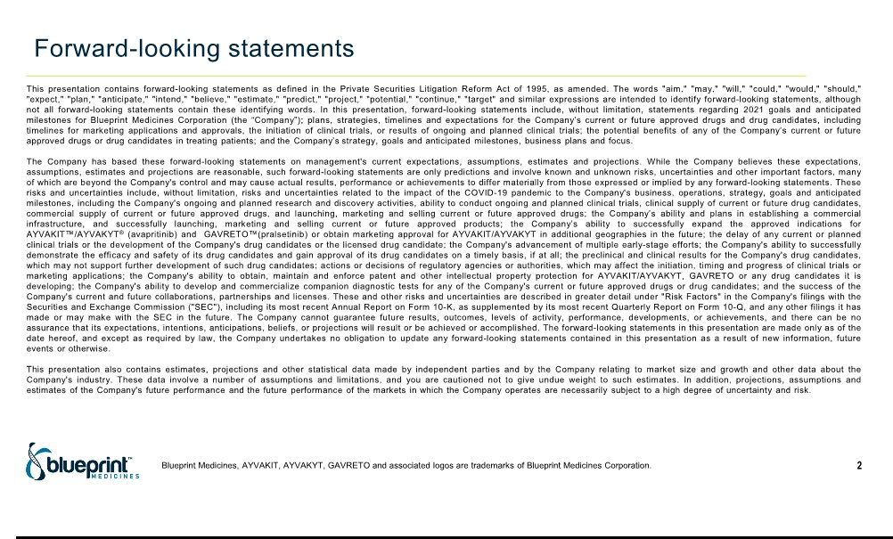

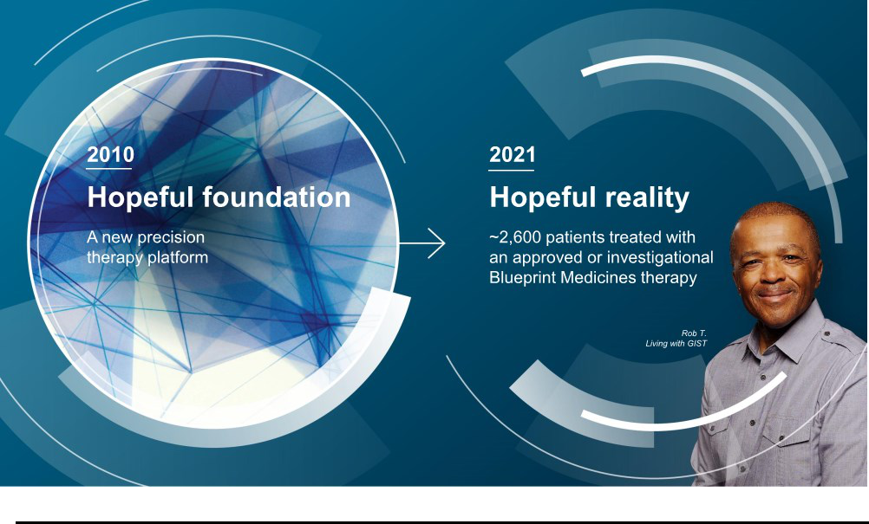

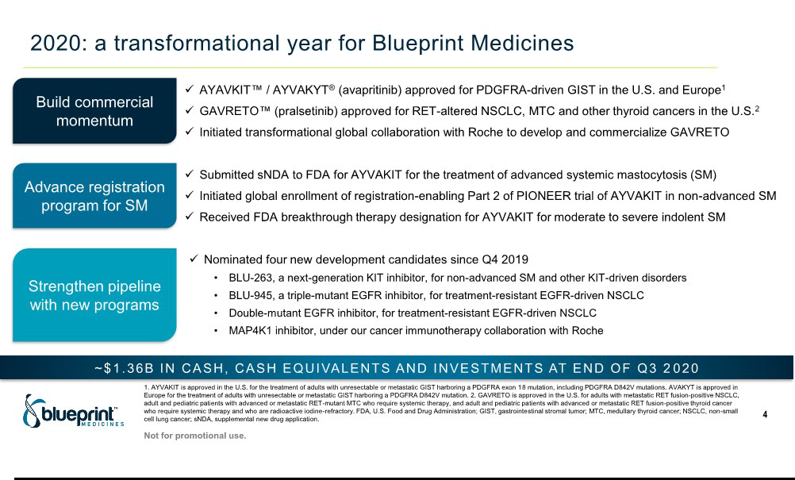

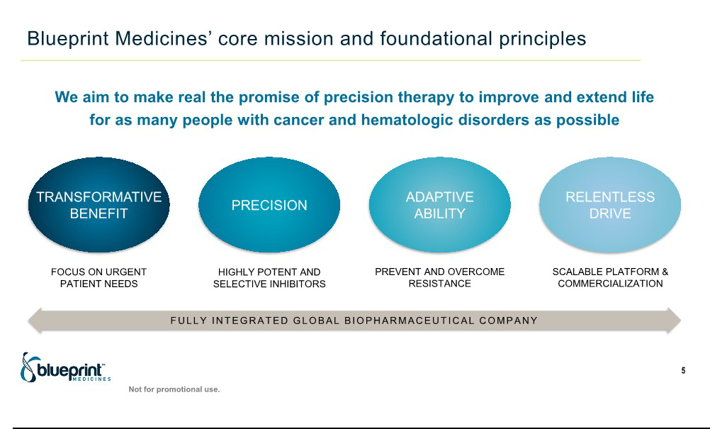

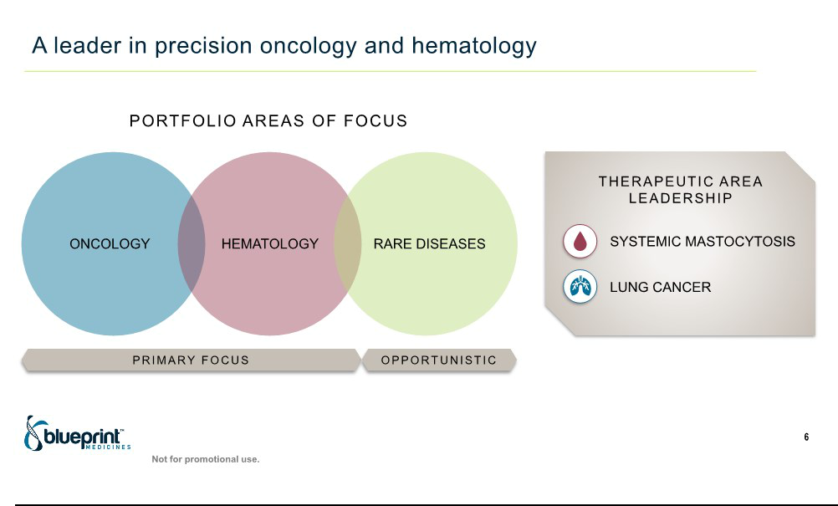

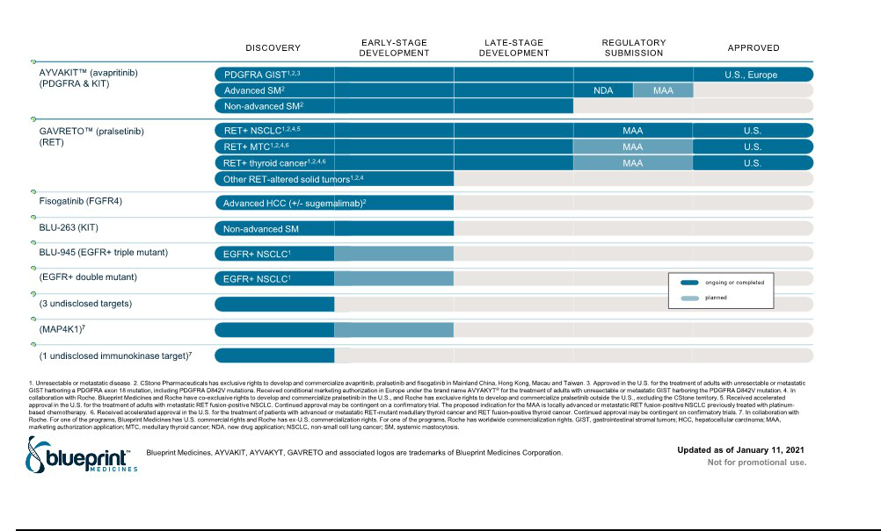

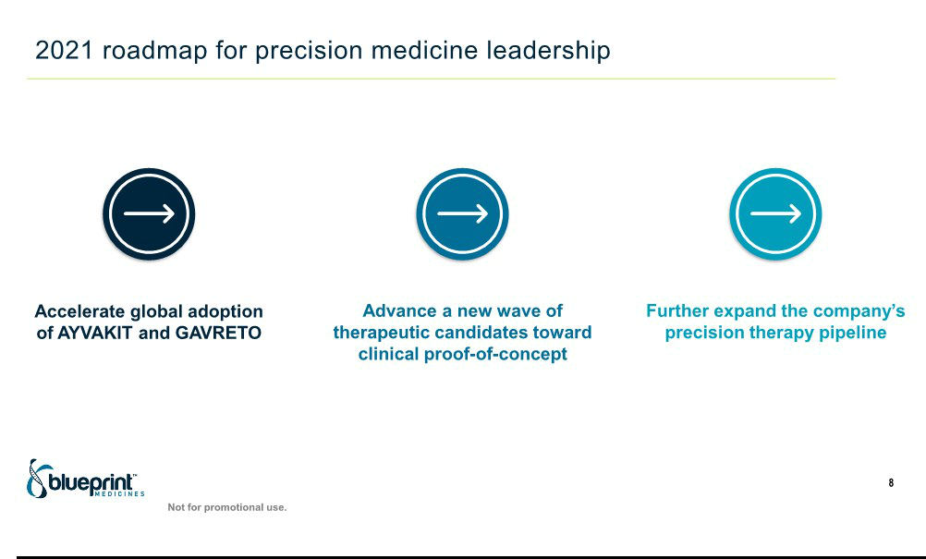

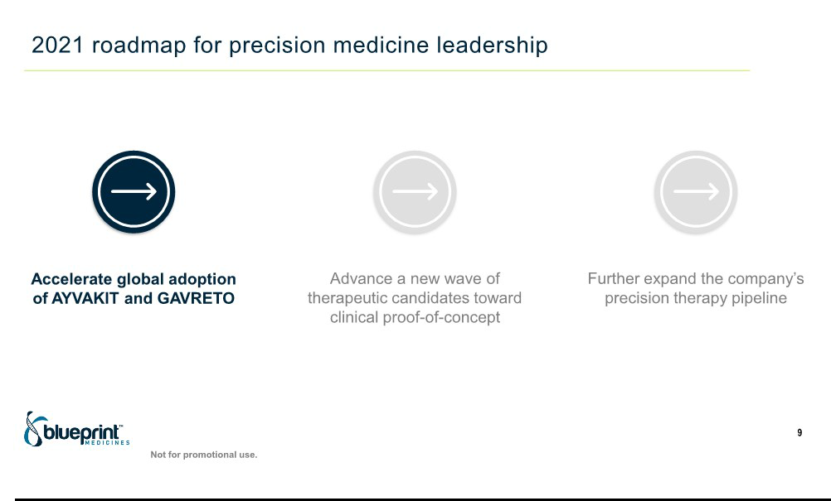

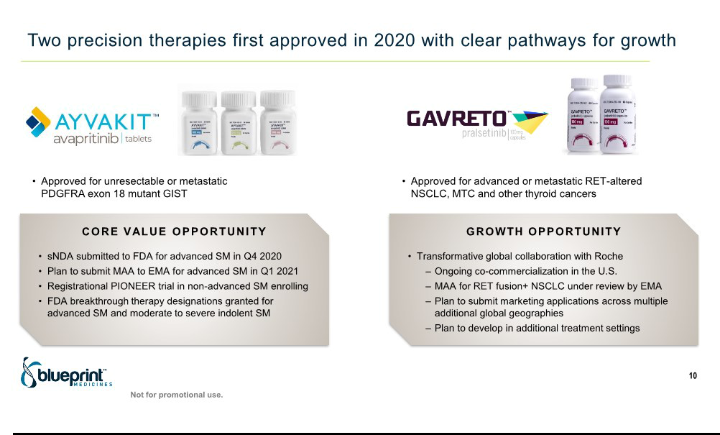

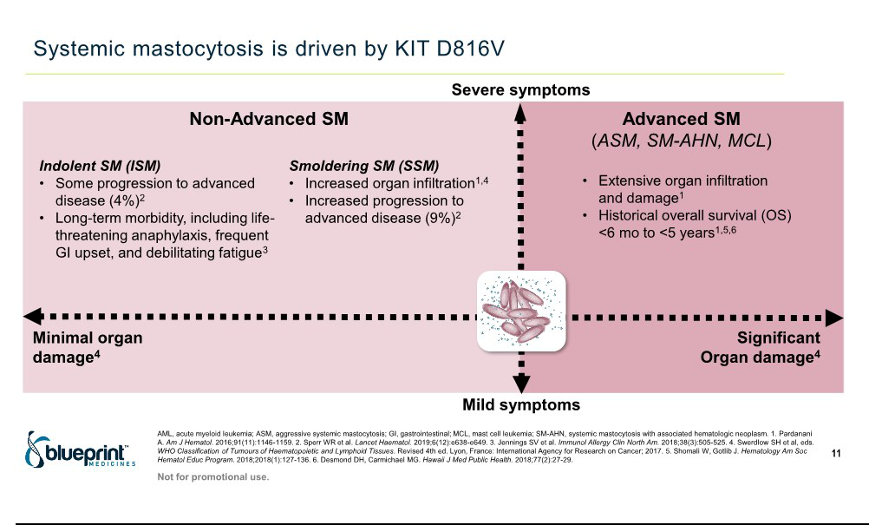

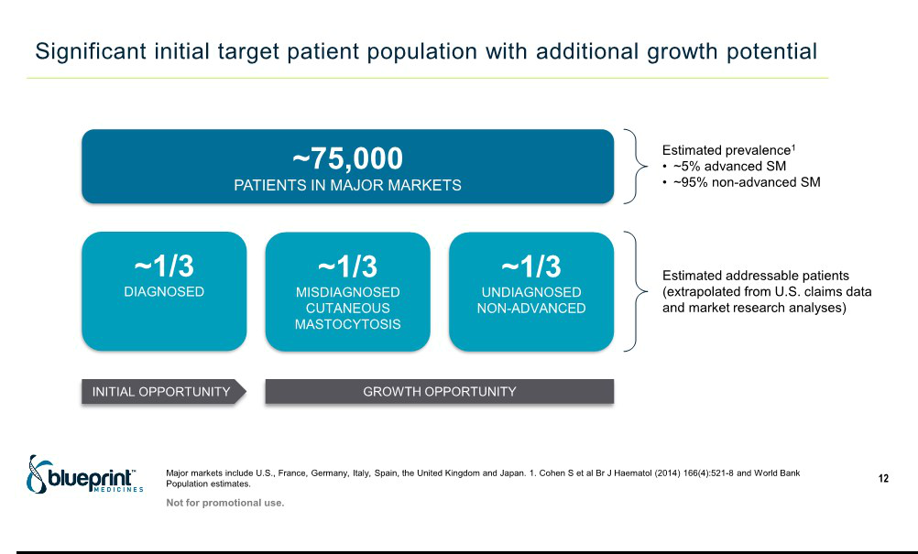

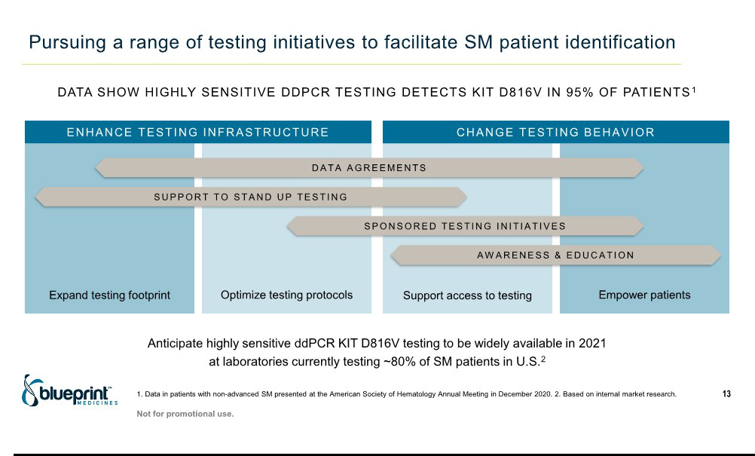

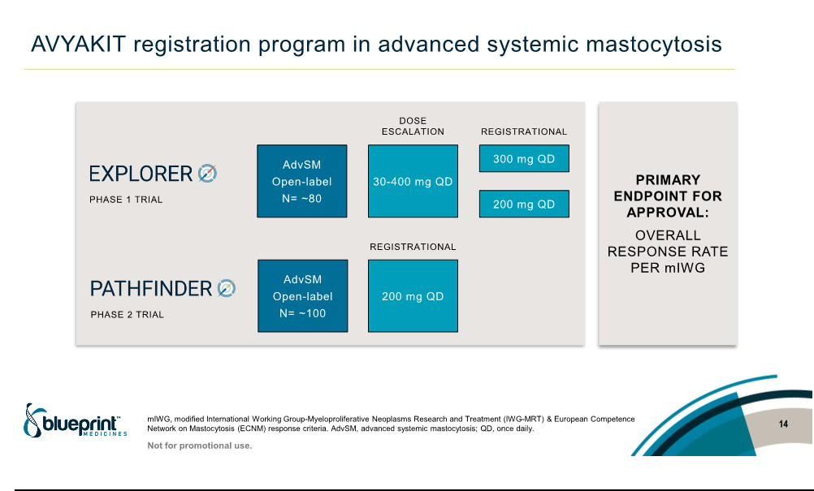

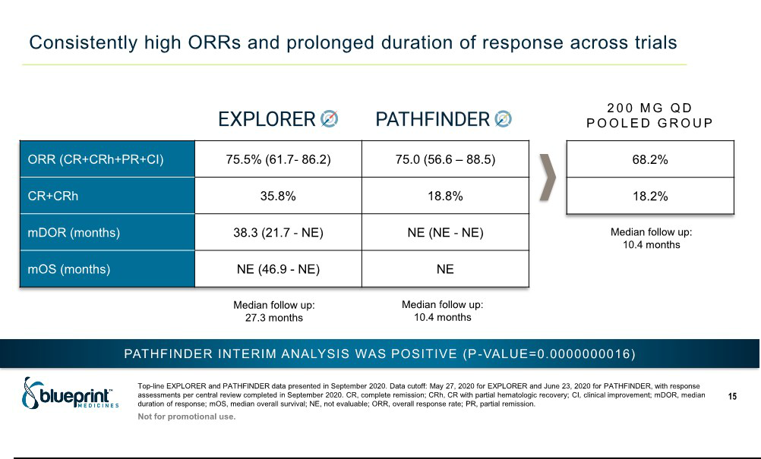

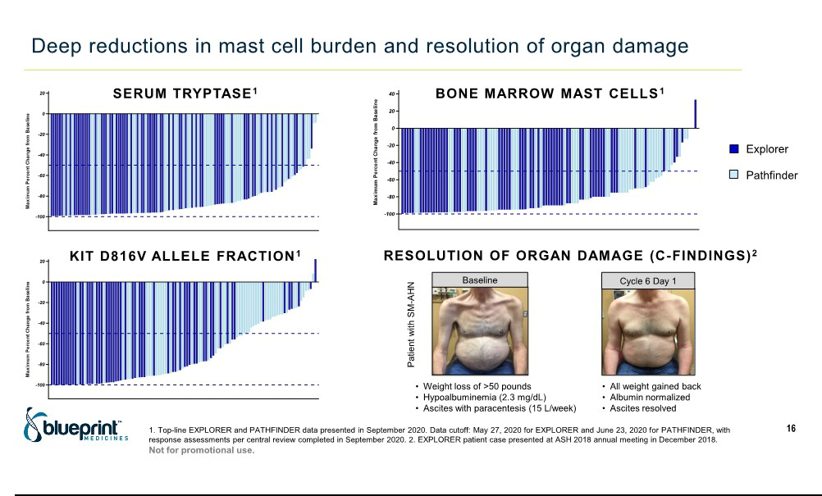

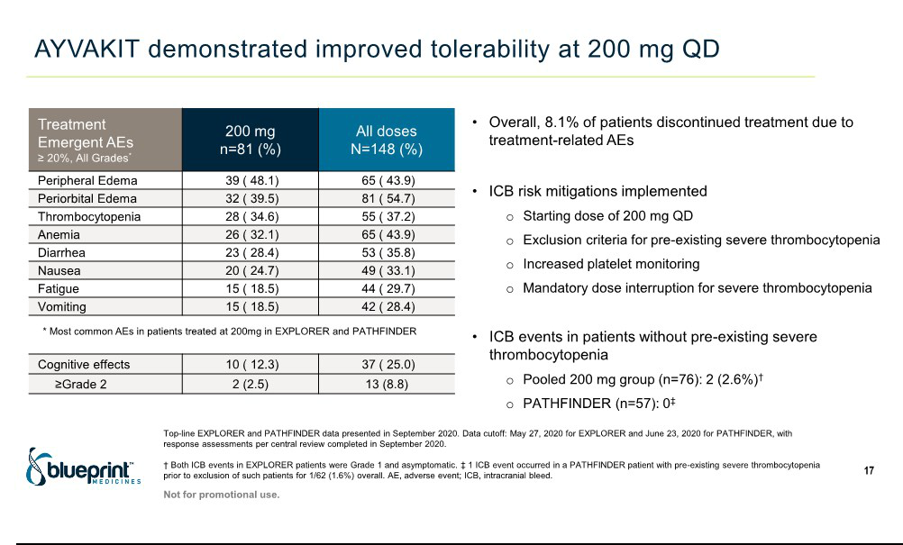

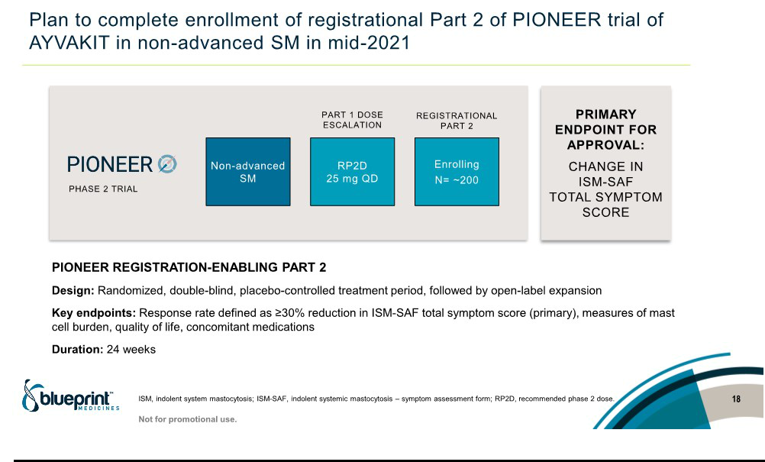

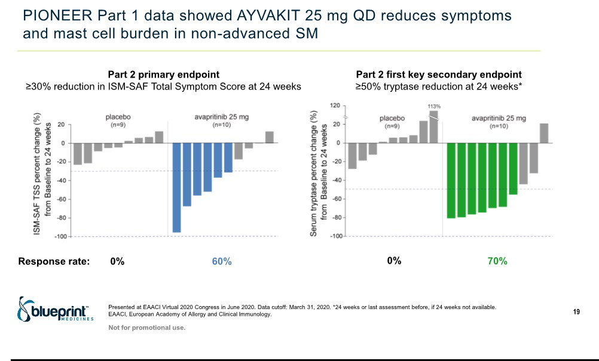

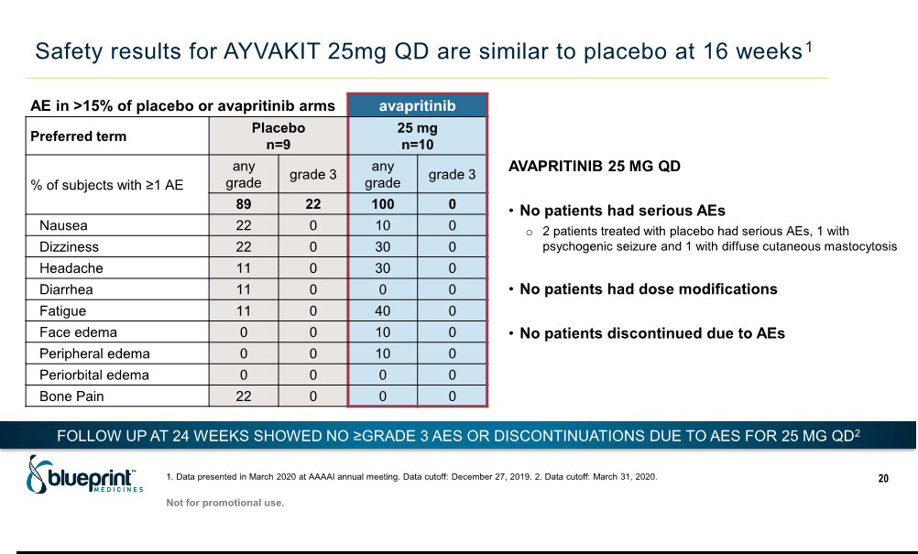

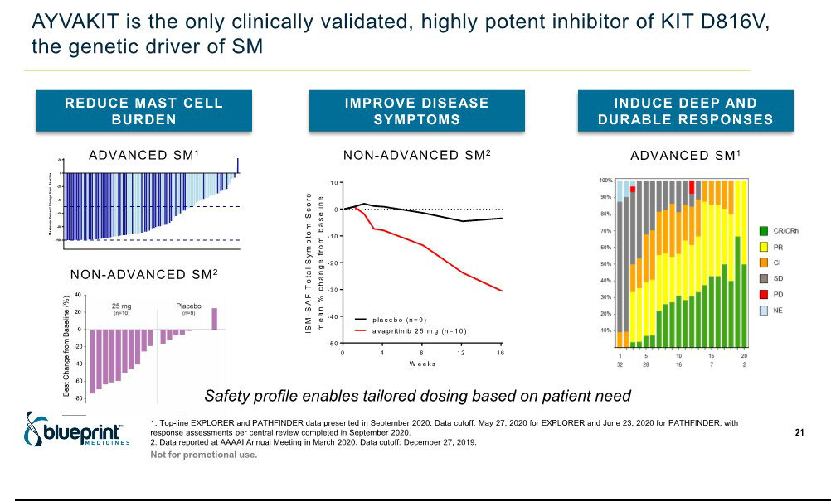

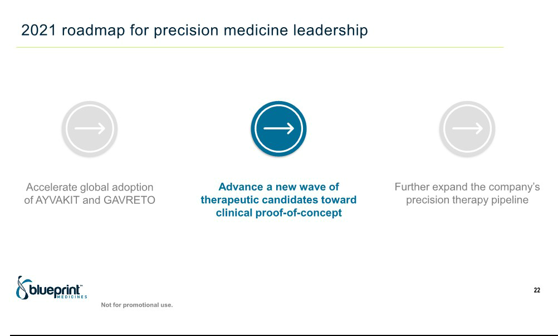

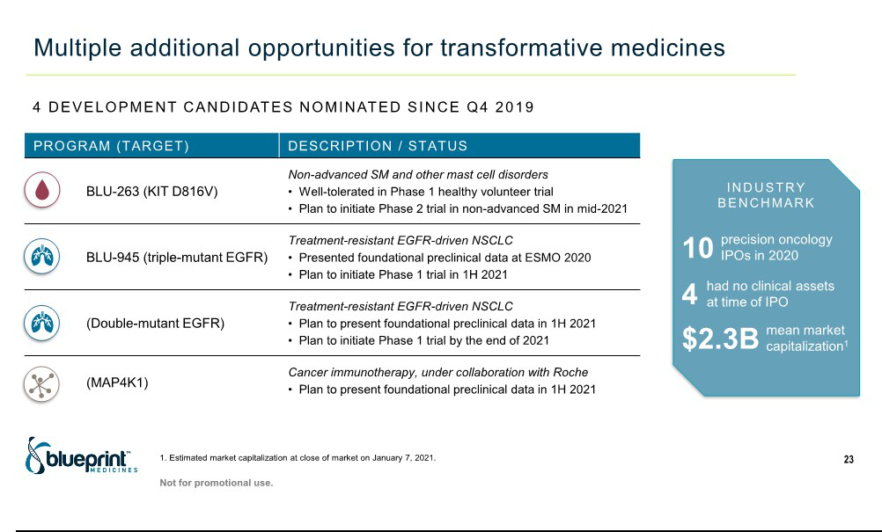

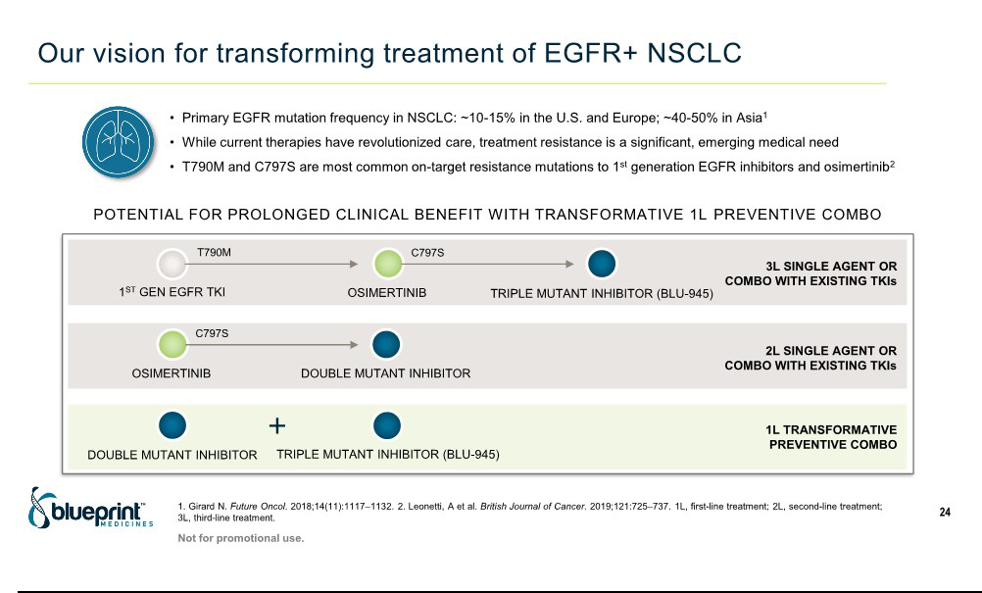

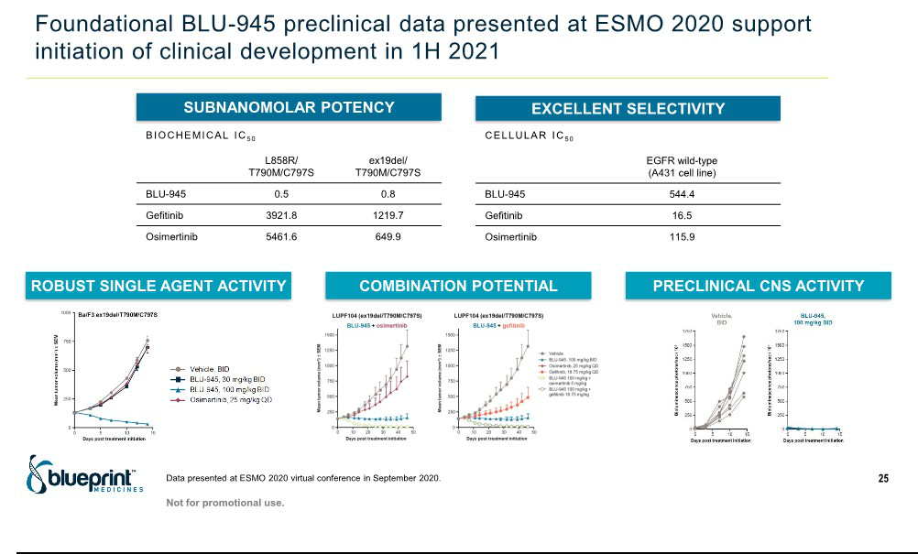

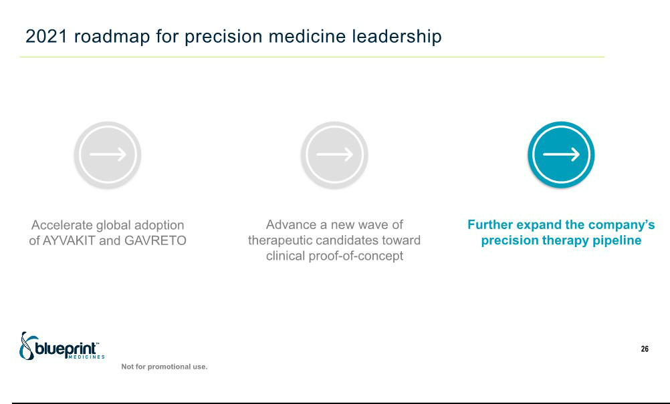

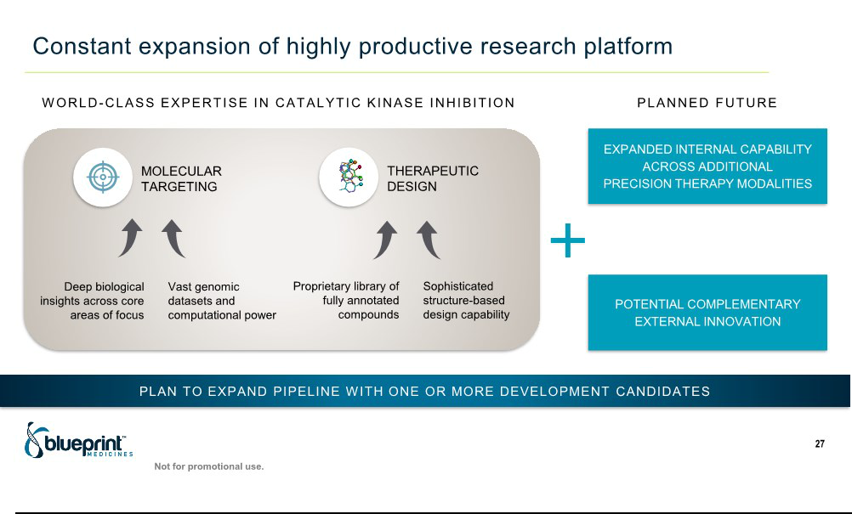

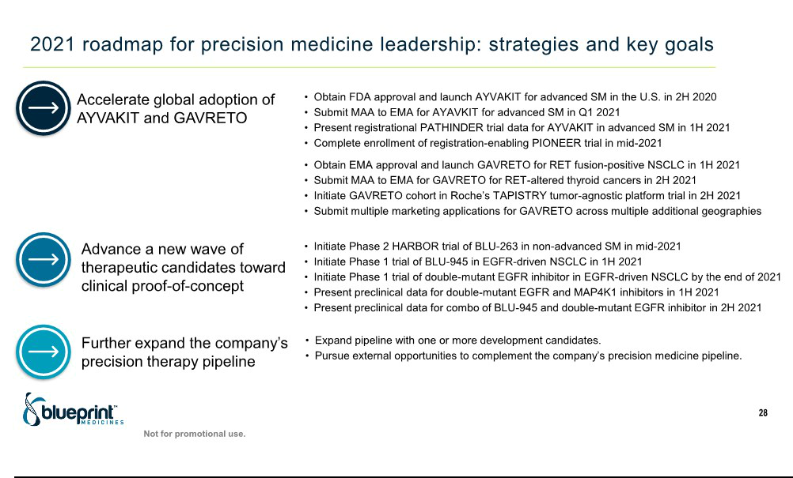

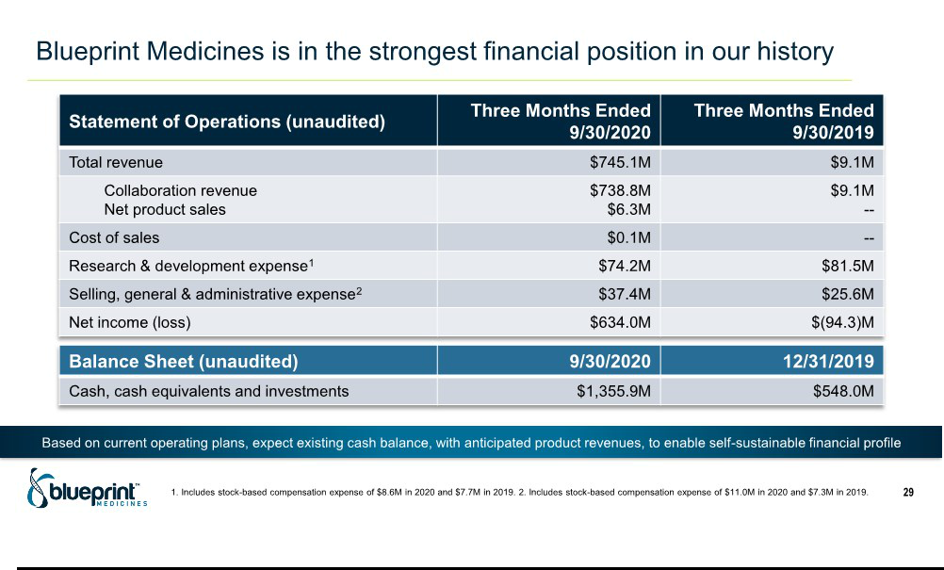

Exhibit 99.2

Blueprint Medicines Reports Portfolio Milestones and Outlines 2021 Roadmap for Precision Medicine Leadership

- AYVAKIT™ (avapritinib) granted FDA breakthrough therapy designation for the treatment of moderate to severe indolent systemic mastocytosis -

-

  - Positive top-line results from Phase 1 healthy volunteer trial of BLU-263 support plans to initiate Phase 2 HARBOR trial in non-advanced

systemic mastocytosis in mid-2021 --

      - Nominated potential first-in-class development candidate targeting double-mutant EGFR, deepening leadership in lung cancer --

    - Nominated potential best-in-class development candidate targeting MAP4K1 under cancer immunotherapy collaboration with Roche --

CAMBRIDGE, Mass., Jan. 11, 2021 /PR Newswire/ -- Blueprint Medicines Corporation (NASDAQ: BPMC) today provided an update on key portfolio milestones and outlined a strategic roadmap to become the world’s leading precision therapy company.

“For the first time, we enter a new year as a fully integrated, global biopharmaceutical company, with four regulatory approvals in the United States and Europe in 2020, a pipeline of eight wholly owned or partnered precision therapies, and the strongest financial position since our inception,” said Jeff Albers, Chief Executive Officer of Blueprint Medicines. “With this solid foundation, we are now scaling our ambition and aim to make real the promise of precision medicine to improve and extend life for as many people with cancer and hematologic disorders as possible. We will do this by bringing our medicines to more patients globally, rapidly advancing a wave of new therapeutic candidates to clinical proof-of-concept, and further expanding our platform-enabled research pipeline.”

In addition, Blueprint Medicines today announced the achievement of several portfolio milestones:

- AYVAKIT received breakthrough therapy designation from the U.S. Food and Drug Administration (FDA) for the treatment of moderate to severe indolent systemic mastocytosis (SM), which encompasses the majority of patients with SM, highlighting the medical need in this population as well as the clinical potential of AYVAKIT to demonstrate substantial improvement over the current standard of care.
- Positive top-line results from a Phase 1 trial in healthy volunteers showed BLU-263 was well-tolerated across a range of single- and multiple-ascending doses predicted to potently inhibit D816V mutant KIT, the underlying SM disease driver. These data support development of BLU-263 as a potential treatment for patients with SM and other mast cell disorders.
- The company nominated a selective, brain-penetrant development candidate for treatment-resistant double-mutant EGFR-driven non-small cell lung cancer (NSCLC), with the potential to be first-in-class, showing potent activity against the activating L858R or exon 19 deletion mutations and the acquired C797S mutation, the most common on-target resistance mutation to osimertinib.
- The company nominated a development candidate targeting MAP4K1, a kinase believed to play a role in T-cell regulation, with the potential to be best-in-class. The program was developed under the company’s cancer immunotherapy collaboration with Roche. In addition, Blueprint Medicines and Roche have amended their agreement to focus on MAP4K1 and one additional undisclosed target, collectively identified as the most promising targets of the collaboration to date.

Entering 2021, the company’s key strategies and goals include:

1. Accelerate global adoption of AYVAKIT and GAVRETO™ (pralsetinib)

AYVAKIT, a selective KIT and PDGFRA inhibitor, is approved in the U.S. and Europe for the treatment of patients with unresectable or metastatic gastrointestinal stromal tumor driven by certain PDGFRA mutations.
- Obtain FDA approval and launch AYVAKIT in advanced SM in the U.S. in the second half of 2021.

- Submit a Type II variation marketing authorization application (MAA) to the European Medicines Agency (EMA) for AYVAKYT® (avapritinib) for advanced SM in the first quarter of 2021.

- Present registrational data from the PATHFINDER trial of AYVAKIT in advanced SM in the first half of 2021.

- Complete enrollment of the registration-enabling Part 2 of the PIONEER trial of AYVAKIT in non-advanced SM in mid-2021.

GAVRETO, a selective RET inhibitor, is approved in the U.S. for the treatment of patients with certain advanced or metastatic RET fusion-positive NSCLC, RET-mutant medullary thyroid cancer (MTC) and RET fusion-positive thyroid cancer. Under a global collaboration, Blueprint Medicines and Roche are developing and commercializing GAVRETO for the treatment of RET-altered cancers.
  - Obtain regulatory approval from the European Commission and launch GAVRETO in RET fusion-positive NSCLC in Europe in the first half of 2021.
  - Submit a Type II variation MAA to the EMA for GAVRETO for RET-altered thyroid cancers in the second half of 2021.

  - Initiate a GAVRETO cohort in Roche’s TAPISTRY tumor-agnostic platform trial in the second half of 2021.

  - Submit marketing applications for GAVRETO for RET-altered NSCLC and thyroid cancers across multiple additional global geographies in 2021.

- Advance a new wave of innovative therapeutic candidates into clinical development, with plans to achieve rapid proof-of-concept and regulatory approval.

BLU-263, a next-generation selective KIT inhibitor

- Initiate the Phase 2 HARBOR trial of BLU-263 in patients with non-advanced SM in mid-2021.

Development candidates for treatment-resistant EGFR-driven NSCLC

- Initiate a Phase 1 trial of BLU-945, a triple-mutant EGFR inhibitor, in patients with treatment-resistant EGFR-driven NSCLC in the first half of 2021.
- Initiate a Phase 1 trial of the company’s double-mutant EGFR inhibitor in patients with treatment-resistant EGFR-driven NSCLC by the end of 2021.
- Present foundational preclinical data for the company’s double-mutant EGFR inhibitor in the first half of 2021.

- Present preclinical data supporting combination of the company’s wholly owned double- and triple-mutant EGFR inhibitors in treatment-naïve EGFR-driven NSCLC in the second half of 2021.

Development candidate targeting MAP4K1, under the cancer immunotherapy collaboration with Roche

  - Present foundational preclinical data in the first half of 2021.

- Further expand the company’s precision medicine pipeline with a focus on delivering transformational benefit to patients with cancer and hematologic disorders.

  - Expand pipeline with one or more development candidates in 2021.

  - Pursue external opportunities to complement the company’s precision medicine pipeline.

Financial Guidance

Based on its current operating plans, Blueprint Medicines continues to anticipate its existing cash, cash equivalents and investments, together with anticipated future product revenues, will provide sufficient capital to enable the company to achieve a self-sustainable financial profile.

About Blueprint Medicines

Blueprint Medicines is a global precision therapy company that invents life-changing therapies for people with cancer and hematologic disorders. Applying an approach that is both precise and agile, we create medicines that selectively target genetic drivers, with the goal of staying one step ahead across stages of disease. Since 2011, we

have leveraged our research platform, including expertise in molecular targeting and world-class drug design capabilities, to rapidly and reproducibly translate science into a broad pipeline of precision therapies. Today, we are delivering approved medicines directly to patients in the United States and Europe, and we are globally advancing multiple programs for genomically defined cancers, systemic mastocytosis, and cancer immunotherapy. For more information, visit www.BlueprintMedicines.com and follow us on Twitter (@BlueprintMeds) and LinkedIn.

Cautionary Note Regarding Forward-Looking Statements

This press release contains forward-looking statements within the meaning of the Private Securities Litigation Reform Act of 1995, as amended, including, without limitation, statements regarding Blueprint Medicines’ 2021 goals and anticipated milestones; plans, strategies, timelines and expectations for Blueprint Medicines’ current or future approved drugs and drug candidates, including timelines for marketing applications and approvals, the initiation of clinical trials or the results of ongoing and planned clinical trials; the potential benefits of any of Blueprint Medicines’ current or future approved drugs or drug candidates in treating patients; and Blueprint Medicines’ strategy, goals and anticipated milestones, business plans and focus. The words “aim,” “may,” “will,” “could,” “would,” “should,” “expect,” “plan,” “anticipate,” “intend,” “believe,” “estimate,” “predict,” “project,” “potential,” “continue,” “target” and similar expressions are intended to identify forward-looking statements, although not all forward-looking statements contain these identifying words. Any forward-looking statements in this press release are based on management’s current expectations and beliefs and are subject to a number of risks, uncertainties and important factors that may cause actual events or results to differ materially from those expressed or implied by any forward-looking statements contained in this press release, including, without limitation, risks and uncertainties related to the impact of the COVID-19 pandemic to Blueprint Medicines’ business, operations, strategy, goals and anticipated milestones, including Blueprint Medicines’ ongoing and planned research and discovery activities, ability to conduct ongoing and planned clinical trials, clinical supply of current or future drug candidates, commercial supply of current or future approved products, and launching, marketing and selling current or future approved products; Blueprint Medicines’ ability and plans in establishing a commercial infrastructure, and successfully launching, marketing and selling current or future approved products, including AYVAKIT and GAVRETO; Blueprint

Medicines’ ability to successfully expand the approved indications for AYVAKIT and GAVRETO or obtain marketing approval for AYVAKIT and GAVRETO in additional geographies in the future; the delay of any current or planned clinical trials or the development of Blueprint Medicines’ current or future drug candidates; Blueprint Medicines’ advancement of multiple early-stage efforts; Blueprint Medicines’ ability to successfully demonstrate the safety and efficacy of its drug candidates and gain approval of its drug candidates on a timely basis, if at all; the preclinical and clinical results for Blueprint Medicines’ drug candidates, which may not support further development of such drug candidates; actions of regulatory agencies, which may affect the initiation, timing and progress of clinical trials; Blueprint Medicines’ ability to develop and commercialize companion diagnostic tests for its current and future drug candidates; and the success of Blueprint Medicines’ current and future collaborations, partnerships or licensing arrangements, including Blueprint Medicines’ global collaboration with Roche for the development and commercialization of GAVRETO. These and other risks and uncertainties are described in greater detail in the section entitled “Risk Factors”

in Blueprint Medicines’ filings with the Securities and Exchange Commission (SEC), including Blueprint Medicines’ most recent Annual Report on Form 10-K, as supplemented by its most recent Quarterly Report on Form 10-Q and any other filings that Blueprint Medicines has made or may make with the SEC in the future. Any forward-looking statements contained in this press release represent Blueprint Medicines’ views only as of the date hereof and should not be relied upon as representing its views as of any subsequent date. Except as required by law, Blueprint Medicines explicitly disclaims any obligation to update any forward-looking statements.

Trademarks

Blueprint Medicines, AYVAKIT, AYVAKYT, GAVRETO and associated logos are trademarks of Blueprint Medicines Corporation.

Media Contact

Andrew Law

617-844-8205

media@blueprintmedicines.com

Investor Contact

Kristin Hodous

617-714-6674

ir@blueprintmedicines.com

