UNITED STATES

SECURITIES AND EXCHANGE COMMISSION

Washington, D.C. 20549

FORM 8-K

CURRENT REPORT

Pursuant to Section 13 or 15(d)

of the Securities Exchange Act of 1934

Date of Report (Date of Earliest Event Reported): June 14, 2019

Blueprint Medicines Corporation

(Exact name of registrant as specified in its charter)

Delaware

(State or other jurisdiction

of incorporation)

001-37359

(Commission File Number)

26-3632015

(I.R.S. Employer

Identification No.)

45 Sidney Street

(Address of principal executive offices)

(Zip Code)

Registrant’s telephone number, including area code: (617) 374-7580

(Former name or former address, if changed since last report)

Check the appropriate box below if the Form 8-K filing is intended to simultaneously satisfy the filing obligation of the registrant under any of the following provisions:

- Written communications pursuant to Rule 425 under the Securities Act (17 CFR 230.425)

- Soliciting material pursuant to Rule 14a-12 under the Exchange Act (17 CFR 240.14a-12)

- Pre-commencement communications pursuant to Rule 14d-2(b) under the Exchange Act (17 CFR 240.14d-2(b))

- Pre-commencement communications pursuant to Rule 13e-4(c) under the Exchange Act (17 CFR 240.13e-4(c))

Indicate by check mark whether the registrant is an emerging growth company as defined in Rule 405 of the Securities Act of 1933 (§230.405 of this chapter) or Rule 12b-2 of the Securities Exchange Act of 1934 (§240.12b-2 of this chapter).

Emerging growth company ☐

If an emerging growth company, indicate by check mark if the registrant has elected not to use the extended transition period for complying with any new or revised financial accounting standards provided pursuant to Section 13(a) of the Exchange Act. ☐

Securities registered pursuant to Section 12(b) of the Exchange Act:

Title of each class | Trading symbol(s) | Name of each exchange on which registered
Common stock, par value $0.001 per share | BPMC | Nasdaq Global Select Market

Item 7.01 Regulation FD Disclosure.

On June 14, 2019, Blueprint Medicines Corporation (the “Company”) issued a press release announcing the submission of a new drug application (“NDA”) to the U.S. Food and Drug Administration (“FDA”) for avapritinib for the treatment of adult patients with PDGFRA Exon 18 mutant gastrointestinal stromal tumors (“GIST”), regardless of prior therapy, and fourth-line GIST. The Company has requested priority review for the application, which, if granted, could result in a six-month review process. The FDA has a 60-day filing review period to determine whether the NDA is complete and acceptable for filing. A copy of the press release is furnished as Exhibit 99.1 to this Current Report on Form 8-K.

On June 15, 2019, the Company announced updated data from its Phase 1 EXPLORER clinical trial evaluating avapritinib for the treatment of patients with advanced systemic mastocytosis (“SM”). The data were presented on Saturday, June 15, 2019 in an oral presentation at the 24th Congress of the European Hematology Association (“EHA Annual Meeting”) in Amsterdam, The Netherlands. A copy of the press release is furnished as Exhibit 99.2 to this Current Report on Form 8-K, and a copy of the presentation is furnished as Exhibit 99.3 to this Current Report on Form 8-K.

On June 17, 2019, the Company will host an investor call and live webcast to discuss the updated data from its Phase 1 EXPLORER clinical trial, which were presented at the EHA Annual Meeting, and its NDA submission to the FDA for avapritinib for the treatment of adult patients with PDGFRA Exon 18 mutant GIST, regardless of prior therapy, and fourth-line GIST. A copy of the presentation from the investor call is furnished as Exhibit 99.4 to this Current Report on Form 8-K.

The information in Item 7.01 of this Current Report on Form 8-K, including Exhibits 99.1, 99.2, 99.3 and 99.4, is intended to be furnished and shall not be deemed “filed” for purposes of Section 18 of the Securities Exchange Act of 1934, as amended (the “Exchange Act”), or otherwise subject to the liabilities of that section, nor shall it be deemed incorporated by reference in any filing under the Securities Act of 1933, as amended, or the Exchange Act, except as expressly set forth by specific reference in such filing.

Item 9.01 Financial Statements and Exhibits.

(d) Exhibits.
Exhibit No. |  |  | Description
99.1 |  |  | Press release issued by Blueprint Medicines Corporation on June 14, 2019
99.2 |  |  | Press release issued by Blueprint Medicines Corporation on June 15, 2019
99.3 |  |  | Presentation by Blueprint Medicines Corporation at the EHA Annual Meeting on June 15, 2019
99.4 |  |  | Presentation by Blueprint Medicines Corporation at investor call on June 17, 2019

2

SIGNATURES

Pursuant to the requirements of the Securities Exchange Act of 1934, the registrant has duly caused this report to be signed on its behalf by the undersigned hereunto duly authorized.

 | BLUEPRINT MEDICINES CORPORATION
Date: June 17, 2019 | By: /s/ Tracey L.
 |  | McCain
 |  | Tracey L. McCain
 |  | Chief Legal Officer
 | 3

Exhibit 99.1


Blueprint Medicines Submits New Drug Application to U.S. Food and Drug Administration for Avapritinib for the Treatment of PDGFRA Exon 18 Mutant GIST and Fourth-Line GIST

CAMBRIDGE, Mass., June 14, 2019 – Blueprint Medicines Corporation (NASDAQ: BPMC), a precision therapy company focused on genomically defined cancers, rare diseases and cancer immunotherapy, today announced it has submitted a New Drug Application (NDA) to the U.S. Food and Drug Administration (FDA) for avapritinib for the treatment of adult patients with PDGFRA Exon 18 mutant gastrointestinal stromal tumors (GIST), regardless of prior therapy, and fourth-line GIST. Currently, no effective therapy exists for either population. Avapritinib is an investigational, potent and highly selective KIT and PDGFRA inhibitor for patients with advanced GIST.

Avapritinib has received Breakthrough Therapy Designation from the FDA for the treatment of patients with unresectable or metastatic GIST harboring the PDGFRα D842V mutation, as well as Fast Track Designations for the treatment of patients with GIST harboring a PDGFRα D842V mutation regardless of prior therapy, and patients with GIST who have progressed following treatment with imatinib and a second tyrosine kinase inhibitor.

Blueprint Medicines has requested priority review for the application, which, if granted, could result in a six-month review process. The FDA has a 60-day filing review period to determine whether the NDA is complete and acceptable for filing.

“There is an important need for new treatment options that offer durable responses for PDGFRA Exon 18 mutant and fourth-line GIST patients,” said Andy Boral, M.D., Ph.D., Chief Medical Officer at Blueprint Medicines. “By targeting the underlying molecular drivers of GIST, avapritinib has the potential to help these patients realize the benefits of precision therapy. We plan to work closely with the FDA to bring avapritinib to appropriate GIST patients as quickly as possible.”

About GIST

GIST is a sarcoma, or tumor of bone or connective tissue, of the gastrointestinal (GI) tract. Tumors arise from cells in the wall of the GI tract and occur most often in the stomach or small intestine. Most patients are diagnosed between the ages of 50 to 80, and diagnosis is typically triggered by GI bleeding, incidental findings during surgery or imaging and, in rare cases, tumor rupture or GI obstruction.

Most GIST cases are caused by a spectrum of clinically relevant mutations that force the KIT or PDGFRA protein kinases into an increasingly active state. Because currently available therapies primarily bind to the inactive protein conformations, certain primary and secondary mutations typically lead to treatment resistance and disease progression.

In unresectable or metastatic GIST, clinical benefits from existing treatments can vary by mutation type. Mutational testing is critical to tailor therapy to the underlying disease driver and is recommended in expert guidelines. Currently, there are no approved therapies for patients with KIT-driven GIST whose disease progresses beyond imatinib, sunitinib and regorafenib. In patients with metastatic PDGFRα D842V-driven GIST, progression occurs in a median of approximately three to four months with available therapy.

About Avapritinib

Avapritinib is an investigational, oral precision therapy that selectively and potently inhibits KIT and PDGFRA mutant kinases. It is a type 1 inhibitor designed to target the active kinase conformation; all oncogenic kinases signal via this conformation. Avapritinib has demonstrated broad inhibition of KIT and PDGFRA mutations associated with GIST, including potent activity against activation loop mutations that are associated with resistance to currently approved therapies.

Blueprint Medicines is initially developing avapritinib for the treatment of advanced GIST, advanced systemic mastocytosis (SM), and indolent and smoldering SM. The FDA has granted Breakthrough Therapy Designation to avapritinib for two indications: one for the treatment of unresectable or metastatic GIST harboring the PDGFRα D842V mutation and one for the treatment of advanced SM, including the subtypes of aggressive SM, SM with an associated hematologic neoplasm and mast cell leukemia.

Blueprint Medicines has an exclusive collaboration and license agreement with CStone Pharmaceuticals for the development and commercialization of avapritinib and certain other drug candidates in Mainland China, Hong Kong, Macau and Taiwan. Blueprint Medicines retains development and commercial rights for avapritinib in the rest of the world.

About Blueprint Medicines

Blueprint Medicines is a precision therapy company striving to improve human health. With a focus on genomically defined cancers, rare diseases and cancer immunotherapy, we are developing transformational medicines rooted in our leading expertise in protein kinases, which are proven drivers of disease. Our uniquely targeted, scalable approach empowers the rapid design and development of new treatments and increases the likelihood of clinical success. We are currently advancing four investigational medicines in clinical development, along with multiple research programs. For more information, visit www.BlueprintMedicines.com and follow us on Twitter (@BlueprintMeds) and LinkedIn.

Cautionary Note Regarding Forward-Looking Statements

This press release contains forward-looking statements within the meaning of the Private Securities Litigation Reform Act of 1995, as amended, including, without limitation, statements regarding the potential benefits of avapritinib in treating patients with GIST; plans, timelines and expectations for interactions with the FDA; plans, timelines and expectations for the commercialization of avapritinib for the treatment of GIST, if approved by the FDA; and Blueprint Medicines’ strategy, goals and anticipated milestones, business plans and focus. The words “may,” “will,” “could,” “would,” “should,” “expect,” “plan,” “anticipate,” “intend,” “believe,” “estimate,” “predict,” “project,” “potential,” “continue,” “target” and similar expressions are intended to identify forward-looking statements, although not all forward-looking statements contain these identifying words. Any forward-looking statements in this press release are based on management’s current expectations and beliefs and are subject to a number of risks, uncertainties and important factors that may cause actual events or results to differ materially from those expressed or implied by any forward-looking statements contained in this press release, including, without limitation, risks and uncertainties related to the delay of any current or planned clinical trials or the development of Blueprint Medicines’ drug candidates, including avapritinib, BLU-667, BLU-554 and BLU-782; Blueprint Medicines’ advancement of multiple early-stage efforts; Blueprint

Medicines’ ability to successfully demonstrate the safety and efficacy of its drug candidates and gain approval of its drug candidates on a timely basis, if at all; the preclinical and clinical results for Blueprint Medicines’ drug candidates, which may not support further development of such drug candidates; actions of regulatory agencies, which may affect the initiation, timing and progress of clinical trials; Blueprint Medicines’ ability to develop and commercialize companion diagnostic tests for its current and future drug candidates; and the success of Blueprint Medicines’ current and future collaborations, including its cancer immunotherapy collaboration with F. Hoffmann-La Roche Ltd and Hoffmann-La Roche Inc. and its collaboration with CStone Pharmaceuticals. These and other risks and uncertainties are described in greater detail in the section entitled “Risk Factors” in Blueprint Medicines’ Quarterly Report on Form 10-Q for the period ended March 31, 2019, as filed with the Securities and Exchange Commission (SEC) on May 9, 2019, and any other filings that Blueprint Medicines has made or may make with the SEC in the future. Any forward-looking statements contained in this press release represent Blueprint Medicines’ views only as of the date hereof and should not be relied upon as representing its views as of any subsequent date. Except as required by law, Blueprint Medicines explicitly disclaims any obligation to update any forward-looking statements.

Investor Relations Contact

Kristin Hodous
617-714-6674
ir@blueprintmedicines.com

Media Relations Contact

Andrew Law
617-844-8205
media@blueprintmedicines.com

Exhibit 99.2

Blueprint Medicines Presents Updated EXPLORER Trial Data for Avapritinib in Patients with Systemic Mastocytosis at 24th EHA Congress

-- Confirmed 77% ORR per central review in advanced SM --

- Consistent and profound improvements on measures of mast cell burden across all disease subtypes, including in 15 indolent and smoldering SM patients --

-- Median overall survival not reached with ongoing treatment durations up to 34 months --

  - Updated data support plans to submit NDA to FDA in advanced SM in first quarter of 2020 --

-- Blueprint Medicines to host investor conference call and webcast on Monday, June 17, 2019 at 8:30 a.m. ET --

CAMBRIDGE, Mass., June 15, 2019 – Blueprint Medicines Corporation (NASDAQ: BPMC), a precision therapy company focused on genomically defined cancers, rare diseases and cancer immunotherapy, today announced updated data from the ongoing, registration-enabling EXPLORER trial of avapritinib in patients with systemic mastocytosis (SM). The updated data showed a confirmed overall response rate (ORR) of 77 percent in advanced SM patients, as assessed by a central review committee of SM clinical experts. In addition, the data showed durable clinical activity across advanced, smoldering and indolent forms of SM, with patients on therapy up to 34 months and responses continuing to deepen over time. Avapritinib was generally well-tolerated, with most adverse events (AEs) reported by investigators as Grade 1 or 2. The results are being presented today in an oral presentation at the 24th Congress of the European Hematology Association (EHA) in Amsterdam, The Netherlands.

These updated data from the EXPLORER trial support Blueprint Medicines' plans to submit a New Drug Application (NDA) to the U.S. Food and Drug Administration (FDA) for avapritinib for the treatment of advanced SM in the first quarter of 2020, subject to continued discussions with the FDA regarding the data required to support an NDA submission. Avapritinib has received FDA Breakthrough Therapy Designation for the treatment of patients with advanced SM, including the subtypes of aggressive SM (ASM), SM with an associated hematologic neoplasm (SM-AHN) and mast cell leukemia (MCL).

“I believe that potently and selectively targeting KIT D816V, the disease driver in nearly all systemic mastocytosis patients, represents a promising therapeutic approach,” said Dr. Deepti Radia, a hematologist and an investigator on the EXPLORER trial. “These new data showed avapritinib led to profound reductions of objective mast cell burden and durable clinical responses across a broad patient population. In advanced systemic mastocytosis, I am particularly encouraged by the strong activity shown in patients with especially poor survival rates, such as those with mast cell leukemia or high-risk genotypes. These data further reinforce the broad potential of avapritinib to address important medical needs across the spectrum of the disease.”

“These results highlight the promise of avapritinib, a potent and selective KIT D816V inhibitor, to be an important disease-modifying treatment in patients with systemic mastocytosis,” said Andy Boral, M.D., Ph.D., Chief Medical Officer at Blueprint Medicines. “The updated data, including high confirmed

response rates per central review, support our plans to submit a New Drug Application for advanced systemic mastocytosis in the first quarter of 2020. Avapritinib had strong activity in patients with indolent or smoldering systemic mastocytosis as well, providing further confidence in our approach for our ongoing registration-enabling PIONEER trial. By selectively targeting the common driver across all forms of systemic mastocytosis, avapritinib has the potential to address the spectrum of disease manifestations that significantly affect patients with different subtypes.”

Highlights from EHA Presentation of EXPLORER Trial Data

As of the data cutoff date of January 2, 2019, 69 patients were treated with avapritinib in the Phase 1 EXPLORER clinical trial, including seven patients with ASM, 37 patients with SM-AHN, nine patients with MCL, 15 patients with indolent or smoldering SM, and one patient without SM who had chronic myelomonocytic leukemia. Diagnoses were centrally reviewed by a committee of SM experts following an initial assessment by local investigators. Forty-two patients (61 percent) had a prior treatment, including 15 patients (22 percent) who had previously received the multi-kinase inhibitor midostaurin.

Clinical Activity Data

Thirty-nine patients with advanced SM (three ASM, 28 SM-AHN, eight MCL) were evaluable for response by the modified IWG-MRT-ECNM criteria, a rigorous method for assessing clinical response in advanced SM patients with regulatory precedent in the U.S. and Europe. Confirmation of response was defined as a response duration of at least 12 weeks. Evaluable patients generally had more advanced disease at baseline than the overall trial population.

In evaluable patients across all doses studied, the confirmed ORR was 77 percent. Nine patients had complete remission with a full or partial recovery of peripheral blood counts (CR/CRh; 23 percent), 18 patients had partial remission (46 percent) and three patients had clinical improvement (8 percent). No patients had progressive disease as the initial response. In addition, the 12-month duration of response (DOR) rate was 74 percent, and 49 patients (71 percent) remained on treatment with durations up to nearly three years (34 months).

Across all enrolled patients, the median overall survival (OS) was not reached. The estimated 24-month OS rate was 78 percent in all advanced SM patients: 100 percent in ASM patients, 70 percent in SM-AHN patients and 88 percent in MCL patients.

Avapritinib demonstrated strong clinical activity in patients with SRSF2, ASXL1 and/or RUNX1 (S/A/R) mutation positive genotypes, who historically have particularly poor prognoses. In 22 evaluable patients with S/A/R genotypes, the confirmed ORR was 73 percent and five patients had a CR/CRh (23 percent).

Nearly all patients had significant declines on objective measures of mast cell burden. Across all patients evaluable on these measures, 100 percent had a ≥50 percent decline in serum tryptase, 93 percent had a ≥50 percent reduction in bone marrow mast cells, 84 percent had palpable spleens become non-palpable, and 88 percent had a ≥50 percent reduction in KIT D816V mutation allele fraction.

Clinical Activity Data – Indolent or Smoldering SM

Avapritinib showed strong clinical activity in patients with indolent or smoldering SM. Nearly all patients had ≥50 percent reductions in serum tryptase, bone marrow mast cells and KIT D816V mutation allele

fraction. In addition, improvements on these measures were deep and rapid. Thirteen of 15 evaluable patients had normalized serum tryptase levels, and 12 of 13 evaluable patients had complete clearance of mast cell aggregates from the bone marrow. All indolent and smoldering SM patients achieved a ≥50 percent reduction in serum tryptase by the first post-baseline assessment.

Safety Data

Avapritinib was generally well-tolerated with most AEs reported by investigators as Grade 1 or 2. Across all grades, the most common non-hematologic treatment-emergent AEs (regardless of relationship to avapritinib) reported by investigators (>15 percent) were periorbital edema, diarrhea, nausea, fatigue, peripheral edema, vomiting, cognitive effects, hair color changes, arthralgia, abdominal pain, dizziness, decreased appetite, pruritis, constipation and dysgeusia. The most common hematologic treatment-emergent AEs reported by investigators (>10 percent) were anemia, thrombocytopenia and neutropenia. In addition, intracranial bleeding occurred in six patients with pre-existing thrombocytopenia, a known risk factor for intracranial bleeding, and one patient who had a life-threatening fall prior to intracranial bleeding. Five of these patients resumed and remain on treatment with avapritinib following dose modifications. Updated dose modification procedures have been implemented for patients with thrombocytopenia, and to date, no new intracranial bleeding events have been observed. Cytopenias were the most common Grade 3 and 4 treatment-related AEs. No Grade 5 treatment-related AEs were reported by investigators.

Only three patients (4 percent) discontinued treatment with avapritinib due to treatment-related AEs. Nine patients (13 percent) discontinued treatment with avapritinib due to disease progression, with the majority due to either acute myeloid leukemia (n=3) or associated hematologic neoplasm (n=3).

These updated data on avapritinib are being presented at the 24th Congress of EHA on Saturday, June 15 (Abstract Number: S830). A copy of the oral presentation is available in the “Science—Publications and Presentations” section of Blueprint Medicines’ website at www.BlueprintMedicines.com.

Conference Call Information

Blueprint Medicines will host a live conference call and webcast on Monday, June 17, 2019 at 8:30 a.m. ET to review the updated data for avapritinib in SM, as well as the recently announced NDA submission to the FDA for avapritinib for the treatment of PDGFRA Exon 18 mutant gastrointestinal stromal tumors (GIST), regardless of prior therapy, and fourth-line GIST. The conference call may be accessed by dialing (855) 728-4793 (domestic) or (503) 343-6666 (international) and referring to conference ID 8549897. A live webcast of the conference call will be available under the “Investors & Media—Events & Presentations” section of Blueprint Medicines’ website at www.BlueprintMedicines.com. A replay of the webcast will be available approximately two hours after the call and will be available for 30 days following the call.

About the Clinical Development Program for Avapritinib in SM


Blueprint Medicines is pursuing a broad clinical development program for avapritinib across advanced, indolent and smoldering forms of SM. Avapritinib is currently being evaluated in three ongoing, registration-enabling clinical trials for SM: the Phase 1 EXPLORER trial, the Phase 2 PATHFINDER trial and the Phase 2 PIONEER trial.

The Phase 1 EXPLORER trial was designed to identify the recommended Phase 2 dose for further study and demonstrate proof-of-concept in advanced SM, including patients with ASM, SM-AHN and MCL. The dose escalation portion is complete, and the expansion portion of the trial is ongoing at multiple sites in the United States and United Kingdom. Trial objectives include assessing safety and tolerability, response per modified IWG-MRT-ECNM criteria and patient-reported outcomes.


The Phase 2 PATHFINDER trial is an open-label, single-arm, registration-enabling trial in patients with advanced SM. Patient dosing is ongoing in the trial, which is designed to enroll up to 60 advanced SM patients at sites in the United States, Canada and European Union. The primary efficacy endpoints are ORR and DOR based on modified IWG-MRT-ECNM criteria.

The Phase 2 PIONEER trial is a randomized, placebo-controlled, registration-enabling trial in patients with indolent and smoldering SM. Patient dosing is ongoing in the trial, which is designed to enroll up to 112 indolent and smoldering SM patients at sites in the United States, Canada and European Union. The primary endpoint is symptom reductions for avapritinib versus placebo based on the Indolent and Smoldering SM Assessment Form Total Symptom Score. All patients who complete the dose-finding (part 1) and placebo-controlled efficacy (part 2) portions of this trial will have an opportunity to receive avapritinib in an open-label extension (part 3).

SM patients and clinicians interested in ongoing clinical trials can contact the Blueprint Medicines study director at SM@blueprintmedicines.com or 1-617-714-6707. Additional details are available at www.blueprintclinicaltrials.com/SM/ or www.clinicaltrials.gov.

About SM

SM results from the abnormal proliferation and survival of mast cells, which mediate allergic responses. The clinical presentation of SM is heterogeneous, ranging from indolent or smoldering SM to three advanced subtypes – ASM, SM-AHN and MCL. The KIT D816V mutation drives approximately 95 percent of all SM cases, causing debilitating and difficult-to-manage symptoms such as pruritus, flushing, headaches, bone pain, nausea, vomiting, diarrhea, anaphylaxis, abdominal pain and fatigue. While these effects occur across SM patients, symptom burden and poor quality of life are the predominant disease manifestations of indolent and smoldering SM. Advanced SM patients experience organ damage and a median overall survival of about 3.5 years in ASM, two years in SM-AHN and less than six months in MCL.

Currently, there are no approved therapies that selectively inhibit KIT D816V in advanced SM, and no approved therapies for indolent and smoldering SM. New treatments are needed that are more effective and better tolerated than existing advanced SM therapy, as well as for indolent and smoldering SM patients whose symptoms are often not well controlled with symptom-directed therapies.

About Avapritinib

Avapritinib is an investigational, oral precision therapy that selectively and potently inhibits KIT and PDGFRA mutant kinases. It is a type 1 inhibitor designed to target the active kinase conformation; all oncogenic kinases signal via this conformation. Avapritinib has demonstrated broad inhibition of KIT and PDGFRA mutations associated with GIST, including potent activity against activation loop mutations that are associated with resistance to currently approved therapies. In contrast to approved multi-kinase inhibitors, avapritinib has shown marked selectivity for KIT and PDGFRA over other kinases. In addition,

avapritinib is uniquely designed to selectively bind and inhibit D816V mutant KIT, the common driver of disease in approximately 95 percent of all SM patients. Preclinical studies have shown avapritinib potently inhibited KIT D816V at sub-nanomolar potencies with minimal off-target activity.

Blueprint Medicines is initially developing avapritinib for the treatment of advanced GIST, advanced SM, and indolent and smoldering SM. The FDA has granted Breakthrough Therapy Designation to avapritinib for two indications: one for the treatment of unresectable or metastatic GIST harboring the PDGFRα D842V mutation and one for the treatment of advanced SM, including the subtypes of ASM, SM-AHN and MCL.

Blueprint Medicines has an exclusive collaboration and license agreement with CStone Pharmaceuticals for the development and commercialization of avapritinib and certain other drug candidates in Mainland China, Hong Kong, Macau and Taiwan. Blueprint Medicines retains development and commercial rights for avapritinib in the rest of the world.

About Blueprint Medicines

Blueprint Medicines is a precision therapy company striving to improve human health. With a focus on genomically defined cancers, rare diseases and cancer immunotherapy, we are developing transformational medicines rooted in our leading expertise in protein kinases, which are proven drivers of disease. Our uniquely targeted, scalable approach empowers the rapid design and development of new treatments and increases the likelihood of clinical success. We are currently advancing four investigational medicines in clinical development, along with multiple research programs. For more information, visit www.BlueprintMedicines.com and follow us on Twitter (@BlueprintMeds) and LinkedIn.

Cautionary Note Regarding Forward-Looking Statements

This press release contains forward-looking statements within the meaning of the Private Securities Litigation Reform Act of 1995, as amended, including, without limitation, statements regarding plans and timelines for the clinical development of avapritinib and Blueprint Medicines’ ability to implement those plans; expectations regarding the potential for Blueprint Medicines’ current or future clinical trials to be registration-enabling; plans, timelines and expectations for interactions with the FDA and other regulatory authorities; plans and timelines for submitting an NDA to the FDA for avapritinib for the treatment of advanced SM; expectations regarding the potential benefits of avapritinib in treating patients with SM; and Blueprint Medicines’ strategy, goals and anticipated milestones, business plans and focus. The words “may,” “will,” “could,” “would,” “should,” “expect,” “plan,” “anticipate,” “intend,” “believe,” “estimate,” “predict,” “project,” “potential,” “continue,” “target” and similar expressions are intended to identify forward-looking statements, although not all forward-looking statements contain these identifying words. Any forward-looking statements in this press release are based on management’s current expectations and beliefs and are subject to a number of risks, uncertainties and important factors that may cause actual events or results to differ materially from those expressed or implied by any forward-looking statements contained in this press release, including, without limitation, risks and uncertainties related to the delay of any current or planned clinical trials or the development of Blueprint Medicines’ drug candidates, including avapritinib, BLU-667, BLU-554 and BLU-782; Blueprint Medicines’ advancement of multiple early-stage efforts; Blueprint Medicines’ ability to successfully demonstrate the safety and efficacy of its drug candidates and gain approval of its drug candidates on a timely basis, if at all; the preclinical and clinical results for Blueprint Medicines’ drug candidates, which

may not support further development of such drug candidates; actions of regulatory agencies, which may affect the initiation, timing and progress of clinical trials; Blueprint Medicines’ ability to develop and commercialize companion diagnostic tests for its current and future drug candidates; and the success of Blueprint Medicines’ current and future collaborations, including its cancer immunotherapy collaboration with F. Hoffmann-La Roche Ltd and Hoffmann-La Roche Inc. and its collaboration with CStone Pharmaceuticals. These and other risks and uncertainties are described in greater detail in the section entitled “Risk Factors” in Blueprint Medicines’ Quarterly Report on Form 10-Q for the period ended March 31, 2019, as filed with the Securities and Exchange Commission (SEC) on May 9, 2019, and any other filings that Blueprint Medicines has made or may make with the SEC in the future. Any forward-looking statements contained in this press release represent Blueprint Medicines’ views only as of the date hereof and should not be relied upon as representing its views as of any subsequent date. Except as required by law, Blueprint Medicines explicitly disclaims any obligation to update any forward-looking statements.

Investor Relations Contact

Kristin Hodous
617-714-6674
ir@blueprintmedicines.com

Media Relations Contact

Andrew Law
617-844-8205
media@blueprintmedicines.com

Exhibit 99.3


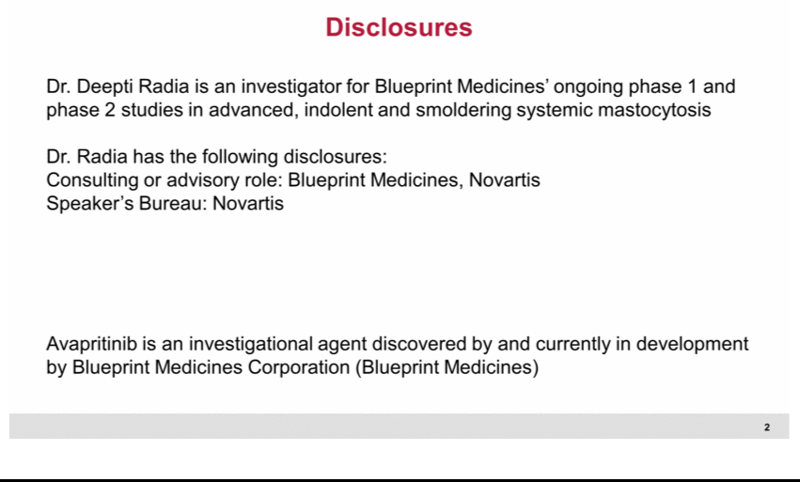

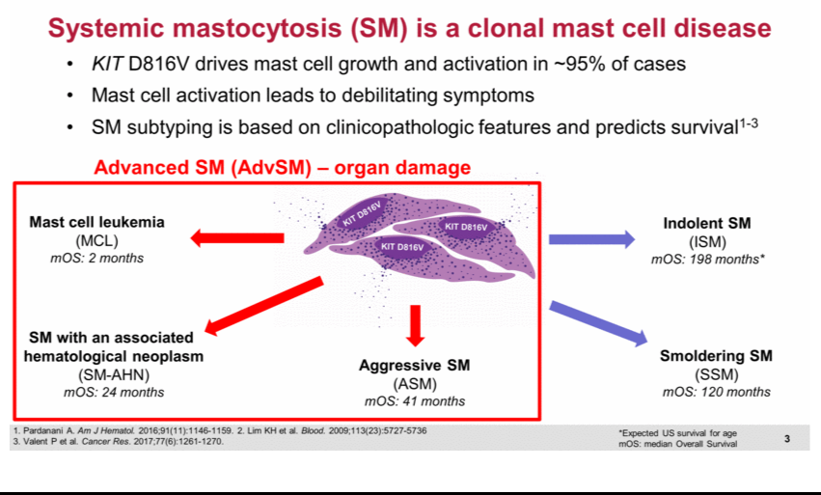

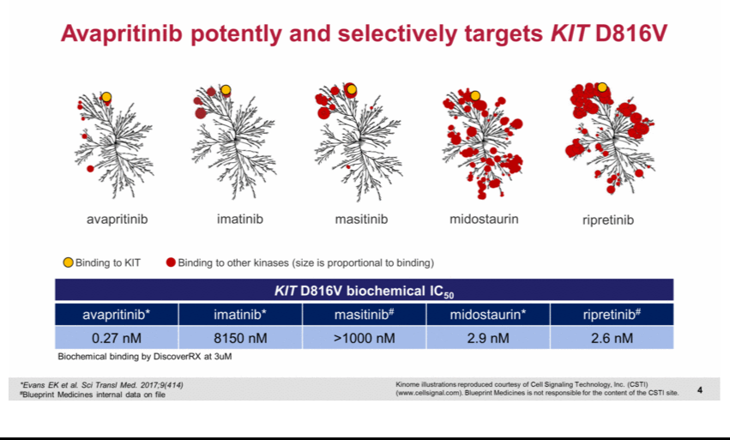

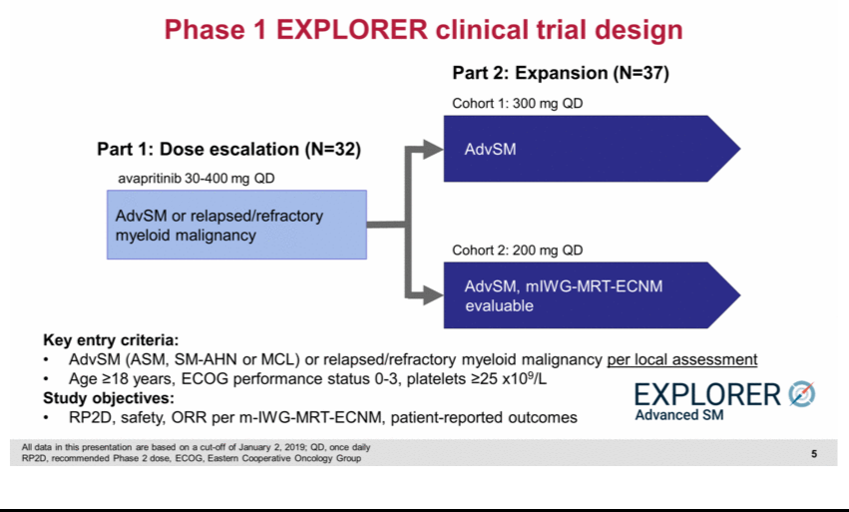

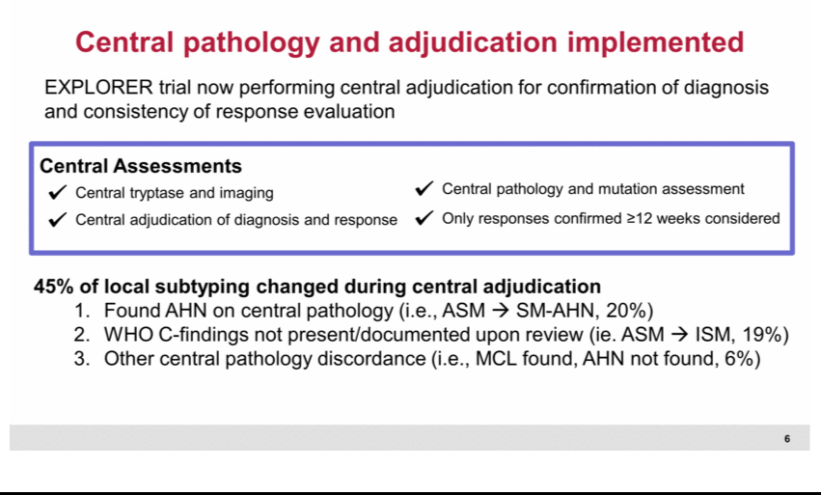

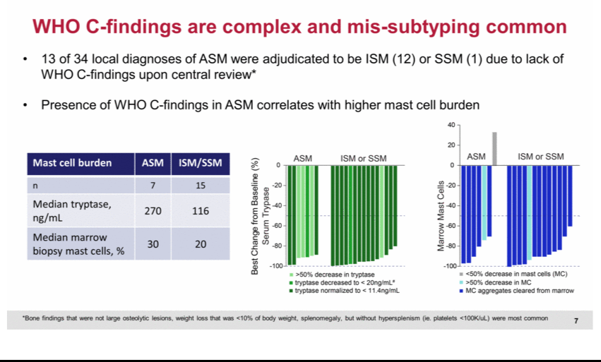

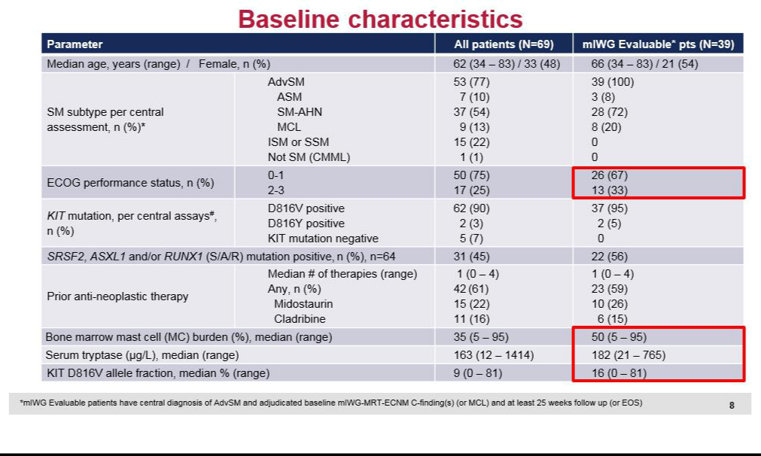

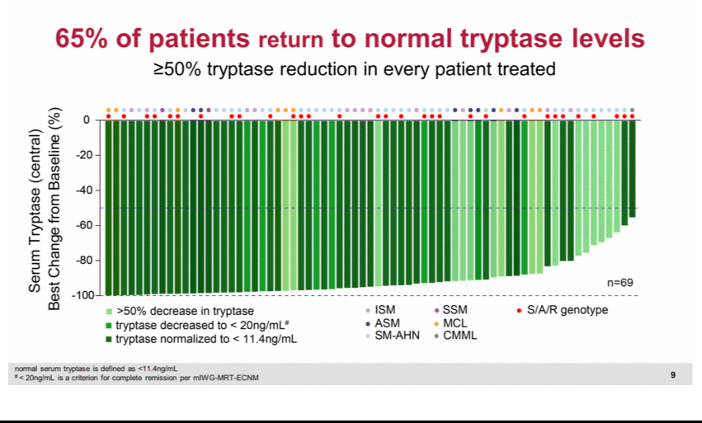

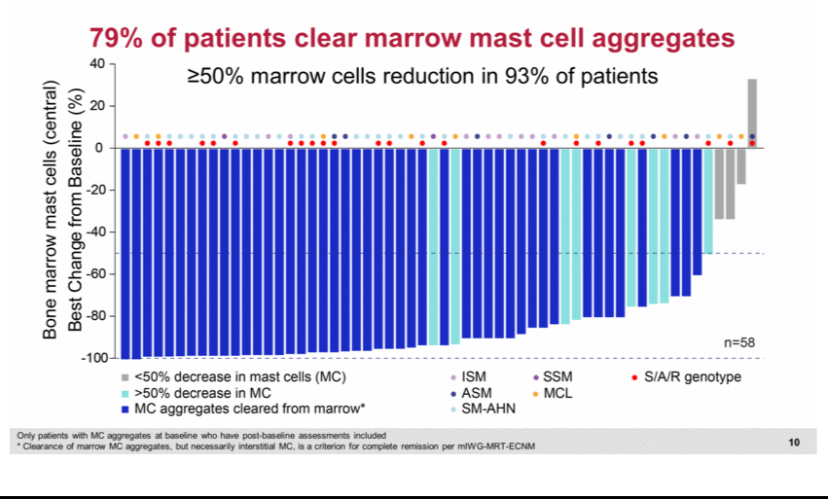

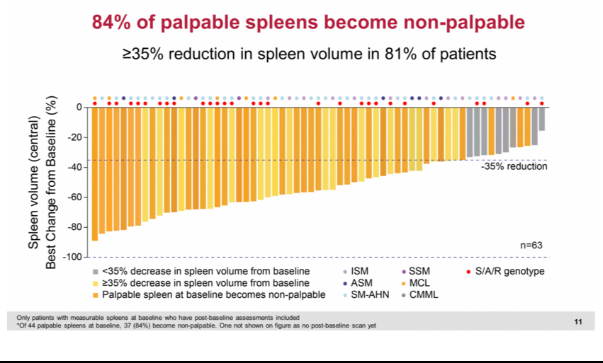

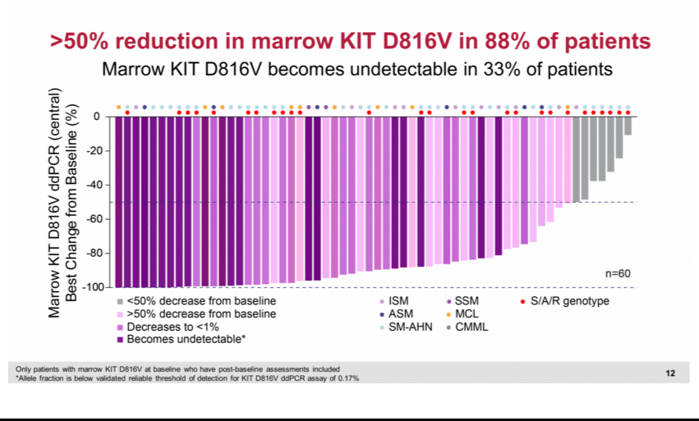

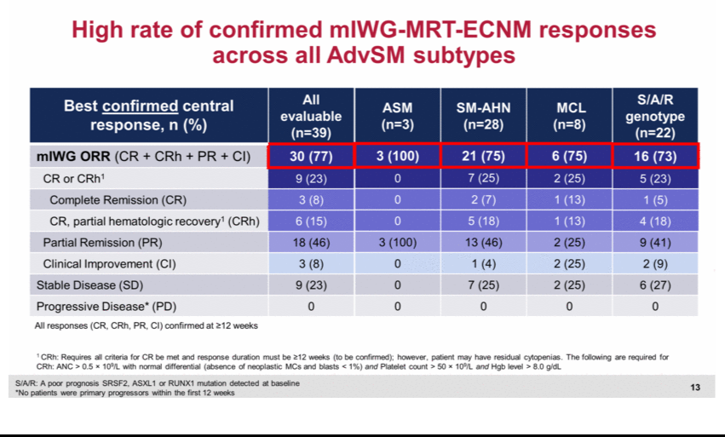

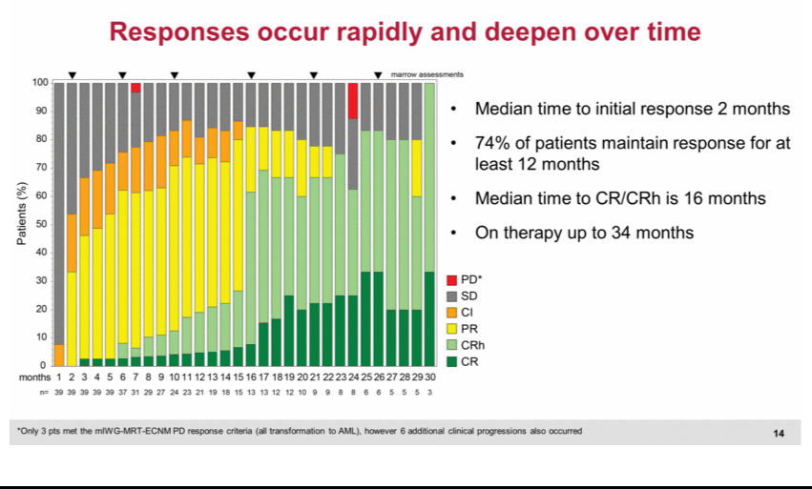

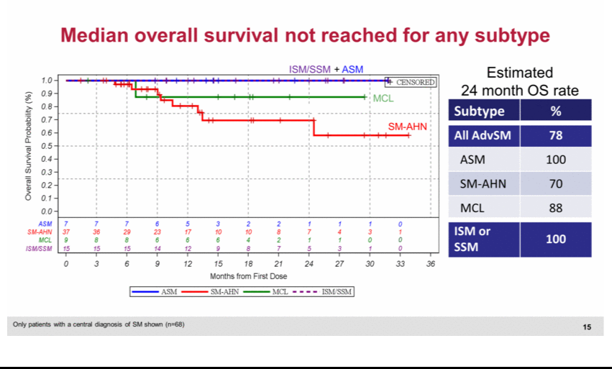

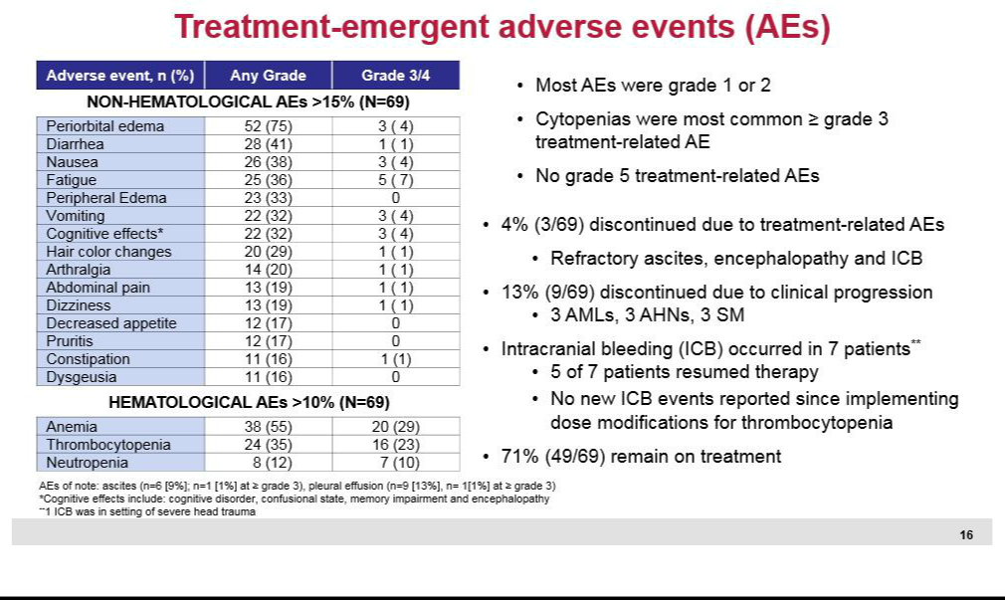

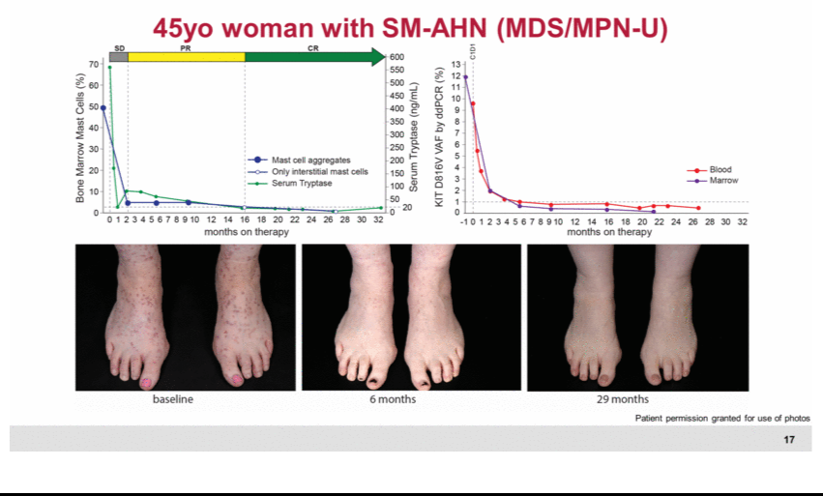

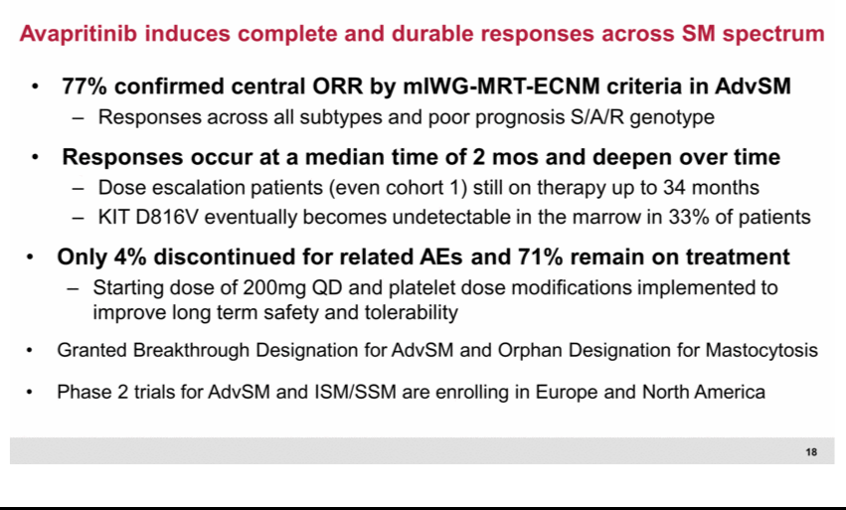

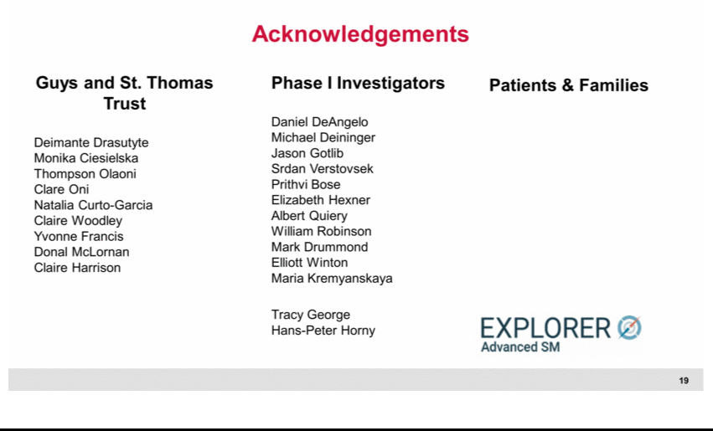

Exhibit 99.4






