UNITED STATES

SECURITIES AND EXCHANGE COMMISSION
Washington, D.C. 20549

FORM 8-K

CURRENT REPORT

Pursuant to Section 13 or 15(d)

of the Securities Exchange Act of 1934

Date of Report (Date of Earliest Event Reported): June 9, 2022

Blueprint Medicines Corporation

(Exact name of registrant as specified in its charter)

Delaware

(State or other jurisdiction

of incorporation)

001-37359

(Commission File Number)

26-3632015

(I.R.S. Employer

Identification No.)

45 Sidney Street

Cambridge, Massachusetts

(Address of principal executive offices)

02139

(Zip Code)

Registrant’s telephone number, including area code: (617) 374-7580

(Former name or former address, if changed since last report)

Check the appropriate box below if the Form 8-K filing is intended to simultaneously satisfy the filing obligation of the registrant under any of the following provisions:

- Written communications pursuant to Rule 425 under the Securities Act (17 CFR 230.425)

- Soliciting material pursuant to Rule 14a-12 under the Exchange Act (17 CFR 240.14a-12)

- Pre-commencement communications pursuant to Rule 14d-2(b) under the Exchange Act (17 CFR 240.14d-2(b))

- Pre-commencement communications pursuant to Rule 13e-4(c) under the Exchange Act (17 CFR 240.13e-4(c))

Indicate by check mark whether the registrant is an emerging growth company as defined in Rule 405 of the Securities Act of 1933 (§230.405 of this chapter) or Rule 12b-2 of the Securities Exchange Act of 1934 (§240.12b-2 of this chapter).

Emerging growth company ☐

If an emerging growth company, indicate by check mark if the registrant has elected not to use the extended transition period for complying with any new or revised financial accounting standards provided pursuant to Section 13(a) of the Exchange Act.

Securities registered pursuant to Section 12(b) of the Exchange Act:

Title of each class | Trading symbol(s) | Name of each exchange on which registered
Common stock, par value $0.001 per share | BPMC | Nasdaq Global Select Market

Item 7.01 Regulation FD.

On June 9, 2022, Blueprint Medicines Corporation (the “Company”) is presenting updates on the AYVAKIT/AYVAKYT (avapritinib) development program in systemic mastocytosis and other business updates at the 2022 Jefferies Healthcare Conference. A copy of the presentation is furnished as Exhibit 99.1 to this Current Report on Form 8-K.

The information in Item 7.01 of this Current Report on Form 8-K, including Exhibit 99.1 attached hereto, is intended to be furnished and shall not be deemed “filed” for purposes of Section 18 of the Securities Exchange Act of 1934, as amended (the “Exchange Act”), or otherwise subject to the liabilities of that section, nor shall it be deemed incorporated by reference in any filing under the Securities Act of 1933, as amended, or the Exchange Act, except as expressly set forth by specific reference in such filing.

Item 8.01 Other Events.

On June 9, 2022, the Company issued a press release announcing data from the AYVAKIT/AYVAKYT (avapritinib) development program from various presentations at the European Hematology Association 2022 Congress. A copy of the press release is filed herewith as Exhibit 99.2 to this Current Report on Form 8-K and incorporated herein by reference.

Item 9.01 Financial Statements and Exhibits.

(d) Exhibits.
Exhibit No. |  |  |  |  | Description
 | 99.1 |  |  | Corporate slide presentation of Blueprint Medicines Corporation dated June 9, 2022
99.2 |  |  |  | Press release issued by Blueprint Medicines Corporation on June 9, 2022

- Cover Page Interactive Data File (embedded within the Inline XBRL document and incorporated as Exhibit 101)

SIGNATURES

Pursuant to the requirements of the Securities Exchange Act of 1934, the registrant has duly caused this report to be signed on its behalf by the undersigned hereunto duly authorized.

BLUEPRINT MEDICINES CORPORATION

Date: June 9, 2022 By: /s/ Kathryn Haviland
Kathryn Haviland

Chief Executive Officer

Exhibit 99.1


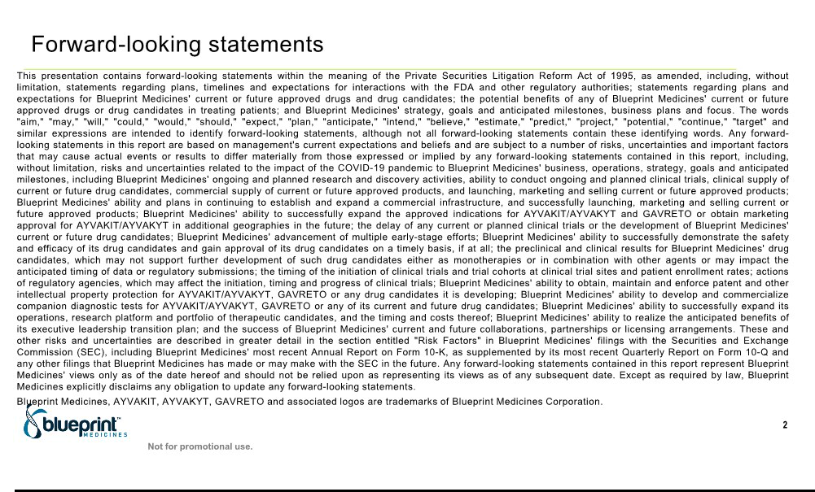

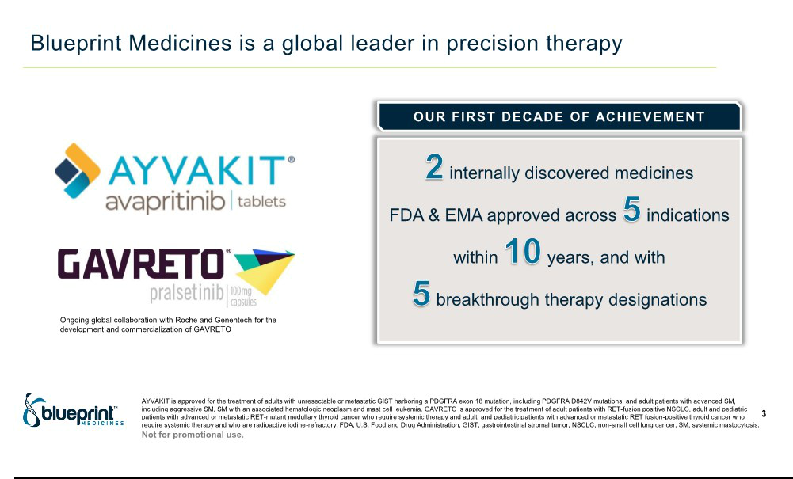

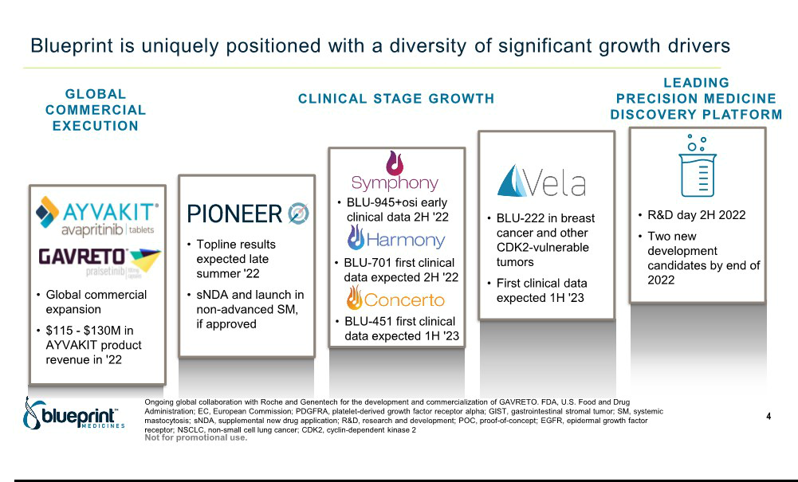



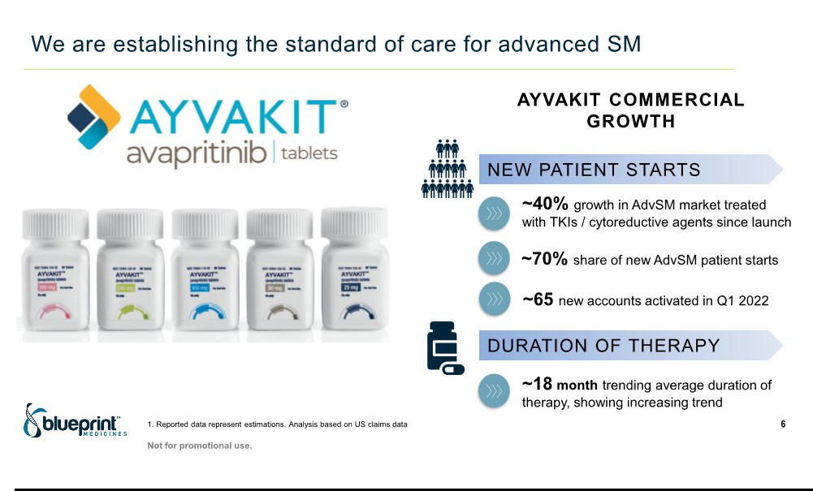

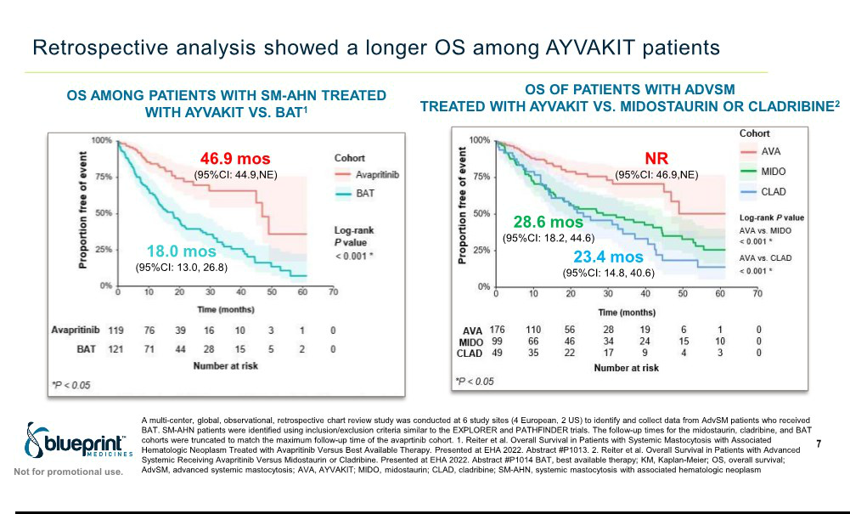



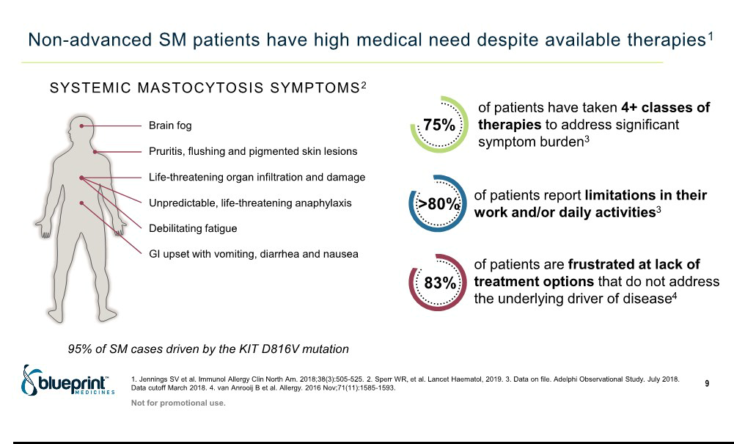

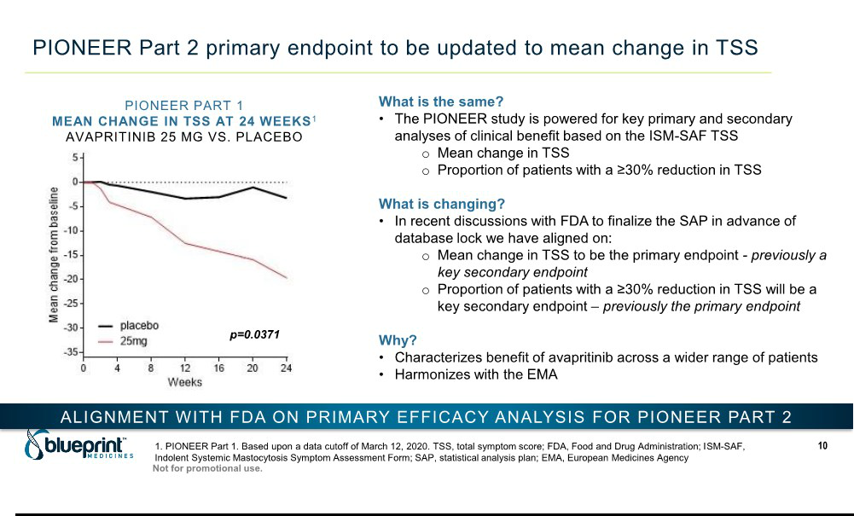

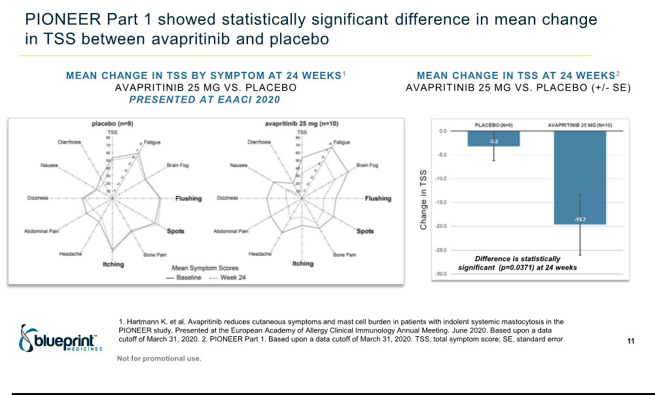

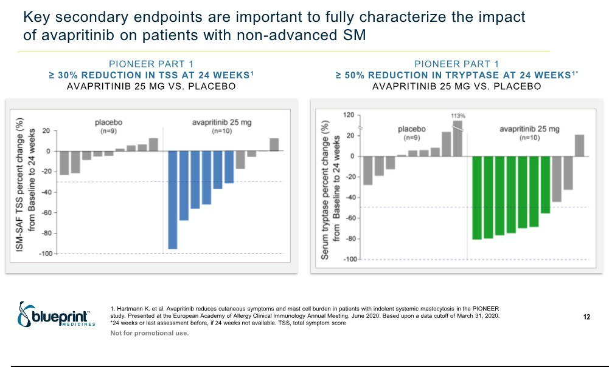

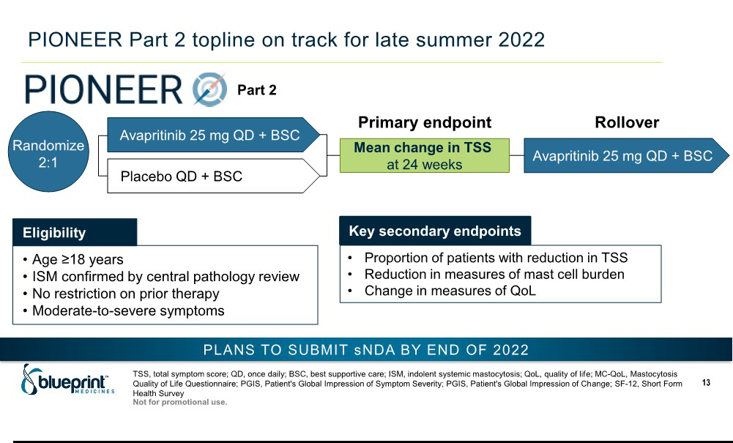

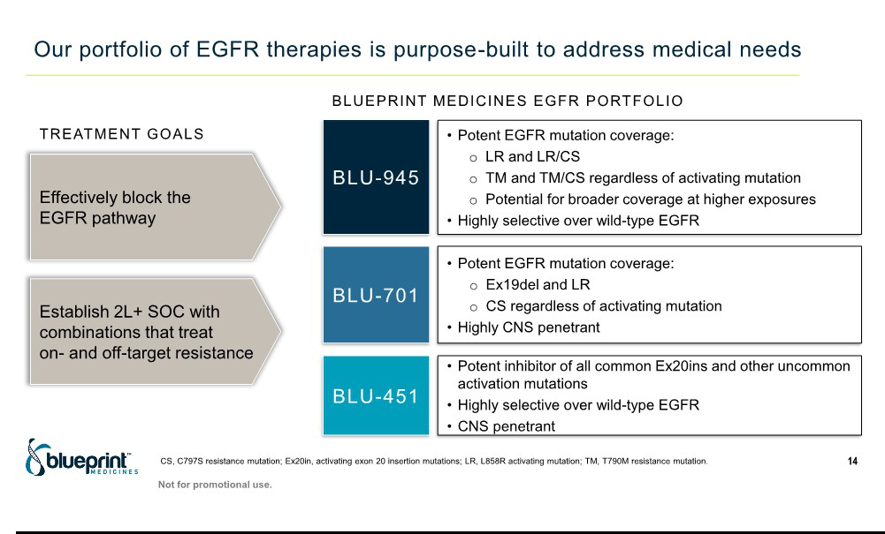

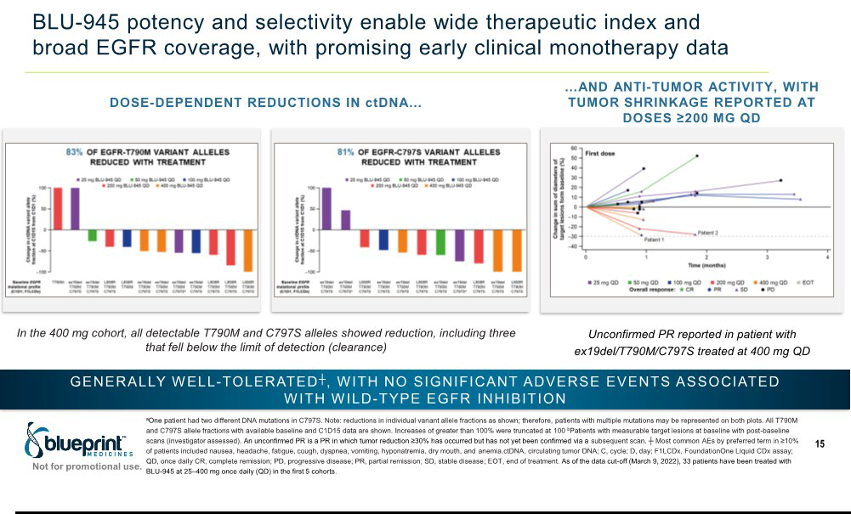

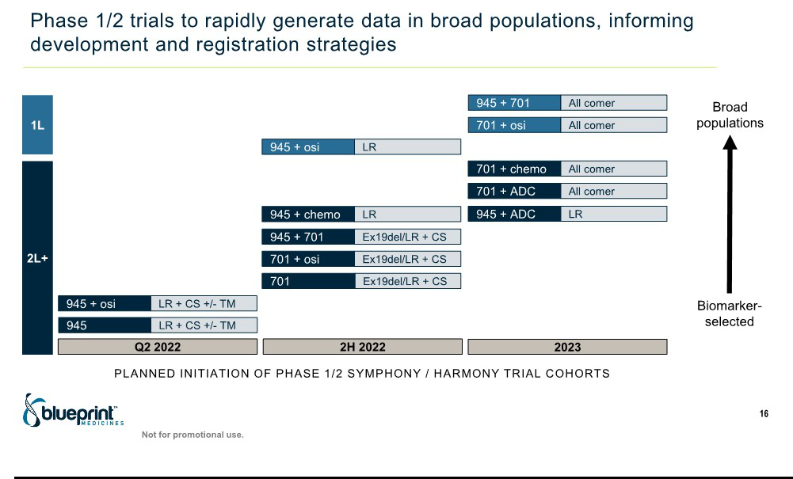

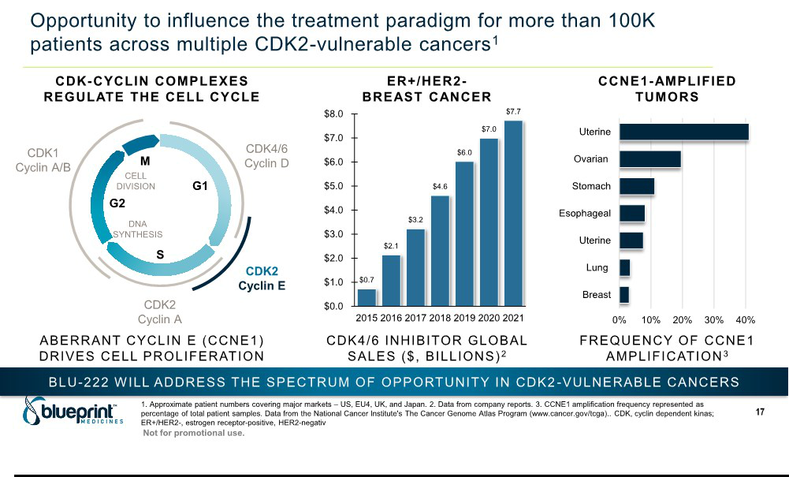

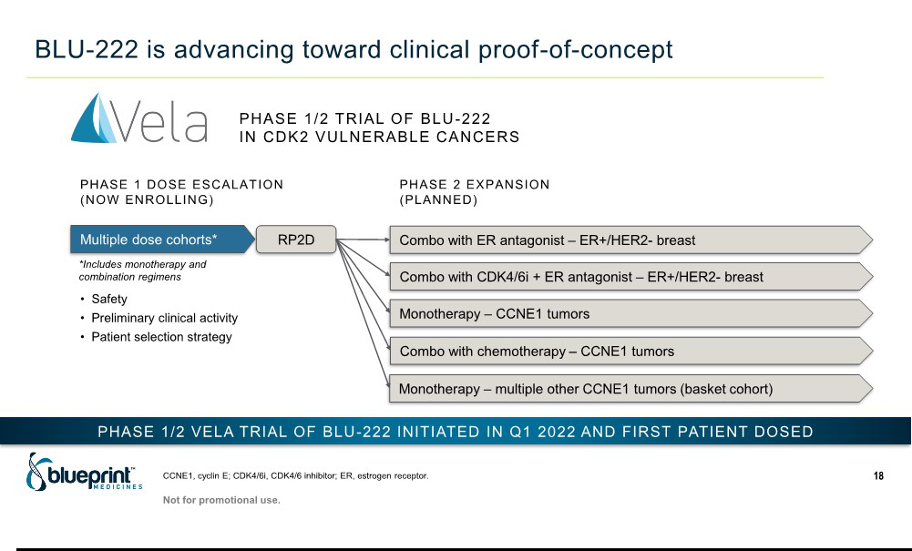

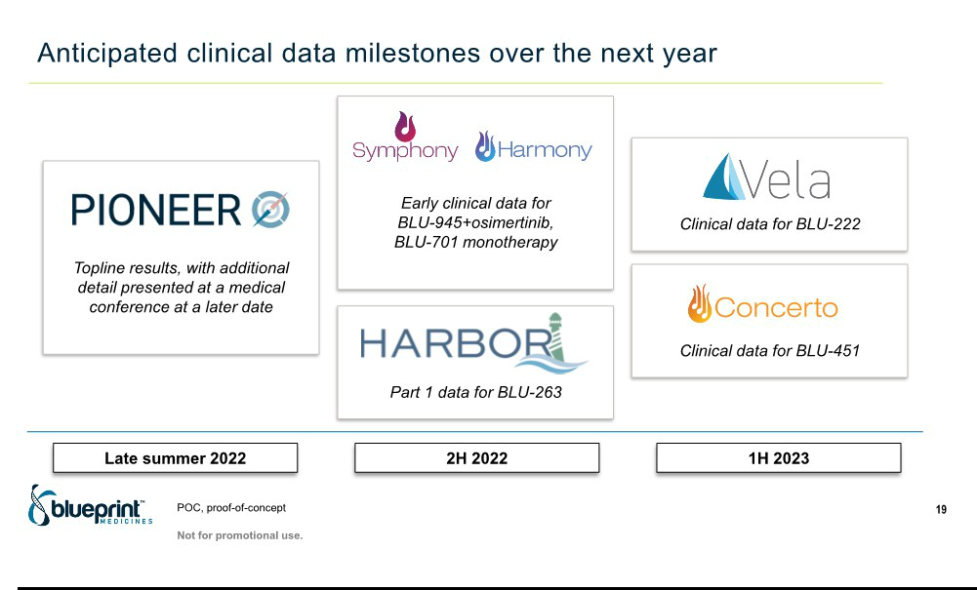



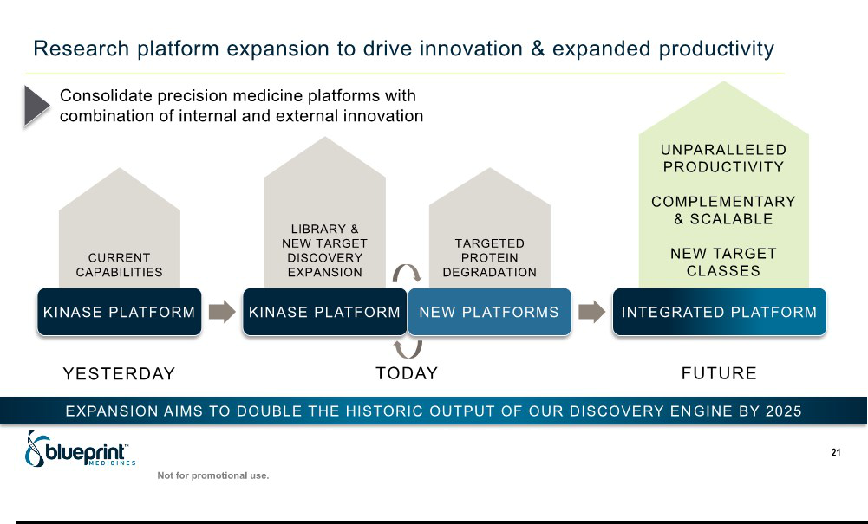

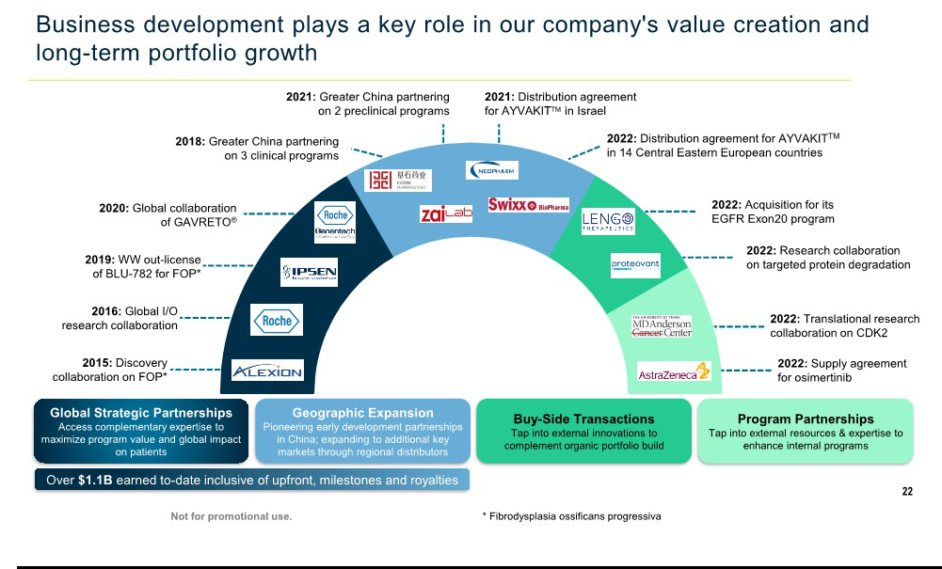

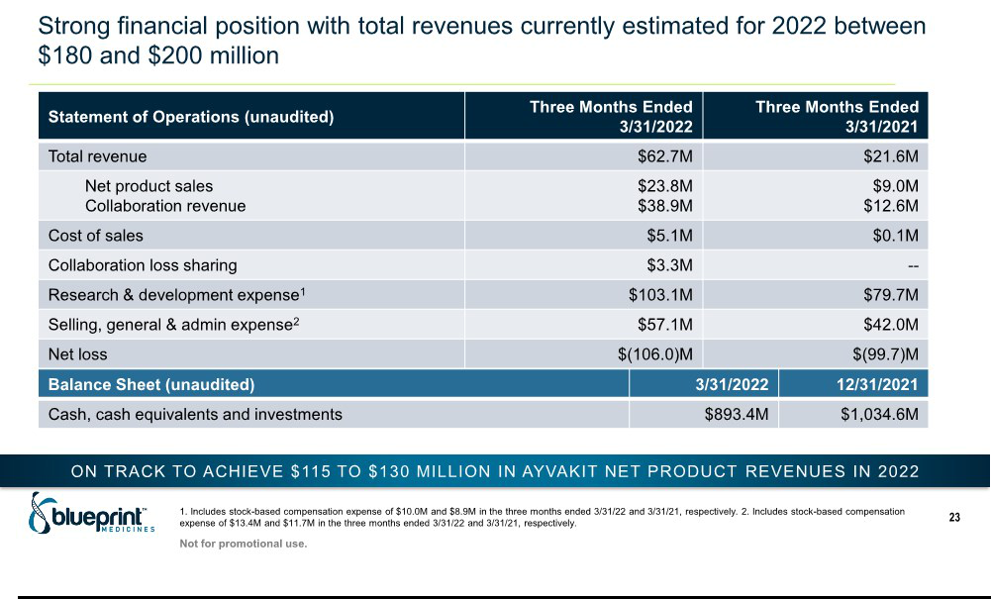

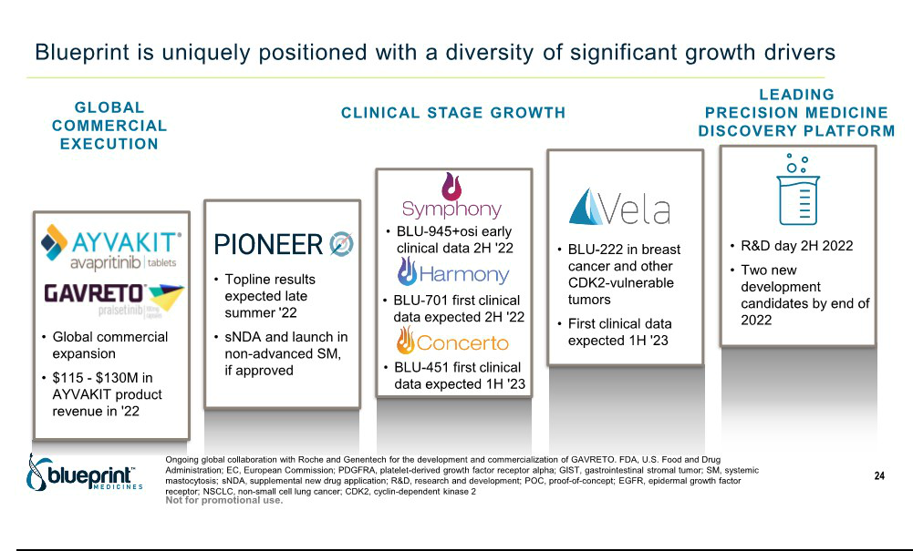

Exhibit 99.2

Blueprint Medicines Reports Continued Progress Toward Goal of Transforming Treatment of Systemic Mastocytosis

- New analyses showing AYVAKIT® (avapritinib) significantly improved overall survival in advanced SM, when indirectly compared to real-world data for prior standard therapies, to be
presented at EHA 2022 Congress --

  - Primary endpoint of PIONEER trial of AYVAKIT in non-advanced SM to be updated to mean change in total symptom score, previously a key secondary endpoint, based on U.S. FDA

recommendation --

      - On track to report top-line registrational data from PIONEER trial in late summer 2022 --

    - Kate Haviland, Chief Executive Officer, to present at Jefferies Healthcare Conference today at 1:30 p.m. EDT --

CAMBRIDGE, Mass., June 9, 2022 -- Blueprint Medicines Corporation (NASDAQ: BPMC) today announced updates on the AYVAKIT®/AYVAKYT® (avapritinib) development program in systemic mastocytosis (SM):

- New analyses, which will be presented this week at the European Hematology Association (EHA) 2022 Congress, add to the growing body of clinical evidence supporting AYVAKIT as the standard of care for patients with advanced SM. Findings showed AYVAKIT improved overall survival (OS), as well as other clinical outcomes, in patients with advanced SM, when indirectly compared to real-world data for prior best available therapies. Based on these analyses, patients treated with AYVAKIT had a 41 percent reduction in the risk of death compared to patients treated with midostaurin and a 68 percent reduction in the risk of death compared to patients treated with cladribine. In total, Blueprint Medicines is supporting the presentation of seven abstracts at the EHA 2022 Congress, highlighting the company’s leadership in SM.

- In addition, Blueprint Medicines plans to update the primary endpoint of the registrational PIONEER trial of AYVAKIT in patients with non-advanced SM, based on a written recommendation from the U.S. Food and Drug Administration (FDA) on statistical considerations ahead of the planned database lock. The mean absolute change in total symptom score (TSS), previously a key secondary endpoint, will be the primary endpoint and the proportion of patients with a 30 percent or greater decrease in TSS, previously the primary endpoint, will be a key secondary endpoint. Both analyses were previously defined as key endpoints that the PIONEER trial was powered to assess. In addition, both endpoints are based on the Indolent SM Symptom Assessment Form, a patient-reported outcomes tool that has been developed and validated in collaboration with the SM community and global regulatory authorities. Blueprint Medicines continues to plan to report top-line data from the PIONEER trial in late summer 2022 and submit a supplemental new drug application to the FDA for AYVAKIT for non-advanced SM by the end of 2022.

“Based on the recommendation of the FDA, we have re-ordered pre-planned efficacy analyses in Part 2 of the PIONEER trial, elevating mean change in total symptom score, which characterizes clinical benefit across all patients,” said Becker Hewes, M.D., Chief Medical Officer of Blueprint Medicines. “Consistent with Part 1 data, we believe the mean change in total symptom score, together with other measures of improvement in clinical outcomes, quality of life and mast cell burden, will paint a compelling picture of AYVAKIT clinical benefit, including its ability to modify the disease biology and provide meaningful relief to patients living with debilitating symptoms of non-advanced SM.”

Highlights from AYVAKIT Presentations at the EHA 2022 Congress

Three presentations at the EHA 2022 Congress will highlight results from a study (NCT04695431) indirectly comparing clinical outcomes in advanced SM patients receiving AYVAKIT in the registrational EXPLORER and PATHFINDER trials, versus patients treated with best available therapy in real-world clinical practice. Results showed that AYVAKIT improved clinical outcomes when retrospectively compared to best available therapies, including the two other most common treatments (midostaurin, cladribine) identified in the real-world study cohort.

“These rigorous, retrospective analyses highlight the prolonged survival, extended duration of treatment and observed reduction in mast cell burden shown by avapritinib in patients with advanced systemic mastocytosis,” said Prof. Dr. Andreas Reiter, M.D., University Medical Centre, Heidelberg University, Mannheim, Germany. “Notably, in an indirect comparative analysis of patients with SM and an associated hematologic neoplasm, those treated in avapritinib clinical trials had a significantly lower risk of death than those receiving prior best available therapy in the real-world setting. These results are highly meaningful for this patient population, which has a significant disease burden and limited treatment options.”

For this study, patients treated in real-world clinical practice were identified in a retrospective medical chart review at six centers with similar patient eligibility criteria as EXPLORER and PATHFINDER. Retrospective data were collected and analyzed using methods to balance key baseline variables; however, the study may have limitations due to inherent differences between data collected from prospective trials and real-world experience. No prospective, randomized, controlled head-to-head studies have been conducted comparing AYVAKIT to other therapies in patients with advanced SM. EXPLORER and PATHFINDER results were reported as of an April 20, 2021 cutoff date.

Overall Survival Data in Advanced SM

 | AYVAKIT¹ | Midostaurin | Cladribine
Number of patients | 176 | 94 | 44
Median in months (95% CI) | NR (46.9, NE) | 28.6 (18.2, 44.6) | 23.4 (14.8, 40.6)
Hazard ratio (95% CI)² | --- | HR: 0.59 (0.36, 0.97) | HR: 0.32 (0.15, 0.67)
P-value² | --- | p<0.001 | p=0.003

- Pooled data from EXPLORER and PATHFINDER clinical trials of AYVAKIT in advanced SM (all doses).

- Comparative analyses used inverse-probability-of-treatment-weighting to balance differences in key baseline covariates; HR<1 favors AYVAKIT.

Additional weighted, indirect comparison analyses showed:

- AYVAKIT (all doses) reduced the risk of death by 58 percent compared to best available therapy (p<0.001) in patients with SM with an associated hematological neoplasm (SM-AHN).

- AYVAKIT (≤200 mg once-daily dose) reduced the risk of treatment discontinuation by 64 percent compared to best available therapy (p<0.001) in advanced SM patients.

- The maximum percent reduction in serum tryptase levels for AYVAKIT (≤200 mg once-daily dose) was 85 percent, compared to 9 percent for best available therapy (p<0.001), in advanced SM patients.

Regulatory approvals in the U.S. and EU were based on results from the EXPLORER and PATHFINDER trials. In the U.S., AYVAKIT is indicated for the treatment of adults with Advanced SM, including aggressive SM (ASM), SM-AHN and mast cell leukemia (MCL). AYVAKIT is not recommended for the treatment of patients with advanced SM with low platelet counts (less than 50,000/µL). Warnings and precautions include intracranial hemorrhage, cognitive effects and embryo-fetal toxicity. The most common adverse reactions were edema, diarrhea, nausea and fatigue/asthenia.

Further details from these analyses, along with additional SM data, will be reported in multiple presentations at the EHA 2022 Congress:

- Overall survival in patients with advanced systemic mastocytosis receiving avapritinib versus midostaurin or cladribine (Abstract P1014)

- Overall survival in patients with systemic mastocytosis with associated hematologic neoplasm treated with avapritinib versus best available therapy (Abstract P1013)

- Duration of treatment and reduction in serum tryptase levels in patients with advanced systemic mastocytosis treated with avapritinib versus best available therapy (Abstract P1015)

- Responses to avapritinib in patients with advanced systemic mastocytosis: histopathologic analyses from EXPLORER and PATHFINDER clinical studies (Abstract P1027)

- Clinicopathologic and molecular correlates of organ damage across the spectrum of advanced systemic mastocytosis (Abstract P1038)

- Utility of KIT p.D816 in myeloid neoplasm without documented systemic mastocytosis to detect hidden mast cells in bone marrow (Abstract P996)

- HARBOR: A phase 2/3 study of BLU-263 in patients with indolent systemic mastocytosis and monoclonal mast cell activation syndrome (Trial-in-progress abstract P1017)

Tomorrow, June 10, copies of the posters will be available on the EHA congress website and in the “Science—Publications and Presentations” section of Blueprint Medicines’ website.

Upcoming Investor Conference

Kate Haviland, Chief Executive Officer at Blueprint Medicines, will present a company overview at the Jefferies Healthcare Conference today at 1:30 p.m. EDT. A live webcast of the presentation will be available by visiting the Investors & Media section of Blueprint Medicines’ website at http://ir.blueprintmedicines.com. A replay of the webcast will be archived on Blueprint Medicines’ website for 30 days following the presentation.

About AYVAKIT (avapritinib)

AYVAKIT (avapritinib) is a kinase inhibitor approved by the FDA for the treatment of adults with Advanced SM, including aggressive SM (ASM), SM with an associated hematological neoplasm (SM-AHN) and mast cell leukemia (MCL), and adults with unresectable or metastatic gastrointestinal stromal tumor (GIST) harboring a PDGFRA exon 18 mutation, including PDGFRA D842V mutations. For more information, visit AYVAKIT.com. Under the brand name AYVAKYT (avapritinib), this medicine is approved by the European Commission for the treatment of adults with ASM, SM-AHN or MCL, after at least one systemic therapy, as well as adults with unresectable or metastatic GIST harboring the PDGFRA D842V mutation.

AYVAKIT/AYVAKYT is not approved for the treatment of any other indication in Europe and the U.S.

Blueprint Medicines is developing AYVAKIT globally for the treatment of advanced and non-advanced SM. The FDA granted breakthrough therapy designation to AYVAKIT for the treatment of moderate to severe indolent SM. The European Commission granted orphan medicinal product designation for AYVAKYT for the treatment of GIST and mastocytosis.

To learn about ongoing or planned clinical trials, contact Blueprint Medicines in the U.S. at medinfo@blueprintmedicines.com or +1 888-258-7768, or in Europe at medinfoeurope@blueprintmedicines.com or +31 85 064 4001. Additional information is available at blueprintclinicaltrials.com and clinicaltrials.gov.

Please click here to see the full U.S. Prescribing Information for AYVAKIT, and click here to see the European Summary of Product Characteristics for AYVAKYT.

Important Safety Information

Serious intracranial hemorrhage (ICH) may occur with AYVAKIT treatment; fatal events occurred in <1% of patients. Overall, ICH (eg, subdural hematoma, ICH, and cerebral hemorrhage) occurred in 2.9% of 749 patients who received AYVAKIT. In Advanced SM patients who received AYVAKIT at 200 mg daily, ICH occurred in 2 of 75 patients (2.7%) who had platelet counts

≥50 x 10⁹/L prior to initiation of therapy and in 3 of 80 patients (3.8%) regardless of platelet counts. Monitor patients closely for risk of ICH including those with thrombocytopenia, vascular aneurysm or a history of ICH or cerebrovascular accident within the prior year. Permanently discontinue AYVAKIT if ICH of any grade occurs. A platelet count must be performed prior to
initiating therapy. AYVAKIT is not recommended in Advanced SM patients with platelet counts <50 x 10⁹/L. Following treatment initiation, platelet counts must be performed every 2 weeks for

the first 8 weeks. After 8 weeks of treatment, monitor platelet counts every 2 weeks or as clinically indicated based on platelet counts. Manage platelet counts of <50 x 10⁹/L by treatment interruption or dose reduction.

Cognitive adverse reactions can occur in patients receiving AYVAKIT. Cognitive adverse reactions occurred in 39% of 749 patients and in 28% of 148 SM patients (3% were Grade >3). Memory impairment occurred in 16% of patients; all events were Grade 1 or 2. Cognitive disorder occurred in 10% of patients; <1% of these events were Grade 3. Confusional state occurred in 6% of patients; <1% of these events were Grade 3. Other events occurred in <2% of patients. Depending on the severity, withhold AYVAKIT and then resume at same dose or at a reduced dose upon improvement, or permanently discontinue.

AYVAKIT can cause fetal harm when administered to a pregnant woman. Advise pregnant women of the potential risk to a fetus. Advise females and males of reproductive potential to use an effective method of contraception during treatment with AYVAKIT and for 6 weeks after the final dose of AYVAKIT. Advise women not to breastfeed during treatment with AYVAKIT and for 2 weeks after the final dose.

The most common adverse reactions (≥20%) at all doses were edema, diarrhea, nausea, and fatigue/asthenia.

Avoid coadministration of AYVAKIT with strong and moderate CYP3A inhibitors. If coadministration with a moderate CYP3A inhibitor cannot be avoided, reduce dose of AYVAKIT. Avoid coadministration of AYVAKIT with strong and moderate CYP3A inducers.

To report suspected adverse reactions, contact Blueprint Medicines Corporation at 1-888-258-7768 or FDA at 1-800-FDA-1088 or www.fda.gov/medwatch.

Please click here to see the full Prescribing Information for AYVAKIT.

About Systemic Mastocytosis

Systemic mastocytosis (SM) is a rare disease primarily driven by the KIT D816V mutation. Uncontrolled proliferation and activation of mast cells result in chronic, severe and often unpredictable symptoms for patients across the spectrum of SM. The vast majority of those affected have non-advanced (indolent or smoldering) SM, with debilitating symptoms that lead to a profound, negative impact on quality of life. A minority of patients have advanced SM, which encompasses a group of high-risk SM subtypes including ASM, SM-AHN and MCL. In addition to mast cell activation symptoms, advanced SM is associated with organ damage due to mast cell infiltration and poor survival. Across advanced SM subtypes, the median OS is approximately 3.5

years in ASM, approximately two years in SM-AHN and less than six months in MCL.^{i} In Europe, there are about 40,000 patients with SM, and advanced SM represents about 5 to 10 percent of this patient population.^{ii}

Debilitating symptoms, including anaphylaxis, maculopapular rash, pruritis, diarrhea, brain fog, fatigue and bone pain, often persist across all forms of SM despite treatment with a number of symptomatic therapies. Patients often live in fear of severe, unexpected symptoms, have limited ability to work or perform daily activities, and isolate themselves to protect against unpredictable triggers. Historically, there had been no approved therapies for the treatment of SM that selectively inhibit D816V mutant KIT.^{iii,iv}

About Blueprint Medicines

Blueprint Medicines is a global precision therapy company that invents life-changing therapies for people with cancer and blood disorders. Applying an approach that is both precise and agile, we create medicines that selectively target genetic drivers, with the goal of staying one step ahead across stages of disease. Since 2011, we have leveraged our research platform, including expertise in molecular targeting and world-class drug design capabilities, to rapidly and reproducibly translate science into a broad pipeline of precision therapies. Today, we are delivering approved medicines directly to patients in the United States and Europe, and we are globally advancing multiple programs for systemic mastocytosis, lung cancer and other genomically defined cancers, and cancer immunotherapy. For more information, visit www.BlueprintMedicines.com and follow us on Twitter (@BlueprintMeds) and LinkedIn.

Cautionary Note Regarding Forward-Looking Statements

This press release contains forward-looking statements within the meaning of the Private Securities Litigation Reform Act of 1995, as amended, including, without limitation, statements regarding plans, timelines and expectations for interactions with the FDA and other regulatory authorities; plans and timelines to update the primary endpoint of the registrational PIONEER trial of AYVAKIT in patients with non-advanced SM; expectations regarding the potential benefits of AYVAKIT in treating patients with non-advanced SM and advanced SM; and Blueprint Medicines’ strategy, goals and anticipated milestones, business plans and focus. The words “aim,” “may,” “will,” “could,” “would,” “should,” “expect,” “plan,” “anticipate,” “intend,” “believe,” “estimate,” “predict,” “project,” “potential,” “continue,” “target” and similar expressions are intended to identify forward-looking statements, although not all forward-looking statements contain these identifying words. Any forward-looking statements in this report are based on management’s current expectations and beliefs and are subject to a number of risks, uncertainties and important factors that may cause actual events or results to differ materially from those expressed or implied by any forward-looking statements contained in this report, including, without limitation, risks and uncertainties related to the impact of the COVID-19 pandemic to Blueprint Medicines’ business, operations, strategy, goals and anticipated milestones, including Blueprint Medicines’ ongoing and planned research and discovery activities, ability to conduct ongoing and planned clinical trials, clinical supply of current or future drug candidates, commercial supply of current or future approved products, and launching, marketing and selling current or future approved products; Blueprint Medicines’ ability and plans in continuing to establish and expand a commercial infrastructure, and successfully launching, marketing and selling current or future approved products; Blueprint Medicines’ ability to successfully expand the approved indications for AYVAKIT/AYVAKYT and GAVRETO or obtain marketing approval for AYVAKIT/AYVAKYT in additional geographies in the future; the delay of any current or planned clinical trials or the development of Blueprint Medicines’ current or future drug candidates; Blueprint Medicines’ advancement of multiple early-stage efforts; Blueprint Medicines’ ability to successfully demonstrate the safety and efficacy of its drug candidates and gain approval of its drug candidates on a timely basis, if at all; the preclinical and clinical results for Blueprint Medicines’ drug candidates, which may not support further development of such drug candidates either as monotherapies or in combination with other agents or may impact the anticipated timing of data or regulatory submissions; the timing of the initiation of clinical trials and trial cohorts at clinical trial sites and patient enrollment rates; actions of regulatory agencies, which may affect the initiation, timing and progress of clinical trials; Blueprint Medicines’ ability to obtain, maintain and enforce patent and other intellectual property protection for AYVAKIT/AYVAKYT, GAVRETO or any drug candidates it is developing; Blueprint Medicines’ ability to develop and commercialize companion diagnostic tests for AYVAKIT/AYVAKYT, GAVRETO or any of its current and future drug candidates; Blueprint Medicines’ ability to successfully expand its operations, research platform and portfolio of therapeutic candidates, and the timing and costs thereof; Blueprint Medicines’ ability to realize the anticipated benefits of its executive leadership transition plan; and the success of Blueprint Medicines’ current and future collaborations, acquisitions, partnerships or licensing arrangements. These and other risks and uncertainties are described in greater detail in the section entitled “Risk Factors” in Blueprint Medicines’ filings with the Securities and Exchange Commission (SEC), including Blueprint Medicines’ most recent Annual Report on Form 10-K, as supplemented by its most recent Quarterly Report on Form 10-Q and any other filings that Blueprint Medicines has made or may make with the SEC in the future. Any forward-looking statements contained in this report represent Blueprint Medicines’ views only as of the date hereof and should not be relied upon as representing its views as of any subsequent date. Except as required by law, Blueprint Medicines explicitly disclaims any obligation to update any forward-looking statements.

Trademarks

Blueprint Medicines, AYVAKIT, AYVAKYT, GAVRETO and associated logos are trademarks of Blueprint Medicines Corporation.

Media Contact

Sarah Mena Guerrero

+1 (617)-714-6684

media@blueprintmedicines.com

Investor Relations Contact

Kristin Hodous

+1 (617)-714-6674

ir@blueprintmedicines.com

References

- Sperr WR, Kundi M, Alvarez-Twose I, et al. International prognostic scoring system for mastocytosis (IPSM): a retrospective cohort study. Lancet Haematol. 2019;6(12):e638-e649.

- Estimated SM prevalence and patient subtypes based on internal claims analysis and epidemiology reported in Orphanet (orpha.net) and Cohen SS, Skovbo S, Vestergaard H, et al. Epidemiology of systemic mastocytosis in Denmark. Br J Haemotol. 2014;166(4):521-528.
- Jennings SV, Slee VM, Zack RM, et al. Patient perceptions in mast cell disorders. Immunol Allergy Clin North Am. 2018;38(3):505-525.

- Mesa RA, Sullivan EM, Dubinski D, et al. Patient reported outcomes among systemic mastocytosis (SM) patients in routine clinical practice: results from the TouchStone Survey. Blood. 2020;136(1):37.

